Chapter 1: Assessment of the Walleye Pollock Stock in the Eastern Bering Sea

James Ianelli, Ben Fissel, Kirstin Holsman, Taina Honkalehto, Stan Kotwicki, Cole Monnahan, Elizabeth Siddon,

Sarah Stienessen, and James Thorson

Alaska Fisheries Science Center, National Marine Fisheries Service National Oceanic and Atmospheric Administration

7600 Sand Point Way NE., Seattle, WA 98115-6349 December 03, 2019

##### Executive summary

This chapter covers the Eastern Bering Sea (EBS) region—the Aleutian Islands region (Chapter 1A) and the Bogoslof Island area (Chapter 1B) are presented separately.

*Summary of changes in assessment inputs*

Relative to last year’s BSAI SAFE report, the following substantive changes have been made in the EBS pollock stock assessment.

*Changes in the data*

1. The 2019 NMFS bottom-trawl survey (BTS) biomass and abundance at age estimates were included.
2. The 2018 NMFS acoustic-trawl survey (ATS) age composition data were updated using sam- ples from the ATS survey (in last year’s assessment the age-length key was mainly composed of samples from the BTS)
3. The 2019 opportunistic acoustic data from vessels (AVO) conducting the bottom trawl survey was used as an added index of pollock biomass in mid- water.
4. Observer data for catch-at-age and average weight-at-age from the 2018 fishery were finalized and included.
5. Total catch as reported by NMFS Alaska Regional oﬃce was updated and included through 2019.

*Changes in the assessment methods*

There were some minor changes to the assessment model. We added the facility to incorporate a full time and age varying matrix of natural mortality rates to be specified (previously we used a time- constant vector of natural-mortality-at-age). This was done to provide an alternative evaluation of the output from the multi-species trophic model (CEATTLE; this volume). Also, new information is becoming available on the relative availability of pollock to our bottom trawl survey gear. To make comparisons, we added control over the way selectivity in that survey impacts the relative “catchability” for key age groups. The control allows an approach to approximate the relative amount of process error to allow for selectivity changes (previously, the process error variance was specified through the ascending logistic parameters). This allowed us to compare results from an availability study that is presently being completed.

We continued to refine treatment of survey data via spatial-temporal models for creating an alter- native index including the broader region of the northern Bering Sea. Additionally, we applied the VAST model to age-specific data to derive alternative estimates of age composition data for the bottom-trawl survey. Preliminary results from applying spatial smoothers to the acoustic index was also provided as a sensitivity.

###### Summary of EBS pollock results

The following table applies for Model 16.1, the model used for last year’s assessment advice. An alternative table is provided for this same model but uses the VAST-treated survey data and in- cludes the Northern Bering Sea is provided at the end of this draft. Here, the ABC recommendation reflects the Tier 3 estimate.

|  |  |  |  |  |
| --- | --- | --- | --- | --- |
| Quantity | As estimated or *specified*  *last* year for:  2019 2020 | | As estimated or *recommended*  *this* year for:  2020 2021 | |
| M (natural mortality rate, ages 3+) | 0.3  1a 9,110,000 t  3,107,000 t  5,866,000 t  2,280,000 t  0.645  0.510  0.356  3,913,000 t  3,096,000 t  2,163,000 t | 0.3  1a 8,156,000 t  2,725,000 t  5,866,000 t  2,280,000 t  0.645  0.51  0.375  3,082,000 t  2,437,000 t  1,792,000 t | 0.3 | 0.3 |
| Tier | 1a | 1a |
| Projected total (age 3+) biomass (t) | 8,580,000 t | 7,990,000 t |
| Projected female spawning biomass (t) | 2,781,000 t | 2,476,000 t |
| 5,748,000 t | 5,748,000 t |
| *B*0 |
| 2,147,000 t | 2,147,000 t |
| *Bmsy* |
| 0.528 | 0.528 |
| *FOFL* |
| 0.442 | 0.442 |
| *maxFABC* |
| 0.253 | 0.262 |
| *FABC* |
| 4,273,000 t | 3,458,000 t |
| *OFL* |
| 3,578,000 t | 2,895,000 t |
| *maxABC* |
| 2,045,000 t | 1,716,000 t |
| *ABC* |
| Status | 2017 | 2018 | 2018 | 2019 |
| Overfishing  Overfished Approaching overfished | No  n/a n/a | n/a  No No | No  n/a n/a | n/a  No No |

###### Response to SSC and Plan Team comments

*General comments*

The SSC recommends that one additional column be added to include concerns related to fishery/resource- use performance and behavior, considering commercial as well as local/traditional knowledge for

a broader set of observations. This additional column should not include socio-economic consider- ations, but rather indications of concern such as inability to catch the TAC, or dramatic changes in spatial or temporal distribution that could indicate anomalous biological conditions. The SSC requests that all authors fill out the risk table in 2019, and that the PTs provide comment on the author’s results in any cases where a reduction to the ABC may be warranted (concern levels 2-4).

*The risk table was again included, this year with the requested additional column on fishery performance*

*•*

The Plan Team noted that if the survey index is going to include the NBS, then inclusion of the NBS in compositional data should also be explored (although this should not make much of a diﬀerence since the size compositions in the EBS and NBS are suﬃciently similar)

*A model run with VAST processed age composition data was included and compared with the survey standard estimates.*

*•*

Conduct a sensitivity test of the VAST index, with environmental covariates, by omitting one or two years of NBS data at a time.

*Thanks to the work of Thorson 2019 we were able to evaluate an index that included the extent of the cold pool as a covariate. Comparisons of index fitting out of sample as suggested has been done for several of the publications using VAST*

*•*

Regarding the apparent shift in year class dominance between 2012 and 2013, the possibility of a shift in mean length at age should be explored, as should the possible influence of ageing error

*Age determination experts re-examined subsets of these data and age estimates seems to be consistent and correct.*

*•*

Full treatment of both the existing model and models with alternative treatments of the data should continue to be provided, along with maxABC values under Tier 3 for all models.

* *Summary tables for alternative treatments of data including Tier 3 are provided.*

Re-examine the geographic subset of data currently used to develop the AVO index, specifically to see if including Bristol Bay data improves the correlation

*Due to staﬃng issues, including the government shutdown, this was given low priority over other work.*

*•*

Explore “A” season trends in mean weight at length with a GAM or similar technique, to determine if the trends are either predominantly environmental or predominantly fishery-driven, Regarding *σR*, explore alternative fixed values or estimation methods.

*Trends in mean weight given length are again presented. The extent that fishery aﬀects this pattern was shown to be related to timing. Further work is needed to establish a mean baseline (in time and space) to try to sort out environmental eﬀects hypotheses. Values of σR were explored in previous years, no further work was done on this in 2019.*

*•*

*We included an expanded evaluation of fishery performance this year. Specifically, we examined the spatial pattern of the fishery and developed a statistic of dispersion of individual tows*

##### Introduction

###### General

Walleye pollock (*Gadus chalcogrammus*; hereafter referred to as pollock) are broadly distributed throughout the North Pacific with the largest concentrations found in the Eastern Bering Sea. Also known as Alaska pollock, this species continues to play important roles ecologically and economically.

###### Review of Life History

In the EBS pollock spawn generally in the period March-May and in relatively localized regions during specific periods (Bailey 2000). Generally spawning begins nearshore north of Unimak Island in March and April and later near the Pribilof Islands (Jung et al. 2006, Bacheler et al. 2010). Females are batch spawners with up to 10 batches of eggs per female per year. Eggs and larvae of EBS pollock are planktonic for a period of about 90 days and appear to be sensitive to environmen- tal conditions. These conditions likely aﬀect their dispersal into favorable areas (for subsequent separation from predators) and also aﬀect general food requirements for over-wintering survival (Gann et al. 2015, Heintz et al., 2013, Hunt et al. 2011, Ciannelli et al. 2004). Duﬀy-Anderson et al. (2015) provide a review of the early life history of EBS pollock.

Throughout their range juvenile pollock feed on a variety of planktonic crustaceans, including calanoid copepods and euphausiids. In the EBS shelf region, one-year-old pollock are found throughout the water column, but also commonly occur in the NMFS bottom trawl survey. Ages 2 and 3 year old pollock are rarely caught in summer bottom trawl survey gear and are more com- mon in the midwater zone as detected by mid-water acoustic trawl surveys. Younger pollock are generally found in the more northern parts of the survey area and appear to move to the southeast as they age (Buckley et al. 2009). Euphausiids, principally *Thysanoessa inermis* and *T. raschii*, are among the most important prey items for pollock in the Bering Sea (Livingston, 1991; Lang et al., 2000; Brodeur et al., 2002; Cianelli et al., 2004; Lang et al., 2005). Pollock diets become more piscivorous with age, and cannibalism has been commonly observed in this region. However, Buckley et al. (2016) showed spatial patterns of pollock foraging by size of predators. For example, the northern part of the shelf region between the 100 and 200 m isobaths (closest to the shelf break) tends to be more piscivorous than counterparts in other areas.

###### Stock structure

Data from the survey work in the Northern Bering Sea (NBS) region (north of Nunivak Island to the Russian convention line and into Norton Sound) from 2017 and 2018, as shown below and evaluated in the appendix, suggests that there are concentrations of pollock present which contrasts with the 2010 survey when relatively few pollock were present. The pattern of temperatures in the region likely aﬀect the pollock distribution in ways that likely vary over time. However, there is evidence of a relationship between mean bottom temperatures in the US zone on the EBS shelf and subsequent biomass estimates in the Navarin basin (the Russian area adjacent to the Convention Line; e.g., Stepanenko and Gritsay 2018, Ianelli et al. 2015). Some genetic samples were taken from pollock and collections continue. Pending funding availability, analysis of these samples could help ascertain the extent that these fish are related to those observed in the normal EBS shelf survey area. Genetic samples taken from the 2017 summer bottom trawl survey from the Northern Bering Sea can be compared with samples from the standard Bering Sea Unimak, Pribilof, Bogoslof, and Zhemchug. This planned study should help improve stock structure evaluation (last done in Ianelli et al. 2015).

##### Fishery

###### Description of the directed fishery

Historically, EBS pollock catches were low until directed foreign fisheries began in 1964. Catches increased rapidly during the late 1960s and reached a peak in 1970–75 when they ranged from 1.3 to 1.9 million t annually. Following the peak catch in 1972, bilateral agreements with Japan and the USSR resulted in reductions. During a 10-year period, catches by foreign vessels operating in the “Donut Hole” region of the Aleutian Basin were substantial totaling nearly 7 million t (Table 1). A fishing moratorium for this area was enacted in 1993 and only trace amounts of pollock have been harvested from the Aleutian Basin region since then. Since the late 1970s, the average EBS pollock catch has been about 1.2 million t, ranging from 0.810 million t in 2009 to nearly 1.5 million t during 2003–2006 (Table 1). United States vessels began fishing for pollock in 1980 and by 1987 they were able to take 99% of the quota. Since 1988, U.S. flagged vessels have been operating in this fishery. The current observer program for the domestic fishery formally began in 1991 and prior to that, observers were deployed aboard the foreign vessels since the late 1970s. From the period 1991 to 2011 about 80% of the catch was observed at sea or during dockside oﬄoading. Since 2011, regulations require that all vessels participating in the pollock fishery carry at least one observer so nearly 100% of the pollock fishing operations are monitored by scientifically trained observers. Historical catch estimates used in the assessment, along with management measures (i.e., ABCs and TACs) are shown in Table 2.

*Catch patterns*

The "A-season" for directed EBS pollock fishing opens on January 20th and fishing typically extends into early-mid April. During this season the fishery targets pre-spawning pollock and produces pollock roe that, under optimal conditions, can comprise over 4% of the catch in weight. The summer, or "B-season" presently opens on June 10th and fishing extends through noon on November 1st. The A-season fishery concentrates primarily north and west of Unimak Island depending on ice conditions and fish distribution. There has also been eﬀort along the 100m depth contour (and

deeper) between Unimak Island and the Pribilof Islands. The general pattern by season (and area) has varied over time with recent B-season catches occurring in the southeast portion of the shelf (east of 170*◦*W longitude; Fig. 1). Since 2011, regulations and industry-based measures to reduce Chinook salmon bycatch have aﬀected the spatial distribution of the fishery and to some degree, the way individual vessel operators fish (Stram and Ianelli, 2014).

The catch estimates by sex for the seasons indicate that over time, the number of males and females has been fairly equal (Fig. 2). The 2019 A-season fishery spatial pattern had relatively high concentrations of fishing on the shelf north of Unimak Island and extended along the 200m depth contour (Fig. 3). The 2019 A-season catch rates was very high improving even on the good conditions observed in other recent A seasons (Fig. 4). Beginning in 2017, due to a regulatory change, up to 45% of the TAC could be taken in the A-season (previously only 40% of the TAC could be taken). This conservation measure was made to allow greater flexibility to avoid Chinook salmon in the B-season. To date, it appears that the pollock fleet as a whole took advantage of this added flexibility (Fig. 5). While an important product from the winter fishery is the sale of pollock roe, production during the B-season is consistently about 10% of the annual production (Fig. 6).

The fishing in summer-fall 2019 was quite diﬀerent than recent years with fishing much more broadly distributed and concentrated along the shelf break. Catches in the northwestern continued to increase relative 2017 and 2918 (Fig. 7).

The 2019 summer and fall (B-season) catch per hour fished was lower than the last few years (Fig. 8). Since 1979 the catch of EBS pollock has averaged 1.19 million t with the lowest catches occurring in 2009 and 2010 when the limits were set to 0.81 million t due to stock declines (Table 2). Pollock retained and discarded catch (based on NMFS observer estimates) in the Eastern Bering Sea and Aleutian Islands for 1991–2019 are shown in Table 3. Since 1991, estimates of discarded pollock have ranged from a high of 9.1% of total pollock catch in 1992 to recent lows of around 0.6%. These low values reflect the implementation of the NMFS’ Improved Retention /Improved Utilization program. Prior to the implementation of the American Fisheries Act (AFA) in 1999, higher discards may have occurred under the “race for fish” and pollock marketable sizes were caught incidentally. Since implementation of the AFA, the vessel operators have more time to pursue optimal sizes of pollock for market since the quota is allocated to vessels (via cooperative arrangements). In addition, several vessels have made gear modifications to avoid retention of smaller pollock. In all cases, the magnitude of discards counts as part of the total catch for management (to ensure the TAC is not exceeded) and within the assessment. Bycatch of other non-target, target, and prohibited species is presented in the section titled Ecosystem Considerations below. In that section it is noted that the bycatch of pollock in other target fisheries is more than double the bycatch of other target species (e.g., Pacific cod) in the pollock fishery.

As noted above, the 2019 B-season suggested that the fishery was dispersed and experienced rela- tively low catch rates compared to recent years. Also, an approach to computing fleet dispersion (the relative distance or spread of the fishery in space) was developed and indicated that while the A-season was the most intensely concentrated for the fleet during this season (since 2000), the B-season indicated the most dispersed fishing activity over the same period (Fig 9).

###### Management measures

The EBS pollock stock is managed by NMFS regulations that provide limits on seasonal catch. The NMFS observer program data provide near real-time statistics during the season and vessels operate within well-defined limits. In most years the TACs have been set well below the ABC value

and catches have stayed within these constraints (Table 2). Allocations of the TAC split first with 10% to western Alaska communities as part of the Community Development Quota (CDQ) program and the remainder between at-sea processors and shore-based sectors. For a characterization of the CDQ program see Haynie (2014). Seung and Ianelli (2016) combined a fish population dynamics model with an economic model to evaluate regional impacts.

Due to concerns that groundfish fisheries may impact the rebuilding of the Steller sea lion popu- lation, a number of management measures have been implemented over the years. Some measures were designed to reduce the possibility of competitive interactions between fisheries and Steller sea lions. For the pollock fisheries, seasonal fishery catch and pollock biomass distributions (from surveys) indicated that the apparent disproportionately high seasonal harvest rates within Steller sea lion critical habitat could lead to reduced sea lion prey densities. Consequently, management measures redistributed the fishery both temporally and spatially according to pollock biomass distributions. This was intended to disperse fishing so that localized harvest rates were more con- sistent with estimated annual exploitation rates. The measures include establishing: 1) pollock fishery exclusion zones around sea lion rookery or haulout sites; 2) phased-in reductions in the seasonal proportions of TAC that can be taken from critical habitat; and 3) additional seasonal TAC releases to disperse the fishery in time.

Prior to adoption of the above management measures, the pollock fishery occurred in each of the three major NMFS management regions of the North Pacific Ocean: the Aleutian Islands (1,001,780 km2 inside the EEZ), the Eastern Bering Sea (968,600 km2), and the Gulf of Alaska (1,156,100 km2). The marine portion of Steller sea lion critical habitat in Alaska west of 150 *◦* W encompasses 386,770 km2 of ocean surface, or 12% of the fishery management regions.

From 1995–1999 84,100 km2, or 22% of the Steller sea lion critical habitat was closed to the pollock fishery. Most of this closure consisted of the 10 and 20 nm radius all-trawl fishery exclusion zones around sea lion rookeries (48,920 km2, or 13% of critical habitat). The remainder was largely management area 518 (35,180 km2, or 9% of critical habitat) that was closed pursuant to an international agreement to protect spawning stocks of central Bering Sea pollock. In 1999, an additional 83,080 km2 (21%) of critical habitat in the Aleutian Islands was closed to pollock fishing along with 43,170 km2 (11%) around sea lion haulouts in the GOA and Eastern Bering Sea. In 1998, over 22,000 t of pollock were caught in the Aleutian Island region, with over 17,000 t taken within critical habitat region. Between 1999 and 2004 a directed fishery for pollock was prohibited in this region. Subsequently, 210,350 km2 (54%) of critical habitat was closed to the pollock fishery. In 2000 the remaining phased-in reductions in the proportions of seasonal TAC that could be caught within the BSAI Steller sea lion Conservation Area (SCA) were implemented.

On the EBS shelf, an estimate (based on observer at-sea data) of the proportion of pollock caught in the SCA has averaged about 44% annually. During the A-season, the average is also about 44%. Nonetheless, the proportion of pollock caught within the SCA varies considerably, presumably due to temperature regimes and the relative population age structure. The annual proportion of catch within the SCA varies and has ranged from an annual low of 11% in 2010 to high of 60% in 1998–the 2019 annual value was 58% but and quite high again in the A-season (68%; Table 4). The higher values in recent years were likely due to good fishing conditions close to the main port.

The AFA reduced the capacity of the catcher/processor fleet and permitted the formation of coop- eratives in each industry sector by the year 2000. Because of some of its provisions, the AFA gave the industry the ability to respond eﬃciently to changes mandated for sea lion conservation and salmon bycatch measures. Without such a catch-share program, these additional measures would likely have been less eﬀective and less economical (Strong and Criddle 2014).

An additional strategy to minimize potential adverse eﬀects on sea lion populations is to disperse the fishery throughout more of the pollock range on the Eastern Bering Sea shelf. While the distribution of fishing during the A-season is limited due to ice and weather conditions, there appears to be some dispersion to the northwest area (Fig. 3).

The majority (about 56%) of Chinook salmon caught as bycatch in the pollock fishery originate from western Alaskan rivers. An Environmental Impact Statement (EIS) was completed in 2009 in conjunction with the Council’s recommended bycatch management approach. This EIS evaluated the relative impacts of diﬀerent bycatch management approaches as well as estimated the impact of bycatch levels on adult equivalent salmon (AEQ) returning to river systems (NMFS/NPFMC 2009). As a result, revised Chinook salmon bycatch management measures went into eﬀect in 2011 which imposed new prohibited species catch (PSC) limits. These limits, when reached, close the fishery by sector and season (Amendment 91 to the BSAI Groundfish Fishery Management Plan (FMP) resulting from the NPFMC’s 2009 action). Previously, all measures for salmon bycatch imposed seasonal area closures when PSC levels reached the limit (fishing could continue outside of the closed areas). The current program imposes a dual cap system by fishing sector and season. A goal of this system was to maintain incentives to avoid bycatch at a broad range of relative salmon abundance (and encounter rates). Participants are also required to take part in an incentive program agreement (IPA). These IPAs are approved and reviewed annually by NMFS to ensure individual vessel accountability. The fishery has been operating under rules to implement this program since January 2011.

Further measures to reduce salmon bycatch in the pollock fishery were developed and the Council took action on Amendment 110 to the BSAI Groundfish FMP in April 2015. These additional measures were designed to add protection for Chinook salmon by imposing more restrictive PSC limits in times of low western Alaskan Chinook salmon abundance. This included provisions within the IPAs that reduce fishing in months of higher bycatch encounters and mandate the use of salmon excluders in trawl nets. These provisions were also included to provide more flexible management measures for chum salmon bycatch within the IPAs rather than through regulatory provisions implemented by Amendment 84 to the FMP. The new measure also included additional seasonal flexibility in pollock fishing so that more pollock (proportionally) could be caught during seasons when salmon bycatch rates were low. Specifically, an additional 5% of the pollock can be caught in the A-season (eﬀectively changing the seasonal allocation from 40% to 45% (as noted above in Fig. 5). These measures are all part of Amendment 110 and a summary of this and other key management measures is provided in Table 5.

###### Economic conditions as of 2018

Alaska pollock is the dominant species in terms of catch in the Bering Sea & Aleutian Island (BSAI) region. In 2018 pollock accounted for 70% of the BSAI’s FMP groundfish harvest and 90% of the total pollock harvest in Alaska. Retained catch of pollock increased 1.5% to 1.38 million t in 2018 (Table 6). BSAI pollock first-wholesale value was $1.38 billion 2018, which was 3% increase from 2017 and above the 2005–2007 average of $1.25 billion (Table 7). The higher revenues in recent years is the combined eﬀect of strong catch and production levels and a steady increase in the average first-wholesale price between 2016 and 2017. The increases in the average first-wholesale price of pollock products in 2016 and 2017 were largely due to increases the price of surimi products while the price increase in 2018 was largely due to an increase in the price of fillets.

Pollock is targeted exclusively with pelagic trawl gear. The catch of pollock in the BSAI was ratio-

nalized with the passage of the AFA in 1998,1 which, among other things, established a proportional allocation of the total allowable catch (TAC) among vessels in sectors which were allowed to form into cooperatives.2

Prior to 2008 pollock catches were high at approximately 1.4 million t in the BSAI for an extended period (Table 6). The U.S. accounted for over 50% of the global pollock catch (Table 8). Between 2008–2010 conservation reductions in the pollock total allowable catch (TAC) trimmed catches to an average 867 kt. The supply reduction resulted in price increases for most pollock products, which mitigated the short-term revenue loss (Table 8). Over this same period, the pollock catch in Russia increased from an average of 1 million t in 2005–2007 to 1.4 million t in 2008–2010 and Russia’s share of global catch increased to over 50% and the U.S. share decreased to 35%. Russia lacks the primary processing capacity of the U.S. and much of their catch is exported to China and is re-processed as twice-frozen fillets. Around the mid- to late- 2000s, buyers in Europe, an important segment of the fillet market, started to source fish products with the MSC sustainability certification, and retailers in the U.S. later began to follow suit. Asian markets, an important export destination for a number of pollock products, have shown less interest in requiring MSC certification. The U.S. was the only producer of MSC certified pollock until 2013 when roughly 50% of the Russian catch became MSC certified.3 Since 2010 the U.S. pollock stock rebounded with catches in the BSAI ranging from 1.2–1.3 million t and Russia’s catch has stabilized at 1.5 to 1.6 million t. The majority of pollock is exported; consequently exchange rates can have a significant impact on market dynamics, particularly the Dollar-Yen and Dollar-Euro.4 In 2015 the oﬃcial U.S. market name changed from “Alaska pollock” to “pollock” enabling U.S. retailers to diﬀerentiate between pollock caught in Alaska and Russia. Additionally, pollock more broadly competes with other whitefish that, to varying degrees, can serve as substitutes depending on the product. The pollock industry has avoided U.S. tariﬀs that would have a significant negative impact on them in the U.S.-China trade war. However, Chinese tariﬀs on U.S. products could inhibit growth in that market.

This market environment accounts for some of the major trends in prices and production across product types. Fillet prices peaked in 2008–2010 but declined afterwards because of the greater supply from U.S. and Russia. The 2013 MSC certification of Russian-caught pollock enabled access to segments of European and U.S. fillet markets, which has put continued downward pressure on prices. Pollock roe prices and production have declined steadily over the last decade as international demand has waned with changing consumer preferences in Asia. Additionally, the supply of pollock roe from Russia has increased with catch. The net eﬀect has been not only a reduction in the supply of roe from the U.S. industry, but also a significant reduction in roe prices which are roughly half pre-2008 levels. Prior to 2008, roe comprised 23% of the U.S. wholesale value share, and since 2011 it has been roughly 10% (Table 7). With the U.S. supply reduction in 2008–2010, surimi production from pollock came under increased pressure as U.S. pollock prices rose and markets sought cheaper sources of raw materials (see Guenneugues and Ianelli 2013 for a global review of surimi resources and market). This contributed to a growth in surimi from warm-water fish of southeast Asia. Surimi prices spiked in 2008–2010 and have since tapered oﬀ as production from

1The AFA was implemented in 1999 for catcher/processors, and in 2000 for catcher vessel and motherships.

2The BSAI pollock TAC is divided between Community Development Program (10% oﬀ the top), with the remaining amount split among shore-based catcher vessels (50%), at-sea catcher/processors (40%) and motherships (10%).

3Alaska caught pollock in the BSAI became certified by the Marine Stewardship Council (MSC) in 2005, an NGO

based third-party sustainability certification, which some buyers seek.

4Aggregate exports in Table 8 may not fully account for all pollock exports as products such as meal, minced fish and other ancillary product may be coded as generic fish type for export purposes.

warm-water species increased (as has pollock). A relatively small fraction of pollock caught in Russian waters is processed as surimi. Surimi is consumed globally, but Asian markets dominate the demand for surimi and demand has remained strong.

The catch of pollock can be broadly divided between the shore-based sector where catcher vessels make deliveries to inshore processors, and the at-sea sector where catch is processed at-sea by catcher/processors and motherships before going directly to the wholesale markets. The retained catch of the shore-based sector increased 1% to 718 kt. The value of these deliveries (shore-based ex-vessel value) totaled $236.7 million in 2018, which was up 15% from the ex-vessel value in 2017 driven mostly by a 14% increase in the ex-vessel price (Table 6). The first-wholesale value of pollock products was $811 million for the at-sea sector and $568 million for the shore-based sector (Table 7). The higher revenue in recent years is largely the result of increased catch levels as the average price of pollock products has declined since peaking in 2008–2010 and since 2013 has been close to the 2005–2007 average, though this varies across products types. The average price of pollock products in 2018 decreased for the at-sea sector and increased for the shore-based sectors. The increase in the at-sea sector revenues was largely due to an increase in surimi prices. Fillet product prices increased 6.5% in 2018. Roe prices also increased slightly however they remain low relative to levels roughly a decade ago.

The portfolios of products shore-based and at-sea processors produce are similar. In both sectors the primary products processed from pollock are fillets, surimi and roe, with each accounting for approximately 40%, 40%, and 10% of first-wholesale value (Table 7). The price of products produced at-sea tend to be higher than comparable products produced by the shore-based because of the shorter time span between catch, processing and freezing. Since 2014 the price of fillets produced at-sea tend to be about 10% higher, surimi prices tend to be about 30% higher and the price of roe about 50% higher. Average prices for fillets produced at-sea also tend to be higher because they produce proportionally more higher-priced fillet types (like deep-skin fillets). The at-sea price first wholesale premium averaged roughly $0.30 per pound between 2005–2010 but has decreased to an average of $0.25 per pound between 2014–2018, in part, because the shore-based sector increased their relative share of surimi production.5

*Pollock fillets*

A variety of diﬀerent fillets are produced from pollock, with pin-bone-out (PBO) and deep-skin fillets typically accounting for approximately 70% and 30% of production in the BSAI, respectively. Deep-skin fillet’s share of production decreased to 34% in 2018. Total fillet production increased 7% to 168 kt in 2018, but since 2010 has increased with aggregate production and catch and has been higher than the 2005–2007 average (Table 7). The average price of fillet products in the BSAI increased 7% to $1.37 per pound and is below the inflation adjusted average price of fillets in 2005– 2007 of $1.49 per pound (2017 dollars). Media reports indicate that headed-and-gutted (H&G) and fillet prices tended to be strong throughout much of 2018 relative to 2017. Pollock fillets sourced from Russia are the direct competitor to Alaska sourced pollock fillets. Fillets were a relatively small portion of Russian primary production however, they plan to upgrade their fillet production capacity. Much of the Russian catch goes to China for secondary processing into fillets so this would do little to increase the overall volume, however, increased primary fillet processing in Russia could increase competition with U.S. produced single-frozen fillet products. Approximately 30%

5The at-sea price premium is the diﬀerence between the average price of first-wholesale products at-sea and the average price of first-wholesale products shore- based.

of the fillets produced in Alaska are estimated to remain in the domestic market, which accounts for roughly 45% of domestic pollock fillet consumption (AFSC 2016).6 As pollock markets in recent years have become increasingly tight, the industry has tried to maintain value by increasing domestic marketing for fillet based product and creating product types that are better suited to the American palette, in addition to increased utilization of by-products. Reductions in whitefish supplies in 2018 may have put upward pressure on pollock fillet prices.

*Surimi seafood*

Surimi production in 2018 was 196.5 kt, which was approximately the same as 2017 and was above the 2005–2007 average. Prices which have been rising since 2013, decrased 3% to $1.26 per pound in the BSAI in 2018 (Table 7). Because surimi and fillets are both made from pollock meat, activity in the fillet market can influence the decision of processors to produce surimi as smaller average size of fish can incentivize surimi production, particularly if it yields a higher value than fillets. Additionally, the supply of raw surimi material in Japan has been limited.

*Pollock roe*

Roe is a high priced product that is the focus of the A season catch destined primarily for Asian markets. Roe production in the BSAI tapered oﬀ in the late–2000s and since has generally fluctu- ated at under or near 20 kt annually. Production averaged 27 kt in 2005–2007 and was 20.6 kt in 2018, which was up 12% from 2017 (Fig. 6). Prices peaked in the mid-2000s and have followed a decreasing trend over the last decade which continued until 2015. The Yen to U.S. Dollar exchange rate can influence prices and relatively stable through 2018 relative to 2017. The average roe price in the BSAI was up 0.5% in 2018 to $2.89 per pound, and value rose 12% with the increase in production to $132 million (Table 7).

*Fish oil*

Using oil production per 100 tons as a basic index (tons of oil per ton retained catch) shows increases for the at-sea sector. In 2005–2007 it was 0.3% and starting in 2008 it increased and leveled oﬀ after 2010 with over 1.5% of the catch being converted to fish oil (Table 9). This represents about a 5-fold increase in recorded oil production during this period. Oil production from the shore-based fleet was somewhat higher than the at-sea processors prior to 2008 but has been relatively stable. Oil production estimates from the shore-based fleet may be biased low because some production occurs at secondary processors (fishmeal plants) in Alaska. The increased production of oil beginning in 2008 can be attributed to the steady trend to add more value per ton of fish landed. The oil production index remained stable in 2018.

##### Data

The following lists the data used in this assessment:

6Additionally, roughly 10% of the at-sea BSAI production is processed as H&G which is mostly exported, primarily to China, where is reprocessed as fillets and some share of which returns to the U.S.. China also processes H&G from Russia into fillets which are also imported into the domestic market. Current data collection does not allow us to estimate the share of U.S. returning imports.

Source Type Years

Fishery Catch biomass 1964–2019

Fishery Catch age composition 1964–2018

Fishery Japanese trawl CPUE 1965–1976

EBS bottom trawl Area-swept biomass and

age-specific proportions

Acoustic trawl survey Biomass index and age-

specific proportions

1982–2019

1994, 1996, 1997, 1999, 2000, 2002, 2004,

2006–2010, 2012, 2014, 2016, 2018

Acoustic vessels of op- Biomass index 2006–2019

portunity (AVO)

###### Fishery

*Catch*

The catch-at-age composition was estimated using the methods described by Kimura (1989) and modified by Dorn (1992). Length-stratified age data are used to construct age-length keys for each stratum and sex. These keys are then applied to randomly sampled catch length frequency data. The stratum-specific age composition estimates are then weighted by the catch within each stratum to arrive at an overall age composition for each year. Data were collected through shore- side sampling and at-sea observers. The three strata for the EBS were: i) January–June (all areas, but mainly east of 170*◦*W); ii) INPFC area 51 (east of 170*◦*W) from July–December; and iii) INPFC area 52 (west of 170*◦*W) from July–December. This method was used to derive the age compositions from 1991–2018 (the period for which all the necessary information is readily available). Prior to 1991, we used the same catch-at-age composition estimates as presented in Wespestad et al. (1996).

The catch-at-age estimation method uses a two-stage bootstrap re-sampling of the data. Observed tows were first selected with replacement, followed by re- sampling actual lengths and age specimens given that set of tows. This method allows an objective way to specify the eﬀective sample size for fitting fishery age composition data within the assessment model. In addition, estimates of stratum- specific fishery mean weights-at-age (and variances) are provided which are useful for evaluating general patterns in growth and growth variability. For example, Ianelli et al. (2007) showed that seasonal aspects of pollock condition factor could aﬀect estimates of mean weight-at-age. They showed that within a year, the condition factor for pollock varies by more than 15%, with the heaviest pollock caught late in the year from October- December (although most fishing occurs during other times of the year) and the thinnest fish at length tending to occur in late winter. They also showed that spatial patterns in the fishery aﬀect mean weights, particularly when the fishery is shifted more towards the northwest where pollock tend to be smaller at age. In 2011 the winter fishery catch consisted primarily of age 5 pollock (the 2006 year class) and later in that year age 3 pollock (the 2008 year class) were present. In 2012–2016 the 2008 year class was prominent in the catches with 2015 showing the first signs of the 2012 year-class as three year-olds in the catch (Fig. 10; Table 10). The sampling eﬀort for age determinations, weight-length measurements, and length frequencies is shown in Tables 11, 12, and 13. Sampling for pollock lengths and ages by area has been shown to be relatively proportional to catches (e.g., Fig. 1.8 in Ianelli et al. 2004). The precision of total pollock catch biomass is considered high with estimated CVs to be on the order of 1% (Miller 2005).

Scientific research catches are reported to fulfill requirements of the Magnuson-Stevens Fisheries

Conservation and Management Act. The annual estimated research catches (1963–2018) from NMFS surveys in the Bering Sea and Aleutian Islands Region are given in (Table 14). Since these values represent extremely small fractions of the total removals (about 0.02%) they are ignored for assessment purposes.

###### Surveys

*Bottom trawl survey (BTS)*

Trawl surveys have been conducted annually by the AFSC to assess the abundance of crab and groundfish in the Eastern Bering Sea since 1979 and since 1982 using standardized gear and meth- ods. For pollock, this survey has been instrumental in providing an abundance index and infor- mation on the population age structure. This survey is complemented by the acoustic trawl (AT) surveys that sample mid-water components of the pollock stock. Between 1991 and 2018 the BTS biomass estimates ranged from 2.28 to 8.39 million t (Table 15; Fig. 11). In the mid-1980s and early 1990s several years resulted in above-average biomass estimates. The stock appeared to be at lower levels during 1996–1999 then increased moderately until about 2003 and since then has averaged just over 4 million t. These surveys provide consistent measurements of environmental conditions, such as the sea surface and bottom temperatures. Large-scale zoogeographic shifts in the EBS shelf documented during a warming trend in the early 2000s were attributed to temperature changes (e.g., Mueter and Litzow 2008). However, after the period of relatively warm conditions ended in 2005, the next eight years were mainly below average, indicating that the zoogeographic responses may be less temperature-dependent than they initially appeared (Kotwicki and Lauth 2013). Bot- tom temperatures increased in 2011 to about average from the low value in 2010 but declined again in 2012–2013. However, in the period 2014–2016, bottom temperatures increased and reached a new high in 2016. In 2018 bottom temperatures were nearly as warm (after 2017 was slightly above average) but was highly unusual due to the complete lack of “cold pool” (i.e., a defined area where water near bottom was less than zero degrees. In 2019, the mean bottom temperature was the warmest during the period the survey has occurred (since 1982; Fig. 12).

Beginning in 1987 NMFS expanded the standard survey area farther to the northwest. The pollock biomass levels found in the two northern strata in 2019 was 9%–considerably more than the 4.3% average for the four previous survey years and the long-term average of 5% (Table 15). In some years (e.g., 1997 and 1998) some stations had high catches of pollock in that region and this resulted in high estimates of sampling uncertainty (CVs of 95% and 65% for 1997 and 1998 respectively). This region is contiguous with the Russian border and the NBS region, and measures to increase consideration of those regions relative to exploited pollock stock continues.

The 2019 bottom-trawl survey biomass estimate (design-based, area swept) was 5.48 million t, above the average for this survey (4.7 million t). This is a substantial increase over the 3.11 million t estimated from the 2018 estimates. Both years were unusual in that there was a near-complete lack of cold water on the bottom throughout the survey area (Fig. 13). Pollock appeared to be distributed more broadly over the shelf in 2019, diﬀerent than in 2017 and 2018 where fish were more concentrated (Fig. 14).

The BTS abundance-at-age estimates show variability in year-class strengths with substantial con- sistency over time (Fig. 15). Pollock above 40 cm in length generally appear to be fully selected and in some years many 1-year olds occur on or near the bottom (with modal lengths around 10–19 cm). Age 2 or 3 pollock (lengths around 20–29 cm and 30–39 cm, respectively) are relatively rare in

this survey presumably because they are more pelagic as juveniles. Observed fluctuations in survey estimates may be attributed to a variety of sources including unaccounted-for variability in natural mortality, survey catchability, and migrations. As an example, some strong year classes appear in the surveys over several ages (e.g., the 1989 year class) while others appear only at older ages (e.g., the 1992 and 2008 year class). Sometimes initially strong year classes appear to wane in successive assessments (e.g., the 1996 year class estimate (at age 1) dropped from 43 billion fish in 2003 to 32 billion in 2007 (Ianelli et al. 2007). Retrospective analyses (e.g., Parma 1993) have also highlighted these patterns, as presented in Ianelli et al. (2006, 2011). Kotwicki et al. (2013) also found that the catchability of either the BTS or AT survey for pollock is variable in space and time because it depends on environmental variables, and is density-dependent in the case of the BTS survey.

The 2019 survey age compositions were developed from age-structures collected during the survey (June-July) and processed at the AFSC labs within a few weeks after the survey was completed. The level of sampling for lengths and ages in the BTS is shown in (Table 16). The estimated numbers-at- age from the BTS for strata (1–9 except for 1982–84 and 1986, when only strata 1–6 were surveyed) are presented in Table 17 (based on the method in Kotwicki et al. 2014). Mean body mass at ages from the survey are shown in (Table 18) and the diﬀerent alternative time series of BTS survey indices is shown in Table 19.

The bottom trawl survey has extended to the north in 2010, 2017, 2018 (limited to 49 stations) and again this year. Given that the pollock abundance was quite high in 2017 and 2018, a method for incorporating this information as part of the standard survey was desired. One approach for constructing a full time series that included the NBS area is to use observed spatial and temporal correlations. We used the vector-autoregressive spatial temporal (VAST) model of Thorson (2018b) together with the density- dependent corrected CPUE values from each station (including stations where pollock were absent; Table 19). Please refer to the appendix for further details on the implementation. The appendix also shows results that indicate the VAST model diagnostics are reasonable and provide consistent interpretations relative to the observations. Notably, results indicate increased uncertainty in years and areas when stations were missing. Application of this index within the stock assessment model requires accounting for the temporal covariation. Since this has been part of the assessment for the time series of biomass used in past years, including the covariance specification was simple to implement and required no changes to the assessment model code.

*Acoustic trawl (AT) surveys*

The AT surveys are conducted biennially and are designed to estimate the oﬀ- bottom component of the pollock stock (compared to the BTS which are conducted annually and provide an abundance index of the near-bottom pollock). The number of trawl hauls, lengths, and ages sampled from the AT survey are presented in (Table 20). Estimated pollock biomass (to 3m from bottom) for the shelf was above 4 million tons in the early years of the time series (Table 19). It dipped below 2 million t in 1991. Since 1994, the years for which AT survey estimates are available to within 0.5 m of bottom, the biomass increased and remained between about 3 and 4.5 million t for a decade (1994–2004). The early 2000s (a relatively ‘warm’ period) were characterized by low pollock recruitment, which was subsequently reflected in lower pollock biomass estimates between 2006 and 2012 (the ‘cold’ period; Honkalehto and McCarthy 2015). In 2014 and 2016 (another ‘warm’ period) with the growth of the strong 2012 year class, AT biomass estimates increased to over 4 million t, exceeding levels observed in 1994-2004 (Tables 19 and 21).

Relative estimation errors for the total biomass were derived from a one- dimensional (1D) geo- statistical method, and accounts for observed spatial structure for sampling along transects (Table 21; Petitgas 1993, Walline 2007, Williamson and Traynor 1996). As in previous assessments, the other sources of error (e.g., target strength, trawl selectivity) were accounted for by inflating the annual error estimates to have an overall average CV of 25% for application within the assessment model. In 2018 we estimated the 2018 EBS acoustic-trawl survey population numbers-at-age based primarily on the BT survey age samples with supplemental samples from the AT survey. In 2019 those data were updated using only the 2018 ATS age samples (Fig. 16; Table 22).

###### Other time series used in the assessment

*Japanese fishery CPUE index*

An available time series relating the abundance of pollock during the period 1965–1976 was included. This series is based on Japanese fishery catch rates which used the same size class of trawl vessels as presented in Low and Ikeda (1980). A coeﬃcient of variation of 20% was applied.

*Biomass index from Acoustic-Vessels-of-Opportunity (AVO)*

The details of how acoustic backscatter data from the two commercial fishing vessels chartered for the eastern Bering Sea bottom trawl survey (BTS) were used to compute a midwater abundance index for pollock can be found in Honkalehto et al. (2011). We updated the data through 2019 and after a gradual decline since 2015, the biomass was about the same as from 2018 (Table 23).

##### Analytic approach

###### General model structure

A statistical age-structured assessment model conceptually outlined in Fournier and Archibald (1982) and like Methot’s (1990) stock synthesis model was applied over the period 1964–2019. A technical description is presented in the Model Details section attached. The analysis was first introduced in the 1996 SAFE report and compared to the cohort analyses that had been used previously and was document Ianelli and Fournier 1998). The model was implemented using auto- matic diﬀerentiation software developed as a set of libraries under the C++ language (“ADMB,” Fournier et al. 2012). The data updated from last year’s analyses include:

The 2019 EBS bottom trawl survey estimates of population numbers-at- age and biomass were added

*•*

The 2019 AVO acoustic backscatter data (as collected from the EBS bottom trawl survey vessels) as a biomass index was added

*•*

* The 2019 EBS acoustic-trawl survey estimates of population numbers-at- age were updated
* The 2018 fishery age composition data were added
* The catch biomass estimates were updated through to the current year

A simplified version of the assessment (with mainly the same data and likelihood-fitting method) is included as a supplemental multi-species assessment model. As presented since 2016, it allows for trophic interactions among key prey and predator species and for pollock, and it can be used to evaluate age and time-varying natural mortality estimates in addition to alternative catch scenarios and management targets (see this volume: [EBS multi-species model](https://www.afsc.noaa.gov/refm/stocks/plan_team/2018/EBSmultispp.pdf)).

###### Description of alternative models

Model configuration options continue to be developed for alternative data treatment. The spatio- temporal model fit to BTS CPUE data *including stations from the NBS* was expanded using the VAST methods detailed in Thorson (2018). This application included a spatio-temporal treatment of the age composition data; diﬀerences were relatively minor compared to the standard design- based expansion of ages (Fig. 17).

A second data treatment also included the application of VAST in which the cold pool extent (CPE) was modeled as a covariate (Thorson 2019b). Comparisons of this eﬀect were relatively minor (e.g., Fig. 66).

A third treatment included a preliminary evaluation of spatio-temporal smoothing from the ATS data (index value diﬀerences shown in Table 19).

*Input sample size*

Sample sizes assumed were re-evaluated in 2016 against the trade-oﬀ with flexibility in time and age varying selectivity. This resulted in tuning the recent era (1991-present year) to average sample sizes of 350 for the fishery and then using estimated values for the intermediate and earliest period (Table 24). We assumed average values of 100 and 50 for the BTS and ATS data, respectively with inter-annual variability reflecting the variability in the number of hauls sampled for ages. The tuning aspects for these eﬀective sample size weights were estimated following Francis 2011 (equation TA1.8, hereafter referred to as Francis weights).

###### Parameters estimated outside of the assessment model

*Natural mortality and maturity at age*

The baseline 16.1 model specification has been to use constant natural mortality rates at age (M=0.9, 0.45, and 0.3 for ages 1, 2, and 3+ respectively based on earlier work of Wespestad and Terry 1984). These values have been applied to catch-age models and forecasts since 1982 and appear reasonable for pollock. When predation was explicitly considered estimates tend to be higher and more variable (Holsman et al. 2015; Livingston and Methot 1998; Hollowed et al. 2000). Clark (1999) noted that specifying a conservative (lower) natural mortality rate may be advisable when natural mortality rates are uncertain. More recent studies confirm this (e.g., Johnson et al. 2015). In the 2014 assessment diﬀerent natural mortality vectors were evaluated in which the “Lorenzen” approach and that of Gislason et al (2010) were tested. The values assumed for pollock natural mortality-at-age and maturity-at-age (for all models; Smith 1981) consistent with previous assessments were:

In the supplemental multi-species assessment model alternative values of age and time-varying natural mortality are presented. As in past years the estimates indicate higher values than used

Age 1 2 3 4 5 6 7 8 9 10 11 12 13 14 15

*M* 0.90 0.45 0.30 0.30 0.30 0.30 0.30 0.30 0.30 0.30 0.30 0.30 0.30 0.30 0.30

*Pmat* 0.00 0.008 0.29 0.64 0.84 0.90 0.95 0.96 0.97 1.00 1.00 1.00 1.00 1.00 1.00

here. In last year’s evaluation of natural mortality it was noted that the survey age compositions favored lower values of M while the fishery age composition favored higher values. This is consistent with the patterns seen in the BTS survey data as they show increased abundances of “fully selected” cohorts. Hence, given the model specification (asymptotic selectivity for the BTS age composition data), lower natural mortality rates would be consistent with those data. Given these trade-oﬀs, structural model assumptions were held to be the same as previous years for consistency (i.e., the mortality schedule presented above).

Maturity-at-age values used for the EBS pollock assessment are originally based on Smith (1981) and were reevaluated (e.g., Stahl 2004; Stahl and Kruse 2008a; and Ianelli et al. 2005). These studies found inter-annual variability but general consistency with the current assumed schedule of proportion mature at age.

*Length and Weight at Age*

Age determination methods have been validated for pollock (Kimura et al. 1992; Kimura et al. 2006, and Kastelle and Kimura 2006). EBS pollock size-at-age show important diﬀerences in growth with diﬀerences by area, year, and year class. Pollock in the northwest area are typically smaller at age than pollock in the southeast area. The diﬀerences in average weight-at-age are taken into account by stratifying estimates of catch-at-age by year, area, season, and weighting estimates proportional to catch.

The assessment model for EBS pollock accounts for numbers of individuals in the population. As noted above, management recommendations are based on allowable catch levels expressed as tons of fish. While estimates of pollock catch-at-age are based on large data sets, the data are only available up until the most recent completed calendar year of fishing (e.g., 2018 for this year). Consequently, estimates of weight-at-age in the current year are required to map total catch biomass (typically equal to the quota) to numbers of fish caught (in the current year). Therefore, these estimates can have large impacts on recommendations (e.g., ABC and OFL).

The mean weight at age in the fishery can vary due to environmental conditions in addition to spatial and temporal patterns of the fishery. Bootstrap distributions of the within-year sampling variability indicate it is relatively small compared to between-year variability in mean weights-at- age. This implies that processes determining mean weights in the fishery cause more variability than sampling (Table 25). The coeﬃcients of variation between years are on the order of 6% to 9% (for the ages that are targeted) whereas the sampling variability is generally around 1% or 2%. The approach to account for the identified mean weight-at-age having clear year and cohort eﬀects was continued (e.g., Fig. 19). Details were provided in appendix 1A of Ianelli et al. (2016). The results from this method showed the relative variability between years and cohorts and provide estimates (and uncertainty) for 2019–2021 (Table 25). The changes in weight-at-age in the fishery can be substantial, especially for the apparent abundant year-classes (e.g., the 3–6 year-olds from 2015–2018 representing the 2012 year class; Fig. 19). To examine this more closely, we split the bootstrap results into area-season strata and were able to get an overall picture of the pattern by strata (Fig. 20) and Fig. 21).

Extensive fishery observer data were available for examining patterns in length-weight condition (standardized for length over all years and areas, 1991–2018). The process for these data were:

1. extract all data where non-zero measurements of pollock length and weight were available between the lengths of 35 and 60 cm for the EBS region
2. compute the mean value of body mass (weight) for each cm length bin over all areas and time
3. divide each weight measurement by that mean cm-specific value (the “standardization” step)
4. plot these standardized values by diﬀerent areas, years, months etc. to evaluate condition diﬀerences (pooling over ages is eﬀective as there were no size-specific biases apparent)

In the first instance, the overarching seasonal pattern in body mass relative to the mean shows that as the winter progresses prior to peak spawning, pollock are generally skinnier than average whereas in July, the median is about average (Fig. 22). As the summer/fall progresses, fish were at their heaviest given length (Fig. 22). This is also apparent when the data are aggregated by A- and B-seasons (and by east and west of 170*◦*W; referred to as SE and NW respectively) when plotted over time (Fig. 23. Last year we highlighted a concern of relatively poor condition (skinniness) of the A-season. However, as can be seen in Fig. 23, the 2019 weight given length for A-season fish improved.

###### Parameters estimated within the assessment model

For the selected model, 952 parameters were estimated conditioned on data and model assumptions. Initial age composition, subsequent recruitment, and stock- recruitment parameters account for 79 parameters. This includes vectors describing the initial age composition (and deviation from the equilibrium expectation) in the first year (as ages 2–15 in 1964) and the recruitment mean and deviations (at age 1) from 1964–2018 and projected recruitment variability (using the variance of past recruitments) for five years (2020–2025). The two- parameter stock-recruitment curve is included in addition to a term that allows the average recruitment before 1964 (that comprises the initial age composition in that year) to have a mean value diﬀerent from subsequent years. Note that the stock-recruit relationship is fit only to stock and recruitment estimates from 1978 year-class through to the 2017 year-class.

Fishing mortality is parameterized to be semi-separable with year and age (selectivity) components. The age component is allowed to vary over time; changes are allowed in each year. The mean value of the age component is constrained to equal one and the last 5 age groups (ages 11–15) are specified to be equal. This latter specification feature is intended to reduce the number of parameters while acknowledging that pollock in this age-range are likely to exhibit similar life-history characteristics (i.e., unlikely to change their relative availability to the fishery with age). The annual components of fishing mortality result in 56 parameters and the age-time selectivity schedule forms a 10x56 matrix of 560 parameters bringing the total fishing mortality parameters to 616. The rationale for including time- varying selectivity has recently been supported as a means to improve retrospective patterns (Szuwalski, Ianelli, and Punt 2017) and as best practice (Martell and Stewart, 2013).

For surveys and indices, the treatment of the catchability coeﬃcient, and interactions with age- specific selectivity require consideration. For the BTS index, selectivity-at-age is estimated with a logistic curve in which year specific deviations in the parameters is allowed. Such time-varying

survey selectivity is estimated to account for changes in the availability of pollock to the survey gear and is constrained by pre-specified variance terms. For the AT survey, which originally began in 1979 (the current series including data down to 0.5m from bottom begins in 1994), optional parameters to allow for age and time-varying patterns exist but for this assessment and other recent assessments, ATS selectivity is constant over time. Overall, five catchability coeﬃcients were estimated: one each for the early fishery catch-per-unit eﬀort (CPUE) data (from Low and Ikeda, 1980), the early bottom trawl survey data (where only 6 strata were surveyed), the main bottom trawl survey data (including all strata surveyed), the AT survey data, and the AVO data. An uninformative prior distribution is used for all of the indices. The selectivity parameters for the 2 main indices total 135 (the CPUE and AVO data mirror the fishery and AT survey selectivities, respectively).

Additional fishing mortality rates used for recommending harvest levels are estimated conditionally on other outputs from the model. For example, the values corresponding to the *F*40% *F*35% and *FMSY* harvest rates are found by satisfying the constraint that, given age-specific population pa- rameters (e.g., selectivity, maturity, mortality, weight-at-age), unique values exist that correspond to these fishing mortality rates. The likelihood components that are used to fit the model can be categorized as:

* Total catch biomass (log-normal, *σ* = 0*.*05)

Log-normal indices of pollock biomass; bottom trawl surveys assume annual estimates of sampling error, as represented in Fig. 11 along with the covariance matrices (for the density- dependent and VAST index series); for the AT index the annual errors were specified to have a mean of 0.20; while for the AVO data, a value relative to the AT index was estimated and gave a mean of about 0.25).

*•*

Fishery and survey proportions-at-age estimates (multinomial with eﬀective sample sizes pre- sented Table 24).

*•*

* Age 1 index from the AT survey (CV set equal to 30% as in prior assessments).

Selectivity constraints: penalties/priors on age-age variability, time changes, and decreasing (with age) patterns.

*•*

Stock-recruitment: penalties/priors involved with fitting a stochastic stock-recruitment rela- tionship within the integrated model.

*•*

“Fixed eﬀects” terms accounting for cohort and year sources of variability in fishery mean weights-at-age estimated based on available data from 1991-2018 from the fishery (and 1982- 2019 for the bottom-trawl survey data) and externally estimated variance terms as described in Appendix 1A of Ianelli et al. (2016).

*•*

Work evaluating temperature and predation-dependent eﬀects on the stock- recruitment estimates continues (Spencer et al. 2016). This approach modified the estimation of the stock-recruitment relationship by including the eﬀect of temperature and predation mortality. A relationship between recruitment residuals and temperature was noted (similar to that found in Mueter et al., 2011) and

lower pollock recruitment during warmer conditions might be expected. Similar results relating summer temperature conditions to subsequent pollock recruitment for recent years were also found by Yasumiishi et al. (2015).

##### Results

###### Model evaluation

A sequential sensitivity of available new data showed that adding the 2018 fishery catch-at-age data and the 2019 catch biomass information was relatively uninformative with respect to spawning biomass estimates (Fig. 24). As the bottom trawl survey data was added to the model, the biomass estimate dropped lower (Fig. 24). We evaluated a number of diﬀerent assessment configurations and present the following:

1. Last year’s model (“Model 16.1”) without any data update (only for comparison purposes)
2. The same as last year but with all data time series updated through the most recently available information
3. With Model 16.1 we evaluated the variability of the eﬀective catchability of the bottom trawl survey for ages 3-8, the age range over which selectivity is allowed to vary. This pattern (and extent of variability) was compared with new independent analysis specifically dealing with the spatio-temporal patterns in 3 dimensions.

This work provides new evidence on the extent of variability in eﬀective catchability for the diﬀerent survey gears used for assessing pollock.

*•*

1. The same as last year but with the survey time series including an alternative treatment of the NBS indicative biomass (application of the VAST model for the bottom trawl

survey index). This step included the revised VAST derived age compositions (Fig. 17).

The rationale for considering this is the likelihood that pollock in the NBS are related and contribute to the EBS fishery

*•*

1. As with 3 but based Thorson’s (2019) evaluation of including the cold pool extent as a covariate in creating an index.
2. As with option 3 above including a preliminary treatment of using a spatio-temporal model on just the acoustic-trawl survey data.

The reference model (Model 16.1) diﬀered from models with diﬀerent data treatments. The recruit- ment and spawning biomass estimates were generally higher compared to last year, and higher with the new data treatments, (Fig. 25). The recent recruitment pattern (at age 1) shows an increase in the 2014 value (representing the 2013 year-class) and a decline in the 2013 estimate (the 2012 year-class; Fig. 26). Diagnostics of model fits between the set evaluated are given in Table 27 and comparisons of management quantities are given in Table 28).

The BTS and ATS sample from distinct overlapping subsets of the water column: the BT covers from bottom to midwater, and AT from midwater to surface. The proportion of fish available to

each gear type depends on their vertical distribution, which varies in space and time. In the cur- rent and past assessments, this uncertainty counted as a type of process error (but with somewhat subjective approach to specifying the degree of variability allowed). A new method under develop- ment (Monnahan et al. in prep) that explicitly models the vertical distribution of fish in discrete, spatially-correlated depth strata. This model accounts for vertically-overlapping gears and is in- formed by both acoustic and bottom trawl data sets simultaneously. These capabilities were added to the spatio-temporal standardization software VAST (Thorson 2019) which provides a convenient analysis platform and allows inclusion of temporal smoothing and environmental covariates, among other features. Spatial patterns of pollock density for some selected years are shown in Fig. 28 and the relative availability to the gear types is shown in Fig. 29). As the results become available, a model configuration using the combined index will be meshed as a direct alternative survey data series fitting (e.g., by explicitly modeling survey availability).

This new study prompted an evaluation of the degree to which BTS selectivity (and eﬀectively, catchability/availability) is allowed to vary over time. As before, the two parameters governing the ascending slope and age at 50% selected were modeled as random walk processes with a penalty (or prior constraint) specified to balance fitting composition and trend data from all sources reasonably. Profiling on the selectivity change constraint showed that, as parameterized via logistic parameters, a relatively high process error variance term (low penalty) still indicated that the model was not overfitting diﬀerent data components (e.g., the standard deviation of the normalized residuals (SDNR) scores are near 1.0 and not below (which would indicate over-fitting; Table 26.). This provided some objective justification for this specification and is illustrated with the availability study (30.). The impact of the assumption to allow eﬀective catchability to vary appears to be conservative, with more constraining selectivity changes resulting in higher spawning stock biomass estimates (Fig. 30.).

The fit to the early Japanese fishery CPUE data (Low and Ikeda 1980) was consistent with the estimated population trends for this period (Fig. 33). The model fits the fishery- independent index from the 2006–2019 AVO data well indicating a downward trend since 2015 but stabilizing compared to 2018 values (Fig. 34). The fits to the bottom-trawl survey biomass (the density- dependent corrected series) were reasonable (Fig. 35). Similarly, the fits to the acoustic-trawl survey biomass series was consistent with the specified observation uncertainty (Fig. 32).

The estimated parameters and standard errors are provided [online](https://www.afsc.noaa.gov/refm/stocks/plan_team/2019/EBSpollock_params.pdf). The code for the model (with dimensions and links to parameter names) and input files are available on request.

The input sample size (as tuned in 2016 using “Francis Weights”) can be evaluated visually for consistency with expectations of mean annual age for the diﬀerent gear types (Fig. 36; Francis 2011). The estimated selectivity pattern changes over time and reflects to some degree the extent to which the fishery is focused on particularly prominent year- classes (Fig. 37). The model fits the fishery age- composition data quite well under this form of selectivity (Fig. 38).

Bottom-trawl survey selectivity (Fig. 39) and fits to the pollock biomass index indicate that the model predicts fewer pollock than observed in the 2014 and 2015 survey but slightly more than observed in the since then (Fig. 35). The pattern of bottom trawl survey age composition data in recent years shows a decline in the abundance of older pollock since 2011. The 2006 year-class observations are below model expectations in 2012 and 2013, partly due to the fact that in 2010 the survey estimates are greater than the model predictions (Fig. 40). The model predicted much higher proportions of age 6 (2012 year class) than observed in the 2018 survey data whereas the expectations of 5-year old pollock was much lower than observations (both surveys indicated that the 2013 year class was more abundant than the 2012 year-class).

The fit to the ATS biomass index survey generally falls within the confidence bounds of the survey sampling distributions (here assumed to have an average CV of 25%) with a reasonable pattern of residuals (Fig. 32). The AT age compositions consistently track large year classes through the population and the model fits these patterns reasonably well (Fig. 41).

As in past assessments, an evaluation of the multivariate posterior distribution was performed by running a chain of 3 million Monte-Carlo Markov chain (MCMC) simulations and saving every 600th iteration (final posterior draws totaled 5,000). A pairwise comparison for some key parameters could be evaluated (along with their marginal distributions; Fig. 42). To compare the point estimates (highest posterior density) with the mean of the posterior marginal distribution, overplotting the former on the latter for the 2019 spawning biomass estimate were similar (Fig. 43).

###### Time series results

The time series of begin-year biomass estimates (ages 3 and older) suggests that the abundance of Eastern Bering Sea pollock remained at a high level from 1982–88, with estimates ranging from 8 to 11 million t (Table 29). Historically, biomass levels increased from 1979 to the mid-1980s due to the strong 1978 and relatively strong 1982 and 1984 year classes recruiting to the fishable population. The stock is characterized by peaks in the mid-1980s, the mid-1990s and again appears to be increasing to new highs over 13 million t in 2016 following the low in 2008 of 4.68 million

1. The estimate for 2019 is trending downward and at 9.33 million t. with 2020 estimated at round(M$age3plus1)/1000,2)‘ million t.

The level of fishing relative to biomass estimates show that the spawning exploitation rate (SER, defined as the percent removal of egg production in each spawning year) has been mostly below 20% since 1980 (Fig. 44). During 2006 and 2007 the rate averaged more than 20% and the average fishing mortality for ages 3–8 increased during the period of stock decline. The estimate for 2009 through 2019 was below 20% due to the reductions in TACs relative to the maximum permissible ABC values and increases in the spawning biomass. The average F (ages 3–8) increased in 2011 to above 0.25 when the TAC increased but has dropped since then and in 2019 is estimated at about 17%. Age specific fishing mortality rates reflect these patterns and show some increases in the oldest ages from 2011–2013 but also indicate a decline in recent years (Fig. 45). Last year’s estimates of age 3+ pollock biomass were similar to the estimates (Fig. 46, Table 29).

Estimated numbers-at-age are presented in (Table 30) and estimated catch-at-age values are pre- sented in (Table 31). Estimated summary biomass (age 3+), female spawning biomass, and age-1 recruitment are given in (Table 32). To compare these estimates with mean values, and to show the relative age composition of the population, Fig. 59 shows the diminishing impact of the strong 2012 and 2013 year-classes in 2019 and 2020. Applying the weights-at-age estimates and accumulating over ages shows that by 2020, the biomass will be below-average (Fig. 48) and spawning biomass will trend downwards (Fig. 48).

To evaluate past management and assessment performance it can be useful to examine estimated fishing mortality relative to reference values. For EBS pollock, we computed the reference fishing mortality from Tier 1 (unadjusted) and recalculated the historical values for *FMSY* (since selectivity has changed over time). Since 1977 the current estimates of fishing mortality suggest that during the early period, harvest rates were above *FMSY* until about 1980. Since that time, the levels of fishing mortality have averaged about 35% of the *FMSY* level (Fig. 49). Projections of spawning stock biomass given the 2020 estimate of fishing mortality rate given catches equal to the 2019 values shows a decline through 2021 and then an increase after; albeit with considerable uncertainty due

to uncertainty in recruitment (Fig. 50).

###### Recruitment

Model estimates indicate that the 2008, 2012, and 2013 year classes are above average (Fig. 51). The stock-recruitment curve as fit within the integrated model shows a fair amount of variability both in the estimated recruitments and in the uncertainty of the curve (Fig. 52). Note that the 2015 and 2016 year classes (as age 1 recruits in 2016 and 2017) are excluded from the stock-recruitment curve estimation. Separate from fitting the stock- recruit relationship within the model, examining the estimated recruits-per-spawning biomass shows variability over time but seems to lack trend and also is consistent with the Ricker stock- recruit relationship used within the model (Fig. 53).

Environmental factors aﬀecting recruitment are considered important and contribute to the vari- ability. Previous studies linked strong Bering Sea pollock recruitment to years with warm sea temperatures and northward transport of pollock eggs and larvae (Wespestad et al. 2000; Mueter et al. 2006). As part of the Bering-Aleutian Salmon International Survey (BASIS) project research has also been directed toward the relative density and quality (in terms of condition for survival) of young-of-year pollock. For example, Moss et al. (2009) found age-0 pollock were very abundant and widely distributed to the north and east on the Bering Sea shelf during 2004 and 2005 (warm sea temperature; high water column stratification) indicating high northern transport of pollock eggs and larvae during those years. Mueter et al. (2011) found that warmer conditions tended to result in lower pollock recruitment in the EBS. This is consistent with the hypothesis that when sea tem- peratures on the eastern Bering Sea shelf are warm and the water column is highly stratified during summer, age-0 pollock appear to allocate more energy to growth than to lipid storage (presumably due to a higher metabolic rate), leading to low energy density prior to winter. This then may result in increased over-winter mortality (Swartzman et al. 2005, Winter et al. 2005). Ianelli et al. (2011) evaluated the consequences of current harvest policies in the face of warmer conditions with the link to potentially lower pollock recruitment and noted that the current management system is likely to face higher chances of ABCs below the historical average catches.

###### Retrospective analysis

Running the assessment model over a grid with progressively fewer years included (going back to 20 years, i.e., assuming the data extent ended in 1999) results in a fair amount of variability in both spawning biomass and recruitment (Fig. 54) Although the variability is high, the average bias appears to be low with Mohns *ρ* equal to 0.059 for the 10 year retrospective and 0.104 if extended back 20-years.

##### Harvest recommendations

###### Status summary

The estimate of *BMSY* is 2,147 kt (with a CV of 25%) which is less than the projected 2020 spawning biomass of 2,800 kt; (Table 33). For 2019, the Tier 1 levels of yield are 3,578,000 t from a fishable biomass estimated at around 8,088 kt (Table 34; about 130% of the *BMSY* level). A diagnostic (see section below on model details) on the impact of fishing shows that the 2019 spawning stock size is about 60% of the predicted value had no fishing occurred since 1978 (Table 33). This compares

with the 52% of *B*100% (based on the SPR expansion using mean recruitment from 1978–2016) and 150% of *BMSY* (based on the estimated stock-recruitment curve). The latter two values are based on expected recruitment from the mean value since 1978 or from the estimated stock recruitment relationship.

Relative to Tier 3 indicators, the model indicates that spawning biomass will be above *B*40% (2,800 kt) in 2020. The probability that the current stock size is below 20% of *B*0 (a level important for additional management measures related to Steller sea lion recovery) is <0.1% for 2020 and 2021.

###### Amendment 56 Reference Points

Amendment 56 to the BSAI Groundfish Fishery Management Plan (FMP) defines overfishing level (OFL), the fishing mortality rate used to set OFL (FOFL), the maximum permissible ABC, and the fishing mortality rate used to set the maximum permissible ABC. The fishing mortality rate used to set ABC (*FABC* ) may be less than this maximum permissible level, but not greater. Estimates of reference points related to maximum sustainable yield (MSY) are currently available. However, their reliability is questionable. We therefore present both reference points for pollock in the BSAI to retain the option for classification in either Tier 1 or Tier 3 of Amendment 56. These Tiers require reference point estimates for biomass level determinations. Consistent with other groundfish stocks, the following values are based on recruitment estimates from post-1976 spawning events:

*BMSY* = 2,147 kt female spawning biomass *B*0 = 5,748 kt female spawning biomass *B*100% = 6,165 kt female spawning biomass *B*40% = 2,466 kt female spawning biomass *B*35% = 2,158 kt female spawning biomass

###### Specification of OFL and Maximum Permissible ABC

Assuming the stock-recruit relationship the 2020 spawning biomass is estimated to be 2,781,000 t (at the time of spawning, assuming the stock is fished at about recent catch levels). This is above the *BMSY* value of 2,147,000 t. Under Amendment 56, this stock has qualified under Tier 1 and the harmonic mean value is considered a risk-averse policy since reliable estimates of *FMSY* and its pdf are available (Thompson 1996). The exploitation- rate type value that corresponds to the *FMSY* level was applied to the fishable biomass for computing ABC levels. For a future year, the fishable biomass is defined as the sum over ages of predicted begin-year numbers multiplied by age specific fishery selectivity (normalized to the value at age 6) and mean body mass. The uncertainty in the average weights-at-age projected for the fishery and “future selectivity” has been demonstrated to aﬀect the buﬀer between ABC and OFL (computed as 1-ABC/OFL) for Tier 1 maximum permissible ABC (Ianelli et al. 2015). The uncertainty in future mean weights-at-age had a relatively large impact as did the selectivity estimation.

Since the 2020 female spawning biomass is estimated to be above the *BMSY* level (2,147 kt) and the *B*40% value (2,466 kt) in 2020 and if the 2019 catch is as specified above, then the OFL and maximum permissible ABC values by the diﬀerent Tiers would be:

Tier Year MaxABC OFL 1a 2020 3,578,000 4,273,000

1a 2021 2,895,000 3,458,000 3a 2020 2,045,000 2,539,000

3a 2021 1,716,000 2,098,000

###### Standard Harvest Scenarios and Projection Methodology

A standard set of projections is required for each stock managed under Tiers 1, 2, or 3 of Amendment 56 to the FMP. This set of projections encompasses seven harvest scenarios designed to satisfy the requirements of Amendment 56, the National Environmental Policy Act, and the Magnuson-Stevens Fishery Conservation and Management Act (MSFCMA). While EBS pollock is generally considered to fall within Tier 1, the standard projection model requires knowledge of future uncertainty in *FMSY* . Since this would require a number of additional assumptions that presume future knowledge about stock-recruit uncertainty, the projections in this subsection are based on Tier 3.

For each scenario, the projections begin with the vector of 2019 numbers at age estimated in the assessment. This vector is then projected forward to the beginning of 2020 using the schedules of natural mortality and selectivity described in the assessment and the best available estimate of total (year- end) catch assumed for 2019. In each subsequent year, the fishing mortality rate is prescribed on the basis of the spawning biomass in that year and the respective harvest scenario. Annual recruits are simulated from an inverse Gaussian distribution whose parameters consist of maximum likelihood estimates determined from the estimated age-1 recruits. Spawning biomass is computed in each year based on the time of peak spawning and the maturity and weight schedules described in the assessment. Total catch is assumed to equal the catch associated with the respective harvest scenario in all years. This projection scheme is run 1,000 times to obtain distributions of possible future stock sizes and catches under alternative fishing mortality rate scenarios.

Five of the seven standard scenarios will be used in an Environmental Assessment prepared in conjunction with the final SAFE. These five scenarios, which are designed to provide a range of harvest alternatives that are likely to bracket the final TAC for 2020, are as follows (“*maxF ABC*” refers to the maximum permissible value of FABC under Amendment 56):

**Scenario 1:** In all future years, *F* is set equal to max*FABC* . (Rationale: Historically, TAC has been constrained by ABC, so this scenario provides a likely upper limit on future TACs).

**Scenario 2:** In 2020 and 2021 the catch is set equal to 1.35 million t and in future years *F* is set equal to the Tier 3 estimate (Rationale: this was has been about equal to the catch level in recent years).

**Scenario 3:** In all future years, *F* is set equal to the 2018 average *F* . (Rationale: For some stocks, TAC can be well below ABC, and recent average *F* may provide a better indicator of *FT AC* than *FABC* .)

**Scenario 4:** Scenario 4: In all future years, *F* is set equal to *F*60%. (Rationale: This scenario provides a likely lower bound on *FABC* that still allows future harvest rates to be adjusted downward when stocks fall below reference levels.

**Scenario 5:** Scenario 5: In all future years, *F* is set equal to zero. (Rationale: In extreme cases, TAC may be set at a level close to zero.)

**Scenario 6:** In all future years, F is set equal to *FOF L*. (Rationale: This scenario determines whether a stock is overfished. If the stock is expected to be 1) below its MSY level in 2019 or 2) below half of its MSY level in 2019 or below its MSY level in 2029 under this scenario, then the stock is overfished.)

**Scenario 7:** In 2020 and 2021, F is set equal to *maxFABC*, and in all subsequent years, F is set equal to *FOF L*. (Rationale: This scenario determines whether a stock is approaching an overfished condition. If the stock is 1) below its MSY level in 2021 or 2) below 1/2 of its MSY level in 2021 and expected to be below its MSY level in 2031 under this scenario, then the stock is approaching an overfished condition).

The latter two scenarios are needed to satisfy the MSFCMA’s requirement to determine whether a stock is currently in an overfished condition or is approaching an overfished condition (for Tier 3 stocks, the MSY level is defined as *B*35%).

###### Projections and status determination

For the purposes of these projections, we present results based on selecting the *F*40% harvest rate as the *FABC* value and use *F*35% as a proxy for *FMSY* . Scenarios 1 through 7 were projected 14 years from 2019 (Tables 35 through 42 for Model 16.1 and for 16.2–the configuration that uses the NBS VAST data set). Under the catch set to Tier 3 ABC estimates, the expected spawning biomass will decline until 2020 and stabilize slightly above *B*40% (in expectation, Fig. 55).

Any stock that is below its minimum stock size threshold (MSST) is defined to be overfished. Any stock that is expected to fall below its MSST in the next two years is defined to be approaching an overfished condition. Harvest scenarios 6 and 7 are used in these determinations as follows:

Is the stock overfished? This depends on the stock’s estimated spawning biomass in 2019:

* + If spawning biomass for 2019 is estimated to be below 1/2 *B*35% the stock is below its MSST.
  + If spawning biomass for 2019 is estimated to be above *B*35%, the stock is above its MSST.

If spawning biomass for 2019 is estimated to be above 1/2 *B*35% but below *B*35%, the stock’s status relative to MSST is determined by referring to harvest scenario 6 ((Tables 39 through 42). If the mean spawning biomass for 2029 is below *B*35%, the stock is below its MSST. Otherwise, the stock is above its MSST.

*•*

Is the stock approaching an overfished condition? This is determined by referring to harvest Sce- nario 7:

If the mean spawning biomass for 2018 is below 1/2 *B*35%, the stock is approaching an overfished condition.

*•*

If the mean spawning biomass for 2018 is above *B*35%, the stock is not approaching an overfished condition.

*•*

If the mean spawning biomass for 2021 is above 1/2 *B*35% but below *B*35%, the determination depends on the mean spawning biomass for 2028. If the mean spawning biomass for 2031 is below *B*35%, the stock is approaching an overfished condition. Otherwise, the stock is not approaching an overfished condition.

*•*

For scenarios 6 and 7, we conclude that pollock is above MSST for the year 2019, and it is expected to be above the “overfished condition” based on Scenario 7 (the mean spawning biomass in 2019 is above the *B*35% estimate; (Table 42). Based on this, the EBS pollock stock is being fished below the overfishing level and the stock size is estimated to be above, and stay above the overfished level.

###### ABC Recommendation

ABC levels are aﬀected by estimates of *FMSY* which depends principally on the estimated stock- recruitment steepness parameter, demographic schedules such as selectivity-at-age, maturity, and growth. The current stock size (both spawning and fishable) is estimated to be at above-average levels and projections indicate declines. Updated data and analysis result in an estimate of 2019 spawning biomass (3,220 kt) which is about 150% of *BMSY* (2,147 kt). This follows a period of increases from 2008–2017 and is expected. The extent that the stock will decline further depends on recruitment, which is always uncertain. Some issues to consider in the medium-term are that

1. The conditions in summer 2019 were exceptional with another near absence of a “cold pool”, very warm conditions on the inner part of the EBS shelf, and being a third consecutive year with significant abundances found outside of the standard survey area.
2. Recruitment since the 2013 year class is below average and this is expected to reduce spawning biomass below *BMSY* by 2021.
3. The BTS data continue to show low abundances of pollock aged 10 and older (Table 17). Historically there had been good representation of older fish in data from this survey.
4. The multispecies model suggests that the *BMSY* level is around 2.9 million t instead of the

2.1 million t estimated in the current assessment (noting that the total natural mortality is higher in the multispecies model).

1. Pollock are an important prey species for other species in the ecosystem and apparent changes in the distribution may shift their availability as prey.
2. Given the same estimated aggregate fishing eﬀort in 2019, the estimated stock trend is down- wards except at low catch levels. Furthermore, the ability to catch roughly the same amount as in 2019 through to 2022 will require more eﬀort (eﬀectively) and will result in further declines in spawning biomass.

*Should the ABC be reduced below the maximum permissible ABC?*

The SSC in its September 2018 minutes recommended that assessment authors and Plan Teams use the risk matrix table below when determining whether to recommend an ABC lower than the maximum permissible.

**Assessment-related Population**

**dynamics**

**Considerations**

**Environmental & ecosystem**

Fishery performance

Level 1 Normal

Level 2 Substan- tially increased concerns

Level 3 Major

Concern

Level 4 Extreme concern

Typical to moderately increased uncertainty & minor unresolved issues in assessment Substantially increased assessment uncertainty

unresolved issues.

Major problems with the stock assessment, very poor fits to data, high level of uncertainty, strong retrospective bias.

Severe problems with the stock assessment, severe retrospective bias. Assessment

considered unreliable.

Stock trends are typical for the stock; recent recruitment is within normal range. Stock trends are unusual; abundance increasing or decreasing faster than has been seen recently, or recruitment pattern is atypical.

Stock trends are highly unusual; very rapid changes in stock abundance, or highly atypical recruitment patterns.

Stock trends are unprecedented. More rapid changes in stock abundance than have ever been seen previously, or a very long stretch of poor recruitment compared to previous patterns.

No apparent

environmental &

ecosystem concerns

Some indicators

showing an adverse signals but the

pattern is inconsistent across all indicators.

Multiple indicators showing consistent adverse signals a) across the same

trophic level, and/or

1. up or down trophic levels (i.e., predators and prey of stock) Extreme anomalies in multiple ecosystem indicators that are highly likely to impact the stock. Potential for cascading eﬀects on other ecosystem

components

No apparent fishery/resource-use performance and/or behavior concerns Some indicators

showing adverse signals but the

pattern is inconsistent across all indicators.

Multiple indicators showing consistent adverse signals a) across diﬀerent

sectors, and/or b) diﬀerent gear types

Extreme anomalies in multiple performance indicators that are highly like to impact the stock.

The table is applied by evaluating the severity of three types of considerations that could be used to support a scientific recommendation to reduce the ABC from the maximum permissible. Examples of the types of concerns that might be relevant include the following (as identified by the work- group):

* 1. Assessment considerations
     + *Data-inputs:* biased ages, skipped surveys, lack of fishery-independent trend data
     + *Model fits:* poor fits to fits to fishery or survey data, inability to simultaneously fit multiple data inputs.
     + *Model performance:* poor model convergence, multiple minima in the likelihood surface, parameters hitting bounds.
     + *Estimation uncertainty:* poorly-estimated but influential year classes.
     + Retrospective bias in biomass estimates.
  2. Population dynamics considerations—decreasing biomass trend, poor recent recruitment, in- ability of the stock to rebuild, abrupt increase or decrease in stock abundance.
  3. Environmental/ecosystem considerations—adverse trends in environmental/ecosystem indi- cators, ecosystem model results, decreases in ecosystem productivity, decreases in prey abun- dance or availability, increases or increases in predator abundance or productivity.
  4. Fisheries considerations

*Assessment considerations* The EBS pollock assessment model appears to track the stock from year based on retrospective analysis (the pattern lacks tendency to over or under estimate the stock trend. The model tracks the available data well including multiple abundance indices. Of minor concern (presently) is the fact that the model estimate of declining abundance is somewhat less than that suggested by the survey data. The data and model appear to be consistent without big surprises relative to the ability to fit the information and provide a trade-oﬀ between process and observation errors (which combined, provide relatively high estimates of uncertainty). **We therefore rated the assessment-related concern as level 1, normal.**

*Population dynamics considerations* The age structure of EBS pollock has exhibited some peculiari- ties over time. On the positive side, some strong year-classes appear to have increased in abundance based on the bottom-trawl survey data (e.g., the 1992 and 2012 year classes). Conversely, the period from 2000–2007 had relatively poor year-class strengths which resulted in declines in stock below *Bmsy* and reduced TACs due to lower ABC values. There also are clear density-dependent eﬀects on growth, in particular, the 2012 year class. The stock is estimated to be well above *Bmsy* at present, but projections indicate a decline given recent catch levels and future trends will depend on pollock survival at egg, larval, and juvenile stages which may be compromised given the lack of a cold pool and a considerable redistribution into the northern part of the Bering Sea. Recruitment in the near term could be below average yet projections assume average recruitment (with uncertainty). Additional age-specific aspects of the spawning population indicates that the stock has recovered somewhat from a low diversity of ages (for both the population and the mean age of the spawning stock weighted by spawning output Fig. 56). **We therefore rated the population-dynamic concern as level 2, a substantially increased concern.**

*Environmental/Ecosystem considerations* The winter of 2018/2019 began with near-average accu- mulation of sea ice in the Bering Sea during December and January, but warm moist winds from the southwest persisted throughout February and reduced sea ice extent to low levels (only 2018 was lower). Winter sea ice patterns and the resulting extent of the cold pool in summer were similar between 2018 and 2019 (Thoman in 2019 EBS ESR) due to these unusual wind patterns. Ecosystem indicators from 2018 may provide insights into 2019 conditions for pollock. In 2018, warm water temperatures and higher salinity north of St. Lawrence Island may have contributed to the northward movement of pollock into the northern Bering Sea (see Eisner et al. in 2019 EBS ESR). With warm conditions persisting through winter 2018/2019, pollock may have remained in the northern Bering Sea or moved along the shelf (north or south) early in the spring/summer of 2019. The 2018 year class apparently experienced favorable conditions between a cooler summer as age-0s (2018) followed by a warmer spring as age-1s in 2019 (see Yasumiishi in 2019 EBS ESR).

The 2018 year class was sampled using surface trawls in the southern and northern Bering Sea as age-0 in late summer 2018. Summer of 2018 was warm (above-average thermal conditions) and age-0 fish had low energy density across the shelf (see Siddon et al. and Sewall et al. 2019 EBS ESR). The mean size of the 2018 year class was average but their biomass index was below average (Whitehouse in 2019 EBS ESR). However, anomalous winds from the southwest during February 2019 may have bolstered productivity over the shelf, sustained metabolic demands, and subsidized overwinter survival of the 2018 year class of pollock.

The 2019 condition of juvenile (age-1) and adult pollock based on length-weight residuals was assessed in the southern and northern survey regions. Over the southern shelf, age-1 pollock have had positive length-weight residuals for the past 4 years while adult pollock had negative residuals

in 2017-2018, but switched to positive residuals in 2019. The negative values are driven by fish sampled in the inner domain where unprecedentedly warm temperatures may have tested metabolic limits. Over the northern shelf, age-1 pollock had positive residuals (although less positive than 2018) while adult pollock continued negative residuals for the past 3 years (see Laman in 2019 EBS ESR). Over the southern shelf, abundance increased 53% while biomass increased 75%, indicating movement of adult fish back over the southern shelf. In the northern Bering Sea, abundance increased 59%, but biomass decreased 11%, indicating successful recruitment of younger age classes of pollock over the northern shelf.

*Prey:* Small copepods form the prey base for larval to early juvenile pollock during spring. Late juvenile pollock feed on a variety of planktonic crustaceans, including calanoid copepods and eu- phausiids (principally *Thysanoessa inermis* and *T. raschii*). Pollock diets become more piscivorous with age and cannibalism is commonly observed.

The number of small copepods available to juvenile pollock across the shelf during spring 2019 was high compared to historical abundances and increased from spring to fall, indicating good foraging conditions for larval and juvenile pollock early in the year. However, the abundance of large (typically more lipid-rich) copepods was low overall (lower than in 2018). Although direct measurements of euphausiid abundances for both 2018 and 2019 indicate low abundances, age- 0 fish diets from 2018 contained over 50% euphausiids, suggesting euphausiids may provide an alternative, lipid-rich prey source when large copepods are not as abundant. Indirect information on prey resources for pollock is discussed below under ‘Competitors’.

*Predators:* Pollock are cannibalistic and rates of cannibalism might be expected to increase as the biomass of older, larger fish increases concurrent with increases in juvenile abundance. With the lack of a cold pool over the southern shelf or thermal barrier between the southern and northern shelves, spatial overlap and the potential for cannibalism are increased. Warmer waters also increase the metabolic demand and potentially increase foraging rates; the CEATTLE multispecies model indicates an increase in demand of individual predators, although total mortality is reduced relative to high levels in 2016 due to declines in abundance of older conspecifics and adult cod. Other predators of pollock include northern fur seals. At this time there are no indicators that suggest these populations are increasing in the eastern Bering Sea (although note that the Bogoslof Island population of northern fur seals is increasing while the Pribilof Islands populations are decreasing; see C. Kuhn ‘Noteworthy’ in the 2019 EBS ESR). Fur seal consumption of adult pollock generally increases in years when juvenile pollock are less abundant (Kuhn).

*Competitors:* While historical recruitment trends between Pacific cod and walleye pollock have mirrored each other, suggesting the species respond similarly to environmental conditions, the timeseries appear to decouple after approximately 2010 and may indicate broad-scale transitions in the southeastern Bering Sea ecosystem (e.g., from pelagic- to benthic-dominated production; Fig 58). The mechanisms driving early life history survival versus recruitment success of Pacific cod and walleye pollock may diﬀer based on pelagic versus benthic habitat associations (e.g., prey availability). The decoupling of abundance timeseries after 2010 suggests a shift (or greater disparity) between drivers of survival in these two populations.

A widespread die-oﬀ event of short-tailed shearwaters began in the SEBS in June 2019 and extended into the NBS and Chukchi Sea in August. These events may reflect 2018 conditions as shearwaters feed in the Bering Sea in summer before migrating to the southern hemisphere for breeding during the winter. Most sampled birds showed signs of emaciation; shearwaters are planktivorous birds and feed on euphausiids.

The following are notes on ecosystem aspects that may aﬀect the survival of recruits from the 2018 and 2019 year classes.

*2018 year class:*

The 2018 year class experienced favorable conditions between a cooler summer as age-0s (2018) followed by a warmer spring as age-1s (2019);

*•*

The 2018 year class of age-0 fish had low energy density across the shelf, average mean size, and below average biomass index;

*•*

Anomalous winds from the southwest during February 2019 may have bolstered productivity over the shelf, sustained metabolic demands, and subsidized overwinter survival of the 2018 year class;

*•*

The 2019 Shearwater die-oﬀ events could reflect feeding conditions (i.e., euphausiids) in the EBS in 2018.

*•*

*2019 year class:*

* Second winter of low sea ice extent in the eastern Bering Sea (only 2018 was lower);
* A small cold pool occurred in 2019 and may have impacted pollock movement and distribution;

2019 condition (length-weight residuals) of age-1 pollock was positive over the entire shelf; adult pollock condition was positive in the south, but negative in the north;

*•*

Over the southern shelf, abundance increased 53% while biomass increased 75%, indicating movement of adult fish to the region;

*•*

Over the northern shelf, abundance increased 59%, but biomass decreased 11%, indicating successful recruitment of younger age classes;

*•*

Small copepod abundance was high, indicating good foraging conditions for larval and juvenile pollock early in the year;

*•*

* Large copepod abundance was low overall;

Low abundances of euphausiids were observed in 2018 (MACE acoustic survey) and 2019 (RPA RZA), but age-0 fish diets from 2018 contained over 50% euphausiids;

*•*

Lack of cold pool over the southern shelf and thermal barrier between the southern and northern shelves suggests spatial overlap and the potential for cannibalism are increased;

*•*

the 2019 year class may experience higher rates of cannibalism due to adult biomass returning over the shelf (75% increase in 2019) and the apparent strong 2018 year class;

*•*

Fur seal consumption of adult pollock increases in years when juvenile pollock are less abun- dant;

*•*

The decoupling of abundance timeseries for Pacific cod and walleye pollock after 2010 sug- gests a shift in drivers of survival in these two populations. Mechanistic understanding of recruitment drivers is less well-known than for pollock.

*•*

**We therefore rated the Ecosystem concern as Level 2, substantially increased concern.** Some indicators showing adverse signals relevant to the stock but the pattern was inconsistent across indicators.

*Fishery performance* As noted above, the 2019 B-season suggested that the fishery was dispersed and experienced relatively low catch rates compared to recent years. Also, an approach to computing fleet dispersion (the relative distance or spread of the fishery in space) was developed and indicated that while the A-season was the most intensely concentrated for the fleet during this season (since 2000), the B-season indicated the most dispersed fishing activity over the same period (Fig 9).

The pollock fishery was challenged to simultaneously avoid a number of PSC species. Chinook salmon (a top priority) encounters were relatively high and some sectors exceeded their performance standard (which was lowered due to a 2018 index of Chinook salmon abundance from three key western Alaska rivers rivers falling below a specified threshold thus requiring lower cap limits in 2019). The encounter rates were high this year probably because the returning salmon were high (in fact, in 2019 the 3-river index was well above the threshold that triggers a lower performance standard). Chum salmon encounter rates were high as well during some periods of summer 2019 and the fleet moved to avoid them. Finally, a high abundance of sablefish and low region-specific OFL set for the EBS put them on PSC status and the fleet took active avoidance measures for the entire B-season.

Given the combination of pollock being broadly distributed into the EBS shelf region during the summer (based on survey data), and the fact that the pollock fleet were more widely dispersed than seen in recent decades indicates that **fishery performance could be scored a 2, substantially increased concerns.**

These results are summarized as:

Considerations

Assessment- related

Population dynamics

Environmental or ecosystem

Fisheries Score (max of individual)

Level 1: No concern

Level 2: Substantially increased

concerns

Level 2: Substantially increased

concerns

Level 2: Substantially increased

concerns

Level 2: Substantially increased

concerns

The overall score is level 2, the maximum of the individual scores, suggests that setting an ABC below the maximum permissible is warranted. The SSC recommended against using a table that showed example alternatives to select buﬀers based on that risk level. Thompson (unpublished Sept 2018 plan team document) tabulated the magnitude of buﬀers applied by the Plan Teams for the period 2003–2017, and found that the mode of the buﬀers recommended was 10–20%. Using this as a guideline, a buﬀer of 15% would give an ABC as 0*.*85 ABC*max* = 3,041 kt). In the past, the SSC has considered factors similar to those presented above and selected an ABC based on Tier 3 estimates. We recommend this added precaution again this year, (i.e., ABC = 2,045 kt) which implies a buﬀer of 43%. The SSC requested “an explicit set of concerns that explain the ABC adjustment.” In response, we direct attention to the decision table 49) and the fact that the biological basis for the continued stock productivity has most to do with the OY constraint which has eﬀectively maintained fishery production at around 1.3 million t since 1990. Demonstrations that would allow fishing to near *FMSY* catch quantities would show that catch variability would be extremely high (and unrealistic give current capacity and OY limits for combined BSAI groundfish;

*×*

Ianelli 2005). Furthermore, the frequency of being at much lower spawning stock sizes would be much higher, and would likely be riskier and fishing eﬀort would need to be much higher. While the biological basis for ABC setting is founded in sound conservation of spawning biomass, the history of the current fishery productivity should inform desirable biomass. In only 5 of the 38 years since 1981 has the stock been below the *BMSY* level (13% of the years). The mean spawning biomass over this period has averaged about 30% higher than the estimated *BMSY* . In terms of an actual “management target”, Punt et al. (2013) developed some robust estimators for *BMEY* (Maximum Economic Yield) noting that a typical target would be 1.2 *BMSY* . In this case that would make the female spawning biomass target at 2.576 million t. It therefore seems worth considering making an explicit harvest control rule that achieves the productivity and ecosystem stability given the catches and biomass estimates observed over the past 30 years.

*×*

Recognizing that the actual catch will be constrained by other factors (the 2 million t BSAI ground- fish catch limit and bycatch avoidance measures), applying the maximum permissible Tier 1a ABC seems clearly risky. Such high catches would result in unprecedented variability and removals from the stock (and require considerably more capacity and eﬀort). Less variability in catch would also result in less spawning stock variability (and reduce risks to the fishery should another period of poor recruitments occur). To more fully evaluate these considerations performance indicators as modified from Ianelli et al. (2012) were developed to evaluate some near-term risks given alternative 2020 catch values. These indicators and rationale for including them are summarized in Table 48). Model 16.1 results for these indicators are provided in Table 49. Each column of this table uses a fixed 2020 catch and assumes the same eﬀort for the four additional projection years (2021–2024). Given this specification , there is a low probability that any of the catches shown in the first row would exceed the *FMSY* level. Also, in the near term it appears unlikely that the spawning stock will be below *BMSY* (rows 3 and 4). Relative to the historical mean spawning biomass, by 2020 it is more likely than not that the spawning biomass will be lower than the historical mean (fifth row). The range of catches examined have relatively small or no impact on the age diversity indicators. However, for catch to equal the 2019 value, more fishing eﬀort will likely be required and there is a good chance that the proportion of the stock less than age 6 will be greater than the historical average. In terms of catch advice, the results presented in the decision table indicates that catches above 1.0 million t will very likely result in 2021 spawning stock estimates being below the long term mean (but above *BMSY* ).

##### Additional ecosystem considerations

In general, a number of key issues for ecosystem conservation and management can be highlighted. These include:

* Preventing overfishing;
* Avoiding habitat degradation;
* Minimizing incidental bycatch;
* Monitoring bycatch and the level of discards; and
* Considering multi-species trophic interactions relative to harvest policies.

For the case of pollock in the Eastern Bering Sea, the NPFMC and NMFS continue to manage the fishery on the basis of these issues in addition to the single- species harvest approach (Hollowed et

al. 2011). The prevention of overfishing is clearly set out as the main guideline for management. Habitat degradation has been minimized in the pollock fishery by converting the industry to pelagic- gear only. Bycatch in the pollock fleet is closely monitored by the NMFS observer program and managed on that basis. Discard rates of many species have been reduced in this fishery and eﬀorts to minimize bycatch continue.

In comparisons of the Western Bering Sea (WBS) with the Eastern Bering Sea using mass-balance food-web models based on 1980–85 summer diet data, Aydin et al. (2002) found that the production in these two systems is quite diﬀerent. On a per-unit-area measure, the western Bering Sea has higher productivity than the EBS. Also, the pathways of this productivity are diﬀerent with much of the energy flowing through epifaunal species (e.g., sea urchins and brittlestars) in the WBS whereas for the EBS, crab and flatfish species play a similar role. In both regions, the keystone species in 1980–85 were pollock and Pacific cod. This study showed that the food web estimated for the EBS ecosystem appears to be relatively mature due to the large number of interconnections among species. In a more recent study based on 1990–93 diet data (see Appendix 1 of the Ecosystem Considerations chapter for methods), pollock remain in a central role in the ecosystem. The diet of pollock is similar between adults and juveniles with the exception that adults become more piscivorous (with consumption of pollock by adult pollock representing their third largest prey item).

Regarding specific small-scale ecosystems of the EBS, Ciannelli et al. (2004a, 2004b) presented an application of an ecosystem model scaled to data available around the Pribilof Islands region. They applied bioenergetics and foraging theory to characterize the spatial extent of this ecosystem. They compared energy balance, from a food web model relevant to the foraging range of northern fur seals and found that a range of 100 nautical mile radius encloses the area of highest energy balance representing about 50% of the observed foraging range for lactating fur seals. This has led to a hypothesis that fur seals depend on areas outside the energetic balance region. This study develops a method for evaluating the shape and extent of a key ecosystem in the EBS (i.e., the Pribilof Islands). Furthermore, the overlap of the pollock fishery and northern fur seal foraging habitat (see Sterling and Ream 2004, Zeppelin and Ream 2006). Currently, a multi-agency project is investigating diet properties and forage related issues for northern fur seals (See https://tinyurl.com/y3vcg54e).

A brief summary of these two perspectives (ecosystem eﬀects on pollock stock and pollock fishery eﬀects on ecosystem) is given in (Table 46). Unlike the food-web models discussed above, examining predators and prey in isolation may overly simplify relationships. This table serves to highlight the main connections and the status of our understanding or lack thereof.

###### Ecosystem eﬀects on the EBS pollock stock

The pollock stock condition appears to have benefited substantially from the recent conditions in the EBS. The conditions on the shelf during 2008 apparently aﬀected age-0 northern rock sole due to cold conditions and apparently unfavorable currents that retain them into the over- summer nursery areas (Cooper et al. 2014). It may be that such conditions favor pollock recruitment. Hol- lowed et al. (2012) provided an extensive review of habitat and density for age-0 and age-1 pollock based on survey data. They noted that during cold years, age-0 pollock were distributed primarily in the outer domain in waters greater than 1*◦*C and during warm years, age-0 pollock were dis- tributed mostly in the middle domain. This temperature relationship, along with interactions with available food in early-life stages, appears to have important implications for pollock recruitment success (Coyle et al. 2011). The fact that the 2012 year-class appears to be strong, as it ages that

contribution to the stock will diminish.

A separate section presented again this year updates a multispecies model with more recent data and is presented as a supplement to the BSAI SAFE report. In this approach, a number of simplifications for the individual species data and fisheries processes (e.g., constant fishery selectivity and the use of design-based survey indices for biomass). However, that model mimics the biomass levels and trends with the single species reasonably well. It also allows specific questions to be addressed regarding pollock TACs. For example, since predation (and cannibalism) is explicitly modeled, the impact of relative stock sizes on subsequent recruitment to the fishery can be now be directly estimated and evaluated (in the model presented here, cannibalism is explicitly accounted for in the assumed Ricker stock-recruit relationship).

Euphausiids make up a large component of the pollock diet. The euphausiid abundance on the Bering Sea shelf is presented as a section of the 2017 Ecosystem Considerations Chapter of the SAFE report and shows a continued decline in abundance since the peak in 2009 (for details see De Robertis et al. (2010) and Ressler et al. (2012). The role that the apparent recent 2009 peak abundance had in the survival of the 2008 year class of EBS pollock is interesting. Contrasting this with how the feeding ecology of the 2012 year class (also apparently well above average) may diﬀer is something to evaluate in the future.

###### EBS pollock fishery eﬀects on the ecosystem.

Since the pollock fishery is primarily pelagic in nature, the bycatch of non- target species is small relative to the magnitude of the fishery (Table 45). Jellyfish represent the largest component of the bycatch of non-target species and had averaged around 5–6 kt per year but more than doubled in 2014 but has dropped in 2015 and been about average since then. The data on non-target species shows a high degree of inter-annual variability, which reflects the spatial variability of the fishery and high observation error. This variability may reduce the ability to detect significant trends for bycatch species.

The catch of other target species in the pollock fishery (defined as any trawl set where the catch represents more than 80% of the catch) represents less than 1% of the total pollock catch. Incidental catch of Pacific cod has varied but in the past three years it is about half of the 2011 and 2012 levels (Table 43). There has been a marked in increase in the incidental catch of Pacific ocean perch, sablefish, and Atka mackerel and a decrease in flatfish species. Proportionately, the incidental catch decreased since the overall levels of pollock catch have increased since 2008. In fact, the bycatch of pollock in other target fisheries is more than double the bycatch of target species in the pollock fishery (Table 44).

The number of non-Chinook salmon (nearly all made up of chum salmon) taken incidentally has steadily increased since 2014 with 2017 number in excess of 465 thousand fish but the 2018 level was slightly more than the 2003–2017 average of 227 thousand fish; Table 46). Chinook salmon bycatch has also increased steadily since 2012 with the 2017 counts at just below 30,000 (which was 18% below the 2003–2017 mean value). In 2018 the bycatch dropped back down to 13.5 thousand fish (Table 46). Ianelli and Stram (2014) provided estimates of the bycatch impact on Chinook salmon runs to the coastal west Alaska region and found that the peak bycatch levels exceeded 7% of the total run return. Since 2011, the impact has been estimated to be below 2%. Updated estimates given new genetic information and these levels of PSC were provided to the Council in 2018 and impact levels remain low.

##### Data gaps and research priorities

The available data for EBS pollock are extensive yet many processes behind the observed patterns continue to be poorly understood.

The recent patterns of abundance observed in the northern Bering Sea provide an example. As such, we recommend the following research priorities:

Continue to investigate using spatial processes for estimation purposes (e.g., combining acous- tic and bottom trawl survey data). The application of the geostatistical methods (presented for comparative purposes in this assessment) seems like a reasonable approach to statistically model disparate data sources for generating better abundance indices. Also, examine the po- tential to use pelagic samples from the BASIS survey to inform recruitment and subsequent spatial patterns.

*•*

Develop methods to use spatio-temporal models to estimate composition information (i.e., length and age).

*•*

Study the relationship between climate and recruitment and trophic interactions of pollock within the ecosystem would be useful for improving ways to evaluate the current and alterna- tive fishery management system. In particular, studies investigating the processes aﬀecting recruitment of pollock in the diﬀerent regions of the EBS (including potential for influx from the GOA) should be pursued.

*•*

Apply new technologies (e.g., bottom-moored echosounders) to evaluate pollock movement between regions.

*•*

Expand genetic sample collections for pollock (and process available samples) and apply high resolution genetic tools for stock structure analyses.

*•*

##### Acknowledgments

We thank the survey staﬀ who always collect samples diligently, especially this year when extra eﬀort was required to process data due to unforeseen problems with vessel operations. The AFSC age-and-growth department is thanked for their continued excellence in promptly processing the samples used in this assessment. Finally, thanks to the many colleagues who provided edits and suggestions to improve this document.

##### References

Alaska Fisheries Science Center (AFSC). 2016. Wholesale market profiles for Alaska groundfish and crab fisheries. 134 p. Alaska Fish. Sci. Cent., NOAA, Natl. Mar. Fish. Serv., 7600 San Point Way NE, Seattle WA 98115.

Aydin, K. Y., et al.2002. A comparison of the Eastern Bering and western Bering Sea shelf and slope ecosystems through the use of mass-balance food web models. U.S. Department of Commerce, Seattle, WA. (NOAA Technical Memorandum NMFS-AFSC-130) 78p.

Bacheler, N.M., L. Ciannelli, K.M. Bailey, and J.T. Duﬀy-Anderson. 2010. Spatial and temporal patterns of walleye pollock (*Theragra chalcogramma*) spawning in the eastern Bering Sea inferred from egg and larval distributions. Fish. Oceanogr. 19:2. 107-120.

Bailey, K.M., T.J. Quinn, P. Bentzen, and W.S. Grant. 1999. Population structure and dynamics of walleye pollock, *Theragra chalcogramma*. Advances in Mar. Biol. 37:179-255.

Bailey, K. M. 2000. Shifting control of recruitment of walleye pollock *Theragra chalcogramma* after a major climatic and ecosystem change. Mar. Ecol. Prog. Ser., 198, 215–224. [link](http://doi.org/10.3354/meps198215)

Barbeaux, S. J., S. Gaichas, J. N. Ianelli, and M. W. Dorn. 2005. Evaluation of biological sampling protocols for at-sea groundfish observers in Alaska. Alaska Fisheries Research Bulletin 11(2):82- 101.

Barbeaux, S.J., Horne, J., Ianelli, J. 2014. A novel approach for estimating location and scale specific fishing exploitation rate of eastern Bering Sea walleye pollock (*Theragra chalcogramma*). Fish. Res. 153 p. 69 – 82.

Brodeur, R.D.; Wilson, M.T.; Ciannelli, L.; Doyle, M. and Napp, J.M. (2002). Interannual and regional variability in distribution and ecology of juvenile pollock and their prey in frontal structures of the Bering Sea. Deep-Sea Research II. 49: 6051-6067.

Butterworth, D.S., J.N. Ianelli, and R. Hilborn. 2003. A statistical model for stock assessment of southern bluefin tuna with temporal changes in selectivity. Afr. J. mar. Sci. 25: 331-361.

Buckley, T.W., Greig, A., Boldt, J.L., 2009. Describing summer pelagic habitat over the continental shelf in the eastern Bering Sea, 1982–2006. United States Depart- ment of Commerce, NOAA Technical Memorandum. NMFS-AFSC-196. pp. 49.

Buckley, T. W., Ortiz, I., Kotwicki, S., & Aydin, K. (2015). Summer diet composition of walleye pollock and predator-prey relationships with copepods and euphausiids in the eastern Bering Sea, 1987-2011. Deep-Sea Research Part II: Topical Studies in Oceanography, 134, 302–311. [link](http://doi.org/10.1016/j.dsr2.2015.10.009).

Canino, M.F., P.T. O’Reilly, L. Hauser, and P. Bentzen. 2005. Genetic diﬀerentiation in walleye pollock (*Theragra chalcogramma*) in response to selection at the pantophysin (Pan I) locus. Can. J. Fish. Aquat. Sci. 62:2519-2529.

Ciannelli, L., B.W. Robson, R.C. Francis, K. Aydin, and R.D. Brodeur 2004a. Boundaries of open marine ecosystems: an application to the Pribilof Archipelago, southeast Bering Sea. Ecological Applications, Volume 14, No. 3. pp. 942-953.

Ciannelli, L.; Brodeur, R.D., and Napp, J.M. 2004b. Foraging impact on zooplankton by age-0 walleye pollock (*Theragra chalcogramma*) around a front in the southeast Bering Sea. Marine Biology. 144: 515-525.

Clark, W.G. 1999. Eﬀects of an erroneous natural mortality rate on a simple age-structured model.

Can. J. Fish. Aquat. Sci. 56:1721-1731.

Cooper, D. W., Duﬀy-Anderson, J. T., Norcross, B. L., Holladay, B. A., & Stabeno, P. J. (2014). Nursery areas of juvenile northern rock sole (*Lepidopsetta polyxystra*) in the eastern Bering Sea in relation to hydrography and thermal regimes. ICES Journal of Marine Science, 71(7), 1683–1695. doi:10.1093/icesjms/fst210

Cotter, A.J.R., L. Burt, C.G.M Paxton, C. Fernandez, S.T. Buckland, and J.X Pan. 2004. Are stock assessment methods too complicated? Fish and Fisheries, 5:235-254.

Cotter, A. J. R., Mesnil, B., and Piet, G. J. 2007. Estimating stock parameters from trawl cpue- at-age series using year-class curves. – ICES Journal of Marine Science, 64: 234–247.

Coyle, K. O., Eisner, L. B., Mueter, F. J., Pinchuk, A. I., Janout, M. A., Cieciel, K. D., . . . Andrews, A. G. (2011). Climate change in the southeastern Bering Sea: impacts on pollock stocks and implications for the oscillating control hypothesis. Fisheries Oceanography, 20(2), 139–156. doi:10.1111/j.1365-2419.2011.00574.x

De Robertis, A., and K. Williams. 2008. Weight-length relationships in fisheries studies: the standard allometric model should be applied with caution. Trans. Am. Fish. Soc. 137:707-719.

De Robertis, A., McKelvey, D.R., and Ressler, P.H. 2010. Development and application of empirical multi-frequency methods for backscatter classification in the North Pacific. Can. J. Fish. Aquat. Sci. 67: 1459-1474.

De Robertis, A., Taylor, K., Wilson, C., and Farley, E. 2017. Abundance and Distribution of Arctic cod (Boreogadus saida) and other Pelagic Fishes over the U.S. Continental Shelf of the Northern Bering and Chukchi Seas Deep-Sea Research II, 135: 51-65.

Dorn, M.W. 1992. Detecting environmental covariates of Pacific whiting Merluccius productus growth using a growth-increment regression model. Fish. Bull. 90:260-275.

Duﬀy-Anderson, J. T., Barbeaux, S. J., Farley, E., Heintz, R., Horne, J. K., Parker-Stetter, S. L.,

. . . Smart, T. I. (2016). The critical first year of life of walleye pollock (Gadus chalcogrammus) in the eastern Bering Sea: Implications for recruitment and future research. Deep-Sea Research Part II: Topical Studies in Oceanography, 134, 283–301. [link](http://doi.org/10.1016/j.dsr2.2015.02.001).

Eisner, L., J. Gann, K. Cieciel. 2019. “Variations in Temperature and Salinity During Late Summer/ Early Fall 2002-2018 in the Eastern Bering Sea - BASIS.” In Siddon, E., and Zador, S., 2019. Ecosystem Status Report 2019: Eastern Bering Sea, Stock Assessment and Fishery Evaluation Report, North Pacific Fishery Management Council, 605 W 4th Ave, Suite 306, Anchorage, AK 99501.

Fissel, B., M. Dalton, R. Felthoven, B. Garber-Yonts, A. Haynie, A. Himes-Cornell, S. Kasperski,

J. Lee, D. Lew, and C. Seung. 2014. Stock assessment and fishery evaluation report for the Groundfish fisheries of the Gulf of Alaska and Bering Sea/Aleutian Islands area: Economic status of the groundfish fisheries oﬀ Alaska, 2013.

Fournier, D.A. and C.P. Archibald. 1982. A general theory for analyzing catch-at-age data. Can.

J. Fish. Aquat. Sci. 39:1195-1207.

Fournier, D.A., J.R. Sibert, J. Majkowski, and J. Hampton. 1990. MULTIFAN a likelihood-based method for estimating growth parameters and age composition from multiple length frequency samples with an application to southern bluefin tuna (Thunnus maccoyii). Can. J. Fish. Aquat. Sci. 47:301-317.

Francis, R.I.C.C., and Shotton, R. 1997. Risk in fisheries management: a review. Can. J. Fish.

Aquat. Sci.54: 1699–1715.

Francis, R.I.C.C. 1992. Use of risk analysis to assess fishery management strategies: a case study

using orange roughy (Hoplostethus atlanticus) on the Chatham Rise, New Zealand. Can. J. Fish. Aquat. Sci. 49: 922-930.

Francis, R I C C 2011. Data weighting in statistical fisheries stock assessment models. Can. Journ.

Fish. Aquat. Sci. 1138: 1124-1138.

Gann, J. C., Eisner, L. B., Porter, S., Watson, J. T., Cieciel, K. D., Mordy, C. W., Farley, E. V. (2015). Possible mechanism linking ocean conditions to low body weight and poor recruitment of age-0 walleye pollock (*Gadus chalcogrammus*) in the southeast Bering Sea during 2007. Deep Sea Research Part II: Topical Studies in Oceanography, 134, 1–13. [link](http://doi.org/10.1016/j.dsr2.2015.07.010).

Gislason, H., Daan, N., Rice, J. C., & Pope, J. G. (2010). Size, growth, temperature and the natural mortality of marine fish. Fish and Fisheries, 11(2), 149–158. doi:10.1111/j.1467- 2979.2009.00350.

Grant, W. S., Spies, I., and Canino, M. F. 2010. Shifting-balance stock structure in North Pacific walleye pollock (*Gadus chalcogrammus*). – ICES Journal of Marine Science, 67:1686-1696.

Greiwank, A., and G.F. Corliss (eds.) 1991. Automatic diﬀerentiation of algorithms: theory, im- plementation and application. Proceedings of the SIAM Workshop on the Automatic Diﬀerenti- ation of Algorithms, held Jan. 6-8, Breckenridge, CO. Soc. Indust. And Applied Mathematics, Philadelphia.

Guenneugues, P., & Ianelli, J. (2013). Surimi Resources and Market. In Surimi and Surimi Seafood, Third Edition (pp. 25–54). CRC Press. [link](http://doi.org/10.1201/b16009-4).

Haynie, A. C. (2014). Changing usage and value in the Western Alaska Community Development Quota (CDQ) program. Fisheries Science, 80(2), 181–191. [link](http://doi.org/10.1007/s12562-014-0723-0).

Heintz, R. a., Siddon, E. C., Farley, E. V., & Napp, J. M. (2013). Correlation between recruitment and fall condition of age-0 pollock (*Theragra chalcogramma*) from the eastern Bering Sea under varying climate conditions. Deep Sea Research Part II: Topical Studies in Oceanography, 94, 150–156. [link](http://doi.org/10.1016/j.dsr2.2013.04.006).

Hinckley, S. 1987. The reproductive biology of walleye pollock, *Theragra chalcogramma*, in the Bering Sea, with reference to spawning stock structure. Fish. Bull. 85:481-498.

Hollowed, A. B., J. N. Ianelli, and P. A. Livingston. 2000. Including predation mortality in stock assessments: A case study involving Gulf of Alaska walleye pollock. ICES Journal of Marine Science, 57, pp. 279-293.

Hollowed, A. B., Aydin, K. Y., Essington, T. E., Ianelli, J. N., Megrey, B. a, Punt, A. E., & Smith,

A. D. M. (2011). Experience with quantitative ecosystem assessment tools in the northeast Pacific. Fish and Fisheries, 12(2), 189–208. doi:10.1111/j.1467-2979.2011.00413.

Hollowed, A. B., Barbeaux, S. J., Cokelet, E. D., Farley, E., Kotwicki, S., Ressler, P. H., . . . Wilson, C. D. 2012. Eﬀects of climate variations on pelagic ocean habitats and their role in structuring forage fish distributions in the Bering Sea. Deep Sea Research Part II: Topical Studies in Oceanography, 65-70, 230–250. doi:10.1016/j.dsr2.2012.02.008

Honkalehto, T., Ressler, P.H., Towler, R.H., Wilson, C.D., 2011. Using acoustic data from fishing vessels to estimate walleye pollock (*Theragra chalcogramma*) abundance in the eastern Bering Sea. 2011. Can. J. Fish. Aquat. Sci. 68: 1231–1242

Honkalehto, T., D. McKelvey, and N. Williamson. 2005. Results of the echo integration-trawl survey of walleye pollock (*Theragra chalcogramma*) on the U.S. and Russian Bering Sea shelf in June and July 2004. AFSC Processed Rep. 2005-02, 43 p.

Honkalehto, T, A. McCarthy, P. Ressler, K. Williams, and D. Jones. 2012. Results of the Acoustic-

Trawl Survey of Walleye Pollock (*Theragra chalcogramma*) on the U.S. and Russian Bering Sea Shelf in June - August 2010. AFSC Processed Rep. 2012-01, 57 p. Alaska Fish. Sci. Cent., NOAA, Natl. Mar. Fish. Serv., 7600 Sand Point Way NE, Seattle WA 98115.

Honkalehto, T., A. McCarthy, P. Ressler, and D. Jones, 2013. Results of the acoustic-trawl survey of walleye pollock (*Theragra chalcogramma*) on the U.S., and Russian Bering Sea shelf in June– August 2012 (DY1207). AFSC Processed Rep. 2013-02, 60 p. Alaska Fish. Sci. Cent. NOAA, Natl. Mar. Fish. Serv., 7600 Sand Point Way NE, Seattle WA 98115. [Available](http://www.afsc.noaa.gov/Publications/ProcRpt/PR2013-02.pdf)

Honkalehto, T, P. H. Ressler, S. C. Stienessen, Z. Berkowitz, R. H. Towler, a. L. Mccarthy, and R.

R. Lauth. 2014. Acoustic Vessel-of-Opportunity (AVO) index for midwater Bering Sea walleye pollock, 2012-2013. AFSC Processed Rep. 2014-04, 19 p. Alaska Fish. Sci. Cent., NOAA, Natl. Mar. Fish. Serv., 7600 Sand Point Way NE, Seattle WA 98115. [Available](http://www.afsc.noaa.gov/Publications/ProcRpt/PR2013-02.pdf)

Honkalehto, T, and A. McCarthy. 2015. Results of the Acoustic-Trawl Survey of Walleye Pollock (*Gaddus chalcogrammus*) on the U.S. and Russian Bering Sea Shelf in June - August 2014. AFSC Processed Rep. 2015-07, 62 p. Alaska Fish. Sci. Cent., NOAA, Natl. Mar. Fish. Serv., 7600 Sand Point Way NE, Seattle WA 98115. [Available](http://www.afsc.noaa.gov/Publications/ProcRpt/%20PR2015-07.pdf)

Hulson, P.-J.F., Miller, S.E., Ianelli, J.N., and Quinn, T.J., II. 2011. Including mark–recapture data into a spatial age-structured model: walleye pollock (*Theragra chalcogramma*) in the eastern Bering Sea. Can. J. Fish. Aquat. Sci. 68(9): 1625–1634. doi:10.1139/f2011-060.

Hulson, P. F., Quinn, T. J., Hanselman, D. H., Ianelli, J. N. (2013). Spatial modeling of Bering Sea walleye pollock with integrated age-structured assessment models in a changing environment. Canadian Journal of Fisheries & Aquatic Sciences, 70(9), 1402-1416. doi:10.1139/cjfas-2013- 0020.

Hunt Jr., G.L., Coyle, K.O., Eisner, L.B., Farley, E.V., Heintz, R.A., Mueter, F., Napp, J.M., Overland, J.E., Ressler, P.H., Salo, S., Stabeno, P.J., 2011. Climate impacts on eastern Bering Sea foodwebs: a synthesis of new data and an assessment of the Oscillating Control Hypothesis. ICES J. Mar. Sci. 68 (6), 1230–1243. link.

Ianelli, J.N. 2005. Assessment and Fisheries Management of Eastern Bering Sea Walleye Pollock: is Sustainability Luck Bulletin of Marine Science, Volume 76, Number 2, April 2005 , pp. 321- 336(16)

Ianelli, J.N. and D.A. Fournier. 1998. Alternative age-structured analyses of the NRC simulated stock assessment data. In Restrepo, V.R. [ed.]. Analyses of simulated data sets in support of the NRC study on stock assessment methods. NOAA Tech. Memo. NMFS-F/SPO-30. 96 p.

Ianelli, J.N., L. Fritz, T. Honkalehto, N. Williamson and G. Walters 1998. Bering Sea-Aleutian Islands Walleye Pollock Assessment for 1999. In: Stock assessment and fishery evaluation report for the groundfish resources of the Bering Sea/Aleutian Islands regions. North Pac. Fish. Mgmt. Council, Anchorage, AK, section 1:1-79.

Ianelli, J.N., S. Barbeaux, T. Honkalehto, N. Williamson and G. Walters. 2003. Bering Sea- Aleutian Islands Walleye Pollock Assessment for 2003. In: Stock assessment and fishery evalua- tion report for the groundfish resources of the Bering Sea/Aleutian Islands regions. North Pac. Fish. Mgmt. Council, Anchorage, AK, section 1:1-101.

Ianelli, J.N., S. Barbeaux, T. Honkalehto, S. Kotwicki, K. Aydin and N. Williamson. 2011. Assess- ment of the walleye pollock stock in the Eastern Bering Sea. In Stock assessment and fishery evaluation report for the groundfish resources of the Bering Sea/Aleutian Islands regions. North Pac. Fish. Mgmt. Council, Anchorage, AK, section 1:58-157.

Ianelli, J.N., T. Honkalehto, S. Barbeaux, S. Kotwicki, K. Aydin, and N. Williamson, 2013. Assess-

ment of the walleye pollock stock in the Eastern Bering Sea, pp. 51-156. In Stock assessment and fishery evaluation report for the groundfish resources of the Bering Sea/Aleutian Islands regions for 2014. North Pacific Fishery Management Council, Anchorage, AK. [Available](http://www.afsc.noaa.gov/REFM/docs/2013/EBSpollock.pdf)

Ianelli, J.N., T. Honkalehto, S. Barbeaux, S. Kotwicki, B. Fissel, and K. Holsman, 2016. Assessment of the walleye pollock stock in the Eastern Bering Sea, pp. 51-156. In Stock assessment and fishery evaluation report for the groundfish resources of the Bering Sea/Aleutian Islands regions for 2017. North Pacific Fishery Management Council, Anchorage, AK. [Available](http://www.afsc.noaa.gov/REFM/docs/2016/EBSpollock.pdf)

Ianelli, J.N., A.B. Hollowed, A.C. Haynie, F.J. Mueter, and N.A. Bond. 2011. Evaluating manage- ment strategies for eastern Bering Sea walleye pollock (*Theragra chalcogramma*) in a changing environment. ICES Journal of Marine Science, doi:10.1093/icesjms/fsr010.

Ianelli, J.N. and D.L. Stram. 2014. Estimating impacts of the pollock fishery bycatch on western Alaska Chinook salmon. ICES Journal of Marine Science. doi:10.1093/icesjms/fsu173

Jensen, A. 1996. Beverton and Holt life history invariants result from optimal trade-oﬀ of repro- duction and survival. Canadian Journal of Fisheries and Aquatic Sciences 53, 820–822.

Johnson, K. F., Monnahan, C. C., McGilliard, C. R., Vert-pre, K. A., Anderson, S. C., Cunningham,

C. J., . . . Punt, A. E. (2015). Time-varying natural mortality in fisheries stock assessment models: identifying a default approach. ICES Journal of Marine Science, 72(1), 137–150. [link](http://doi.org/10.1093/icesjms/fsu055).

Jurado-Molina J., P. A. Livingston and J. N. Ianelli. 2005. Incorporating predation interactions to a statistical catch-at-age model for a predator-prey system in the eastern Bering Sea. Canadian Journal of Fisheries and Aquatic Sciences. 62(8): 1865-1873.

Kastelle, C. R., and Kimura, D. K. 2006. Age validation of walleye pollock (*Theragra chalcogramma*) from the Gulf of Alaska using the disequilibrium of Pb-210 and Ra-226. e ICES Journal of Ma- rine Science, 63: 1520e1529.

Kimura, D.K. 1989. Variability in estimating catch-in-numbers-at-age and its impact on cohort analysis. In R.J. Beamish and G.A. McFarlane (eds.), Eﬀects on ocean variability on recruitment and an evaluation of parameters used in stock assessment models. Can. Spec. Publ. Fish. Aq. Sci. 108:57-66.

Kimura, D.K., J.J. Lyons, S.E. MacLellan, and B.J. Goetz. 1992. Eﬀects of year-class strength on age determination. Aust. J. Mar. Freshwater Res. 43:1221-8.

Kimura, D.K., C.R. Kastelle , B.J. Goetz, C.M. Gburski, and A.V. Buslov. 2006. Corroborat- ing ages of walleye pollock (*Theragra chalcogramma*), Australian J. of Marine and Freshwater Research 57:323-332.

Kotenev, B.N. and A.I. Glubokov. 2007. Walleye pollock *Theregra chalcogramma* from the Navarin Region and adjacent waters of the Bering Sea: ecology, biology, and stock structure. Moscow VNIRO publishing. 180p.

Kotwicki, S., T.W. Buckley, T. Honkalehto, and G. Walters. 2004. Comparison of walleye pol- lock data collected on the Eastern Bering Sea shelf by bottom trawl and echo integration trawl surveys. (poster presentation available at: ftp://ftp.afsc.noaa.gov/posters/pKotwicki01 pol- lock.pdf).

Kotwicki, S., T.W. Buckley, T. Honkalehto, and G. Walters. 2005. Variation in the distribution of walleye pollock (*Theragra chalcogramma*) with temperature and implications for seasonal migration. Fish. Bull 103:574–587.

Kotwicki, S., A. DeRobertis, P. vonSzalay, and R. Towler. 2009. The eﬀect of light intensity on the availability of walleye pollock (*Theragra chalcogramma*) to bottom trawl and acoustic surveys.

Can. J. Fisheries and Aquatic Science. 66(6): 983–994.

Kotwicki, S. and Lauth R.R. 2013. Detecting temporal trends and environmentally-driven changes in the spatial distribution of groundfishes and crabs on the eastern Bering Sea shelf. Deep-Sea Research Part II: Topical Studies in Oceanography. 94:231-243.

Kotwicki, S., Ianelli, J. N., & Punt, A. E. 2014. Correcting density-dependent eﬀects in abundance estimates from bottom-trawl surveys. ICES Journal of Marine Science, 71(5), 1107–1116.

Kuhn, C., J. Sterling, E. McHuron. 2019. “Contrasting Trends in Northern Fur Seal Foraging E ort Between St. Paul and Bogoslof Islands: 2019 Preliminary Results.” In Siddon, E., and Zador, S., 2019. Ecosystem Status Report 2019: Eastern Bering Sea, Stock Assessment and Fishery Evaluation Report, North Pacific Fishery Management Council, 605 W 4th Ave, Suite 306, Anchorage, AK 99501.

Laman, N. 2019. “Eastern and Northern Bering Sea Ground

sh Condition.” In Siddon, E., and Zador, S., 2019. Ecosystem Status Report 2019: Eastern Bering Sea, Stock Assessment and Fishery Evaluation Report, North Pacific Fishery Management Coun- cil, 605 W 4th Ave, Suite 306, Anchorage, AK 99501.

Lang, G.M., Livingston, P.A., Dodd, K.A., 2005. Groundfish food habits and predation on com- mercially important prey species in the eastern Bering Sea from 1997 through 2001. U.S. Dep. Commer., NOAA Tech. Memo. NMFS-AFSC-158, 230p. [URL](http://www.afsc.noaa.gov/Publications/AFSC-TM/NOAA-TM-AFSC-158.pdf)

Lang, G.M., R.D. Brodeur, J.M. Napp, and R. Schabetsberger. (2000). Variation in groundfish predation on juvenile walleye pollock relative to hydrographic structure near the Pribilof Islands, Alaska. ICES Journal of Marine Science. 57:265-271.

Lauﬀenberger, N., De Robertis, A., and Kotwicki, S. 2017. Combining bottom trawls and acous- tics in a diverse semipelagic environment: What is the contribution of walleye pollock (Gadus chalcogrammus) to near-bottom acoustic backscatter? Can J. Fish. Aquat. Sci., 74: 256-264.

Lauth, R.R., J.N. Ianelli, and W.W. Wakefield. 2004. Estimating the size selectivity and catching eﬃciency of a survey bottom trawl for thornyheads, Sebastolobus spp. using a towed video camera sled. Fisheries Research. 70:39-48.

Lehodey, P., I. Senina, and R. Murtugudde. 2008. A spatial ecosystem and populations dynamics model (SEAPODYM) – Modeling of tuna and tuna-like populations. Progress in Oceanography 78: 304–318.

Livingston, P. A., and Methot, R. D. (1998). Incorporation of predation into a population as- sessment model of Eastern Bering Sea walleye pollock. In Fishery Stock Assessment Models. NOAA Technical Report 126, NMFS F/NWC-54, Alaska Sea Grant Program, 304 Eielson Build- ing, University of Alaska Fairbanks, Fairbanks, AK 99775. pp. 663-678.

Livingston, P.A. (1991). Walleye pollock. Pages 9-30 in: P.A. Livingston (ed.). Groundfish food habits and predation on commercially important prey species in the eastern Bering Sea, 1984- 1986. U.S. Dep. Commer., NOAA Tech. Memo. NMFS-F/NWC-207, 240 p.

Lorenzen, K. 1996. The relationship between body weight and natural mortality in juvenile and adult fish: a comparison of natural ecosystems and aquaculture. J. Fish. Biol. 49:627-647.

Lorenzen, K. 2000. Allometry of natural mortality as a basis for assessing optimal release size in fish-stocking programmes. Canadian Journal of Fisheries and Aquatic Sciences 57, 2374-2381.

Low, L.L., and Ikeda. 1980. Average density index of walleye pollock in the Bering Sea. NOAA Tech. Memo. SFRF743.

Mace, P., L. Botsford, J. Collie, W. Gabriel, P. Goodyear J. Powers, V. Restrepo, A. Rosenberg,

M. Sissenwine, G. Thompson, J. Witzig. 1996. Scientific review of definitions of overfishing in

U.S. Fishery Management Plans. NOAA Tech. Memo. NMFS-F/SPO-21. 20 p.

MacLennan, D. N., Fernandes, P. G., and Dalen, J. 2002. A consistent approach to definitions and symbols in fisheries acoustics. ICES J. Mar Sci, 59: 365-369.

Martell, S., & Stewart, I. (2013). Towards defining good practices for modeling time-varying selectivity. Fisheries Research, 1–12. [URL]([link](http://doi.org/10.1016/j.fishres.2013.11.001)

Martinson, E.C., H.H. Stokes and D.L. Scarnecchia. 2012. Use of juvenile salmon growth and temperature change indices to predict groundfish post age-0 yr class strengths in the Gulf of Alaska and eastern Bering Sea. Fisheries Oceanography 21:307-319.

McAllister, M.K. and Ianelli, J.N. 1997. Bayesian stock assessment using catch-age data and the sampling-importance resampling algorithm. Can. J. Fish. Aquat. Sci. 54:284-300.

Merritt, M.F. and T.J. Quinn II. 2000. Using perceptions of data accuracy and empirical weighting of information: assessment of a recreational fish population. Canadian Journal of Fisheries and Aquatic Sciences. 57: 1459-1469.

Methot, R.D. 1990. Synthesis model: an adaptable framework for analysis of diverse stock assess- ment data. In Proceedings of the symposium on applications of stock assessment techniques to Gadids. L. Low [ed.]. Int. North Pac. Fish. Comm. Bull. 50: 259-277.

Miller, T.J. 2005. Estimation of catch parameters from a fishery observer program with multiple objectives. PhD Dissertation. Univ. of Washington. 419p.

Mohn, R. 1999. The retrospective problem in sequential population analysis: An investigation using cod fishery and simulated data. Ices J. Mar Sci. 56, 473-488.

Moss, J.H., E.V. Farley, Jr., A.M. Feldmann, and J.N. Ianelli. 2009. Spatial distribution, energetic status, and food habits of eastern Bering Sea age-0 walleye pollock. Transactions of the American Fisheries Society.

Mueter, F. J., and M. Litzow. 2008. Sea ice retreat alters the biogeography of the Bering Sea continental shelf. Ecological Applications 18:309–320.

Mueter, F. J., C. Ladd, M. C. Palmer, and B. L. Norcross. 2006. Bottom-up and top-down controls of walleye pollock (*Theragra chalcogramma*) on the Eastern Bering Sea shelf. Progress in Oceanography 68:152-183.

Mueter, F. J., N.A. Bond, J.N. Ianelli, and A.B. Hollowed. 2011. Expected declines in recruitment of walleye pollock (*Theragra chalcogramma*) in the eastern Bering Sea under future climate change. ICES Journal of Marine Science.

O’Reilly, P.T., M.F. Canino, K.M. Bailey and P. Bentzen. 2004. Inverse relationship between FST and microsatellite polymorphism in the marine fish, walleye pollock (*Theragra chalcogramma*): implications for resolving weak population structure. Molecular Ecology (2004) 13, 1799–1814

Parma, A.M. 1993. Retrospective catch-at-age analysis of Pacfic halibut: implications on assess- ment of harvesting policies. In Proceedings of the International Symposium on Management Strategies of Exploited Fish Populations. Alaska Sea Grant Rep. No. 93-02. Univ. Alaska Fairbanks.

Petitgas, P. 1993. Geostatistics for fish stock assessments: a review and an acoustic application.

ICES J. Mar. Sci. 50: 285-298.

Petrik, C. M., Duﬀy-Anderson, J. T., Mueter, F., Hedstrom, K., & Curchitser, E. N. 2014. Biophys- ical transport model suggests climate variability determines distribution of Walleye Pollock early life stages in the eastern Bering Sea through eﬀects on spawning. Progress in Oceanography,

138, 459–474. [link](http://doi.org/10.1016/j.pocean.2014.06.004).

Powers, J. E. 2014. Age-specific natural mortality rates in stock assessments: size-based vs. density- dependent. ICES Journal of Marine Science, 71(7), 1629–1637.

Press, W.H., S.A. Teukolsky, W.T. Vetterling, B.P. Flannery. 1992. Numerical Recipes in C. Second Ed. Cambridge University Press. 994 p.

Punt, E, Anthony D M Smith, David C Smith, Geoﬀrey N Tuck, and Neil L Klaer. 2014. Selecting Relative Abundance Proxies for BMSY and BMEY. ICES Journal of Marine Science 71: 469–83. https://doi.org/10.1093/icesjms/fst162.

Punt, A.E., Smith, D.C., KrusicGolub, K. and Robertson, S. 2008. Quantifying age-reading error for use in fisheries stock assessments, with application to species in Australia’s Southern and Eastern Scalefish and Shark Fishery. Can. J. Fish. Aquat. Sci. 65:1991-2005.

Ressler, P.H., De Robertis, A., Warren, J.D., Smith, J.N., and Kotwicki, S. (2012). Using an acoustic index of euphausiid abundance to understand trophic interactions in the Bering Sea ecosystem. Deep-Sea Res. II. 0967-0645,

Restrepo, V.R., G.G. Thompson, P.M Mace, W.L Gabriel, L.L. Low, A.D. MacCall, R.D. Methot,

J.E. Powers, B.L. Taylor, P.R. Wade, and J.F. Witzig. 1998. Technical guidance on the use of precautionary approaches to implementing National Standard 1 of the Magnuson-Stevens Fishery Conservation and Management Act. NOAA Tech. Memo. NMFS-F/SPO-31. 54 p.

Schnute, J.T. 1994. A general framework for developing sequential fisheries models. Can. J. Fish.

Aquat. Sci. 51:1676-1688.

Schnute, J.T. and Richards, L.J. 1995. The influence of error on population estimates from catch- age models. Can. J. Fish. Aquat. Sci. 52:2063-2077.

Seung, C., & Ianelli, J. (2016). Regional economic impacts of climate change: a computable general equilibrium analysis for an Alaskan fishery. Natural Resource Modeling, 29(2), 289–333. [link](http://doi.org/10.1111/nrm.12092).

Sewall, F., K. Cieciel, T. Jarvis, J. Murphy, H. Schultz, J. Watson. 2019. “Total Energy Trends Among Juvenile Fishes in the Northern Bering Sea.” In Siddon, E., and Zador, S., 2019. Ecosys- tem Status Report 2019: Eastern Bering Sea, Stock Assessment and Fishery Evaluation Report, North Pacific Fishery Management Council, 605 W 4th Ave, Suite 306, Anchorage, AK 99501.

Siddon, E. C., Heintz, R. a., & Mueter, F. J. (2013). Conceptual model of energy allocation in walleye pollock (*Theragra chalcogramma*) from age-0 to age-1 in the southeastern Bering Sea. Deep Sea Research Part II: Topical Studies in Oceanography, 94, 140–149. [link](http://doi.org/10.1016/j.dsr2.2012.12.007).

Siddon, E.C., T. Jarvis, R. Heintz, E. Farley, B. Cormack. 2019. “Condition of Age-0 Walleye Pollock and Pacic Cod.” In Siddon, E., and Zador, S., 2019. Ecosystem Status Report 2019: Eastern Bering Sea, Stock Assessment and Fishery Evaluation Report, North Pacific Fishery Management Council, 605 W 4th Ave, Suite 306, Anchorage, AK 99501.

Smart, T. I., Siddon, E. C., & Duﬀy-Anderson, J. T. (2013). Vertical distributions of the early life stages of walleye pollock (*Theragra chalcogramma*) in the Southeastern Bering Sea. Deep Sea Research Part II: Topical Studies in Oceanography, 94, 201–210. [link](http://doi.org/10.1016/j.dsr2.2013.03.030).

Smith, G.B. 1981. The biology of walleye pollock. In Hood, D.W. and J.A. Calder, The Eastern Bering Sea Shelf: Oceanography and Resources. Vol. I. U.S. Dep. Comm., NOAA/OMP 527-551.

Stahl, J. 2004. Maturation of walleye pollock, *Theragra chalcogramma*, in the Eastern Bering Sea in relation to temporal and spatial factors. Masters thesis. School of Fisheries and Ocean Sciences, Univ. Alaska Fairbanks, Juneau. 000p.

Stahl, J., and G. Kruse. 2008a. Spatial and temporal variability in size at maturity of walleye pollock in the eastern Bering Sea. Transactions of the American Fisheries Society 137:1543– 1557.

Stahl, J., and G. Kruse. 2008b. Classification of Ovarian Stages of Walleye Pollock (*Theragra chalcogramma*). In Resiliency of Gadid Stocks to Fishing and Climate Change. Alaska Sea Grant College Program AK-SG-08-01.

Sterling, J. T. and R. R. Ream 2004. At-sea behavior of juvenile male northern fur seals (Callorhinus ursinus). Canadian Journal of Zoology 82: 1621-1637.

Stewart, I. J., & Martell, S. J. D. (2015). Reconciling stock assessment paradigms to better inform fisheries management. ICES Journal of Marine Science: Journal Du Conseil, 72(8), 2187–2196. [link](http://doi.org/10.1093/icesjms/fsv061).

Strong, J. W., & Criddle, K. R. (2014). A Market Model of Eastern Bering Sea Alaska Pollock: Sensitivity to Fluctuations in Catch and Some Consequences of the American Fisheries Act. North American Journal of Fisheries Management, 34(6), 1078–1094. [link](http://doi.org/10.1080/02755947.2014.944678).

Stram, D. L., and Ianelli, J. N. 2014. Evaluating the eﬃcacy of salmon bycatch measures using fishery-dependent data. ICES Journal of Marine Science, 3(2). doi:10.1093/icesjms/fsu168

Szuwalski, C.S, Ianelli, J.N, and Punt, A.E. 2018. Reducing retrospective patterns in stock assess- ment and impacts on management performance, ICES Journal of Marine Science, Volume 75, Issue 2, 1 March 2018, Pages 596–609, https://doi.org/10.1093/icesjms/fsx159

Swartzman, G.L., A.G. Winter, K.O. Coyle, R.D. Brodeur, T. Buckley, L. Ciannelli, G.L. Hunt, Jr.,

J. Ianelli, and S.A. Macklin (2005). Relationship of age-0 pollock abundance and distribution around the Pribilof Islands with other shelf regions of the Eastern Bering Sea. Fisheries Research, Vol. 74, pp. 273-287.

Takahashi, Y, and Yamaguchi, H. 1972. Stock of the Alaska pollock in the eastern Bering Sea.

Bull. Jpn. Soc. Sci. Fish. 38:418-419.

Thoman, R.L. 2019. “Sea Ice Metrics for the Bering Sea.” In Siddon, E., and Zador, S., 2019. Ecosystem Status Report 2019: Eastern Bering Sea, Stock Assessment and Fishery Evaluation Report, North Pacific Fishery Management Council, 605 W 4th Ave, Suite 306, Anchorage, AK 99501.

Thompson, G.G. 1996. Risk-averse optimal harvesting in a biomass dynamic model. Unpubl. Manuscr., 54 p. Alaska Fisheries Science Center, 7600 Sand Pt. Way NE, Seattle WA, 98115. Distributed as Appendix B to the Environmental Analysis Regulatory Impact Review of Am- mendments 44/44 to the Fishery Management Plans for the Groundfish Fisheries of the Bering Sea and Aleutian Islands Area and the Gulf of Alaska.

Thorson, J. T., & Taylor, I. G. (2014). A comparison of parametric, semi-parametric, and non- parametric approaches to selectivity in age-structured assessment models. Fisheries Research, 158, 74–83. [link](http://doi.org/10.1016/j.fishres.2013.10.002).

Thorson, J.T., Ianelli, J.N., Larsen, E., Ries, L., Scheuerell, M.D., Szuwalski, C., and Zipkin,

E. 2016. Joint dynamic species distribution models: a tool for community ordination and spatiotemporal monitoring. Glob.Ecol. Biogeogr. 25(9): 1144-1158. doi:10.1111/geb.12464. url: <http://onlinelibrary.wiley.com/doi/10.1111/geb.12464/abstract>

Thorson, J.T., Shelton, A.O., Ward, E.J., Skaug, H.J., 2015. Geostatistical delta-generalized linear mixed models improve precision for estimated abundance indices for West Coast ground- fishes. ICES J. Mar. Sci. J.Cons. 72(5), 1297-1310. doi:10.1093/icesjms/fsu243. URL: <http://icesjms.oxfordjournals.org/content/72/5/1297>

Thorson, J.T., and Kristensen, K. 2016. Implementing a generic method for bias correction in sta- tisticalmodels using random eﬀects, with spatial and population dynamics examples. Fish. Res.

175: 66-74.doi:10.1016/j.fishres.2015.11.016. url: <http://www.sciencedirect.com/science/article/pii/S01657836>

Thorson, J.T., Rindorf, A., Gao, J., Hanselman, D.H., and Winker, H. 2016. Density-dependent changes in eﬀective area occupied for sea-bottom-associated marine fishes. Proc R Soc B

283(1840): 20161853.doi:10.1098/rspb.2016.1853. URL: <http://rspb.royalsocietypublishing.org/content/283/18> see these entries in BibTeX format, use ‘print(, bibtex=TRUE)’, ‘toBibtex(.)’, or set ‘op- tions(citation.bibtex.max=999)’.10

Thorson, J.T. 2018a, *In Press*. Predicting recruitment density dependence and intrinsic growth rate for all fishes worldwide using a data-integrated life-history model. Fish and Fisheries.

Thorson, J..T. 2018b. Guidance for decisions using the Vector Autoregressive Spatio-Temporal (VAST) package in stock, ecosystem, habitat and climate assessments, Fisheries Research, Vol-

ume 210, 2019, Pages 143-161, ISSN 0165-7836, https://doi.org/10.1016/j.fishres.2018.10.013.(http://www.scien

Thorson, James T. 2019. Measuring the Impact of Oceanographic Indices on Species Distribution Shifts : The Spatially Varying Eﬀect of Cold-Pool Extent in the Eastern Bering Sea, 1–14. https://doi.org/10.1002/lno.11238.

von Szalay PG, Somerton DA, Kotwicki S. 2007. Correlating trawl and acoustic data in the East- ern Bering Sea: A first step toward improving biomass estimates of walleye pollock (*Theragra chalcogramma*) and Pacific cod (Gadus macrocephalus)? Fisheries Research 86(1) 77-83.

Walline, P. D. 2007. Geostatistical simulations of eastern Bering Sea walleye pollock spatial distri- butions, to estimate sampling precision. ICES J. Mar. Sci. 64:559-569.

Walters, C. J., and J. F. Kitchell. 2001. Cultivation/depensation eﬀects on juvenile survival and recruitment. Can. J. Fish. Aquat. Sci. 58:39-50.

Wespestad, V. G. and J. M. Terry. 1984. Biological and economic yields for Eastern Bering Sea walleye pollock under diﬀering fishing regimes. N. Amer. J. Fish. Manage., 4:204-215.

Wespestad, V. G., J. Ianelli, L. Fritz, T. Honkalehto, G. Walters. 1996. Bering Sea-Aleutian Islands Walleye Pollock Assessment for 1997. In: Stock assessment and fishery evaluation report for the groundfish resources of the Bering Sea/Aleutian Islands regions. North Pac. Fish. Mgmt. Council, Anchorage, AK, section 1:1-73.

Wespestad, V. G., L. W. Fritz, W. J. Ingraham, and B. A. Megrey. 2000. On relationships between cannibalism, climate variability, physical transport, and recruitment success of Bering Sea walleye pollock (*Theragra chalcogramma*). ICES Journal of Marine Science 57:272-278.

Whitehouse, A., G. Lang. 2019.“Mean Length of the Fish Community.” In Siddon, E., and Zador, S., 2019. Ecosystem Status Report 2019: Eastern Bering Sea, Stock Assessment and Fishery Evaluation Report, North Pacific Fishery Management Council, 605 W 4th Ave, Suite 306, Anchorage, AK 99501.

Williamson, N., and J. Traynor. 1996. Application of a one-dimensional geostatistical procedure to fisheries acoustic surveys of Alaskan pollock. ICES J. Mar. Sci. 53:423-428.

Winter, A.G., G.L. Swartzman, and L. Ciannelli (2005). Early- to late-summer population growth and prey consumption by age-0 pollock (*Theragra chalcogramma*), in two years of contrasting pollock abundance near the Pribilof Islands, Bering Sea. /Fisheries Oceanography/, Vol. 14, No. 4, pp. 307-320.

Yasumiishi, E. M., K. R. Criddle, N. Hillgruber, F. J. Mueter, and J. H. Helle. 2015. Chum salmon (Oncorhynchus keta) growth and temperature indices as indicators of the year–class strength

of age-1 walleye pollock (*Gadus chalcogrammus*) in the eastern Bering Sea. Fish. Oceanogr. 24:242-256.

Yasumiishi, E. 2019. “ Pre- and Post-Winter Temperature Change Index and the Recruitment of Bering Sea Pollock.” In Siddon, E., and Zador, S., 2019. Ecosystem Status Report 2019: Eastern Bering Sea, Stock Assessment and Fishery Evaluation Report, North Pacific Fishery Management Council, 605 W 4th Ave, Suite 306, Anchorage, AK 99501.

Zeppelin, T. K. and R.R. Ream. 2006. Foraging habitats based on the diet of female northern fur seals (Callorhinus ursinus) on the Pribilof Islands, Alaska. Journal of Zoology 270(4): 565-576.

##### Tables

Table 1: Catch from the Eastern Bering Sea by area, the Aleutian Islands, the Donut Hole, and the Bogoslof Island area, 1979–2019 (2019 values through October 15th 2019). The southeast area refers to the EBS region east of 170W; the Northwest is west of 170W. Note: 1979–1989 data are from Pacfin, 1990–2019 data are from NMFS Alaska Regional Oﬃce, and include discards. The 2019 EBS catch estimates are preliminary.

|  |  |  |  |  |  |  |
| --- | --- | --- | --- | --- | --- | --- |
| Eastern Bering Sea | | | | | | |
| Year | Southeast | Northwest | Total | Aleutians | Donut Hole | Bogoslof I. |
| 1979 | 368,848 | 566,866 | 935,714 | 9,446 |  |  |
| 1980 | 437,253 | 521,027 | 958,280 | 58,157 |  |  |
| 1981 | 714,584 | 258,918 | 973,502 | 55,517 |  |  |
| 1982  1983 | 713,912  687,504 | 242,052  293,946 | 955,964  981,450 | 57,753 |  |  |
| 1984 | 442,733 | 649,322 | 1,092,055 | 77,595 | 181,200 | |
| 1985 | 604,465 | 535,211 | 1,139,676 | 58,147 | 363,400 | |
| 1986 | 594,997 | 546,996 | 1,141,993 | 45,439 | 1,039,800 |  |
| 1987 | 529,461 | 329,955 | 859,416 | 28,471 | 1,326,300 | 377,436 |
| 1988 | 931,812 | 296,909 | 1,228,721 | 41,203 | 1,395,900 | 87,813 |
| 1989 | 904,201 | 325,399 | 1,229,600 | 10,569 | 1,447,600 | 36,073 |
| 1990 | 640,511 | 814,682 | 1,455,193 | 79,025 | 917,400 | 151,672 |
| 1991 | 653,555 | 542,109 | 1,195,664 | 98,918 | 293,400 | 316,038 |
| 1992 | 830,559 | 559,741 | 1,390,299 | 52,559 | 10,000 | 241 |
| 1993 | 1,094,429 | 232,173 | 1,326,602 | 57,238 | 1,957 | 886 |
| 1994 | 1,152,575 | 176,777 | 1,329,352 | 58,853 |  | 556 |
| 1995 | 1,172,306 | 91,941 | 1,264,247 | 65,201 |  | 334 |
| 1996 | 1,086,843 | 105,939 | 1,192,781 | 29,158 |  | 499 |
| 1997 | 819,889 | 304,544 | 1,124,433 | 26,629 |  | 163 |
| 1998 | 971,388 | 132,515 | 1,103,903 | 23,823 |  | 8 |
| 1999 | 782,983 | 206,698 | 989,680 | 1,016 |  | 29 |
| 2000 | 839,177 | 293,532 | 1,132,710 | 1,244 |  | 29 |
| 2001 | 961,977 | 425,220 | 1,387,197 | 825 |  | 258 |
| 2002 | 1,160,334 | 320,442 | 1,480,776 | 1,177 |  | 1,042 |
| 2003 | 933,191 | 557,588 | 1,490,779 | 1,649 |  | 24 |
| 2004 | 1,090,008 | 390,544 | 1,480,552 | 1,158 |  | 0 |
| 2005 | 802,154 | 680,868 | 1,483,022 | 1,817 |  | 0 |
| 2006 | 827,207 | 660,824 | 1,488,031 | 1,775 |  | 0 |
| 2007 | 728,249 | 626,253 | 1,354,502 | 2,680 |  | 0 |
| 2008 | 482,698 | 507,880 | 990,578 | 1,428 |  | 9 |
| 2009 | 358,252 | 452,532 | 810,784 | 1,668 |  | 73 |
| 2010 | 255,132 | 555,075 | 810,207 | 1,460 |  | 176 |
| 2011 | 747,890 | 451,151 | 1,199,041 | 1,208 |  | 173 |
| 2012 | 618,869 | 586,343 | 1,205,212 | 975 |  | 71 |
| 2013 | 695,667 | 575,098 | 1,270,765 | 3,107 |  | 57 |
| 2014 | 858,240 | 439,180 | 1,297,419 | 2,375 |  | 427 |
| 2015 | 696,249 | 625,331 | 1,321,581 | 919 |  | 733 |
| 2016 | 1,167,088 | 185,571 | 1,352,659 | 1,329 |  | 1,005 |
| 2017 | 1,178,112 | 181,162 | 1,359,274 | 1,507 |  | 186 |
| 2018 | 1,061,598 | 333,169 | 1,394,767 | 1,962 |  | 133 |
| 2019 | 1,050,535 | 296,014 | 1,346,549 | 1,504 |  | 119 |
| Avg. | 796,279 | 411,646 | 1,207,925 | 25,012 | 697,696 | 29,584 |

59,021

Table 2: Time series of 1964–1976 catch (left) and ABC, TAC, and catch for EBS pollock, 1977– 2019 in t. Source: compiled from NMFS Regional oﬃce web site and various NPFMC reports. Note that the 2019 value is based on catch reported to October 25th 2019 plus an added component due to bycatch of pollock in other fisheries.

Year Catch Year ABC TAC Catch

|  |  |  |  |  |  |
| --- | --- | --- | --- | --- | --- |
| 1964 | 174,792 | 1977 | 950,000 | 950,000 | 978,370 |
| 1965 | 230,551 | 1978 | 950,000 | 950,000 | 979,431 |
| 1966 | 261,678 | 1979 | 1,100,000 | 950,000 | 935,714 |
| 1967 | 550,362 | 1980 | 1,300,000 | 1,000,000 | 958,280 |
| 1968 | 702,181 | 1981 | 1,300,000 | 1,000,000 | 973,502 |
| 1969 | 862,789 | 1982 | 1,300,000 | 1,000,000 | 955,964 |
| 1970 | 1,256,565 | 1983 | 1,300,000 | 1,000,000 | 981,450 |
| 1971 | 1,743,763 | 1984 | 1,300,000 | 1,200,000 | 1,092,055 |
| 1972 | 1,874,534 | 1985 | 1,300,000 | 1,200,000 | 1,139,676 |
| 1973 | 1,758,919 | 1986 | 1,300,000 | 1,200,000 | 1,141,993 |
| 1974 | 1,588,390 | 1987 | 1,300,000 | 1,200,000 | 859,416 |
| 1975 | 1,356,736 | 1988 | 1,500,000 | 1,300,000 | 1,228,721 |
| 1976 | 1,177,822 | 1989 | 1,340,000 | 1,340,000 | 1,229,600 |
|  |  | 1990 | 1,450,000 | 1,280,000 | 1,455,193 |
|  |  | 1991 | 1,676,000 | 1,300,000 | 1,195,664 |
|  |  | 1992 | 1,490,000 | 1,300,000 | 1,390,299 |
|  |  | 1993 | 1,340,000 | 1,300,000 | 1,326,602 |
|  |  | 1994 | 1,330,000 | 1,330,000 | 1,329,352 |
|  |  | 1995 | 1,250,000 | 1,250,000 | 1,264,247 |
|  |  | 1996 | 1,190,000 | 1,190,000 | 1,192,781 |
|  |  | 1997 | 1,130,000 | 1,130,000 | 1,124,433 |
|  |  | 1998 | 1,110,000 | 1,110,000 | 1,102,159 |
|  |  | 1999 | 992,000 | 992,000 | 989,680 |
|  |  | 2000 | 1,139,000 | 1,139,000 | 1,132,710 |
|  |  | 2001 | 1,842,000 | 1,400,000 | 1,387,197 |
|  |  | 2002 | 2,110,000 | 1,485,000 | 1,480,776 |
|  |  | 2003 | 2,330,000 | 1,491,760 | 1,490,779 |
|  |  | 2004 | 2,560,000 | 1,492,000 | 1,480,552 |
|  |  | 2005 | 1,960,000 | 1,478,500 | 1,483,022 |
|  |  | 2006 | 1,930,000 | 1,485,000 | 1,488,031 |
|  |  | 2007 | 1,394,000 | 1,394,000 | 1,354,502 |
|  |  | 2008 | 1,000,000 | 1,000,000 | 990,578 |
|  |  | 2009 | 815,000 | 815,000 | 810,784 |
|  |  | 2010 | 813,000 | 813,000 | 810,206 |
|  |  | 2011 | 1,270,000 | 1,252,000 | 1,199,041 |
|  |  | 2012 | 1,220,000 | 1,200,000 | 1,205,212 |
|  |  | 2013 | 1,375,000 | 1,247,000 | 1,270,768 |
|  |  | 2014 | 1,369,000 | 1,267,000 | 1,297,420 |
|  |  | 2015 | 1,637,000 | 1,310,000 | 1,321,581 |
|  |  | 2016 | 2,090,000 | 1,340,000 | 1,352,707 |
|  |  | 2017 | 2,800,000 | 1,345,000 | 1,343,217 |
|  |  | 2018 | 2,592,000 | 1,364,341 | 1,379,306 |

2019 2,163,000 1,397,000 1,387,000

1977–2019 mean 1,455,902 1,241,006 1,188,382

Table 3: Estimates of discarded pollock (t), percent of total (in parentheses) and total catch for the Aleutians, Bogoslof, Northwest and Southeastern Bering Sea, 1991–2019. SE represents the EBS east of 170W, NW is the EBS west of 170W, source: NMFS Blend and catch-accounting system database. 2019 data are preliminary. Note that the higher discard rates in the Aleutian Islands and Bogoslof region reflect the lack of directed pollock fishing.

|  |  |  |  |  |  |  |  |  |  |  |
| --- | --- | --- | --- | --- | --- | --- | --- | --- | --- | --- |
| Aleut. Is. | | Bog. | Discarded pollock  NW SE | | Total | Aleut. Is. | Total (retained plus discard)  Bog. NW SE | | | Total |
| 1991 | 5,231 (5%) | 20,327 (6%) | 48,257 (9%) | 66,792 (10%) | 140,607 (9%) | 98,604 | 316,038 | 542,109 | 653,555 | 1,610,306 |
| 1992 | 2,986 (6%) | 240 (100%) | 57,581 (10%) | 71,194 (9%) | 132,002 (9%) | 52,362 | 241 | 559,750 | 830,559 | 1,442,912 |
| 1993 | 1,740 (3%) | 308 (35%) | 26,107 (11%) | 83,986 (8%) | 112,141 (8%) | 57,138 | 886 | 232,180 | 1,094,429 | 1,384,633 |
| 1994 | 1,373 (2%) | 11 (2%) | 16,084 (9%) | 88,098 (8%) | 105,566 (8%) | 58,659 | 556 | 176,777 | 1,152,575 | 1,388,567 |
| 1995 | 1,380 (2%) | 267 (80%) | 9,715 (11%) | 87,492 (7%) | 98,855 (7%) | 64,925 | 334 | 91,941 | 1,172,306 | 1,329,506 |
| 1996 | 994 (3%) | 7 (1%) | 4,838 (5%) | 71,368 (7%) | 77,208 (6%) | 29,062 | 499 | 105,939 | 1,086,843 | 1,222,342 |
| 1997 | 618 (2%) | 13 (8%) | 22,557 (7%) | 71,032 (9%) | 94,220 (8%) | 25,940 | 163 | 304,544 | 819,889 | 1,150,536 |
| 1998 | 162 (1%) | 3 (39%) | 1,581 (1%) | 14,291 (1%) | 16,037 (1%) | 22,054 | 8 | 132,515 | 969,644 | 1,124,221 |
| 1999 | 480 (48%) | 11 (39%) | 1,912 (1%) | 26,912 (3%) | 29,315 (3%) | 1,010 | 29 | 206,698 | 782,983 | 990,719 |
| 2000 | 790 (64%) | 20 (67%) | 1,942 (1%) | 19,678 (2%) | 22,430 (2%) | 1,244 | 29 | 293,532 | 839,177 | 1,133,983 |
| 2001 | 380 (46%) | 28 (11%) | 2,450 (1%) | 14,874 (2%) | 17,732 (1%) | 825 | 258 | 425,220 | 961,977 | 1,388,280 |
| 2002 | 779 (66%) | 12 (1%) | 1,441 (tr) | 19,430 (2%) | 21,661 (1%) | 1,177 | 1,042 | 320,442 | 1,160,334 | 1,482,995 |
| 2003 | 468 (28%) | 19 (79%) | 2,959 (1%) | 13,795 (1%) | 17,241 (1%) | 1,649 | 24 | 557,588 | 933,191 | 1,492,453 |
| 2004 | 287 (25%) | 0 (100%) | 2,781 (1%) | 20,380 (2%) | 23,448 (2%) | 1,158 | 0 | 390,544 | 1,090,008 | 1,481,710 |
| 2005 | 324 (20%) | 0 (89%) | 2,586 (tr) | 14,838 (2%) | 17,748 (1%) | 1,621 | 0 | 680,868 | 802,154 | 1,484,643 |
| 2006 | 311 (18%) | 0 (50%) | 3,677 (1%) | 11,877 (1%) | 15,865 (1%) | 1,745 | 0 | 660,824 | 827,207 | 1,489,776 |
| 2007 | 425 (17%) | 0 (%) | 3,769 (1%) | 12,334 (2%) | 16,528 (1%) | 2,519 | 0 | 626,253 | 728,249 | 1,357,021 |
| 2008 | 81 (6%) | 0 (%) | 1,643 (tr) | 5,968 (1%) | 7,692 (1%) | 1,278 | 9 | 507,880 | 482,698 | 991,865 |
| 2009 | 395 (24%) | 6 (8%) | 1,936 (tr) | 4,014 (1%) | 6,352 (1%) | 1,662 | 73 | 452,532 | 358,252 | 812,519 |
| 2010 | 142 (12%) | 53 (30%) | 1,271 (tr) | 2,511 (1%) | 3,976 (tr) | 1,235 | 176 | 555,075 | 255,132 | 811,618 |
| 2011 | 75 (6%) | 23 (13%) | 1,378 (tr) | 3,456 (tr) | 4,932 (tr) | 1,208 | 173 | 451,151 | 747,890 | 1,200,422 |
| 2012 | 95 (10%) | 0 (%) | 1,191 (tr) | 4,187 (1%) | 5,473 (tr) | 975 | 71 | 586,343 | 618,869 | 1,206,258 |
| 2013 | 108 (4%) | 0 (1%) | 1,226 (tr) | 4,144 (1%) | 5,478 (tr) | 2,964 | 57 | 575,098 | 695,667 | 1,273,786 |
| 2014 | 138 (6%) | 54 (13%) | 1,787 (tr) | 12,568 (1%) | 14,547 (1%) | 2,375 | 427 | 439,180 | 858,240 | 1,300,221 |
| 2015 | 20 (2%) | 138 (19%) | 2,419 (tr) | 7,053 (1%) | 9,638 (1%) | 916 | 733 | 625,331 | 696,250 | 1,323,230 |
| 2016 | 59 (5%) | 7.24 (1%) | 998 (1%) | 8,141 (1%) | 9,209 (1%) | 1,257 | 1,004 | 185,572 | 1,167,089 | 1,354,922 |
| 2017 | 18 (1%) | 2.46 (1%) | 1,357 (1%) | 6,940 (1%) | 8,299 (1%) | 1,507 | 186 | 181,161 | 1,178,113 | 1,360,968 |
| 2018 | 216 (12%) | 2.12 (1%) | 2,012 (1%) | 9,195 (1%) | 11,209 (1%) | 1,860 | 14 | 330,588 | 1,048,718 | 1,381,180 |
| 2019 | 57 (4%) | 0.129 (1%) | 1,793 (1%) | 6,475 (1%) | 8,268 (1%) | 1,462 | 117 | 292,339 | 1,035,640 | 1,329,559 |

Table 4: Total EBS shelf pollock catch recorded by observers (rounded to nearest 100 t) by year and season with percentages indicating the proportion of the catch that came from within the Steller sea lion conservation area (SCA), 1998–2019. The 2019 data are preliminary.

|  |  |  |  |
| --- | --- | --- | --- |
| Year | A season | B-season | Total |
| 1998 | 385,000 t (82%) | 403,000 t (38%) | 788,000 t (60%) |
| 1999 | 339,000 t (54%) | 468,000 t (23%) | 807,000 t (36%) |
| 2000 | 375,000 t (36%) | 572,000 t ( 4%) | 947,000 t (16%) |
| 2001 | 490,000 t (27%) | 674,000 t (46%) | 1,164,000 t (38%) |
| 2002 | 512,200 t (56%) | 689,100 t (42%) | 1,201,200 t (48%) |
| 2003 | 532,400 t (47%) | 737,400 t (40%) | 1,269,800 t (43%) |
| 2004 | 532,600 t (45%) | 710,800 t (34%) | 1,243,300 t (38%) |
| 2005 | 530,300 t (45%) | 673,200 t (17%) | 1,203,500 t (29%) |
| 2006 | 533,400 t (51%) | 764,300 t (14%) | 1,297,700 t (29%) |
| 2007 | 479,500 t (57%) | 663,200 t (11%) | 1,142,700 t (30%) |
| 2008 | 341,700 t (46%) | 498,800 t (12%) | 840,500 t (26%) |
| 2009 | 282,700 t (39%) | 388,800 t (13%) | 671,500 t (24%) |
| 2010 | 269,800 t (15%) | 403,100 t ( 9%) | 672,900 t (11%) |
| 2011 | 477,600 t (54%) | 666,600 t (32%) | 1,144,200 t (41%) |
| 2012 | 457,100 t (52%) | 687,500 t (17%) | 1,144,600 t (31%) |
| 2013 | 472,200 t (22%) | 708,100 t (19%) | 1,180,300 t (20%) |
| 2014 | 482,800 t (38%) | 741,200 t (37%) | 1,224,000 t (37%) |
| 2015 | 490,400 t (15%) | 765,900 t (45%) | 1,256,300 t (33%) |
| 2016 | 510,700 t (35%) | 784,000 t (62%) | 1,294,700 t (51%) |
| 2017 | 555,300 t (51%) | 750,800 t (54%) | 1,306,100 t (53%) |
| 2018 | 573,000 t (63%) | 746,500 t (46%) | 1,319,500 t (53%) |

2019 573,400 t (68%) 762,800 t (51%) 1,336,200 t (58%)

Table 5: Highlights of some management measures aﬀecting the pollock fishery. Year Management

1977 Preliminary BSAI FMP implemented with several closure areas 1982 FMP implement for the BSAI

1982 Chinook salmon bycatch limits established for foreign trawlers 1984 2 million t groundfish OY limit established

1984 Limits on Chinook salmon bycatch reduced

1990 New observer program established along with data reporting 1992 Pollock CDQ program commences

1994 NMFS adopts minimum mesh size requirements for trawl codends 1994 Voluntary retention of salmon for foodbank donations

1994 NMFS publishes individual vessel bycatch rates on internet

1995 Trawl closures areas and trigger limits established for chum and Chinook salmon 1998 Improved utilization and retention in eﬀect (reduced discarded pollock)

1998 American Fisheries Act (AFA) passed

1999 The AFA was implemented for catcher/processors

1999 Additional critical habitat areas around sea lion haulouts in the GOA and Eastern Bering Sea are closed.

2000 AFA implemented for remaining sectors (catcher vessel and motherships) 2001 Pollock industry adopts voluntary rolling hotspot program for chum salmon

2002 Pollock industry adopts voluntary rolling hotspot program for Chinook salmon 2005 Rolling hotspot program adopted in regulations to exempt fleet from triggered

time/area closures for Chinook and chum salmon

2011 Amendment 91 enacted, Chinook salmon management under hard limits

2015 Amendment 110 (BSAI) Salmon prohibited species catch management in the Bering Sea pollock fishery (additional measures that change limits depending on Chinook salmon run-strength indices) and includes additional provisions for reporting re- quirements (see https://alaskafisheries.noaa.gov/fisheries/chinook-salmon-bycatch- management for update and general information)

2016 Measures of amendment 110 go into eﬀect for 2017 fishing season; Chinook salmon runs above the 3-run index value so bycatch limits stay the same

2017 Due to amendment 110 about 45% of the TAC is taken in the A-season (traditionally only 40% was allowed).

2018 In-river estimates of Chinook salmon (three river index) fell below the threshold and therefore a lower PSC limit applies (from a performance standard of 47,491 to 33,318 and a PSC limit from 60,000 to 45,000 Chinook salmon overall). Additionally, squid have been recategorized as an ecosystem component.

2019 Some pollock sectors experienced high bycatch levels for chum and Chinook salmon

and also for sablefish.

Table 6: BSAI pollock catch and ex-vessel data showing the total and retained catch (in kt), the number of vessels for all sectors and for trawl catcher vessels including ex-vessel value (million US$), price (US$ per pound), and catcher vessel shares. Years covered include the 2005-2007 average, the 2008-2010 average, the 2011-2013 average, and annual from 2014-2018.

Avg 05-07 Avg 08-10 Avg 11-13 2014 2015 2016 2017 2018

|  |  |  |  |  |  |  |  |  |
| --- | --- | --- | --- | --- | --- | --- | --- | --- |
| All sectors Catch | 1,444 | 872 | 1,227 | 1,300 | 1,323 | 1,355 | 1,361 | 1,381 |
| Retained catch | 1,427 | 866 | 1,221 | 1,285 | 1,314 | 1,346 | 1,353 | 1,370 |
| Vessels # | 110.3 | 121 | 120.3 | 121 | 120 | 122 | 118 | 115 |
| Catcher vessels (trawl) |  |  |  |  |  |  |  |  |
| Retained catch | 768.3 | 459.0 | 640.8 | 668.5 | 687.1 | 703.9 | 710.4 | 718.3 |
| Ex-vessel value | $214.18 | $184.89 | $229.62 | $226.54 | $227.42 | $209.36 | $205.54 | $236.67 |
| Ex-vessel price | $0.13 | $0.18 | $0.16 | $0.16 | $0.15 | $0.14 | $0.14 | $0.16 |
| CV share of catch | 54% | 53% | 52% | 52% | 52% | 52% | 53% | 52% |
| Vessels # | 89 | 89 | 88 | 87 | 87 | 89 | 87 | 88 |

Source: NMFS Alaska Region Blend and Catch-accounting System estimates; and ADF&G Commercial Operators Annual Reports (COAR). Data compiled and provided by the Alaska Fisheries Information Network (AKFIN).

Table 7: BSAI pollock first-wholesale market data including production (kt), value (million US$), price (US$ per pound) for all products and then separately for other categories (head and gut, fillet, surimi, and roe production). Years covered include the 2005-2007 average, the 2008-2010 average, the 2011-2013 average, and annual from 2014-2018.

|  |  |  |  |  |  |  |  |  |
| --- | --- | --- | --- | --- | --- | --- | --- | --- |
| Avg 05-07 | | Avg 08-10 | Avg 11-13 | 2014 | 2015 | 2016 | 2017 | 2018 |
| All products volume | BSAI  498.25 | 355.99 | 487.56 | 525.54 | 520.94 | 534.89 | 523.94 | 532.44 |
| All products value | $1,246.4 | $1,133.4 | $1,324.7 | $1,301.4 | $1,275.0 | $1,351.5 | $1,338.1 | $1,378.6 |
| All products price | $1.13 | $1.44 | $1.23 | $1.12 | $1.11 | $1.15 | $1.16 | $1.17 |
| At-sea value share | 59% | 58% | 59% | 58% | 60% | 60% | 62% | 59% |
| Fillets volume | 162.7 | 113.9 | 159.55 | 175.78 | 167.01 | 161.29 | 156.95 | 167.63 |
| Fillets price | $1.24 | $1.73 | $1.51 | $1.374 | $1.355 | $1.412 | $1.286 | $1.370 |
| Fillets value share | 36% | 38% | 40% | 41% | 39% | 37% | 33% | 37% |
| Surimi volume | 173.05 | 100.99 | 153.27 | 171.33 | 187.74 | 190.82 | 196.73 | 196.53 |
| Surimi price | $0.96 | $1.63 | $1.23 | $1.105 | $1.142 | $1.194 | $1.331 | $1.259 |
| Surimi value share | 29% | 32% | 32% | 32% | 37% | 37% | 43% | 40% |
| Roe volume | 27.03 | 17.63 | 16.14 | 20.60 | 18.75 | 14.26 | 18.43 | 20.64 |
| Roe price | $4.84 | $4.14 | $3.78 | $2.915 | $2.291 | $2.844 | $2.877 | $2.892 |
| Roe value share | 23% | 14% | 10% | 10% | 7% | 7% | 9% | 10% |
| At-sea price premium | $0.30 | $0.32 | $0.19 | 0.15 | 0.25 | 0.25 | 0.37 | 0.21 |

Source: NMFS Alaska Region Blend and Catch-accounting System estimates; NMFS Alaska Region At-sea Production Reports; and ADF&G Commercial Operators Annual Reports

(COAR). Data compiled and provided by the Alaska Fisheries Information Network (AKFIN).

Table 8: Alaska pollock U.S. trade and global market data showing global production (in kt) and the U.S. and Russian shares followed by U.S. export volumes (kt), values (million US$), export prices (US$ per pound), import values (million US$), and net exports (million US$). Subsequent rows show the breakout of export shares (of U.S. pollock) by country (Japan, China and Europe) and the share of U.S. export volume and value of fish (i.e., H&G and fillets), and other product categories (surimi and roe). Years covered include the 2005-2007 average, the 2008-2010 average, the 2011-2013 average, and annual from 2014-2019 (2019 through June).

|  |  |  |  |  |  |  |  |  |  |
| --- | --- | --- | --- | --- | --- | --- | --- | --- | --- |
| Avg 05-07 | | Avg 08-10 | Avg 11-13 | 2014 | 2015 | 2016 | 2017 | 2018 | 2019* |
| Global pollock catch | 2,854 | 2,662 | 3,241 | 3,245 | 3,373 | 3,476 | 3,488 | - | - |
| U.S. share | 52% | 35% | 40% | 44% | 44% | 44% | 44% | - | - |
| Russian share | 37% | 53% | 49% | 47% | 48% | 50% | 50% | - | - |
| BSAI share | 51% | 33% | 38% | 40% | 39% | 39% | 39% | - | - |
| Export volume | 278.9 | 192.2 | 326.2 | 395 | 377.8 | 379.6 | 398 | 243.8 | 191.5 |
| Export value | $867.4 | $635.2 | $943.6 | $1,081.7 | $1,038.2 | $990.5 | $1,007.6 | $671.5 | $586.8 |
| Export price | $1.41 | $1.50 | $1.31 | $1.24 | $1.25 | $1.18 | $1.15 | $1.25 | $1.39 |
| Import value | $173.40 | $202.43 | $166.58 | $142.60 | $130.48 | $91.24 | $74.98 | $77.92 | $53.70 |
| Net exports | $694.00 | $432.77 | $777.03 | $939.05 | $907.76 | $899.27 | $932.51 | $1,051.22 | $533.07 |
| Japan volume share | 34% | 27% | 21% | 22% | 25% | 20% | 22% | 23% | 24% |
| Japan value share | 38% | 26% | 19% | 22% | 26% | 20% | 23% | 29% | 27% |
| China volume share | 3% | 9% | 13% | 15% | 13% | 12% | 15% | 14% | 14% |
| China value Share | 2% | 7% | 11% | 12% | 11% | 10% | 13% | 10% | 9% |
| Europe volume share | 34% | 37% | 39% | 38% | 36% | 35% | 33% | 33% | 29% |
| Europe value share | 28% | 37% | 39% | 39% | 36% | 35% | 33% | 33% | 29% |
| Meat volume share | 33% | 46% | 50% | 54% | 49% | 49% | 49% | 49% | 45% |
| Meat value share | 27% | 45% | 48% | 52% | 46% | 46% | 47% | 40% | 39% |
| Surimi volume share | 57% | 46% | 45% | 41% | 45% | 47% | 47% | 43% | 43% |
| Surimi value share | 38% | 33% | 38% | 34% | 39% | 42% | 42% | 39% | 38% |
| Roe volume share | 10% | 8% | 5% | 6% | 5% | 4% | 5% | 9% | 13% |
| Roe value share | 35% | 23% | 14% | 14% | 15% | 11% | 11% | 21% | 23% |

Notes: 2019 data thru June; Exports are from the US and are note specific to the BSAI region. ’Meat’ includes fillets, H&G, minced and other non-surimi meat based products. Europe refers to Austria, Belgium, Denmark, France, Germany, Greece, Ireland, Italy, Netherlands, Norway, Portugal, Spain, Sweden, Switzerland, and United Kingdom.

Source: FAO Fisheries & Aquaculture Dept. Statistics <http://www.fao.org/fishery/statistics/en>. NOAA Fisheries, Fisheries Statistics Division, Foreign Trade Division of the U.S. Census Bureau, <http://www.st.nmfs.noaa.gov/commercial-fisheries/foreign-trade/index>. U.S. Department of Agriculture [http://www.ers.usda.gov/data-products/agricultural-exchange-rate-data-set.aspx.](http://www.ers.usda.gov/data-products/agricultural-exchange-rate-data-set.aspx)

Table 9: BSAI pollock fish oil production index (tons of oil per 100 tons of retained catch); 2005- 2007 average, the 2008-2010 average, the 2011-2013 average, and annual from 2014-2018.

|  |  |  |  |
| --- | --- | --- | --- |
| All sectors | 1.25 | 2.03 | 1.76 2.19 1.84 2.06 1.92 1.93 |
| Shoreside | 2.07 | 2.58 | 2.00 2.42 1.94 2.28 2.09 2.07 |
| At sea | 0.30 | 1.41 | 1.50 1.94 1.72 1.82 1.74 1.77 |

sector Avg 05-07 Avg 08-10 Avg 11-13 2014 2015 2016 2017 2018

Source: NMFS Alaska Region Blend and Catch-accounting System estimates; NMFS Alaska Region At-sea Production Reports; and ADF&G Commercial Operators Annual Reports

(COAR). Data compiled and provided by the Alaska Fisheries Information Network (AKFIN).

Table 10: Eastern Bering Sea pollock catch at age estimates based on observer data, 1979–2018.

|  |  |  |  |  |  |  |  |  |  |  |  |  |
| --- | --- | --- | --- | --- | --- | --- | --- | --- | --- | --- | --- | --- |
| Units are in millions of fish.  Year 1 2 3 | 4 | 5 | 6 | 7 | 8 | 9 | 10 | 11 | 12 | 13 | 14+ | Total |
| 1979 101.4 543.0 719.8 | 420.1 | 392.5 | 215.5 | 56.3 | 25.7 | 35.9 | 27.5 | 17.6 | 7.9 | 3.0 | 1.1 | 2,567.0 |

|  |  |  |  |  |  |  |  |  |  |  |  |  |  |  |  |
| --- | --- | --- | --- | --- | --- | --- | --- | --- | --- | --- | --- | --- | --- | --- | --- |
| 1980 | 9.8 | 462.2 | 822.9 | 443.3 | 252.1 | 210.9 | 83.7 | 37.6 | 21.7 | 23.9 | 25.4 | 15.9 | 7.7 | 3.7 | 2,421.0 |
| 1981 | 0.6 | 72.2 | 1,012.7 | 637.9 | 227.0 | 102.9 | 51.7 | 29.6 | 16.1 | 9.3 | 7.5 | 4.6 | 1.5 | 1.0 | 2,175.0 |
| 1982 | 4.7 | 25.3 | 161.4 | 1,172.2 | 422.3 | 103.7 | 36.0 | 36.0 | 21.5 | 9.1 | 5.4 | 3.2 | 1.9 | 1.0 | 2,004.0 |
| 1983 | 5.1 | 118.6 | 157.8 | 312.9 | 816.8 | 218.2 | 41.4 | 24.7 | 19.8 | 11.1 | 7.6 | 4.9 | 3.5 | 2.1 | 1,745.0 |
| 1984 | 2.1 | 45.8 | 88.6 | 430.4 | 491.4 | 653.6 | 133.7 | 35.5 | 25.1 | 15.6 | 7.1 | 2.5 | 2.9 | 3.7 | 1,938.0 |
| 1985 | 2.6 | 55.2 | 381.2 | 121.7 | 365.7 | 321.5 | 443.2 | 112.5 | 36.6 | 25.8 | 24.8 | 10.7 | 9.4 | 9.1 | 1,920.0 |
| 1986 | 3.1 | 86.0 | 92.3 | 748.6 | 214.1 | 378.1 | 221.9 | 214.3 | 59.7 | 15.2 | 3.3 | 2.6 | 0.3 | 1.2 | 2,041.0 |
| 1987 | - | 19.8 | 111.5 | 77.6 | 413.4 | 138.8 | 122.4 | 90.6 | 247.2 | 54.1 | 38.7 | 21.4 | 28.9 | 14.1 | 1,379.0 |
| 1988 | - | 10.7 | 454.0 | 421.6 | 252.1 | 544.3 | 224.8 | 104.9 | 39.2 | 96.8 | 18.2 | 10.2 | 3.8 | 11.7 | 2,192.0 |
| 1989 | - | 4.8 | 55.1 | 149.0 | 451.1 | 166.7 | 572.2 | 96.3 | 103.8 | 32.4 | 129.0 | 10.9 | 4.0 | 8.5 | 1,784.0 |
| 1990 | 1.3 | 33.0 | 57.0 | 219.5 | 200.7 | 477.7 | 129.2 | 368.4 | 65.7 | 101.9 | 9.0 | 60.1 | 8.5 | 13.9 | 1,746.0 |
| 1991 | 0.4 | 113.2 | 44.4 | 88.9 | 151.8 | 181.9 | 509.7 | 81.5 | 292.9 | 29.5 | 143.9 | 18.2 | 88.3 | 71.8 | 1,816.0 |
| 1992 | 2.0 | 88.2 | 670.8 | 130.3 | 82.9 | 110.2 | 136.2 | 254.8 | 102.7 | 152.5 | 57.9 | 45.4 | 13.7 | 75.5 | 1,923.0 |
| 1993 | 0.1 | 6.9 | 243.6 | 1,144.4 | 108.0 | 73.9 | 68.5 | 53.1 | 91.6 | 20.5 | 35.2 | 10.9 | 13.5 | 23.3 | 1,894.0 |
| 1994 | 1.2 | 35.6 | 58.6 | 347.4 | 1,067.2 | 180.5 | 57.7 | 18.7 | 12.4 | 20.2 | 9.2 | 10.2 | 7.6 | 12.1 | 1,839.0 |
| 1995 | - | 0.4 | 77.1 | 148.5 | 406.8 | 767.1 | 121.9 | 32.0 | 11.2 | 8.1 | 17.7 | 5.2 | 6.7 | 10.4 | 1,613.0 |
| 1996 | - | 16.7 | 51.9 | 82.6 | 161.5 | 362.8 | 481.6 | 186.0 | 32.6 | 14.1 | 8.4 | 8.7 | 4.5 | 11.0 | 1,422.0 |
| 1997 | 1.6 | 77.9 | 39.2 | 107.6 | 472.7 | 282.6 | 252.6 | 200.1 | 65.4 | 14.0 | 5.9 | 5.3 | 3.3 | 14.4 | 1,543.0 |
| 1998 | 0.2 | 42.3 | 85.6 | 70.9 | 154.8 | 697.0 | 202.0 | 131.0 | 107.5 | 29.1 | 6.1 | 6.2 | 2.4 | 9.2 | 1,544.0 |
| 1999 | 0.2 | 9.6 | 294.4 | 224.6 | 102.3 | 159.7 | 470.8 | 130.7 | 56.3 | 34.1 | 3.7 | 2.3 | 0.8 | 2.2 | 1,492.0 |
| 2000 | - | 15.3 | 80.3 | 425.8 | 347.0 | 105.2 | 170.4 | 357.6 | 86.0 | 29.5 | 22.3 | 5.3 | 1.3 | 1.6 | 1,648.0 |
| 2001 | - | 3.1 | 46.9 | 154.7 | 582.6 | 410.5 | 135.9 | 127.0 | 157.3 | 59.0 | 34.4 | 16.0 | 5.4 | 5.7 | 1,738.0 |
| 2002 | 0.9 | 47.0 | 108.6 | 213.4 | 287.4 | 602.3 | 270.2 | 100.6 | 86.3 | 96.8 | 33.9 | 15.3 | 11.0 | 4.5 | 1,878.0 |
| 2003 | - | 14.1 | 408.6 | 323.5 | 367.2 | 307.1 | 331.2 | 158.8 | 49.5 | 38.4 | 36.1 | 22.7 | 6.8 | 6.7 | 2,071.0 |
| 2004 | - | 0.5 | 90.1 | 825.4 | 483.7 | 239.0 | 168.5 | 155.2 | 63.2 | 15.5 | 18.6 | 26.8 | 8.9 | 14.0 | 2,109.0 |
| 2005 | - | 4.1 | 51.1 | 399.4 | 859.1 | 483.5 | 157.6 | 68.7 | 68.3 | 30.8 | 9.6 | 8.9 | 3.0 | 5.0 | 2,149.0 |
| 2006 | - | 10.0 | 83.2 | 293.3 | 615.3 | 592.6 | 283.6 | 109.9 | 49.5 | 40.7 | 17.0 | 8.3 | 8.4 | 11.6 | 2,123.0 |
| 2007 | 1.6 | 16.9 | 60.5 | 137.5 | 388.6 | 508.7 | 300.1 | 139.5 | 47.6 | 27.4 | 24.2 | 9.5 | 6.1 | 14.2 | 1,683.0 |
| 2008 | - | 25.9 | 57.6 | 79.4 | 148.8 | 308.4 | 242.0 | 149.3 | 82.5 | 21.8 | 18.4 | 14.0 | 8.9 | 15.7 | 1,173.0 |
| 2009 | - | 1.3 | 175.9 | 199.9 | 82.4 | 112.9 | 123.4 | 104.0 | 65.9 | 40.5 | 23.9 | 7.6 | 8.2 | 12.3 | 958.0 |
| 2010 | 1.0 | 27.2 | 30.8 | 557.9 | 220.6 | 55.0 | 42.5 | 56.6 | 52.9 | 31.8 | 16.0 | 8.8 | 6.2 | 10.3 | 1,118.0 |
| 2011 | 0.4 | 11.4 | 192.8 | 115.6 | 809.5 | 284.4 | 64.1 | 37.7 | 38.3 | 40.2 | 25.3 | 12.8 | 1.8 | 8.3 | 1,643.0 |
| 2012 | - | 23.7 | 117.8 | 943.8 | 173.7 | 433.1 | 139.9 | 37.0 | 17.6 | 14.7 | 16.2 | 13.8 | 7.8 | 8.9 | 1,948.0 |
| 2013 | 1.7 | 0.8 | 65.3 | 342.1 | 955.5 | 195.2 | 155.9 | 69.1 | 20.1 | 13.3 | 12.5 | 12.0 | 7.9 | 10.4 | 1,862.0 |
| 2014 | - | 39.6 | 31.4 | 168.6 | 397.4 | 752.2 | 210.3 | 86.3 | 29.2 | 9.0 | 4.6 | 4.7 | 4.5 | 9.0 | 1,747.0 |
| 2015 | - | 15.7 | 633.2 | 194.8 | 229.1 | 385.2 | 509.4 | 88.2 | 43.0 | 17.2 | 3.2 | 2.2 | 3.3 | 4.0 | 2,128.0 |
| 2016 | - | 0.5 | 91.7 | 1,389.7 | 159.3 | 175.3 | 175.5 | 223.1 | 34.7 | 13.2 | 7.9 | 0.5 | 1.3 | - | 2,273.0 |
| 2017 | - | 2.0 | 29.8 | 551.4 | 894.6 | 214.7 | 147.5 | 123.2 | 96.3 | 21.5 | 7.8 | 6.3 | 0.6 | 0.4 | 2,096.0 |
| 2018 | - | 1.4 | 13.8 | 114.1 | 1,216.7 | 504.0 | 105.5 | 82.2 | 60.9 | 26.6 | 4.2 | 1.2 | 0.3 | 1.1 | 2,131.99 |
| Avg. | 6.8 | 53.2 | 201.2 | 373.3 | 410.6 | 325.4 | 203.8 | 113.4 | 65.3 | 33.3 | 22.9 | 11.6 | 7.9 | 11.4 | 1,836.87 |

Table 11: Numbers of pollock NMFS observer samples measured for fishery catch length frequency (by sex and strata), 1977–2018.

Length Frequency samples

|  |  |  |  |  |  |  |  |
| --- | --- | --- | --- | --- | --- | --- | --- |
| Year | A Season Males Females | | B Season SE Males Females | | B Season NW Males Females | | Total |
| 1977 | 26,411 | 25,923 | 4,301 | 4,511 | 29,075 | 31,219 | 121,440 |
| 1978 | 25,110 | 31,653 | 9,829 | 9,524 | 46,349 | 46,072 | 168,537 |
| 1979 | 59,782 | 62,512 | 3,461 | 3,113 | 62,298 | 61,402 | 252,568 |
| 1980 | 42,726 | 42,577 | 3,380 | 3,464 | 47,030 | 49,037 | 188,214 |
| 1981 | 64,718 | 57,936 | 2,401 | 2,147 | 53,161 | 53,570 | 233,933 |
| 1982 | 74,172 | 70,073 | 16,265 | 14,885 | 181,606 | 163,272 | 520,273 |
| 1983 | 94,118 | 90,778 | 16,604 | 16,826 | 193,031 | 174,589 | 585,946 |
| 1984 | 158,329 | 161,876 | 106,654 | 105,234 | 243,877 | 217,362 | 993,332 |
| 1985 | 119,384 | 109,230 | 96,684 | 97,841 | 284,850 | 256,091 | 964,080 |
| 1986 | 186,505 | 189,497 | 135,444 | 123,413 | 164,546 | 131,322 | 930,727 |
| 1987 | 373,163 | 399,072 | 14,170 | 21,162 | 24,038 | 22,117 | 853,722 |
| 1991 | 160,491 | 148,236 | 166,117 | 150,261 | 141,085 | 139,852 | 906,042 |
| 1992 | 158,405 | 153,866 | 163,045 | 164,227 | 101,036 | 102,667 | 843,244 |
| 1993 | 143,296 | 133,711 | 148,299 | 140,402 | 27,262 | 28,522 | 621,490 |
| 1994 | 139,332 | 147,204 | 159,341 | 153,526 | 28,015 | 27,953 | 655,370 |
| 1995 | 131,287 | 128,389 | 179,312 | 154,520 | 16,170 | 16,356 | 626,032 |
| 1996 | 149,111 | 140,981 | 200,482 | 156,804 | 18,165 | 18,348 | 683,890 |
| 1997 | 124,953 | 104,115 | 116,448 | 107,630 | 60,192 | 53,191 | 566,527 |
| 1998 | 136,605 | 110,620 | 208,659 | 178,012 | 32,819 | 40,307 | 707,019 |
| 1999 | 36,258 | 32,630 | 38,840 | 35,695 | 16,282 | 18,339 | 178,044 |
| 2000 | 64,575 | 58,162 | 63,832 | 41,120 | 40,868 | 39,134 | 307,689 |
| 2001 | 79,333 | 75,633 | 54,119 | 51,268 | 44,295 | 45,836 | 350,483 |
| 2002 | 71,776 | 69,743 | 65,432 | 64,373 | 37,701 | 39,322 | 348,347 |
| 2003 | 74,995 | 77,612 | 49,469 | 53,053 | 51,799 | 53,463 | 360,390 |
| 2004 | 75,426 | 76,018 | 63,204 | 62,005 | 47,289 | 44,246 | 368,188 |
| 2005 | 76,627 | 69,543 | 43,205 | 33,886 | 68,878 | 63,088 | 355,225 |
| 2006 | 72,353 | 63,108 | 28,799 | 22,363 | 75,180 | 65,209 | 327,010 |
| 2007 | 62,827 | 60,522 | 32,945 | 25,518 | 75,128 | 69,116 | 326,054 |
| 2008 | 46,125 | 51,027 | 20,493 | 23,503 | 61,149 | 64,598 | 266,894 |
| 2009 | 46,051 | 44,080 | 19,877 | 18,579 | 50,451 | 53,344 | 232,379 |
| 2010 | 39,495 | 41,054 | 19,194 | 20,591 | 40,449 | 41,323 | 202,106 |
| 2011 | 58,822 | 62,617 | 60,254 | 65,057 | 51,137 | 48,084 | 345,971 |
| 2012 | 53,641 | 57,966 | 45,044 | 46,940 | 50,167 | 53,224 | 306,982 |
| 2013 | 52,303 | 62,336 | 37,434 | 44,709 | 49,484 | 49,903 | 296,168 |
| 2014 | 55,954 | 58,097 | 46,568 | 51,950 | 46,643 | 46,202 | 305,414 |
| 2015 | 55,646 | 56,507 | 45,074 | 41,218 | 46,237 | 43,084 | 287,766 |
| 2016 | 57,478 | 59,000 | 10,264 | 9,016 | 72,973 | 69,669 | 278,400 |
| 2017 | 55,965 | 64,728 | 15,871 | 14,136 | 70,285 | 66,026 | 287,011 |
| 2018 | 57,156 | 64,639 | 35,811 | 32,842 | 56,243 | 49,671 | 296,362 |

Table 12: Number of EBS pollock measured for weight and length by sex and strata as collected by the NMFS observer program, 1977-2018

Weight-length samples

A Season B Season SE B Season NW

Males Females Males Females Males Females Total

|  |  |  |  |  |  |  |  |
| --- | --- | --- | --- | --- | --- | --- | --- |
| 1977 | 1,222 | 1,338 | 137 | 166 | 1,461 | 1,664 | 5,988 |
| 1978 | 1,991 | 2,686 | 409 | 516 | 2,200 | 2,623 | 10,425 |
| 1979 | 2,709 | 3,151 | 152 | 209 | 1,469 | 1,566 | 9,256 |
| 1980 | 1,849 | 2,156 | 99 | 144 | 612 | 681 | 5,541 |
| 1981 | 1,821 | 2,045 | 51 | 52 | 1,623 | 1,810 | 7,402 |
| 1982 | 2,030 | 2,208 | 181 | 176 | 2,852 | 3,043 | 10,490 |
| 1983 | 1,199 | 1,200 | 144 | 122 | 3,268 | 3,447 | 9,380 |
| 1984 | 980 | 1,046 | 117 | 136 | 1,273 | 1,378 | 4,930 |
| 1985 | 520 | 499 | 46 | 55 | 426 | 488 | 2,034 |
| 1986 | 689 | 794 | 518 | 501 | 286 | 286 | 3,074 |
| 1987 | 1,351 | 1,466 | 25 | 33 | 72 | 63 | 3,010 |
| 1991 | 2,712 | 2,781 | 2,339 | 2,496 | 1,065 | 1,169 | 12,562 |
| 1992 | 1,517 | 1,582 | 1,911 | 1,970 | 588 | 566 | 8,134 |
| 1993 | 1,201 | 1,270 | 1,448 | 1,406 | 435 | 450 | 6,210 |
| 1994 | 1,552 | 1,630 | 1,569 | 1,577 | 162 | 171 | 6,661 |
| 1995 | 1,215 | 1,259 | 1,320 | 1,343 | 223 | 232 | 5,592 |
| 1996 | 2,094 | 2,135 | 1,409 | 1,384 | 1 | 1 | 7,024 |
| 1997 | 628 | 627 | 616 | 665 | 511 | 523 | 3,570 |
| 1998 | 1,852 | 1,946 | 959 | 923 | 327 | 350 | 6,357 |
| 1999 | 5,318 | 4,798 | 7,797 | 7,054 | 3,532 | 3,768 | 32,267 |
| 2000 | 11,346 | 12,457 | 7,736 | 7,991 | 7,800 | 12,463 | 59,793 |
| 2001 | 14,411 | 14,965 | 9,064 | 8,803 | 10,460 | 10,871 | 68,574 |
| 2002 | 13,564 | 14,098 | 7,648 | 7,213 | 13,004 | 12,988 | 68,515 |
| 2003 | 15,535 | 14,857 | 10,272 | 10,031 | 10,111 | 9,437 | 70,243 |
| 2004 | 7,924 | 7,742 | 4,318 | 4,617 | 6,868 | 6,850 | 38,319 |
| 2005 | 7,039 | 7,428 | 6,426 | 6,947 | 4,114 | 5,139 | 37,093 |
| 2006 | 6,566 | 7,381 | 6,442 | 7,406 | 3,045 | 4,006 | 34,846 |
| 2007 | 6,640 | 6,695 | 7,081 | 7,798 | 3,202 | 4,305 | 35,721 |
| 2008 | 4,501 | 4,865 | 5,855 | 6,264 | 2,236 | 2,624 | 26,345 |
| 2009 | 4,033 | 4,382 | 4,655 | 4,511 | 1,723 | 1,934 | 21,238 |
| 2010 | 4,258 | 4,536 | 3,883 | 4,125 | 2,012 | 2,261 | 21,075 |
| 2011 | 5,845 | 6,388 | 4,954 | 4,647 | 5,929 | 6,456 | 34,219 |
| 2012 | 5,494 | 5,979 | 4,923 | 5,346 | 4,507 | 4,774 | 31,023 |
| 2013 | 5,689 | 6,525 | 4,844 | 4,920 | 3,599 | 4,313 | 29,890 |
| 2014 | 5,675 | 5,871 | 4,785 | 4,652 | 4,753 | 5,180 | 30,916 |
| 2015 | 5,310 | 5,323 | 4,648 | 4,194 | 4,365 | 4,064 | 27,904 |
| 2016 | 5,312 | 5,725 | 1,077 | 909 | 6,872 | 6,635 | 26,530 |
| 2017 | 5,238 | 6,047 | 1,586 | 1,343 | 6,575 | 6,254 | 27,043 |
| 2018 | 5,583 | 6,174 | 3,430 | 3,172 | 5,506 | 4,850 | 28,715 |

Table 13: Numbers of pollock fishery samples used for age determination estimates by sex and strata, 1977–2018, as sampled by the NMFS observer program.

A Season B Season SE B Season NW

Males Females Males Females Males Females Total

|  |  |  |  |  |  |  |  |
| --- | --- | --- | --- | --- | --- | --- | --- |
| 1977 | 1,229 | 1,344 | 137 | 166 | 1,415 | 1,613 | 5,904 |
| 1978 | 1,992 | 2,686 | 407 | 514 | 2,188 | 2,611 | 10,398 |
| 1979 | 2,647 | 3,088 | 152 | 209 | 1,464 | 1,561 | 9,121 |
| 1980 | 1,854 | 2,158 | 93 | 138 | 606 | 675 | 5,524 |
| 1981 | 1,819 | 2,042 | 51 | 52 | 1,620 | 1,807 | 7,391 |
| 1982 | 2,030 | 2,210 | 181 | 176 | 2,865 | 3,062 | 10,524 |
| 1983 | 1,200 | 1,200 | 144 | 122 | 3,249 | 3,420 | 9,335 |
| 1984 | 980 | 1,046 | 117 | 136 | 1,272 | 1,379 | 4,930 |
| 1985 | 520 | 499 | 46 | 55 | 426 | 488 | 2,034 |
| 1986 | 689 | 794 | 518 | 501 | 286 | 286 | 3,074 |
| 1987 | 1,351 | 1,466 | 25 | 33 | 72 | 63 | 3,010 |
| 1991 | 420 | 423 | 272 | 265 | 320 | 341 | 2,041 |
| 1992 | 392 | 392 | 371 | 386 | 178 | 177 | 1,896 |
| 1993 | 444 | 473 | 503 | 493 | 124 | 122 | 2,159 |
| 1994 | 201 | 202 | 570 | 573 | 131 | 141 | 1,818 |
| 1995 | 298 | 316 | 436 | 417 | 123 | 131 | 1,721 |
| 1996 | 468 | 449 | 442 | 433 | 1 | 1 | 1,794 |
| 1997 | 433 | 436 | 284 | 311 | 326 | 326 | 2,116 |
| 1998 | 592 | 659 | 307 | 307 | 216 | 232 | 2,313 |
| 1999 | 540 | 500 | 730 | 727 | 306 | 298 | 3,100 |
| 2000 | 629 | 667 | 293 | 254 | 596 | 847 | 3,286 |
| 2001 | 563 | 603 | 205 | 178 | 697 | 736 | 2,982 |
| 2002 | 672 | 663 | 247 | 202 | 890 | 839 | 3,513 |
| 2003 | 653 | 588 | 274 | 262 | 701 | 671 | 3,149 |
| 2004 | 547 | 561 | 221 | 245 | 698 | 600 | 2,872 |
| 2005 | 599 | 617 | 420 | 422 | 490 | 614 | 3,162 |
| 2006 | 528 | 609 | 507 | 568 | 367 | 459 | 3,038 |
| 2007 | 627 | 642 | 552 | 568 | 485 | 594 | 3,468 |
| 2008 | 513 | 497 | 538 | 650 | 342 | 368 | 2,908 |
| 2009 | 404 | 484 | 440 | 432 | 240 | 299 | 2,299 |
| 2010 | 545 | 624 | 413 | 466 | 418 | 505 | 2,971 |
| 2011 | 581 | 808 | 404 | 396 | 582 | 660 | 3,431 |
| 2012 | 517 | 571 | 485 | 579 | 480 | 533 | 3,165 |
| 2013 | 666 | 703 | 525 | 568 | 401 | 518 | 3,381 |
| 2014 | 609 | 629 | 413 | 407 | 475 | 553 | 3,086 |
| 2015 | 653 | 642 | 511 | 493 | 508 | 513 | 3,320 |
| 2016 | 488 | 599 | 157 | 125 | 929 | 969 | 3,267 |
| 2017 | 604 | 778 | 179 | 163 | 777 | 753 | 3,254 |
| 2018 | 569 | 662 | 366 | 358 | 621 | 591 | 3,167 |

Table 14: NMFS total pollock research catch by year in t, 1964–2019.

Year Bering Sea Year Bering Sea Year Bering Sea

|  |  |  |  |  |  |
| --- | --- | --- | --- | --- | --- |
| 1964 | 0 | 1982 | 682 | 2000 | 313 |
| 1965 | 18 | 1983 | 508 | 2001 | 241 |
| 1966 | 17 | 1984 | 208 | 2002 | 440 |
| 1967 | 21 | 1985 | 435 | 2003 | 285 |
| 1968 | 7 | 1986 | 163 | 2004 | 363 |
| 1969 | 14 | 1987 | 174 | 2005 | 87 |
| 1970 | 9 | 1988 | 467 | 2006 | 251 |
| 1971 | 16 | 1989 | 393 | 2007 | 333 |
| 1972 | 11 | 1990 | 369 | 2008 | 168 |
| 1973 | 69 | 1991 | 465 | 2009 | 156 |
| 1974 | 83 | 1992 | 156 | 2010 | 226 |
| 1975 | 197 | 1993 | 221 | 2011 | 1322 |
| 1976 | 122 | 1994 | 267 | 2012 | 219 |
| 1977 | 35 | 1995 | 249 | 2013 | 183 |
| 1978 | 94 | 1996 | 206 | 2014 | 308 |
| 1979 | 458 | 1997 | 262 | 2015 | 256 |
| 1980 | 139 | 1998 | 121 | 2016 | 198 |
| 1981 | 466 | 1999 | 299 | 2017 | 226 |
|  |  |  |  | 2018 | 206 |

2019 -

Table 15: Survey biomass estimates (age 1+, t) of Eastern Bering Sea pollock based on design-based area-swept expansion methods from NMFS bottom trawl surveys 1982–2019.

Survey biomass

Year Strata 1-6 Strata 8-9 Total %NW

|  |  |  |  |  |
| --- | --- | --- | --- | --- |
| 1982 | 2,858,400 | 54,469 | 2,912,869 | 2% |
| 1983 | 5,921,380 | - | 5,921,380 | - |
| 1984 | 4,542,405 | - | 4,542,405 | - |
| 1985 | 4,560,122 | 637,881 | 5,198,003 | 12% |
| 1986 | 4,835,722 | - | 4,835,722 | - |
| 1987 | 5,111,645 | 386,788 | 5,498,433 | 7% |
| 1988 | 7,003,983 | 179,980 | 7,183,963 | 3% |
| 1989 | 5,906,477 | 643,938 | 6,550,415 | 10% |
| 1990 | 7,107,218 | 189,435 | 7,296,653 | 3% |
| 1991 | 5,067,092 | 62,446 | 5,129,538 | 1% |
| 1992 | 4,316,660 | 209,493 | 4,526,153 | 5% |
| 1993 | 5,196,453 | 98,363 | 5,294,816 | 2% |
| 1994 | 4,977,639 | 49,686 | 5,027,325 | 1% |
| 1995 | 5,409,297 | 68,541 | 5,477,838 | 1% |
| 1996 | 2,981,680 | 143,573 | 3,125,253 | 5% |
| 1997 | 2,868,734 | 693,429 | 3,562,163 | 19% |
| 1998 | 2,137,049 | 550,706 | 2,687,755 | 20% |
| 1999 | 3,598,688 | 199,786 | 3,798,474 | 5% |
| 2000 | 4,985,064 | 118,565 | 5,103,629 | 2% |
| 2001 | 4,145,746 | 51,108 | 4,196,854 | 1% |
| 2002 | 4,755,668 | 197,770 | 4,953,438 | 4% |
| 2003 | 8,106,358 | 285,902 | 8,392,261 | 3% |
| 2004 | 3,744,501 | 118,473 | 3,862,974 | 3% |
| 2005 | 4,731,068 | 137,548 | 4,868,616 | 3% |
| 2006 | 2,845,553 | 199,827 | 3,045,380 | 7% |
| 2007 | 4,158,234 | 179,986 | 4,338,220 | 4% |
| 2008 | 2,834,093 | 189,174 | 3,023,267 | 6% |
| 2009 | 2,231,225 | 51,185 | 2,282,410 | 2% |
| 2010 | 3,550,981 | 186,898 | 3,737,878 | 5% |
| 2011 | 2,945,641 | 166,672 | 3,112,312 | 5% |
| 2012 | 3,281,223 | 206,005 | 3,487,229 | 6% |
| 2013 | 4,297,970 | 277,433 | 4,575,403 | 6% |
| 2014 | 6,552,849 | 877,104 | 7,429,952 | 12% |
| 2015 | 5,944,325 | 450,034 | 6,394,359 | 7% |
| 2016 | 4,698,430 | 211,650 | 4,910,080 | 4% |
| 2017 | 4,688,500 | 125,873 | 4,814,373 | 3% |
| 2018 | 3,015,612 | 97,185 | 3,112,797 | 3% |

2019 4,973,872 484,494 5,458,366 9%

Average 4,489,986 245,123 4,735,108 5%

Table 16: Sampling eﬀort for pollock in the EBS from the NMFS bottom trawl survey 1982–2019.

Year Number of Lengths Aged Year Number of Lengths Aged Hauls Hauls

|  |  |  |  |  |  |  |  |
| --- | --- | --- | --- | --- | --- | --- | --- |
| 1982 | 329 | 40,001 | 1,611 | 1999 | 373 | 32,532 | 1,385 |
| 1983 | 354 | 78,033 | 1,931 | 2000 | 372 | 41,762 | 1,545 |
| 1984 | 355 | 40,530 | 1,806 | 2001 | 375 | 47,335 | 1,641 |
| 1985 | 434 | 48,642 | 1,913 | 2002 | 375 | 43,361 | 1,695 |
| 1986 | 354 | 41,101 | 1,344 | 2003 | 376 | 46,480 | 1,638 |
| 1987 | 356 | 40,144 | 1,607 | 2004 | 375 | 44,102 | 1,660 |
| 1988 | 373 | 40,408 | 1,173 | 2005 | 373 | 35,976 | 1,676 |
| 1989 | 373 | 38,926 | 1,227 | 2006 | 376 | 39,211 | 1,573 |
| 1990 | 371 | 34,814 | 1,257 | 2007 | 376 | 29,679 | 1,484 |
| 1991 | 371 | 43,406 | 1,083 | 2008 | 375 | 24,635 | 1,251 |
| 1992 | 356 | 34,024 | 1,263 | 2009 | 375 | 24,819 | 1,342 |
| 1993 | 375 | 43,278 | 1,385 | 2010 | 376 | 23,142 | 1,385 |
| 1994 | 375 | 38,901 | 1,141 | 2011 | 376 | 36,227 | 1,734 |
| 1995 | 376 | 25,673 | 1,156 | 2012 | 376 | 35,782 | 1,785 |
| 1996 | 375 | 40,789 | 1,387 | 2013 | 376 | 35,908 | 1,847 |
| 1997 | 376 | 35,536 | 1,193 | 2014 | 376 | 43,042 | 2,099 |
| 1998 | 375 | 37,673 | 1,261 | 2015 | 376 | 54,241 | 2,320 |
|  |  |  |  | 2016 | 376 | 50,857 | 1,766 |
|  |  |  |  | 2017 | 376 | 47,873 | 1,623 |
|  |  |  |  | 2018 | 376 | 48,673 | 1,486 |
|  |  |  |  | 2019 | 376 | 42,382 | 1,519 |

Table 17: Bottom-trawl survey estimated numbers *millions* at age used for the stock assessment model. Note that in 1982–84 and 1986 only strata 1–6 were surveyed. Note these estimates are based on design-based procedures.

|  |  |  |  |  |  |  |  |  |  |  |  |  |  |  |  |  |
| --- | --- | --- | --- | --- | --- | --- | --- | --- | --- | --- | --- | --- | --- | --- | --- | --- |
| Year | 1 | 2 | 3 | 4 | 5 | 6 | 7 | 8 | 9 | 10 | 11 | 12 | 13 | 14 | 15 | Total |
| 1982 | 1,235 | 2,944 | 3,310 | 4,340 | 1,489 | 203 | 140 | 67 | 42 | 26 | 16 | 10 | 3 | 1 | 1 | 13,827 |
| 1983 | 4,798 | 734 | 1,656 | 2,980 | 6,689 | 2,042 | 371 | 198 | 89 | 77 | 58 | 20 | 8 | 7 | 3 | 19,731 |
| 1984 | 435 | 363 | 538 | 1,535 | 1,905 | 4,451 | 853 | 189 | 88 | 31 | 21 | 8 | 5 | 6 | 3 | 10,431 |
| 1985 | 5,340 | 430 | 1,492 | 692 | 2,653 | 2,011 | 1,501 | 298 | 79 | 64 | 23 | 8 | 9 | 1 |  | 14,600 |
| 1986 | 2,774 | 678 | 533 | 1,875 | 1,135 | 1,890 | 1,653 | 1,501 | 471 | 72 | 33 | 15 | 1 | 4 | 1 | 12,636 |
| 1987 | 379 | 759 | 1,032 | 780 | 4,741 | 1,297 | 1,202 | 479 | 1,521 | 237 | 71 | 28 | 5 | 2 | 2 | 12,535 |
| 1988 | 1,455 | 809 | 1,898 | 3,582 | 1,562 | 5,048 | 1,497 | 1,133 | 647 | 1,536 | 145 | 87 | 18 | 24 | 12 | 19,453 |
| 1989 | 972 | 304 | 467 | 1,564 | 3,884 | 875 | 3,474 | 534 | 663 | 258 | 812 | 142 | 124 | 63 | 87 | 14,223 |
| 1990 | 2,076 | 395 | 142 | 894 | 1,808 | 6,076 | 1,221 | 3,008 | 304 | 537 | 82 | 770 | 67 | 50 | 68 | 17,498 |
| 1991 | 3,025 | 899 | 326 | 103 | 629 | 591 | 1,964 | 740 | 1,594 | 417 | 563 | 116 | 349 | 49 | 44 | 11,408 |
| 1992 | 1,566 | 444 | 2,303 | 375 | 409 | 681 | 616 | 896 | 401 | 770 | 272 | 338 | 146 | 116 | 92 | 9,424 |
| 1993 | 2,553 | 382 | 835 | 3,752 | 818 | 657 | 340 | 467 | 634 | 390 | 343 | 251 | 197 | 109 | 130 | 11,856 |
| 1994 | 1,667 | 752 | 580 | 1,622 | 4,394 | 770 | 200 | 173 | 193 | 364 | 222 | 310 | 117 | 113 | 187 | 11,663 |
| 1995 | 2,231 | 206 | 385 | 1,940 | 2,615 | 4,293 | 1,824 | 481 | 294 | 184 | 346 | 139 | 256 | 101 | 145 | 15,439 |
| 1996 | 1,488 | 318 | 126 | 253 | 897 | 1,311 | 1,213 | 415 | 103 | 111 | 75 | 141 | 46 | 83 | 110 | 6,691 |
| 1997 | 2,502 | 361 | 84 | 100 | 1,459 | 992 | 731 | 923 | 160 | 82 | 62 | 67 | 111 | 36 | 123 | 7,793 |
| 1998 | 678 | 614 | 300 | 176 | 303 | 1,740 | 500 | 353 | 284 | 71 | 33 | 12 | 26 | 30 | 70 | 5,190 |
| 1999 | 1,123 | 1,038 | 966 | 1,041 | 589 | 1,031 | 2,554 | 680 | 322 | 301 | 110 | 47 | 19 | 27 | 93 | 9,939 |
| 2000 | 1,105 | 422 | 532 | 1,811 | 1,792 | 915 | 765 | 2,492 | 975 | 512 | 217 | 146 | 45 | 20 | 86 | 11,835 |
| 2001 | 1,812 | 1,051 | 569 | 542 | 1,369 | 1,432 | 615 | 305 | 908 | 651 | 249 | 199 | 79 | 28 | 76 | 9,885 |
| 2002 | 788 | 400 | 812 | 1,164 | 1,206 | 1,585 | 825 | 404 | 552 | 1,036 | 516 | 228 | 135 | 40 | 43 | 9,734 |
| 2003 | 535 | 150 | 969 | 1,680 | 2,021 | 1,862 | 2,495 | 1,411 | 646 | 839 | 1,714 | 740 | 278 | 146 | 105 | 15,591 |
| 2004 | 389 | 249 | 160 | 1,305 | 1,301 | 999 | 588 | 636 | 314 | 196 | 195 | 352 | 150 | 36 | 28 | 6,897 |
| 2005 | 353 | 119 | 226 | 1,042 | 2,940 | 1,981 | 1,035 | 470 | 357 | 262 | 70 | 148 | 241 | 92 | 95 | 9,431 |
| 2006 | 862 | 66 | 69 | 279 | 910 | 1,218 | 799 | 387 | 221 | 190 | 91 | 57 | 82 | 110 | 109 | 5,450 |
| 2007 | 1,945 | 66 | 165 | 463 | 1,436 | 1,691 | 1,231 | 887 | 377 | 168 | 157 | 137 | 62 | 78 | 151 | 9,014 |
| 2008 | 525 | 117 | 96 | 183 | 516 | 1,036 | 820 | 582 | 371 | 148 | 124 | 95 | 43 | 24 | 149 | 4,829 |
| 2009 | 791 | 220 | 462 | 499 | 289 | 417 | 558 | 435 | 316 | 152 | 101 | 33 | 33 | 17 | 69 | 4,391 |
| 2010 | 471 | 91 | 244 | 2,822 | 1,288 | 403 | 343 | 364 | 383 | 263 | 227 | 82 | 50 | 29 | 62 | 7,121 |
| 2011 | 1,128 | 114 | 212 | 340 | 1,779 | 872 | 252 | 141 | 221 | 221 | 185 | 142 | 60 | 28 | 76 | 5,770 |
| 2012 | 1,145 | 207 | 362 | 2,940 | 729 | 1,192 | 406 | 162 | 122 | 167 | 139 | 122 | 102 | 36 | 65 | 7,895 |
| 2013 | 1,189 | 116 | 223 | 903 | 4,639 | 1,099 | 695 | 245 | 83 | 76 | 100 | 75 | 70 | 38 | 50 | 9,602 |
| 2014 | 2,121 | 581 | 222 | 236 | 1,306 | 5,343 | 2,840 | 644 | 358 | 133 | 51 | 73 | 74 | 34 | 92 | 14,108 |
| 2015 | 1,056 | 670 | 2,161 | 538 | 1,083 | 2,043 | 4,110 | 1,221 | 295 | 141 | 18 | 17 | 29 | 18 | 36 | 13,435 |
| 2016 | 703 | 412 | 653 | 3,280 | 1,331 | 886 | 1,245 | 1,828 | 358 | 140 | 45 | 11 | 11 | 4 | 7 | 10,915 |
| 2017 | 574 | 242 | 451 | 2,346 | 2,834 | 1,231 | 844 | 758 | 893 | 256 | 91 | 33 | 5 | 2 | 7 | 10,565 |
| 2018 | 864 | 373 | 167 | 353 | 2,571 | 1,452 | 492 | 361 | 366 | 281 | 89 | 14 | 2 |  | 6 | 7,391 |
| 2019 | 1,449 | 388 | 333 | 363 | 1,111 | 4,294 | 1,774 | 418 | 298 | 171 | 98 | 43 | 16 | 3 | 1 | 10,761 |
| Avg | 1,476 | 486 | 686 | 1,334 | 1,853 | 1,787 | 1,173 | 702 | 429 | 303 | 204 | 138 | 81 | 42 | 65 | 10,697 |

Table 18: Mean EBS pollock body mass (kg) at age as observed in the summer NMFS bottom trawl survey, 1982–2019.

|  |  |  |  |  |  |  |  |  |  |  |  |  |  |  |  |
| --- | --- | --- | --- | --- | --- | --- | --- | --- | --- | --- | --- | --- | --- | --- | --- |
| Year | 1 | 2 | 3 | 4 | 5 | 6 | 7 | 8 | 9 | 10 | 11 | 12 | 13 | 14 | 15+ |
| 1982 | 0.032 | 0.075 | 0.167 | 0.349 | 0.429 | 0.666 | 1.023 | 1.124 | 1.202 | 1.378 | 1.588 | 1.626 | 1.881 | 1.802 | 2.668 |
| 1983 | 0.017 | 0.141 | 0.240 | 0.360 | 0.493 | 0.578 | 0.727 | 1.074 | 1.126 | 1.020 | 1.121 | 1.130 | 1.558 | 1.115 | 1.936 |
| 1984 | 0.014 | 0.072 | 0.264 | 0.359 | 0.483 | 0.617 | 0.757 | 1.018 | 1.220 | 1.407 | 1.528 | 1.689 | 1.345 | 1.468 | 2.079 |
| 1985 | 0.014 | 0.104 | 0.264 | 0.410 | 0.514 | 0.649 | 0.784 | 0.926 | 1.428 | 1.132 | 1.298 | 1.727 | 1.629 | 1.614 | 2.570 |
| 1986 | 0.012 | 0.102 | 0.183 | 0.356 | 0.462 | 0.638 | 0.718 | 0.851 | 1.012 | 1.291 | 1.322 | 1.149 | 2.295 | 2.165 | 2.422 |
| 1987 | 0.017 | 0.110 | 0.262 | 0.354 | 0.432 | 0.525 | 0.705 | 0.795 | 0.896 | 1.005 | 1.198 | 1.400 | 1.740 | 2.020 | 2.275 |
| 1988 | 0.018 | 0.108 | 0.296 | 0.355 | 0.457 | 0.521 | 0.601 | 0.754 | 0.851 | 1.002 | 1.203 | 1.216 | 1.712 | 0.952 | 1.802 |
| 1989 | 0.016 | 0.092 | 0.168 | 0.385 | 0.455 | 0.529 | 0.629 | 0.673 | 0.927 | 0.924 | 1.046 | 1.078 | 1.124 | 1.187 | 1.284 |
| 1990 | 0.013 | 0.102 | 0.153 | 0.378 | 0.505 | 0.572 | 0.612 | 0.723 | 0.794 | 1.049 | 1.079 | 1.137 | 1.081 | 1.287 | 1.386 |
| 1991 | 0.019 | 0.108 | 0.157 | 0.354 | 0.486 | 0.579 | 0.695 | 0.740 | 0.873 | 0.911 | 1.093 | 1.201 | 1.266 | 1.425 | 1.924 |
| 1992 | 0.014 | 0.113 | 0.285 | 0.371 | 0.512 | 0.625 | 0.780 | 0.841 | 0.900 | 0.990 | 1.107 | 1.260 | 1.393 | 1.350 | 1.391 |
| 1993 | 0.012 | 0.072 | 0.314 | 0.456 | 0.503 | 0.553 | 0.663 | 0.796 | 0.977 | 1.029 | 1.153 | 1.257 | 1.392 | 1.550 | 1.699 |
| 1994 | 0.015 | 0.086 | 0.223 | 0.474 | 0.573 | 0.635 | 0.716 | 0.976 | 1.172 | 1.128 | 1.200 | 1.331 | 1.433 | 1.521 | 1.698 |
| 1995 | 0.013 | 0.088 | 0.145 | 0.380 | 0.486 | 0.628 | 0.654 | 0.801 | 0.939 | 1.172 | 1.136 | 1.308 | 1.353 | 1.434 | 1.683 |
| 1996 | 0.017 | 0.081 | 0.142 | 0.340 | 0.506 | 0.597 | 0.733 | 0.815 | 0.972 | 1.059 | 1.299 | 1.393 | 1.437 | 1.548 | 1.659 |
| 1997 | 0.016 | 0.053 | 0.181 | 0.363 | 0.439 | 0.591 | 0.707 | 0.806 | 0.974 | 1.023 | 1.163 | 1.311 | 1.289 | 1.474 | 1.598 |
| 1998 | 0.016 | 0.070 | 0.173 | 0.334 | 0.474 | 0.523 | 0.698 | 0.837 | 0.925 | 0.997 | 1.081 | 1.359 | 1.357 | 1.750 | 1.804 |
| 1999 | 0.014 | 0.080 | 0.210 | 0.356 | 0.422 | 0.560 | 0.635 | 0.776 | 0.985 | 1.014 | 1.116 | 1.202 | 1.624 | 1.757 | 1.924 |
| 2000 | 0.010 | 0.063 | 0.228 | 0.376 | 0.456 | 0.530 | 0.650 | 0.709 | 0.782 | 0.956 | 1.160 | 1.212 | 1.342 | 1.500 | 1.868 |
| 2001 | 0.016 | 0.069 | 0.169 | 0.374 | 0.505 | 0.601 | 0.674 | 0.771 | 0.857 | 0.911 | 1.099 | 1.207 | 1.412 | 1.396 | 1.688 |
| 2002 | 0.011 | 0.097 | 0.252 | 0.390 | 0.536 | 0.650 | 0.678 | 0.808 | 0.891 | 0.928 | 0.939 | 1.097 | 1.189 | 1.370 | 1.835 |
| 2003 | 0.021 | 0.106 | 0.334 | 0.437 | 0.567 | 0.671 | 0.729 | 0.833 | 0.889 | 0.957 | 0.967 | 1.021 | 1.029 | 1.132 | 1.184 |
| 2004 | 0.019 | 0.099 | 0.297 | 0.481 | 0.556 | 0.680 | 0.756 | 0.791 | 0.942 | 0.951 | 1.038 | 1.048 | 1.123 | 1.343 | 1.438 |
| 2005 | 0.018 | 0.079 | 0.220 | 0.404 | 0.528 | 0.605 | 0.702 | 0.801 | 0.874 | 0.913 | 1.014 | 1.064 | 1.098 | 1.193 | 1.321 |
| 2006 | 0.009 | 0.081 | 0.156 | 0.387 | 0.524 | 0.612 | 0.723 | 0.811 | 0.914 | 1.045 | 1.100 | 1.184 | 1.279 | 1.257 | 1.375 |
| 2007 | 0.012 | 0.095 | 0.276 | 0.427 | 0.547 | 0.671 | 0.777 | 0.846 | 0.926 | 1.078 | 1.126 | 1.110 | 1.328 | 1.301 | 1.423 |
| 2008 | 0.014 | 0.054 | 0.232 | 0.413 | 0.522 | 0.643 | 0.762 | 0.867 | 0.934 | 1.071 | 1.222 | 1.206 | 1.379 | 1.544 | 1.577 |
| 2009 | 0.010 | 0.113 | 0.223 | 0.408 | 0.551 | 0.675 | 0.840 | 0.914 | 0.960 | 1.173 | 1.170 | 1.440 | 1.449 | 1.546 | 1.784 |
| 2010 | 0.018 | 0.078 | 0.237 | 0.404 | 0.546 | 0.678 | 0.899 | 0.984 | 1.021 | 1.124 | 1.157 | 1.274 | 1.457 | 1.559 | 1.966 |
| 2011 | 0.015 | 0.112 | 0.229 | 0.429 | 0.551 | 0.646 | 0.802 | 1.004 | 1.105 | 1.152 | 1.249 | 1.306 | 1.431 | 1.463 | 1.671 |
| 2012 | 0.013 | 0.080 | 0.205 | 0.362 | 0.535 | 0.669 | 0.805 | 0.948 | 1.211 | 1.239 | 1.296 | 1.343 | 1.440 | 1.658 | 1.913 |
| 2013 | 0.017 | 0.069 | 0.222 | 0.421 | 0.495 | 0.624 | 0.834 | 0.978 | 1.093 | 1.225 | 1.297 | 1.343 | 1.468 | 1.609 | 1.730 |
| 2014 | 0.016 | 0.100 | 0.212 | 0.367 | 0.489 | 0.610 | 0.667 | 0.905 | 0.996 | 1.126 | 1.327 | 1.332 | 1.382 | 1.497 | 1.664 |
| 2015 | 0.019 | 0.093 | 0.287 | 0.387 | 0.518 | 0.601 | 0.727 | 0.814 | 1.048 | 1.081 | 1.329 | 1.585 | 1.366 | 1.579 | 1.773 |
| 2016 | 0.023 | 0.083 | 0.234 | 0.435 | 0.512 | 0.607 | 0.695 | 0.777 | 0.842 | 0.922 | 1.079 | 1.096 | 1.395 | 1.708 | 1.839 |
| 2017 | 0.022 | 0.098 | 0.200 | 0.397 | 0.529 | 0.598 | 0.691 | 0.743 | 0.824 | 0.830 | 0.960 | 0.856 | 1.336 | 1.506 | 1.701 |
| 2018 | 0.020 | 0.073 | 0.204 | 0.375 | 0.501 | 0.614 | 0.706 | 0.752 | 0.843 | 0.883 | 0.965 | 0.963 | 1.133 | 1.175 | 1.218 |

2019 0.016 0.089 0.234 0.435 0.546 0.639 0.711 0.792 0.844 0.926 0.898 0.978 0.948 1.401 1.854

Avg 0.016 0.089 0.223 0.391 0.504 0.611 0.728 0.847 0.973 1.053 1.161 1.248 1.392 1.478 1.753

Table 19: Biomass (age 1+) of Eastern Bering Sea pollock as estimated by surveys 1979–2019 (millions of t). Note that the bottom-trawl survey data only represent biomass from the survey strata (1–6) areas in 1982–1984, and 1986. For all other years the estimates include strata 8–9. DDC indicates the values obtained from the Kotwicki et al. Density-Dependence Correction method and the VAST columns are for the standard survey area including the Northern Bering Sea (NBS) extension.

Year Design.Based DDC VAST.NBS VAST.NBS.CPE ATS VAST.ATS

|  |  |  |  |  |  |  |
| --- | --- | --- | --- | --- | --- | --- |
| 1982  1983 | 2,912  5,921 | 4,069  8,409 | 3,916  10,303 | 3,946  9,398 | -  - | -  - |
| 1984 | 4,542 | 6,408 | 7,791 | 6,886 | - | - |
| 1985 | 5,198 | 7,189 | 9,070 | 7,993 | - | - |
| 1986 | 4,835 | 6,825 | 7,658 | 7,276 | - | - |
| 1987 | 5,498 | 7,892 | 7,967 | 7,694 | - | - |
| 1988 | 7,183 | 11,088 | 11,561 | 11,784 | - | - |
| 1989 | 6,550 | 9,795 | 10,450 | 10,745 | - | - |
| 1990 | 7,296 | 11,899 | 12,964 | 11,815 | - | - |
| 1991 | 5,129 | 7,389 | 7,772 | 7,476 | - | - |
| 1992 | 4,526 | 6,210 | 7,121 | 6,628 | - | - |
| 1993 | 5,294 | 7,089 | 8,319 | 7,967 | - | - |
| 1994 | 5,027 | 7,100 | 7,952 | 7,513 | 3,640 | 3,640 |
| 1995 | 5,477 | 9,107 | 7,885 | 7,258 | - | - |
| 1996 | 3,125 | 4,079 | 4,387 | 4,268 | 2,955 | 2,955 |
| 1997 | 3,562 | 5,019 | 5,108 | 4,849 | 3,591 | 3,591 |
| 1998 | 2,687 | 3,509 | 3,731 | 3,586 | - | - |
| 1999 | 3,798 | 5,454 | 5,532 | 5,932 | 4,202 | 4,202 |
| 2000 | 5,103 | 7,355 | 8,255 | 7,747 | 3,614 | 3,614 |
| 2001 | 4,196 | 5,439 | 6,282 | 6,168 | - | - |
| 2002 | 4,953 | 6,770 | 7,392 | 6,878 | 4,330 | 4,330 |
| 2003 | 8,392 | 13,508 | 12,305 | 12,159 | - | - |
| 2004 | 3,862 | 5,105 | 5,866 | 5,866 | 4,016 | 4,016 |
| 2005 | 4,868 | 6,696 | 7,608 | 7,272 | - | - |
| 2006 | 3,045 | 3,886 | 4,582 | 4,251 | 1,887 | 1,887 |
| 2007 | 4,338 | 6,145 | 7,653 | 6,835 | - | - |
| 2008 | 3,023 | 3,994 | 4,751 | 4,830 | 2,288 | 2,083 |
| 2009 | 2,282 | 2,989 | 3,617 | 2,888 | 1,407 | 956 |
| 2010 | 3,737 | 5,131 | 5,829 | 5,328 | 1,323 | 556 |
| 2011 | 3,112 | 3,948 | 4,533 | 4,485 | 2,651 | 2,010 |
| 2012 | 3,487 | 4,613 | 5,186 | 5,076 | 2,299 | 2,337 |
| 2013 | 4,575 | 6,114 | 6,668 | 6,475 | - | - |
| 2014 | 7,429 | 10,331 | 12,172 | 12,007 | 4,727 | 4,905 |
| 2015 | 6,394 | 8,587 | 10,589 | 10,857 | - | - |
| 2016 | 4,910 | 6,607 | 9,128 | 9,539 | 4,829 | 5,514 |
| 2017 | 4,814 | 6,256 | 9,011 | 8,968 | - | - |
| 2018 | 3,112 | 4,187 | 5,826 | 5,823 | 2,499 | 3,663 |
| 2019 | 5,458 | 7,380 | 9,732 | 9,511 | - | - |
| Avg. | 4,728 | 6,673 | 7,539 | 7,262 | 3141.125 | 3141.1875 |

Table 20: Number of (age 1+) hauls and sample sizes for EBS pollock collected by the AT surveys. Sub-headings E and W represent collections east and west of 170W (within the US EEZ) and US represents the US sub-total and RU represents the collections from the Russian side of the surveyed region.

|  |  |  |  |  |  |  |  |  |  |  |  |  |  |
| --- | --- | --- | --- | --- | --- | --- | --- | --- | --- | --- | --- | --- | --- |
| Year | E | Hauls  W US | RU | E | Lengths W | US | RU | E | Otoliths W US | RU | E | Number aged W US | RU |
| 1979 | 25 | | 7,722 | | | | 0 | | | 2,610 | | | |

|  |  |  |  |  |  |  |  |  |  |  |  |  |  |  |  |  |
| --- | --- | --- | --- | --- | --- | --- | --- | --- | --- | --- | --- | --- | --- | --- | --- | --- |
| 1982 | 13 | 31 | 48 | 1,725 | | 6,689 | 8,687 | 840 | | 2,324 | 3,164 | 783 | | 1,958 | 2,741 | |
| 1985 |  |  | 73 |  | |  | 19,872 |  | |  | 2,739 |  | |  | 2,739 | |
| 1988 |  |  | 25 |  | |  | 6,619 |  | |  | 1,471 |  | |  | 1,471 | |
| 1991 |  |  | 62 |  | |  | 16,343 |  | |  | 2,062 |  | |  | 1,663 | |
| 1994 | 25 | 51 | 76 | 19 | 4,553 | 21,011 | 25,564 | 8,930 | 1,560 | 3,694 | 4,966 | 1,270 | 612 | 932 | 1,770 | 455 |
| 1996 | 15 | 42 | 57 |  | 3,551 | 13,273 | 16,824 |  | 669 | 1,280 | 1,949 |  | 815 | 1,111 | 1,926 |  |
| 1997 | 25 | 61 | 86 |  | 6,493 | 23,043 | 29,536 |  | 966 | 2,669 | 3,635 |  | 936 | 1,349 | 2,285 |  |
| 1999 | 41 | 77 | 118 |  | 13,841 | 28,521 | 42,362 |  | 1,945 | 3,001 | 4,946 |  | 946 | 1,500 | 2,446 |  |
| 2000 | 29 | 95 | 124 |  | 7,721 | 36,008 | 43,729 |  | 850 | 2,609 | 3,459 |  | 850 | 1,403 | 2,253 |  |
| 2002 | 47 | 79 | 126 |  | 14,601 | 25,633 | 40,234 |  | 1,424 | 1,883 | 3,307 |  | 1,000 | 1,200 | 2,200 |  |
| 2004 | 33 | 57 | 90 | 15 | 8,896 | 18,262 | 27,158 | 5,893 | 1,167 | 2,002 | 3,169 | 461 | 798 | 1,192 | 2,351 | 461 |
| 2006 | 27 | 56 | 83 |  | 4,939 | 19,326 | 24,265 |  | 822 | 1,871 | 2,693 |  | 822 | 1,870 | 2,692 |  |
| 2007 | 23 | 46 | 69 | 4 | 5,492 | 14,863 | 20,355 | 1,407 | 871 | 1,961 | 2,832 | 319 | 823 | 1,737 | 2,560 | 315 |
| 2008 | 9 | 53 | 62 | 6 | 2,394 | 15,354 | 17,748 | 1,754 | 341 | 1,698 | 2,039 | 177 | 338 | 1,381 | 1,719 | 176 |
| 2009 | 13 | 33 | 46 | 3 | 1,576 | 9,257 | 10,833 | 282 | 308 | 1,210 | 1,518 | 54 | 306 | 1,205 | 1,511 | 54 |
| 2010 | 11 | 48 | 59 | 9 | 2,432 | 20,263 | 22,695 | 3,502 | 653 | 1,868 | 2,521 | 381 | 652 | 1,598 | 2,250 | 379 |
| 2012 | 17 | 60 | 77 | 14 | 4,422 | 23,929 | 28,351 | 5,620 | 650 | 2,045 | 2,695 | 418 | 646 | 1,483 | 2,129 | 416 |
| 2014 | 52 | 87 | 139 | 3 | 28,857 | 8,645 | 37,502 | 747 | 1,739 | 849 | 2,588 | 72 | 845 | 1,735 | 2,580 | 72 |
| 2016 | 37 | 71 | 108 |  | 10,912 | 24,134 | 35,046 |  | 880 | 1,514 | 2,394 |  | 876 | 1,513 | 2,388 |  |
| 2018 | 36 | 55 | 91 |  | 11,031 | 18,654 | 29,685 |  | 1,105 | 1,515 | 2,620 |  | – | – | – |  |

Table 21: Mid-water pollock biomass (near surface down to 3m from the bottom unless otherwise noted) by area as estimated from summer acoustic-trawl surveys on the U.S. EEZ portion of the Bering Sea shelf, 1994–2018 (Honkalehto et al. 2015). CVs for biomass estimates were assumed to average 25% (inter-annual variability arises from the 1-dimensional variance estimation method). Note last column reflects biomass to 0.5m from bottom (as used in the model).

|  |  |  |  |  |  |  |  |
| --- | --- | --- | --- | --- | --- | --- | --- |
|  | | Area |  |  | Biomass |  | |
| Year | Date | (nmi)2 | SCA | E170-SCA | W170 | 3m total | 0.5m total |
| 1994 | 9 Jul - 19 Aug | 78,251 | 0.312 | 0.399 | 2.176 | 2.886 | 3.64 |
| 1996 | 20 Jul - 30 Aug | 93,810 | 0.215 | 0.269 | 1.826 | 2.311 | 2.955 |
| 1997 | 17 Jul - 4 Sept | 102,770 | 0.246 | 0.527 | 1.818 | 2.592 | 3.591 |
| 1999 | 7 Jun - 5 Aug | 103,670 | 0.299 | 0.579 | 2.408 | 3.285 | 4.202 |
| 2000 | 7 Jun - 2 Aug | 106,140 | 0.393 | 0.498 | 2.158 | 3.049 | 3.614 |
| 2002 | 4 Jun - 30 Jul | 99,526 | 0.647 | 0.797 | 2.178 | 3.622 | 4.33 |
| 2004 | 4 Jun - 29 Jul | 99,659 | 0.498 | 0.516 | 2.293 | 3.307 | 4.016 |
| 2006 | 3 Jun - 25 Jul | 89,550 | 0.131 | 0.254 | 1.175 | 1.560 | 1.887 |
| 2007 | 2 Jun - 30 Jul | 92,944 | 0.084 | 0.168 | 1.517 | 1.769 | 2.288 |
| 2008 | 2 Jun - 31 Jul | 95,374 | 0.085 | 0.029 | 0.883 | 0.997 | 1.407 |
| 2009 | 9 Jun - 7 Aug | 91,414 | 0.070 | 0.018 | 0.835 | 0.924 | 1.323 |
| 2010 | 5 Jun - 7 Aug | 92,849 | 0.067 | 0.113 | 2.143 | 2.323 | 2.651 |
| 2012 | 7 Jun - 10 Aug | 96,852 | 0.142 | 0.138 | 1.563 | 1.843 | 2.299 |
| 2014 | 12 Jun - 13 Aug | 94,361 | 0.426 | 1.000 | 2.014 | 3.439 | 4.727 |
| 2016 | 12 Jun - 17 Aug | 100,674 | 0.516 | 1.005 | 2.542 | 4.063 | 4.829 |
| 2018 | 12 Jun - 22 Aug | 98,300 | 0.218 | 0.462 | 1.439 | 2.120 | 2.499 |

Table 22: AT survey estimates of EBS pollock abundance-at-age (millions), 1979–2019. Age 2+ totals and age-1s were modeled as separate indices.

Age Age

Year 1 2 3 4 5 6 7 8 9 10+ 2+ Total

1979 69,110 41,132 3,884 413 534 128 30 4 28 161 46,314 115,424

1982 108 3,401 4,108 7,637 1,790 283 141 178 90 177 17,805 17,913

1985 2,076 929 8,149 898 2,186 1,510 1,127 130 21 15 14,965 17,041

1988 11 1,112 3,586 3,864 739 1,882 403 151 130 414 12,280 12,292

1991 639 5,942 967 215 224 133 120 39 37 53 7,730 8,369

1994 983 4,094 1,216 1,833 2,262 386 107 97 54 175 10,224 11,207

1996 1,800 567 552 2,741 915 634 585 142 39 129 6,303 8,103

1997 13,251 2,879 440 536 2,327 546 313 291 75 152 7,557 20,808

1999 607 1,780 3,717 1,810 652 398 1,548 526 180 228 10,839 11,446

2000 460 1,322 1,230 2,588 1,012 327 308 950 278 241 8,256 8,716

2002 723 4,281 3,931 1,435 839 772 389 149 184 637 12,617 13,340

2004 83 313 1,216 3,118 1,637 568 291 281 121 255 7,800 7,883

2006 525 217 291 654 783 659 390 145 75 149 3,364 3,888

2007 5,775 1,041 345 478 794 729 407 241 98 114 4,246 10,021

2008 71 2,915 1,047 166 161 288 235 136 102 98 5,147 5,218

2009 5,197 816 1,733 277 68 84 117 93 65 84 3,337 8,533

2010 2,568 6,404 984 2,295 446 73 33 37 38 81 10,390 12,958

2012 177 1,989 1,693 2,710 280 367 113 36 25 93 7,305 7,482

2014 4,751 8,655 969 1,161 1,119 1,770 740 170 79 80 14,743 19,494

2016 353 1,185 4,546 4,439 1,194 487 557 650 130 114 13,302 13,655

2018 450 517 249 621 2,268 944 198 112 107 104 5,120 5,570

Avg. 2,359 2,437 1,514 1,676 1,052 558 396 255 103 171 8,161 10,520

Med. 665 1,551 1,131 1,622 877 516 311 147 88 121 7,679 9,369

Table 23: An abundance index derived from acoustic data collected opportunistically aboard bottom-trawl survey vessels (AVO index; Honkalehto et al. 2014). Note values in parentheses are the coeﬃcients of variation from using 1-D geostatistical estimates of sampling variability (Pe- titgas, 1993). See Honkalehto et al. (2011) for the derivation of these estimates. The column “*CVAV O*” was assumed to have a mean value of 0.30 for model fitting purposes (scaling relative to the AT and BTS indices).

Year AT scaled biomass index AVO index *CVAV O*

|  |  |
| --- | --- |
| 0.555 9% | 25% |
| 0.638 14% | 37% |
| 0.316 20% | 56% |
| 0.285 42% | 116% |
| 0.679 13% | 35% |
| 0.543 11% | 29% |
| 0.661 9% | 26% |
| 0.694 6% | 16% |
| 0.897 5% | 13% |
| 0.953 5% | 13% |
| 0.776 5% | 13% |
| 0.730 5% | 13% |
| 0.672 5% | 14% |

2006 1.56 (4%)

2007 1.769 (4%)

2008 0.997 (8%)

2009 0.924 (9%)

2010 2.323 (6%)

2011 *no survey*

*− −*

2012 1.843 (4%)

2013 *no survey*

*− −*

2014 3.439 (5%)

2015 *no survey*

*− −*

2016 4.063 (2%)

2017 *no survey*

*− −*

2018 2.499 (2%)

2019 *−no survey−* 0.680 5% 13%

Table 24: Pollock sample sizes assumed for the age-composition data likelihoods from the fishery, bottom-trawl survey, and AT surveys, 1964–2019. Note fishery sample size for 1964–1977 was fixed at 10.

Year Fishery BTS ATS

|  |  |  |
| --- | --- | --- |
| 1978 | 39 | |
| 1979 | 39 | |
| 1980 | 39 | |
| 1981 | 39 | |
| 1982 | 39 | 105 |
| 1983 | 39 | 126 |
| 1984 | 39 | 118 |
| 1985 | 39 | 125 |
| 1986 | 39 | 88 |
| 1987 | 39 | 105 |
| 1988 | 39 | 76 |
| 1989 | 39 | 80 |
| 1990 | 39 | 82 |
| 1991 | 401 | 71 |
| 1992 | 453 | 82 |
| 1993 | 569 | 90 |
| 1994 | 338 | 74 |
| 1995 | 572 | 75 |
| 1996 | 254 | 90 |
| 1997 | 582 | 78 |
| 1998 | 426 | 82 |
| 1999 | 519 | 90 |
| 2000 | 526 | 101 |
| 2001 | 390 | 107 |
| 2002 | 513 | 110 |
| 2003 | 453 | 107 |
| 2004 | 457 | 108 |
| 2005 | 482 | 109 |
| 2006 | 469 | 102 |
| 2007 | 529 | 97 |
| 2008 | 464 | 82 |
| 2009 | 362 | 87 |
| 2010 | 602 | 90 |
| 2011 | 561 | 113 |
| 2012 | 541 | 116 |
| 2013 | 625 | 120 |
| 2014 | 513 | 137 |
| 2015 | 668 | 151 |
| 2016 | 588 | 115 |
| 2017 | 587 | 105 |
| 2018 | 545 | 100 |
| 2019 100 | | |

43

32

49

67

70

72

51

47

39

35

26

34

44

79

61

25

Table 25: Mean weight-at-age (kg) estimates from the fishery (1991–2018; plus projections 2019– 2021) showing the between-year variability (bottom row)."

|  |  |  |  |  |  |  |  |  |  |  |  |  |  |  |  |
| --- | --- | --- | --- | --- | --- | --- | --- | --- | --- | --- | --- | --- | --- | --- | --- |
| Year | 1 | 2 | 3 | 4 | 5 | 6 | 7 | 8 | 9 | 10 | 11 | 12 | 13 | 14 | 15 |
| 1964-  1990 | 0.007 | 0.17 | 0.303 | 0.447 | 0.589 | 0.722 | 0.84 | 0.942 | 1.029 | 1.102 | 1.163 | 1.212 | 1.253 | 1.286 | 1.312 |
| 1991 | 0.007 | 0.15 | 0.277 | 0.476 | 0.604 | 0.728 | 0.839 | 0.873 | 1.014 | 1.127 | 1.129 | 1.251 | 1.24 | 1.308 | 1.249 |
| 1992 | 0.007 | 0.179 | 0.394 | 0.462 | 0.647 | 0.701 | 0.812 | 0.982 | 1.031 | 1.21 | 1.226 | 1.272 | 1.199 | 1.34 | 1.43 |
| 1993 | 0.007 | 0.331 | 0.497 | 0.61 | 0.65 | 0.754 | 0.904 | 1.04 | 1.211 | 1.232 | 1.391 | 1.538 | 1.61 | 1.646 | 1.584 |
| 1994 | 0.007 | 0.233 | 0.405 | 0.651 | 0.728 | 0.747 | 0.707 | 1.057 | 1.395 | 1.347 | 1.347 | 1.391 | 1.394 | 1.301 | 1.341 |
| 1995 | 0.007 | 0.153 | 0.377 | 0.498 | 0.735 | 0.84 | 0.856 | 0.986 | 1.22 | 1.315 | 1.388 | 1.477 | 1.39 | 1.537 | 1.341 |
| 1996 | 0.007 | 0.293 | 0.368 | 0.427 | 0.679 | 0.794 | 0.949 | 0.953 | 1.02 | 1.096 | 1.362 | 1.5 | 1.52 | 1.71 | 1.598 |
| 1997 | 0.007 | 0.187 | 0.443 | 0.471 | 0.559 | 0.747 | 0.893 | 1.072 | 1.091 | 1.243 | 1.346 | 1.443 | 1.668 | 1.423 | 1.383 |
| 1998 | 0.007 | 0.191 | 0.368 | 0.589 | 0.627 | 0.621 | 0.775 | 1.029 | 1.169 | 1.253 | 1.327 | 1.452 | 1.414 | 1.523 | 1.537 |
| 1999 | 0.007 | 0.188 | 0.405 | 0.507 | 0.643 | 0.701 | 0.728 | 0.891 | 1.037 | 1.25 | 1.248 | 1.431 | 1.485 | 1.585 | 1.236 |
| 2000 | 0.007 | 0.218 | 0.353 | 0.526 | 0.629 | 0.731 | 0.782 | 0.806 | 0.966 | 1.007 | 1.242 | 1.321 | 1.418 | 1.551 | 1.644 |
| 2001 | 0.006 | 0.227 | 0.327 | 0.503 | 0.669 | 0.788 | 0.958 | 0.987 | 1.063 | 1.115 | 1.314 | 1.435 | 1.563 | 1.433 | 1.645 |
| 2002 | 0.007 | 0.231 | 0.386 | 0.509 | 0.666 | 0.795 | 0.91 | 1.03 | 1.104 | 1.095 | 1.288 | 1.448 | 1.597 | 1.343 | 1.683 |
| 2003 | 0.006 | 0.276 | 0.489 | 0.547 | 0.649 | 0.767 | 0.862 | 0.953 | 1.081 | 1.2 | 1.2 | 1.206 | 1.361 | 1.377 | 1.699 |
| 2004 | 0.007 | 0.135 | 0.409 | 0.583 | 0.64 | 0.758 | 0.889 | 0.924 | 1.035 | 1.162 | 1.11 | 1.16 | 1.333 | 1.281 | 1.213 |
| 2005 | 0.007 | 0.283 | 0.346 | 0.508 | 0.642 | 0.741 | 0.882 | 0.954 | 1.062 | 1.096 | 1.225 | 1.276 | 1.251 | 1.174 | 1.373 |
| 2006 | 0.007 | 0.174 | 0.305 | 0.447 | 0.606 | 0.755 | 0.853 | 0.952 | 1.065 | 1.114 | 1.219 | 1.234 | 1.282 | 1.399 | 1.462 |
| 2007 | 0.007 | 0.155 | 0.346 | 0.506 | 0.641 | 0.781 | 0.962 | 1.098 | 1.182 | 1.275 | 1.304 | 1.477 | 1.5 | 1.738 | 1.52 |
| 2008 | 0.007 | 0.208 | 0.33 | 0.52 | 0.652 | 0.774 | 0.903 | 1.049 | 1.119 | 1.282 | 1.421 | 1.524 | 1.553 | 1.921 | 1.66 |
| 2009 | 0.007 | 0.136 | 0.34 | 0.526 | 0.704 | 0.879 | 1.002 | 1.125 | 1.399 | 1.49 | 1.563 | 1.614 | 1.814 | 1.996 | 2.23 |
| 2010 | 0.05 | 0.175 | 0.383 | 0.489 | 0.664 | 0.915 | 1.119 | 1.261 | 1.371 | 1.587 | 1.659 | 1.924 | 1.923 | 2.079 | 2.316 |
| 2011 | 0.031 | 0.205 | 0.29 | 0.509 | 0.665 | 0.808 | 0.976 | 1.225 | 1.346 | 1.518 | 1.585 | 1.621 | 2.176 | 1.754 | 2.287 |
| 2012 | 0.029 | 0.142 | 0.27 | 0.41 | 0.643 | 0.824 | 0.974 | 1.172 | 1.306 | 1.519 | 1.614 | 1.644 | 1.717 | 2.04 | 2.086 |
| 2013 | 0.095 | 0.144 | 0.289 | 0.442 | 0.564 | 0.782 | 1.131 | 1.284 | 1.426 | 1.692 | 1.834 | 1.806 | 1.96 | 2.187 | 2.207 |
| 2014 | 0.014 | 0.193 | 0.316 | 0.455 | 0.617 | 0.751 | 0.894 | 1.154 | 1.31 | 1.37 | 1.692 | 1.815 | 1.733 | 1.658 | 2.236 |
| 2015 | 0.025 | 0.181 | 0.404 | 0.461 | 0.57 | 0.69 | 0.786 | 0.888 | 1.146 | 1.203 | 1.355 | 1.914 | 1.45 | 1.617 | 2.627 |
| 2016 | 0.025 | 0.181 | 0.407 | 0.531 | 0.557 | 0.648 | 0.732 | 0.801 | 0.943 | 1.044 | 1.206 | 1.592 | 1.729 | 1.816 | 1.908 |
| 2017 | 0.025 | 0.191 | 0.404 | 0.498 | 0.651 | 0.694 | 0.75 | 0.827 | 0.893 | 0.911 | 1.018 | 1.085 | 1.667 | 1.797 | 1.878 |
| 2018 | 0.025 | 0.186 | 0.38 | 0.466 | 0.573 | 0.734 | 0.81 | 0.855 | 0.904 | 1.045 | 0.983 | 1.388 | 1.531 | 1.721 | 1.846 |
| 2019 | 0.025 | 0.186 | 0.409 | 0.528 | 0.623 | 0.734 | 0.882 | 0.922 | 0.977 | 1.07 | 1.158 | 1.314 | 1.491 | 1.625 | 1.806 |
| 2020 | - | - | 0.363 | 0.539 | 0.663 | 0.76 | 0.868 | 1.012 | 1.046 | 1.093 | 1.178 | 1.257 | 1.405 | 1.574 | 1.7 |
| 2021 | - | - | 0.363 | 0.494 | 0.674 | 0.8 | 0.894 | 0.999 | 1.136 | 1.162 | 1.201 | 1.277 | 1.348 | 1.487 | 1.648 |
| Mean | 0.007 | 0.17 | 0.305 | 0.449 | 0.592 | 0.721 | 0.839 | 0.941 | 1.029 | 1.107 | 1.164 | 1.215 | 1.251 | 1.289 | 1.314 |
| CV | - | - | 19 | 12 | 8 | 8 | 12 | 14 | 15 | 16 | 17 | 18 | 19 | 21 | 29 |

Table 26: Goodness of fit to primary data used for assessment model parameter estimation profiling over diﬀerent constraints on the extent bottom-trawl survey selectivity/availability is allowed to change; EBS pollock.

Component CV70% CV50% CV20% CV10% CV05% RMSE BTS 0.19 0.20 0.25 0.29 0.31

|  |  |  |  |  |  |
| --- | --- | --- | --- | --- | --- |
| RMSE ATS | 0.22 | 0.22 | 0.22 | 0.23 | 0.25 |
| RMSE AVO | 0.20 | 0.20 | 0.20 | 0.20 | 0.20 |
| RMSE CPUE | 0.09 | 0.09 | 0.09 | 0.09 | 0.09 |
| SDNR BTS | 1.02 | 1.19 | 1.79 | 2.23 | 2.47 |
| SDNR ATS | 1.10 | 1.10 | 1.11 | 1.14 | 1.22 |
| SDNR AVO | 0.76 | 0.75 | 0.74 | 0.72 | 0.71 |
| Eﬀ. N Fishery | 1365.35 | 1372.25 | 1392.11 | 1372.08 | 1278.76 |
| Eﬀ. N BTS | 208.52 | 203.81 | 178.76 | 159.66 | 141.47 |
| Eﬀ. N ATS | 215.15 | 215.49 | 214.48 | 209.18 | 200.06 |
| BTS NLL | 20.82 | 28.35 | 64.62 | 99.67 | 122.72 |
| ATS NLL | 8.83 | 8.85 | 8.96 | 9.32 | 10.32 |
| AVO NLL | 9.55 | 9.54 | 9.53 | 9.60 | 9.71 |
| Fish Age NLL | 137.34 | 138.83 | 143.87 | 149.92 | 159.61 |
| BTS Age NLL | 146.42 | 149.95 | 168.85 | 191.00 | 239.73 |
| ATS Age NLL | 26.81 | 26.89 | 27.61 | 28.90 | 30.68 |

Table 27: Goodness of fit to primary data used for assessment model parameter estimation for diﬀerent model configurations, EBS pollock.

Component lastyr Model 16.1 VAST VAST+cold-pool VAST ATS RMSE BTS 0.240 0.200 0.160 0.170 0.170

|  |  |  |  |  |  |
| --- | --- | --- | --- | --- | --- |
| RMSE ATS | 0.220 | 0.220 | 0.220 | 0.220 | 0.380 |
| RMSE AVO | 0.210 | 0.200 | 0.200 | 0.200 | 0.220 |
| RMSE CPUE | 0.090 | 0.090 | 0.090 | 0.090 | 0.090 |
| SDNR BTS | 1.230 | 1.190 | 1.870 | 2.130 | 2.120 |
| SDNR ATS | 1.110 | 1.100 | 1.130 | 1.140 | 2.940 |
| SDNR AVO | 0.580 | 0.750 | 0.730 | 0.730 | 0.850 |
| Eﬀ. N Fishery | 1438.800 | 1372.250 | 1381.800 | 1376.960 | 1373.430 |
| Eﬀ. N BTS | 168.540 | 203.810 | 202.180 | 203.170 | 204.190 |
| Eﬀ. N ATS | 213.530 | 215.490 | 212.720 | 212.560 | 220.060 |
| BTS NLL | 29.110 | 28.350 | 25.440 | 26.180 | 25.600 |
| ATS NLL | 8.940 | 8.850 | 9.000 | 9.140 | 26.960 |
| AVO NLL | 9.880 | 9.540 | 9.620 | 9.620 | 9.590 |
| Fish Age NLL | 115.290 | 138.830 | 139.130 | 139.550 | 139.040 |
| BTS Age NLL | 165.380 | 149.950 | 144.450 | 145.530 | 146.120 |
| ATS Age NLL | 28.220 | 26.890 | 27.030 | 27.110 | 25.970 |

Table 28: Summary of diﬀerent model results and the stock condition for EBS pollock. Biomass units are thousands of t.

Component Model 16.1 VAST VAST+cold-pool VAST ATS

|  |  |  |  |
| --- | --- | --- | --- |
| *CVB*2020 0.12 | 0.12 | 0.11 | 0.12 |
| *BMSY* 2,147 | 2,148 | 2,153 | 2,182 |
| *CVB* 0.25 | 0.24 | 0.24 | 0.24 |
| *B*2020*/BMSY* 130% | 139% | 142% | 168% |
| *B*0 5,748 | 5,777 | 5,794 | 5,881 |
| *B*35% 2,158 | 2,190 | 2,198 | 2,253 |
| SPR rate at *FMSY* 28% | 27% | 27% | 27% |
| Steepness 0.66 | 0.66 | 0.66 | 0.67 |
| Est. *B*2018*/B*2018*,nofishing* 0.6 | 0.64 | 0.64 | 0.7 |
| *B*2018*/BMSY* 150% | 161% | 163% | 193% |

*B*2020 2,800 3,000 3,100 3,700

*MSY*

Table 29: Estimates of begin-year age 3 and older biomass (thousands of tons) and coeﬃcients of variation (CV) for the current assessment compared to 2012–2018 assessments for EBS pollock.

Year Current CV 2018 CV 2017 CV 2016 CV 2015 CV 2014 CV 2013 CV

|  |  |  |  |  |  |  |  |  |  |  |  |  |  |  |
| --- | --- | --- | --- | --- | --- | --- | --- | --- | --- | --- | --- | --- | --- | --- |
| 1964 | 1,833 | 22 | 1,744 | 22 | 1,779 | 22 | 1,834 | 22 | 1,869 | 24 | 1,622 | 21 | 1,602 | 21 |
| 1965 | 2,232 | 20 | 2,124 | 20 | 2,165 | 20 | 2,229 | 20 | 2,324 | 22 | 2,076 | 19 | 2,051 | 19 |
| 1966 | 2,391 | 19 | 2,277 | 19 | 2,326 | 19 | 2,404 | 19 | 2,563 | 22 | 2,186 | 19 | 2,149 | 19 |
| 1967 | 3,644 | 17 | 3,504 | 17 | 3,566 | 17 | 3,667 | 17 | 3,888 | 19 | 3,397 | 16 | 3,344 | 16 |
| 1968 | 4,163 | 17 | 4,011 | 17 | 4,082 | 17 | 4,198 | 17 | 4,495 | 18 | 3,870 | 16 | 3,800 | 16 |
| 1969 | 5,264 | 15 | 5,105 | 16 | 5,174 | 15 | 5,294 | 15 | 5,690 | 16 | 5,220 | 15 | 5,145 | 16 |
| 1970 | 5,911 | 14 | 5,757 | 15 | 5,820 | 14 | 5,936 | 14 | 6,424 | 15 | 6,252 | 15 | 6,178 | 15 |
| 1971 | 6,354 | 13 | 6,209 | 13 | 6,260 | 13 | 6,360 | 13 | 6,858 | 14 | 6,945 | 13 | 6,884 | 13 |
| 1972 | 6,037 | 12 | 5,902 | 12 | 5,940 | 12 | 6,024 | 12 | 6,431 | 13 | 6,353 | 13 | 6,299 | 13 |
| 1973 | 4,859 | 13 | 4,729 | 13 | 4,765 | 13 | 4,845 | 13 | 5,161 | 14 | 4,748 | 16 | 4,692 | 16 |
| 1974 | 3,601 | 16 | 3,474 | 16 | 3,510 | 16 | 3,589 | 16 | 3,846 | 17 | 3,348 | 19 | 3,291 | 20 |
| 1975 | 3,730 | 12 | 3,585 | 12 | 3,611 | 12 | 3,679 | 12 | 3,868 | 13 | 3,554 | 13 | 3,515 | 13 |
| 1976 | 3,704 | 10 | 3,515 | 10 | 3,538 | 10 | 3,608 | 10 | 3,872 | 11 | 3,609 | 10 | 3,577 | 10 |
| 1977 | 3,692 | 9 | 3,426 | 8 | 3,446 | 8 | 3,535 | 8 | 3,939 | 10 | 3,642 | 9 | 3,612 | 9 |
| 1978 | 3,612 | 8 | 3,250 | 8 | 3,273 | 8 | 3,375 | 8 | 3,888 | 9 | 3,556 | 9 | 3,524 | 9 |
| 1979 | 3,588 | 8 | 3,087 | 8 | 3,116 | 8 | 3,239 | 8 | 3,859 | 9 | 3,426 | 8 | 3,386 | 8 |
| 1980 | 4,534 | 7 | 3,856 | 6 | 3,896 | 6 | 4,068 | 6 | 4,887 | 8 | 4,372 | 7 | 4,307 | 7 |
| 1981 | 8,387 | 5 | 7,314 | 5 | 7,453 | 5 | 7,813 | 4 | 9,054 | 6 | 8,527 | 5 | 8,320 | 6 |
| 1982 | 9,535 | 4 | 8,448 | 5 | 8,645 | 5 | 9,056 | 4 | 10,289 | 5 | 9,766 | 5 | 9,496 | 5 |
| 1983 | 10,802 | 4 | 9,556 | 4 | 9,849 | 4 | 10,240 | 4 | 11,383 | 5 | 10,911 | 4 | 10,560 | 5 |
| 1984 | 10,632 | 4 | 9,428 | 4 | 9,731 | 4 | 10,033 | 4 | 11,040 | 5 | 10,601 | 4 | 10,239 | 5 |
| 1985 | 12,622 | 3 | 11,615 | 4 | 11,887 | 4 | 12,237 | 3 | 12,951 | 4 | 12,838 | 4 | 12,409 | 4 |
| 1986 | 11,821 | 3 | 11,039 | 3 | 11,278 | 4 | 11,531 | 3 | 12,019 | 4 | 12,036 | 4 | 11,621 | 4 |
| 1987 | 12,180 | 2 | 11,734 | 3 | 11,922 | 3 | 12,143 | 3 | 12,334 | 4 | 12,615 | 3 | 12,243 | 3 |
| 1988 | 11,267 | 2 | 11,125 | 3 | 11,291 | 3 | 11,497 | 3 | 11,536 | 4 | 11,906 | 3 | 11,583 | 3 |
| 1989 | 9,389 | 2 | 9,422 | 3 | 9,568 | 3 | 9,755 | 3 | 9,700 | 4 | 10,128 | 3 | 9,860 | 3 |
| 1990 | 7,445 | 3 | 7,536 | 3 | 7,671 | 3 | 7,812 | 3 | 7,701 | 4 | 8,101 | 3 | 7,891 | 4 |
| 1991 | 5,862 | 3 | 5,920 | 4 | 6,054 | 4 | 6,183 | 4 | 6,063 | 5 | 6,331 | 4 | 6,170 | 4 |
| 1992 | 9,352 | 2 | 9,065 | 3 | 9,276 | 3 | 9,476 | 3 | 9,472 | 3 | 9,704 | 3 | 9,561 | 3 |
| 1993 | 11,689 | 2 | 11,181 | 2 | 11,427 | 2 | 11,627 | 2 | 11,712 | 3 | 11,840 | 3 | 11,712 | 3 |
| 1994 | 11,424 | 2 | 10,957 | 2 | 11,188 | 2 | 11,313 | 2 | 11,418 | 3 | 11,402 | 3 | 11,306 | 3 |
| 1995 | 12,960 | 2 | 12,508 | 2 | 12,757 | 2 | 13,000 | 2 | 13,177 | 3 | 13,135 | 3 | 13,074 | 3 |
| 1996 | 11,318 | 2 | 10,751 | 2 | 10,979 | 2 | 11,239 | 2 | 11,358 | 3 | 11,235 | 3 | 11,198 | 3 |
| 1997 | 10,091 | 3 | 9,395 | 2 | 9,603 | 2 | 9,837 | 2 | 9,940 | 3 | 9,816 | 3 | 9,801 | 3 |
| 1998 | 9,746 | 2 | 9,422 | 2 | 9,609 | 2 | 9,908 | 2 | 9,990 | 3 | 9,906 | 3 | 9,902 | 3 |
| 1999 | 10,675 | 2 | 10,390 | 2 | 10,561 | 2 | 10,751 | 2 | 10,853 | 3 | 10,799 | 3 | 10,791 | 3 |
| 2000 | 9,815 | 2 | 9,582 | 2 | 9,735 | 2 | 9,955 | 2 | 10,068 | 3 | 10,031 | 3 | 10,020 | 3 |
| 2001 | 9,546 | 2 | 9,335 | 2 | 9,479 | 2 | 9,702 | 2 | 9,854 | 3 | 9,818 | 3 | 9,802 | 3 |
| 2002 | 9,858 | 2 | 9,698 | 2 | 9,811 | 2 | 10,025 | 2 | 10,276 | 3 | 10,221 | 3 | 10,182 | 3 |
| 2003 | 11,772 | 2 | 11,657 | 2 | 11,750 | 2 | 12,080 | 2 | 12,365 | 3 | 12,278 | 2 | 12,211 | 2 |
| 2004 | 11,070 | 2 | 10,999 | 2 | 11,073 | 2 | 11,401 | 2 | 11,591 | 3 | 11,493 | 2 | 11,416 | 2 |
| 2005 | 9,253 | 2 | 9,197 | 2 | 9,272 | 2 | 9,598 | 2 | 9,705 | 3 | 9,601 | 3 | 9,521 | 3 |
| 2006 | 7,090 | 2 | 7,035 | 2 | 7,110 | 2 | 7,390 | 2 | 7,446 | 3 | 7,343 | 3 | 7,261 | 3 |
| 2007 | 5,733 | 3 | 5,683 | 3 | 5,762 | 3 | 6,046 | 3 | 6,045 | 4 | 5,932 | 4 | 5,840 | 4 |
| 2008 | 4,675 | 3 | 4,651 | 3 | 4,726 | 3 | 4,945 | 3 | 4,849 | 4 | 4,721 | 4 | 4,607 | 4 |
| 2009 | 5,832 | 3 | 5,837 | 3 | 5,943 | 3 | 6,374 | 3 | 6,331 | 5 | 6,068 | 4 | 5,879 | 5 |
| 2010 | 6,160 | 3 | 6,185 | 3 | 6,327 | 3 | 6,657 | 3 | 6,680 | 5 | 5,936 | 5 | 5,622 | 6 |
| 2011 | 8,648 | 3 | 8,788 | 3 | 9,107 | 3 | 9,637 | 3 | 10,053 | 7 | 8,895 | 6 | 7,927 | 7 |
| 2012 | 8,576 | 3 | 8,722 | 3 | 9,051 | 4 | 9,626 | 4 | 10,164 | 8 | 8,822 | 7 | 7,853 | 9 |
| 2013 | 8,430 | 3 | 8,547 | 4 | 8,873 | 4 | 9,504 | 5 | 10,337 | 9 | 9,540 | 8 | 8,261 | 10 |
| 2014 | 7,777 | 4 | 7,855 | 4 | 8,143 | 5 | 8,947 | 6 | 9,805 | 10 | 8,960 | 9 | 8,045 | 11 |
| 2015 | 10,961 | 5 | 11,345 | 6 | 11,913 | 8 | 12,407 | 10 | 10,970 | 11 | 9,203 | 9 | 7,778 | 12 |
| 2016 | 13,837 | 7 | 13,293 | 7 | 13,549 | 10 | 13,495 | 12 | 11,292 | 12 | NA | NA | NA | NA |
| 2017 | 12,320 | 8 | 11,785 | 8 | 12,049 | 11 | 13,033 | 13 | NA | NA | NA | NA | NA | NA |
| 2018 | 9,912 | 9 | 10,202 | 9 | 10,965 | 11 | NA | NA | NA | NA | NA | NA | NA | NA |
| 2019 | 9,327 | 9 | 9,110 | 10 | NA | NA | NA | NA | NA | NA | NA | NA | NA | NA |

Table 30: Estimated billions of EBS pollock at age (columns 2–11) from the 2019 assessment model.

Year 1 2 3 4 5 6 7 8 9 10+

|  |  |  |  |  |  |  |  |  |  |  |
| --- | --- | --- | --- | --- | --- | --- | --- | --- | --- | --- |
| 1964 | 6.47 | 3.55 | 2.24 | 0.48 | 0.21 | 0.41 | 0.18 | 0.06 | 0.04 | 0.22 |
| 1965 | 21.43 | 2.62 | 2.23 | 1.59 | 0.30 | 0.13 | 0.26 | 0.12 | 0.04 | 0.17 |
| 1966 | 15.27 | 8.70 | 1.65 | 1.57 | 0.99 | 0.19 | 0.08 | 0.16 | 0.07 | 0.13 |
| 1967 | 25.85 | 6.19 | 5.46 | 1.16 | 1.00 | 0.63 | 0.12 | 0.05 | 0.11 | 0.14 |
| 1968 | 22.30 | 10.47 | 3.84 | 3.57 | 0.68 | 0.58 | 0.37 | 0.07 | 0.03 | 0.14 |
| 1969 | 26.33 | 9.03 | 6.47 | 2.51 | 2.09 | 0.40 | 0.34 | 0.22 | 0.04 | 0.10 |
| 1970 | 23.66 | 10.65 | 5.55 | 4.10 | 1.48 | 1.24 | 0.24 | 0.21 | 0.13 | 0.09 |
| 1971 | 14.53 | 9.53 | 6.40 | 3.32 | 2.35 | 0.83 | 0.69 | 0.13 | 0.11 | 0.11 |
| 1972 | 11.90 | 5.83 | 5.59 | 3.60 | 1.75 | 1.18 | 0.42 | 0.35 | 0.06 | 0.10 |
| 1973 | 27.42 | 4.78 | 3.32 | 2.93 | 1.76 | 0.84 | 0.57 | 0.20 | 0.16 | 0.07 |
| 1974 | 20.44 | 11.03 | 2.64 | 1.62 | 1.32 | 0.78 | 0.37 | 0.25 | 0.08 | 0.09 |
| 1975 | 17.87 | 8.24 | 5.89 | 1.15 | 0.70 | 0.57 | 0.34 | 0.16 | 0.10 | 0.07 |
| 1976 | 14.18 | 7.22 | 4.67 | 2.70 | 0.53 | 0.33 | 0.27 | 0.16 | 0.07 | 0.07 |
| 1977 | 15.27 | 5.74 | 4.19 | 2.36 | 1.30 | 0.26 | 0.16 | 0.13 | 0.08 | 0.07 |
| 1978 | 26.98 | 6.19 | 3.37 | 2.33 | 1.23 | 0.66 | 0.13 | 0.08 | 0.07 | 0.07 |
| 1979 | 63.53 | 10.94 | 3.67 | 1.89 | 1.22 | 0.62 | 0.34 | 0.07 | 0.04 | 0.07 |
| 1980 | 26.33 | 25.78 | 6.64 | 2.17 | 1.03 | 0.61 | 0.31 | 0.17 | 0.03 | 0.05 |
| 1981 | 32.57 | 10.69 | 16.01 | 4.23 | 1.22 | 0.53 | 0.31 | 0.16 | 0.09 | 0.04 |
| 1982 | 17.43 | 13.23 | 6.72 | 10.96 | 2.58 | 0.69 | 0.30 | 0.17 | 0.09 | 0.07 |
| 1983 | 50.11 | 7.08 | 8.37 | 4.79 | 7.19 | 1.58 | 0.42 | 0.18 | 0.11 | 0.10 |
| 1984 | 13.42 | 20.37 | 4.48 | 6.02 | 3.25 | 4.60 | 0.99 | 0.26 | 0.12 | 0.13 |
| 1985 | 32.32 | 5.46 | 12.91 | 3.23 | 4.13 | 2.06 | 2.88 | 0.62 | 0.17 | 0.15 |
| 1986 | 12.06 | 13.14 | 3.46 | 9.26 | 2.22 | 2.71 | 1.27 | 1.79 | 0.38 | 0.20 |
| 1987 | 6.75 | 4.90 | 8.33 | 2.48 | 6.35 | 1.47 | 1.71 | 0.79 | 1.12 | 0.36 |
| 1988 | 5.65 | 2.75 | 3.12 | 6.02 | 1.75 | 4.33 | 0.97 | 1.13 | 0.51 | 0.96 |
| 1989 | 11.82 | 2.30 | 1.74 | 2.18 | 4.13 | 1.13 | 2.74 | 0.59 | 0.70 | 0.92 |
| 1990 | 50.41 | 4.81 | 1.46 | 1.24 | 1.47 | 2.66 | 0.71 | 1.63 | 0.36 | 1.00 |
| 1991 | 26.29 | 20.49 | 3.05 | 1.04 | 0.81 | 0.85 | 1.52 | 0.39 | 0.88 | 0.77 |
| 1992 | 22.20 | 10.69 | 12.99 | 2.20 | 0.71 | 0.49 | 0.49 | 0.78 | 0.21 | 0.83 |
| 1993 | 45.81 | 9.03 | 6.76 | 9.04 | 1.49 | 0.44 | 0.26 | 0.23 | 0.35 | 0.43 |
| 1994 | 15.29 | 18.62 | 5.74 | 4.81 | 5.74 | 0.98 | 0.26 | 0.14 | 0.12 | 0.41 |
| 1995 | 10.50 | 6.22 | 11.85 | 4.19 | 3.27 | 3.36 | 0.59 | 0.15 | 0.08 | 0.31 |
| 1996 | 22.77 | 4.27 | 3.96 | 8.70 | 2.98 | 2.07 | 1.83 | 0.34 | 0.09 | 0.23 |
| 1997 | 30.87 | 9.26 | 2.71 | 2.89 | 6.32 | 2.04 | 1.20 | 0.91 | 0.16 | 0.17 |
| 1998 | 15.16 | 12.55 | 5.86 | 1.97 | 2.06 | 4.29 | 1.27 | 0.67 | 0.49 | 0.17 |
| 1999 | 16.37 | 6.16 | 7.97 | 4.25 | 1.40 | 1.39 | 2.59 | 0.76 | 0.38 | 0.36 |
| 2000 | 25.50 | 6.66 | 3.92 | 5.68 | 2.96 | 0.95 | 0.90 | 1.54 | 0.46 | 0.45 |
| 2001 | 34.87 | 10.37 | 4.24 | 2.84 | 3.84 | 1.90 | 0.60 | 0.52 | 0.85 | 0.54 |
| 2002 | 23.31 | 14.18 | 6.60 | 3.08 | 1.96 | 2.33 | 1.05 | 0.33 | 0.29 | 0.80 |
| 2003 | 14.27 | 9.48 | 9.01 | 4.78 | 2.10 | 1.20 | 1.19 | 0.54 | 0.17 | 0.61 |
| 2004 | 6.51 | 5.80 | 6.03 | 6.36 | 3.24 | 1.24 | 0.62 | 0.59 | 0.27 | 0.43 |
| 2005 | 4.62 | 2.65 | 3.69 | 4.37 | 4.00 | 1.97 | 0.70 | 0.32 | 0.31 | 0.39 |
| 2006 | 11.59 | 1.88 | 1.69 | 2.68 | 2.89 | 2.21 | 1.06 | 0.39 | 0.18 | 0.41 |
| 2007 | 24.93 | 4.71 | 1.19 | 1.19 | 1.74 | 1.62 | 1.10 | 0.54 | 0.20 | 0.32 |
| 2008 | 13.48 | 10.14 | 3.00 | 0.84 | 0.77 | 0.97 | 0.79 | 0.55 | 0.28 | 0.28 |
| 2009 | 49.85 | 5.48 | 6.45 | 2.16 | 0.55 | 0.44 | 0.46 | 0.38 | 0.27 | 0.29 |
| 2010 | 21.28 | 20.27 | 3.49 | 4.63 | 1.42 | 0.33 | 0.22 | 0.23 | 0.20 | 0.29 |
| 2011 | 13.21 | 8.65 | 12.90 | 2.55 | 2.95 | 0.86 | 0.19 | 0.13 | 0.13 | 0.26 |
| 2012 | 11.57 | 5.37 | 5.51 | 9.39 | 1.76 | 1.46 | 0.41 | 0.09 | 0.06 | 0.19 |
| 2013 | 53.60 | 4.70 | 3.42 | 3.98 | 6.14 | 1.14 | 0.69 | 0.19 | 0.04 | 0.12 |
| 2014 | 50.76 | 21.79 | 2.99 | 2.47 | 2.65 | 3.71 | 0.68 | 0.36 | 0.09 | 0.08 |
| 2015 | 13.17 | 20.64 | 13.87 | 2.17 | 1.68 | 1.62 | 2.08 | 0.35 | 0.18 | 0.09 |
| 2016 | 8.42 | 5.35 | 13.14 | 9.76 | 1.43 | 1.04 | 0.87 | 1.08 | 0.18 | 0.14 |
| 2017 | 14.81 | 3.42 | 3.41 | 9.63 | 6.04 | 0.91 | 0.62 | 0.50 | 0.59 | 0.17 |
| 2018 | 17.49 | 6.02 | 2.18 | 2.50 | 6.64 | 3.68 | 0.51 | 0.34 | 0.27 | 0.43 |

2019 18.52 7.11 3.84 1.61 1.76 3.93 2.26 0.29 0.19 0.42

Table 31: Estimated millions of EBS pollock caught at age (columns 2–11) from the 2019 assessment model.

Year 1 2 3 4 5 6 7 8 9 10+

|  |  |  |  |  |  |  |  |  |  |  |
| --- | --- | --- | --- | --- | --- | --- | --- | --- | --- | --- |
| 1964  1965 | 8.85  28.90 | 38.09  29.05 | 85.60  98.87 | 62.28  213.63 | 27.20  39.65 | 52.56  16.38 | 22.94  30.67 | 7.07  13.46 | 4.31  4.23 | 25.16  18.50 |
| 1966 | 20.65 | 101.19 | 78.72 | 192.86 | 119.35 | 21.96 | 9.23 | 17.55 | 7.83 | 13.76 |
| 1967 | 64.87 | 139.09 | 555.67 | 211.40 | 183.20 | 114.09 | 21.86 | 9.43 | 18.37 | 23.37 |
| 1968 | 64.04 | 262.67 | 395.26 | 657.11 | 121.19 | 101.75 | 64.43 | 12.48 | 5.46 | 24.65 |
| 1969 | 91.02 | 255.28 | 809.14 | 442.71 | 361.04 | 67.55 | 58.60 | 39.06 | 7.73 | 19.06 |
| 1970 | 140.67 | 487.52 | 934.39 | 804.35 | 316.10 | 264.04 | 52.79 | 49.89 | 32.97 | 23.00 |
| 1971 | 121.26 | 615.17 | 1341.78 | 833.39 | 666.61 | 231.43 | 196.24 | 41.76 | 37.11 | 40.90 |
| 1972 | 89.03 | 508.00 | 1428.91 | 1068.29 | 537.51 | 361.05 | 128.71 | 119.31 | 22.49 | 38.33 |
| 1973 | 181.96 | 519.13 | 992.95 | 998.13 | 618.22 | 295.65 | 198.70 | 75.96 | 62.74 | 27.96 |
| 1974 | 118.18 | 1454.82 | 954.95 | 592.28 | 489.17 | 288.25 | 137.05 | 98.57 | 34.90 | 37.42 |
| 1975 | 68.49 | 744.86 | 1967.22 | 373.40 | 222.24 | 179.38 | 105.91 | 52.61 | 36.53 | 24.09 |
| 1976 | 38.99 | 529.50 | 1290.61 | 828.98 | 159.44 | 95.90 | 77.87 | 46.86 | 23.69 | 24.22 |
| 1977 | 29.75 | 366.97 | 902.39 | 609.94 | 347.99 | 69.00 | 42.29 | 34.69 | 22.28 | 20.29 |
| 1978 | 42.82 | 355.82 | 710.07 | 597.76 | 345.06 | 183.93 | 37.21 | 23.07 | 20.68 | 22.58 |
| 1979 | 79.76 | 428.90 | 641.51 | 441.22 | 347.65 | 178.97 | 95.99 | 19.43 | 13.08 | 21.32 |
| 1980 | 22.47 | 537.18 | 804.70 | 459.68 | 269.20 | 167.05 | 82.84 | 44.96 | 9.62 | 15.08 |
| 1981 | 15.87 | 119.36 | 1054.55 | 654.12 | 251.51 | 110.42 | 63.99 | 32.58 | 18.75 | 9.54 |
| 1982 | 4.71 | 84.73 | 218.67 | 1092.03 | 380.53 | 101.36 | 44.00 | 26.14 | 13.85 | 11.44 |
| 1983 | 9.66 | 41.48 | 204.68 | 353.82 | 844.92 | 212.71 | 55.78 | 24.40 | 14.89 | 14.00 |
| 1984 | 2.13 | 96.87 | 111.10 | 390.48 | 407.18 | 614.73 | 134.18 | 35.45 | 15.91 | 18.21 |
| 1985 | 4.27 | 26.31 | 354.36 | 194.31 | 408.17 | 303.20 | 410.51 | 87.15 | 23.07 | 21.78 |
| 1986 | 1.23 | 56.13 | 93.59 | 597.02 | 206.63 | 352.02 | 177.97 | 232.70 | 51.64 | 26.37 |
| 1987 | 0.42 | 14.09 | 184.32 | 108.20 | 436.86 | 141.05 | 163.17 | 88.00 | 123.14 | 38.06 |
| 1988 | 0.40 | 9.82 | 150.64 | 380.00 | 187.21 | 545.98 | 147.31 | 160.11 | 72.29 | 129.59 |
| 1989 | 0.71 | 7.65 | 56.08 | 163.63 | 465.92 | 153.45 | 473.68 | 94.77 | 100.88 | 127.76 |
| 1990 | 3.61 | 21.71 | 44.74 | 129.74 | 283.69 | 525.36 | 162.17 | 381.45 | 79.57 | 202.70 |
| 1991 | 1.72 | 94.59 | 62.20 | 76.83 | 124.63 | 163.84 | 408.92 | 86.96 | 246.89 | 213.00 |
| 1992 | 1.76 | 71.64 | 683.95 | 165.77 | 98.25 | 121.10 | 162.51 | 274.80 | 83.70 | 316.48 |
| 1993 | 1.98 | 20.04 | 231.12 | 1118.84 | 142.31 | 75.85 | 67.70 | 57.61 | 90.44 | 105.77 |
| 1994 | 0.47 | 32.23 | 69.87 | 339.48 | 1042.04 | 165.22 | 52.40 | 26.70 | 22.39 | 75.90 |
| 1995 | 0.28 | 9.75 | 89.23 | 144.03 | 409.45 | 778.33 | 116.53 | 28.89 | 14.32 | 53.27 |
| 1996 | 0.69 | 14.56 | 48.10 | 141.64 | 194.99 | 390.69 | 521.18 | 100.18 | 22.13 | 51.67 |
| 1997 | 0.94 | 58.87 | 40.70 | 98.88 | 464.75 | 286.82 | 262.04 | 216.85 | 47.45 | 44.10 |
| 1998 | 0.36 | 42.85 | 100.20 | 76.03 | 154.38 | 682.17 | 205.55 | 137.43 | 113.27 | 37.31 |
| 1999 | 0.29 | 11.67 | 266.31 | 219.21 | 103.65 | 157.43 | 452.04 | 127.60 | 61.72 | 58.00 |
| 2000 | 0.46 | 11.66 | 81.64 | 421.87 | 348.84 | 114.38 | 166.18 | 337.01 | 83.41 | 73.70 |
| 2001 | 0.67 | 15.95 | 62.52 | 168.46 | 609.83 | 419.69 | 131.77 | 112.35 | 168.60 | 99.79 |
| 2002 | 0.51 | 32.65 | 124.69 | 215.20 | 297.40 | 628.54 | 281.58 | 88.53 | 70.33 | 167.30 |
| 2003 | 0.32 | 17.00 | 372.49 | 348.11 | 367.97 | 307.02 | 345.77 | 152.91 | 43.76 | 130.59 |
| 2004 | 0.12 | 7.76 | 111.39 | 830.41 | 508.41 | 255.34 | 162.06 | 149.16 | 60.87 | 84.40 |
| 2005 | 0.08 | 3.69 | 65.15 | 404.47 | 883.73 | 473.83 | 159.12 | 69.19 | 62.48 | 70.25 |
| 2006 | 0.23 | 3.84 | 65.54 | 288.35 | 608.47 | 629.82 | 286.34 | 100.97 | 43.97 | 90.57 |
| 2007 | 0.49 | 10.89 | 48.22 | 135.38 | 377.07 | 490.47 | 315.29 | 141.54 | 49.75 | 76.89 |
| 2008 | 0.25 | 21.38 | 69.80 | 84.72 | 154.66 | 306.03 | 237.87 | 157.60 | 77.00 | 72.02 |
| 2009 | 0.82 | 7.72 | 167.38 | 210.13 | 90.85 | 118.79 | 123.98 | 101.09 | 71.11 | 76.56 |
| 2010 | 0.28 | 25.16 | 39.13 | 562.42 | 225.26 | 61.47 | 47.06 | 55.56 | 46.54 | 65.95 |
| 2011 | 0.23 | 13.92 | 203.54 | 147.12 | 851.02 | 270.10 | 58.65 | 37.41 | 36.80 | 75.49 |
| 2012 | 0.19 | 10.11 | 112.76 | 945.13 | 196.68 | 462.81 | 127.25 | 29.11 | 18.36 | 56.91 |
| 2013 | 0.79 | 6.20 | 65.16 | 350.95 | 984.48 | 195.07 | 179.68 | 59.16 | 13.48 | 36.96 |
| 2014 | 0.69 | 28.38 | 51.05 | 181.94 | 403.43 | 786.04 | 184.03 | 97.49 | 25.41 | 23.33 |
| 2015 | 0.19 | 19.02 | 604.75 | 207.72 | 238.17 | 384.21 | 546.95 | 92.17 | 51.90 | 26.99 |
| 2016 | 0.09 | 2.82 | 120.62 | 1388.14 | 174.29 | 180.72 | 174.96 | 242.66 | 38.06 | 28.67 |
| 2017 | 0.14 | 1.59 | 28.56 | 577.58 | 935.27 | 201.00 | 139.72 | 111.69 | 121.64 | 35.33 |
| 2018 | 0.13 | 1.90 | 12.90 | 112.92 | 1165.09 | 549.78 | 101.04 | 65.82 | 49.16 | 68.83 |
| 2019 | 0.16 | 2.57 | 25.93 | 82.56 | 347.43 | 662.79 | 507.44 | 63.30 | 39.27 | 75.80 |

Table 32: Estimated EBS pollock age 3+ biomass, female spawning biomass, and age 1 recruitment for 1964–2019. Biomass units are thousands of t, age-1 recruitment is in millions of pollock.

Year SSB CV.SSB Recruitment CV.Rec... Age.3..Biomass CV..

|  |  |  |  |  |  |  |
| --- | --- | --- | --- | --- | --- | --- |
| 1964 | 546 | 27 | 6,468 | 38 | 1,833 | 22 |
| 1965 | 647 | 23 | 21,430 | 25 | 2,232 | 20 |
| 1966 | 752 | 22 | 15,268 | 32 | 2,391 | 20 |
| 1967 | 943 | 20 | 25,849 | 26 | 3,644 | 17 |
| 1968 | 1,165 | 19 | 22,300 | 28 | 4,163 | 17 |
| 1969 | 1,422 | 18 | 26,329 | 26 | 5,264 | 16 |
| 1970 | 1,657 | 18 | 23,656 | 27 | 5,911 | 15 |
| 1971 | 1,749 | 17 | 14,531 | 33 | 6,354 | 13 |
| 1972 | 1,659 | 17 | 11,900 | 34 | 6,037 | 13 |
| 1973 | 1,396 | 18 | 27,415 | 19 | 4,859 | 14 |
| 1974 | 1,042 | 22 | 20,439 | 19 | 3,601 | 16 |
| 1975 | 891 | 20 | 17,865 | 18 | 3,730 | 13 |
| 1976 | 912 | 16 | 14,179 | 17 | 3,704 | 11 |
| 1977 | 963 | 13 | 15,271 | 14 | 3,692 | 9 |
| 1978 | 994 | 12 | 26,979 | 10 | 3,612 | 9 |
| 1979 | 990 | 11 | 63,526 | 6 | 3,588 | 8 |
| 1980 | 1,133 | 9 | 26,328 | 9 | 4,534 | 7 |
| 1981 | 1,816 | 6 | 32,567 | 8 | 8,387 | 5 |
| 1982 | 2,704 | 6 | 17,430 | 10 | 9,535 | 5 |
| 1983 | 3,336 | 5 | 50,111 | 6 | 10,802 | 5 |
| 1984 | 3,601 | 5 | 13,423 | 10 | 10,632 | 5 |
| 1985 | 3,876 | 5 | 32,323 | 6 | 12,622 | 4 |
| 1986 | 4,076 | 4 | 12,061 | 10 | 11,821 | 4 |
| 1987 | 4,146 | 4 | 6,753 | 10 | 12,180 | 3 |
| 1988 | 4,055 | 3 | 5,653 | 10 | 11,267 | 3 |
| 1989 | 3,572 | 3 | 11,823 | 7 | 9,389 | 3 |
| 1990 | 2,826 | 3 | 50,409 | 3 | 7,445 | 3 |
| 1991 | 2,091 | 4 | 26,294 | 5 | 5,862 | 3 |
| 1992 | 2,237 | 3 | 22,203 | 6 | 9,352 | 3 |
| 1993 | 3,163 | 3 | 45,808 | 4 | 11,689 | 3 |
| 1994 | 3,518 | 3 | 15,290 | 6 | 11,424 | 3 |
| 1995 | 3,709 | 3 | 10,502 | 7 | 12,960 | 3 |
| 1996 | 3,719 | 3 | 22,768 | 5 | 11,318 | 3 |
| 1997 | 3,544 | 3 | 30,871 | 4 | 10,091 | 3 |
| 1998 | 3,223 | 3 | 15,163 | 6 | 9,746 | 3 |
| 1999 | 3,242 | 3 | 16,374 | 5 | 10,675 | 3 |
| 2000 | 3,254 | 3 | 25,496 | 4 | 9,815 | 3 |
| 2001 | 3,270 | 3 | 34,867 | 4 | 9,546 | 3 |
| 2002 | 3,073 | 3 | 23,307 | 4 | 9,858 | 3 |
| 2003 | 3,221 | 3 | 14,265 | 5 | 11,772 | 2 |
| 2004 | 3,310 | 3 | 6,513 | 7 | 11,070 | 2 |
| 2005 | 3,034 | 3 | 4,621 | 8 | 9,253 | 3 |
| 2006 | 2,488 | 3 | 11,588 | 5 | 7,090 | 3 |
| 2007 | 2,064 | 3 | 24,929 | 4 | 5,733 | 3 |
| 2008 | 1,540 | 4 | 13,477 | 6 | 4,675 | 3 |
| 2009 | 1,624 | 4 | 49,854 | 4 | 5,832 | 3 |
| 2010 | 1,859 | 4 | 21,280 | 6 | 6,160 | 3 |
| 2011 | 2,226 | 4 | 13,205 | 8 | 8,648 | 3 |
| 2012 | 2,552 | 4 | 11,572 | 9 | 8,576 | 3 |
| 2013 | 2,819 | 4 | 53,600 | 8 | 8,430 | 4 |
| 2014 | 2,683 | 5 | 50,758 | 10 | 7,777 | 5 |
| 2015 | 2,755 | 6 | 13,168 | 17 | 10,961 | 6 |
| 2016 | 3,518 | 7 | 8,423 | 25 | 13,837 | 7 |
| 2017 | 3,954 | 8 | 14,806 | 18 | 12,320 | 8 |
| 2018 | 3,538 | 10 | 17,486 | 20 | 9,912 | 9 |

2019 3,220 11 18,517 21 9,327 10

Table 33: Summary of model 16.1 results and the stock condition for EBS pollock. Biomass units are thousands of t.

Component Model 16.1 VAST

*B*2020 2,800 3,000

*CVB*2020 0.12 0.12

*BMSY* 2,147 2,148

*CVB*

*MSY*

0.25 0.24

*B*2020*/BMSY* 130% 139%

|  |  |  |
| --- | --- | --- |
| *B*0 | 5,748 | 5,777 |
| *B*35% | 2,158 | 2,190 |

SPR rate at *FMSY* 28% 27%

Steepness 0.66 0.66

Est. *B*2019*/B*2019*,nofishing* 0.6 0.64

*B*2019*/BMSY* 150% 161%

Table 34: Summary results of Tier 1 2019 yield projections for EBS pollock.

|  |  |  |
| --- | --- | --- |
| Component | Model 16.1 | VAST |
| 2020 fishable biomass (GM) | 8,088,000 | 9,094,000 |
| Equilibrium fishable biomass at MSY | 4,858,000 | 5,749,000 |
| MSY R (HM) | 0.442 | 0.383 |
| 2020 Tier 1 ABC | 3,578,000 | 3,485,000 |
| 2020 Tier 1 *FOF L* | 0.528 | 0.449 |
| 2020 Tier 1 OFL | 4,273,000 | 4,085,000 |
| MSY R (HM) | 0.376 | 0.326 |
| Recommended ABC | 2,045,000 | 2,043,000 |

Table 35: For the configuration named Model 16.1, Tier 3 projections of EBS pollock catch for the 7 scenarios.

Catch Scenario.1 Scenario.2 Scenario.3 Scenario.4 Scenario.5 Scenario.6 Scenario.7

|  |  |  |  |  |  |  |  |
| --- | --- | --- | --- | --- | --- | --- | --- |
| 2019 | 1,390 | 1,390 | 1,390 | 1,390 | 1,390 | 1,390 | 1,390 |
| 2020 | 2,045 | 1,350 | 1,542 | 904 | 0 | 2,538 | 2,045 |
| 2021 | 1,374 | 1,324 | 1,260 | 828 | 0 | 1,427 | 1,374 |
| 2022 | 1,201 | 1,471 | 1,137 | 792 | 0 | 1,262 | 1,493 |
| 2023 | 1,265 | 1,360 | 1,159 | 825 | 0 | 1,370 | 1,440 |
| 2024 | 1,429 | 1,462 | 1,274 | 915 | 0 | 1,564 | 1,584 |
| 2025 | 1,514 | 1,521 | 1,346 | 978 | 0 | 1,645 | 1,650 |
| 2026 | 1,559 | 1,563 | 1,397 | 1,028 | 0 | 1,678 | 1,680 |
| 2027 | 1,583 | 1,585 | 1,431 | 1,063 | 0 | 1,692 | 1,693 |
| 2028 | 1,590 | 1,587 | 1,447 | 1,084 | 0 | 1,694 | 1,694 |
| 2029 | 1,570 | 1,569 | 1,433 | 1,083 | 0 | 1,666 | 1,666 |
| 2030 | 1,567 | 1,570 | 1,436 | 1,089 | 0 | 1,664 | 1,664 |
| 2031 | 1,555 | 1,556 | 1,428 | 1,087 | 0 | 1,652 | 1,652 |
| 2032 | 1,553 | 1,551 | 1,425 | 1,086 | 0 | 1,649 | 1,649 |

Table 36: For the configuration named Model 16.1, Tier 3 projections of EBS pollock ABC for the 7 scenarios. Note: scenario 2 results for 2020 and 2021 are conditioned on catches in that scenario listed in Table 39).

SSB Scenario.1 Scenario.2 Scenario.3 Scenario.4 Scenario.5 Scenario.6 Scenario.7

|  |  |  |  |  |  |  |  |
| --- | --- | --- | --- | --- | --- | --- | --- |
| 2019 | 3,225 | 3,225 | 3,225 | 3,225 | 3,225 | 3,225 | 3,225 |
| 2020 | 2,696 | 2,803 | 2,775 | 2,866 | 2,981 | 2,610 | 2,696 |
| 2021 | 2,213 | 2,496 | 2,429 | 2,741 | 3,204 | 2,011 | 2,213 |
| 2022 | 2,177 | 2,386 | 2,395 | 2,821 | 3,547 | 1,988 | 2,135 |
| 2023 | 2,323 | 2,408 | 2,537 | 3,039 | 3,988 | 2,133 | 2,183 |
| 2024 | 2,459 | 2,494 | 2,688 | 3,251 | 4,405 | 2,251 | 2,267 |
| 2025 | 2,532 | 2,549 | 2,791 | 3,415 | 4,775 | 2,301 | 2,307 |
| 2026 | 2,581 | 2,592 | 2,870 | 3,547 | 5,104 | 2,333 | 2,335 |
| 2027 | 2,594 | 2,601 | 2,904 | 3,623 | 5,352 | 2,337 | 2,338 |
| 2028 | 2,583 | 2,588 | 2,905 | 3,655 | 5,532 | 2,321 | 2,322 |
| 2029 | 2,571 | 2,576 | 2,899 | 3,671 | 5,669 | 2,309 | 2,309 |
| 2030 | 2,558 | 2,563 | 2,890 | 3,676 | 5,774 | 2,297 | 2,297 |
| 2031 | 2,557 | 2,559 | 2,888 | 3,684 | 5,865 | 2,297 | 2,297 |
| 2032 | 2,570 | 2,572 | 2,900 | 3,702 | 5,952 | 2,311 | 2,311 |

Table 37: For the configuration named Model 16.1, Tier 3 projections of EBS pollock fishing mortality for the 7 scenarios.

F Scenario.1 Scenario.2 Scenario.3 Scenario.4 Scenario.5 Scenario.6 Scenario.7

|  |  |  |  |  |  |  |  |
| --- | --- | --- | --- | --- | --- | --- | --- |
| 2019 | 0.180 | 0.180 | 0.180 | 0.180 | 0.180 | 0.180 | 0.180 |
| 2020 | 0.349 | 0.212 | 0.248 | 0.135 | 0.000 | 0.462 | 0.349 |
| 2021 | 0.310 | 0.251 | 0.248 | 0.135 | 0.000 | 0.371 | 0.310 |
| 2022 | 0.301 | 0.327 | 0.248 | 0.135 | 0.000 | 0.365 | 0.392 |
| 2023 | 0.307 | 0.315 | 0.248 | 0.135 | 0.000 | 0.380 | 0.387 |
| 2024 | 0.312 | 0.315 | 0.248 | 0.135 | 0.000 | 0.390 | 0.392 |
| 2025 | 0.316 | 0.316 | 0.248 | 0.135 | 0.000 | 0.396 | 0.396 |
| 2026 | 0.318 | 0.318 | 0.248 | 0.135 | 0.000 | 0.398 | 0.399 |
| 2027 | 0.318 | 0.317 | 0.248 | 0.135 | 0.000 | 0.397 | 0.397 |
| 2028 | 0.317 | 0.316 | 0.248 | 0.135 | 0.000 | 0.395 | 0.395 |
| 2029 | 0.317 | 0.317 | 0.248 | 0.135 | 0.000 | 0.395 | 0.395 |
| 2030 | 0.316 | 0.316 | 0.248 | 0.135 | 0.000 | 0.394 | 0.394 |
| 2031 | 0.316 | 0.316 | 0.248 | 0.135 | 0.000 | 0.393 | 0.393 |
| 2032 | 0.316 | 0.315 | 0.248 | 0.135 | 0.000 | 0.393 | 0.393 |

Table 38: For the configuration named Model 16.1, Tier 3 projections of EBS pollock spawning biomass (kt) for the 7 scenarios.

ABC Scenario.1 Scenario.2 Scenario.3 Scenario.4 Scenario.5 Scenario.6 Scenario.7

|  |  |  |  |  |  |  |  |
| --- | --- | --- | --- | --- | --- | --- | --- |
| 2019 | 2,440 | 2,440 | 1,838 | 1,076 | 0 | 3,033 | 3,033 |
| 2020 | 2,045 | 2,045 | 1,542 | 904 | 0 | 2,538 | 2,538 |
| 2021 | 1,374 | 1,715 | 1,260 | 828 | 0 | 1,427 | 1,694 |
| 2022 | 1,201 | 1,471 | 1,137 | 792 | 0 | 1,262 | 1,493 |
| 2023 | 1,265 | 1,360 | 1,159 | 825 | 0 | 1,370 | 1,440 |
| 2024 | 1,429 | 1,464 | 1,274 | 915 | 0 | 1,564 | 1,584 |
| 2025 | 1,514 | 1,528 | 1,346 | 978 | 0 | 1,645 | 1,650 |
| 2026 | 1,559 | 1,567 | 1,397 | 1,028 | 0 | 1,678 | 1,680 |
| 2027 | 1,583 | 1,589 | 1,431 | 1,063 | 0 | 1,692 | 1,693 |
| 2028 | 1,590 | 1,594 | 1,447 | 1,084 | 0 | 1,694 | 1,694 |
| 2029 | 1,570 | 1,574 | 1,433 | 1,083 | 0 | 1,666 | 1,666 |
| 2030 | 1,567 | 1,571 | 1,436 | 1,089 | 0 | 1,664 | 1,664 |
| 2031 | 1,555 | 1,558 | 1,428 | 1,087 | 0 | 1,652 | 1,652 |
| 2032 | 1,553 | 1,554 | 1,425 | 1,086 | 0 | 1,649 | 1,649 |

Table 39: For the configuration named VAST, Tier 3 projections of EBS pollock catch for the 7 scenarios.

Catch Scenario.1 Scenario.2 Scenario.3 Scenario.4 Scenario.5 Scenario.6 Scenario.7

|  |  |  |  |  |  |  |  |
| --- | --- | --- | --- | --- | --- | --- | --- |
| 2019 | 1,390 | 1,390 | 1,390 | 1,390 | 1,390 | 1,390 | 1,390 |
| 2020 | 2,043 | 1,350 | 1,592 | 929 | 0 | 2,523 | 2,043 |
| 2021 | 1,500 | 1,324 | 1,318 | 855 | 0 | 1,578 | 1,500 |
| 2022 | 1,289 | 1,586 | 1,214 | 832 | 0 | 1,359 | 1,585 |
| 2023 | 1,320 | 1,431 | 1,231 | 866 | 0 | 1,426 | 1,496 |
| 2024 | 1,472 | 1,513 | 1,343 | 955 | 0 | 1,604 | 1,626 |
| 2025 | 1,545 | 1,557 | 1,405 | 1,013 | 0 | 1,673 | 1,680 |
| 2026 | 1,581 | 1,588 | 1,442 | 1,054 | 0 | 1,698 | 1,701 |
| 2027 | 1,602 | 1,606 | 1,470 | 1,084 | 0 | 1,712 | 1,713 |
| 2028 | 1,607 | 1,604 | 1,482 | 1,101 | 0 | 1,712 | 1,713 |
| 2029 | 1,585 | 1,584 | 1,464 | 1,095 | 0 | 1,682 | 1,682 |
| 2030 | 1,583 | 1,586 | 1,466 | 1,100 | 0 | 1,681 | 1,681 |
| 2031 | 1,572 | 1,573 | 1,458 | 1,098 | 0 | 1,670 | 1,670 |
| 2032 | 1,569 | 1,566 | 1,455 | 1,096 | 0 | 1,667 | 1,667 |

Table 40: For the configuration named VAST, Tier 3 projections of EBS pollock ABC for the 7 scenarios. Note: scenario 2 results for 2020 and 2021 are conditioned on catches in that scenario listed in Table 39).

SSB Scenario.1 Scenario.2 Scenario.3 Scenario.4 Scenario.5 Scenario.6 Scenario.7

|  |  |  |  |  |  |  |  |
| --- | --- | --- | --- | --- | --- | --- | --- |
| 2019 | 3,452 | 3,452 | 3,452 | 3,452 | 3,452 | 3,452 | 3,452 |
| 2020 | 2,911 | 3,015 | 2,980 | 3,073 | 3,190 | 2,831 | 2,911 |
| 2021 | 2,397 | 2,698 | 2,602 | 2,928 | 3,405 | 2,196 | 2,397 |
| 2022 | 2,303 | 2,559 | 2,533 | 2,986 | 3,737 | 2,105 | 2,260 |
| 2023 | 2,410 | 2,524 | 2,636 | 3,175 | 4,165 | 2,211 | 2,267 |
| 2024 | 2,522 | 2,576 | 2,754 | 3,361 | 4,567 | 2,308 | 2,329 |
| 2025 | 2,581 | 2,610 | 2,831 | 3,503 | 4,923 | 2,346 | 2,355 |
| 2026 | 2,624 | 2,642 | 2,893 | 3,620 | 5,240 | 2,373 | 2,377 |
| 2027 | 2,635 | 2,646 | 2,917 | 3,685 | 5,478 | 2,376 | 2,378 |
| 2028 | 2,622 | 2,630 | 2,913 | 3,711 | 5,649 | 2,359 | 2,360 |
| 2029 | 2,610 | 2,617 | 2,905 | 3,724 | 5,780 | 2,347 | 2,347 |
| 2030 | 2,598 | 2,603 | 2,894 | 3,728 | 5,880 | 2,336 | 2,336 |
| 2031 | 2,597 | 2,600 | 2,893 | 3,735 | 5,968 | 2,336 | 2,336 |
| 2032 | 2,610 | 2,612 | 2,905 | 3,754 | 6,052 | 2,350 | 2,350 |

Table 41: For the configuration named VAST, Tier 3 projections of EBS pollock fishing mortality for the 7 scenarios.

|  |  |  |  |  |  |  |  |
| --- | --- | --- | --- | --- | --- | --- | --- |
| F Sc  2019 | enario.1 Sc  0.153 | enario.2 Sc  0.153 | enario.3 Sc  0.153 | enario.4 Sc  0.153 | enario.5 Scenario.6 Scenario.7  0.153 0.153 0.153 | | |
| 2020 | 0.303 | 0.186 | 0.225 | 0.123 | 0.000 | 0.396 | 0.303 |
| 2021 | 0.289 | 0.216 | 0.225 | 0.123 | 0.000 | 0.343 | 0.289 |
| 2022 | 0.273 | 0.296 | 0.225 | 0.123 | 0.000 | 0.326 | 0.350 |
| 2023 | 0.272 | 0.280 | 0.225 | 0.123 | 0.000 | 0.332 | 0.339 |
| 2024 | 0.274 | 0.277 | 0.225 | 0.123 | 0.000 | 0.337 | 0.339 |
| 2025 | 0.276 | 0.277 | 0.225 | 0.123 | 0.000 | 0.341 | 0.341 |
| 2026 | 0.277 | 0.277 | 0.225 | 0.123 | 0.000 | 0.342 | 0.343 |
| 2027 | 0.277 | 0.277 | 0.225 | 0.123 | 0.000 | 0.341 | 0.341 |
| 2028 | 0.276 | 0.275 | 0.225 | 0.123 | 0.000 | 0.339 | 0.339 |
| 2029 | 0.276 | 0.276 | 0.225 | 0.123 | 0.000 | 0.339 | 0.339 |
| 2030 | 0.276 | 0.276 | 0.225 | 0.123 | 0.000 | 0.338 | 0.338 |
| 2031 | 0.275 | 0.275 | 0.225 | 0.123 | 0.000 | 0.338 | 0.338 |
| 2032 | 0.275 | 0.275 | 0.225 | 0.123 | 0.000 | 0.337 | 0.337 |

Table 42: For the configuration named VAST, Tier 3 projections of EBS pollock spawning biomass (kt) for the 7 scenarios.

ABC Scenario.1 Scenario.2 Scenario.3 Scenario.4 Scenario.5 Scenario.6 Scenario.7

|  |  |  |  |  |  |  |  |
| --- | --- | --- | --- | --- | --- | --- | --- |
| 2019 | 2,502 | 2,502 | 1,953 | 1,141 | 0 | 3,085 | 3,085 |
| 2020 | 2,043 | 2,043 | 1,592 | 929 | 0 | 2,523 | 2,523 |
| 2021 | 1,500 | 1,766 | 1,318 | 855 | 0 | 1,578 | 1,831 |
| 2022 | 1,289 | 1,586 | 1,214 | 832 | 0 | 1,359 | 1,585 |
| 2023 | 1,320 | 1,431 | 1,231 | 866 | 0 | 1,426 | 1,496 |
| 2024 | 1,472 | 1,516 | 1,343 | 955 | 0 | 1,604 | 1,626 |
| 2025 | 1,545 | 1,565 | 1,405 | 1,013 | 0 | 1,673 | 1,680 |
| 2026 | 1,581 | 1,593 | 1,442 | 1,054 | 0 | 1,698 | 1,701 |
| 2027 | 1,602 | 1,610 | 1,470 | 1,084 | 0 | 1,712 | 1,713 |
| 2028 | 1,607 | 1,613 | 1,482 | 1,101 | 0 | 1,712 | 1,713 |
| 2029 | 1,585 | 1,590 | 1,464 | 1,095 | 0 | 1,682 | 1,682 |
| 2030 | 1,583 | 1,587 | 1,466 | 1,100 | 0 | 1,681 | 1,681 |
| 2031 | 1,572 | 1,574 | 1,458 | 1,098 | 0 | 1,670 | 1,670 |
| 2032 | 1,569 | 1,570 | 1,455 | 1,096 | 0 | 1,667 | 1,667 |

Table 43: Bycatch estimates (t) of other target species caught in the BSAI directed pollock fishery, 1997–2019 based on then NMFS Alaska Regional Oﬃce reports from observers (2019 data are preliminary).

Arrowtooth.Flounder

Pacific.Ocean.Perch

1991 24,310 5,120 0 5,719 418 417 9 0 0 10,722

1992 24,005 7,233 2 4,311 173 892 7 0 0 14,716

Year

Pacific.Cod

Rock.Sole

Flathead.Sole

Yellowfin.Sole

Sablefish Sharks

Sculpin

Other

1993 20,930 8,713 0 1,222 282 1,102 1 0 0 7,548

1994 14,409 3,009 0 2,010 170 1,207 1 0 0 4,171

1995 19,776 2,179 2,175 1,177 142 675 12 0 0 1,021

1996 15,174 2,042 3,207 1,844 303 1,797 7 0 0 1,638

1997 8,262 1,522 2,350 984 428 605 2 0 0 1,026

1998 6,255 770 2,047 1,712 616 1,744 2 0 0 885

1999 3,220 1,058 1,885 272 120 349 7 0 0 610

2000 3,432 2,687 2,510 978 21 1,465 12 0 0 987

2001 3,879 1,672 2,199 529 574 594 21 0 0 1,312

2002 5,886 1,885 1,844 607 543 768 34 0 0 1,272

2003 5,968 1,418 1,501 617 935 209 48 0 0 1,861

2004 6,436 2,553 2,104 556 393 841 16 0 0 1,328

2005 7,413 1,125 2,351 651 652 63 11 0 0 1,234

2006 7,291 1,360 2,862 1,088 735 256 8 0 0 2,219

2007 5,629 510 4,225 2,795 624 85 11 0 0 2,028

2008 6,971 2,149 4,315 1,715 335 552 4 0 0 3,373

2009 7,875 7,591 4,665 2,202 114 270 2 0 0 4,495

2010 6,964 2,241 4,357 1,466 230 1,056 2 0 0 2,338

2011 10,040 8,480 4,885 1,599 659 1,082 1 65 315 310

2012 10,061 6,701 3,968 748 705 1,496 0 54 286 356

2013 8,957 6,319 3,146 965 610 2,087 0 43 219 339

2014 5,213 4,359 2,553 757 1,300 1,953 1 75 190 724

2015 8,302 1,709 2,259 402 2,516 863 0 51 186 412

2016 4,980 1,141 1,629 297 3,273 895 18 58 124 470

2017 5,955 1,825 956 208 4,818 623 101 92 81 324

2018 4,271 1,150 1,038 278 4,122 788 447 62 60 350

2019 6,160 1,192 1,086 390 6,463 440 1,245 93 55 464

Table 44: Bycatch estimates (t) of pollock caught in the other non-pollock EBS directed fisheries, 1997–2019 based on then NMFS Alaska Regional Oﬃce reports from observers.

Other.fisheries

Pacific.Cod

Yellowfin.Sole

Flathead.Sole

Other.flatfish

1991 10,695 NA 9,711 NA 6,219 2,528 29,154

1992 20,778 13,100 9,824 NA 1,242 757 45,704

Year

Rock.Sole

Total

1993 31,299 15,253 18,582 NA 2,572 632 68,339

1994 26,594 33,200 15,784 NA 6,751 108 82,438

1995 25,691 27,041 7,766 1,851 3,309 113 65,773

1996 22,382 22,254 7,698 4,082 1,338 840 58,597

1997 33,658 24,100 9,123 2,983 421 90 70,376

1998 10,468 15,339 3,960 2,369 298 1,283 33,720

1999 21,131 8,701 5,207 4,040 324 1,604 41,009

2000 14,508 13,425 5,480 6,467 372 748 41,003

2001 11,570 16,502 4,577 4,337 131 759 37,879

2002 15,255 14,489 9,942 1,934 75 262 41,959

2003 15,926 11,578 4,924 2,983 306 642 36,362

2004 18,650 10,383 8,975 5,162 607 819 44,599

2005 14,109 10,312 7,235 3,662 261 1,334 36,917

2006 15,168 5,966 6,986 2,663 53 1,252 32,090

2007 20,319 4,020 3,245 3,417 319 892 32,214

2008 9,533 9,827 4,930 4,102 6 730 29,131

2009 7,875 7,036 6,171 3,160 20 338 24,602

2010 6,406 5,156 6,097 2,997 3 402 21,063

2011 8,991 8,673 6,931 1,473 1 1,128 27,200

2012 8,383 11,199 6,703 903 14 1,248 28,452

2013 9,101 20,171 7,327 2,010 33 2,242 40,886

2014 11,511 24,700 11,270 4,106 8 2,491 54,089

2015 9,077 21,281 9,381 2,632 27 2,762 45,163

2016 9,094 22,306 11,848 1,666 49 2,422 47,387

2017 8,346 23,414 5,616 1,956 149 2,014 41,497

2018 8,061 28,235 5,182 2,833 4 1,643 45,961

2019 4,936 19,828 3,085 6,851 73 979 35,754

Table 45: Bycatch estimates (t) of non-target species caught in the BSAI directed pollock fishery, 2003–2019, based on observer data as processed through the catch accounting system (NMFS Regional Oﬃce, Juneau, Alaska).

Misc.fish Sea.star

Eulachon.Osmerid

Eelpouts

Grenadier Sea.pen Lanternfish

Snails

All.other

2003 5,591 98 88 9 1 20 0 0 0 1

2004 6,490 87 7 20 0 14 0 0 0 1

Year

Scypho.jellies

2005 5,084 146 9 12 1 14 1 0 6 2

2006 2,657 147 8 92 20 15 1 9 0 6

2007 2,150 198 4 136 118 27 3 5 0 6

2008 3,711 103 6 4 7 27 1 0 0 6

2009 3,703 58 4 4 2 3 1 0 0 1

2010 2,153 116 4 0 0 1 1 0 0 1

2011 6,571 216 18 2 0 1 2 0 0 1

2012 2,454 124 3 1 0 0 2 0 0 1

2013 4,734 101 2 0 0 0 1 0 0 2

2014 12,767 43 29 1 7 10 3 0 1 10

2015 4,950 90 41 21 10 4 2 0 1 6

2016 2,203 75 54 1 22 1 1 0 0 3

2017 6,156 48 12 1 18 1 0 0 0 2

2018 7,943 50 22 0 4 9 1 0 0 4

2019 3,815 68 47 0 0 7 0 0 0 3

Table 46: Bycatch estimates of prohibited species caught in the BSAI directed pollock fishery, 1997– 2019 based on the AKFIN (NMFS Regional Oﬃce) reports from observers. Herring and halibut units are in t, all others represent numbers of individuals caught. Data for 2019 are preliminary.

Non.Chinook.Salmon

Bairdi.Tanner.Crab

Golden..King.Crab

1991 1,398,106 39,054 2,156 NA 3,159 28,709 4,380,022 33,345 17,777 NA NA

1992 1,500,764 33,672 2,220 NA 646 40,186 4,569,662 20,384 43,873 NA NA

Year

Chinook.Salmon

Halibut

Halibut.mort

Herring

Snow.Crab

Other.King.Crab

Red.King.Crab

Blue.King.Crab

1993 1,649,103 36,618 1,326 NA 527 241,979 738,259 1,925 58,140 NA NA

1994 371,213 31,889 963 688 1,626 92,010 811,733 513 42,360 NA NA

1995 153,992 13,403 491 397 904 17,754 206,651 941 4,644 NA NA

1996 89,415 55,472 382 320 1,241 77,173 63,398 215 5,933 NA NA

1997 17,046 44,320 257 200 1,134 65,414 216,152 393 137 NA NA

1998 57,036 51,244 352 278 800 60,676 123,400 5,093 14,286 NA NA

1999 2,397 10,381 153 124 799 44,610 15,829 7 90 NA NA

2000 1,484 4,242 110 90 482 56,866 6,480 121 NA NA NA

2001 5,060 30,937 242 199 225 53,903 5,653 5,139 105 NA NA

2002 2,112 32,401 165 137 108 77,177 2,697 193 16 NA NA

2003 732 43,095 88 74 967 179,987 608 NA 52 8 0

2004 1,091 48,799 96 81 1,095 441,188 640 NA 26 4 1

2005 601 66,208 119 100 593 703,076 2,016 NA 0 0 1

2006 1,288 80,915 132 111 433 305,793 2,567 NA 288 0 3

2007 1,465 116,329 312 269 351 86,380 3,033 NA 7 0 3

2008 9,025 20,602 373 311 127 15,119 8,894 NA 670 8 33

2009 6,155 12,284 541 436 64 45,960 7,312 NA 1,136 19 0

2010 12,734 9,816 334 266 351 13,649 9,445 NA 1,122 28 0

2011 10,964 25,499 459 378 376 193,754 6,471 NA 577 25 0

2012 5,547 11,349 462 388 2,352 22,387 6,189 NA 343 0 0

2013 12,426 13,109 334 271 958 125,525 8,605 NA 316 34 107

2014 12,521 15,135 239 199 159 219,837 19,454 NA 368 0 148

2015 8,872 18,329 152 130 1,488 237,803 8,339 NA 0 0 0

2016 2,293 22,203 116 103 1,431 343,208 1,165 NA 439 0 106

2017 7,235 30,076 85 88 965 467,749 3,392 NA 186 0 64

2018 2,249 13,726 55 62 474 295,818 5,142 NA 565 0 53

2019 2,557 22,374 100 109 1,017 336,091 6,024 NA 413 99 445

Table 47: Ecosystem considerations for BSAI pollock and the pollock fishery.

Indicator Observation Interpretation Evaluation

**Ecosystem eﬀects on EBS pollock**

*Prey availability or abundance trends*

Zooplankton Stomach contents, AT and ichthyoplankton surveys, changes mean wt-at-age

*Predator population trends*

Marine mammals Fur seals declin-

ing, Steller sea lions increasing slightly

Birds Stable, some increas- ing some decreasing

Data improving, in- dication of increases from 2004–2009 and subsequent decreasees (for euphausiids in 2012 and 2014)

Possibly lower mortal- ity on pollock

Aﬀects young-of-year mortality

Variable abundance- indicates important recruitment (for prey)

Probably no concern

Probably no concern

Fish (Pollock, Pacific Stable to increasing Possible increases to cod, halibut) pollock mortality

*Changes in habitat quality*

Temperature regime Cold years pollock dis-

tribution towards NW on average

Likely to aﬀect sur- veyed stock

Some concern, the dis- tribution of pollock availability to diﬀerent surveys may change systematically

Winter-spring environ- Aﬀects pre-recruit sur- mental conditions vival

Probably a number of factors

Causes natural vari- ability

Production Fairly stable nutrient flow from upwelled BS Basin

Inter-annual variabil- ity low

No concern

**Fishery eﬀects on ecosystem**

*Fishery contribution to bycatch*

Prohibited species Stable, heavily moni-

tored

Likely to be safe No concern

Forage (including her- ring, Atka mackerel, cod, and pollock)

Stable, heavily moni- tored

Likely to be safe No concern

HAPC biota Likely minor impact Likely to be safe No concern

Marine mammals and Very minor direct-take Safe No concern birds

Sensitive non-target species

Fishery concentration in space and time

Likely minor impact Data limited, likely to

be safe

Generally more diﬀuse Mixed potential im-

pact (fur seals vs Steller sea lions)

No concern Possible concern

Fishery eﬀects on amount of large size target fish

Depends on highly variable year-class strength

Natural fluctuation Probably no concern

Fishery contribution to discards and oﬀal production

Decreasing Improving, but data Possible concern limited

Fishery eﬀects on age- at-maturity and fecun- dity

Maturity study (gonad NA Possible concern collection) underway

Table 48: Details and explanation of the decision table factors selected in response to the Plan Team requests (as originally proposed in the 2012 assessment).

Term Description Rationale

*P* [*F*2020 *> FMSY* ] Probability that the fishing

mortality in 2020 exceeds *FMSY*

*P* [*B*2021 *< BMSY* ] Probability that the spawning

biomass in 2021 is less than *BMSY*

*P* [*B*2022 *< BMSY* ] Probability that the spawning

biomass in 2022 is less than *BMSY*

*P B*2022 *< B*¯ Probability that the spawning

[ ]

biomass in 2021 is less than the 1978–2019 mean

[ ]

*P B*2024 *< B*¯ Probability that the spawning

biomass in 2024 is less than the long term mean

*P* [*B*2024 *< B*2020] Probability that the spawning

biomass in 2024 is less than that estimated for 2020

*P* [*B*2022 *< B*20%] Probability that the spawning

biomass in 2022 is less than *B*20%

*P* [*pa*5*,*2022 *> p*¯*a*5 ] Probability that in 2022 the

proportion of age 1–5 pollock in the population exceeds the

long-term mean

*P* [*D*2021 *< D*1994] Probability that the diversity of

ages represented in the spawning biomass (by weight) in 2021 is less than the value estimated for 1994

*P* [*D*2024 *< D*1994] Probability that the diversity of

ages represented in the spawning biomass (by weight) in 2024 is less than the value estimated for 1994

*P* [*E*2020 *> E*2019] Probability that the theoretical

fishing eﬀort in 2020 will be greater than that estimated in 2019.

OFL definition is based on *FMSY*

*BMSY* is a reference point target and biomass in 2021 provides an indication of the impact of 2020 fishing

*BMSY* is a reference point target and biomass in 2023 provides an indication of the impact of fishing in 2020 and 2021

To provide some perspective of what the stock condition might be relative to historical estimates after fishing in 2020.

To provide some perspective of what the stock condition might be relative to historical estimates after fishing in 2020.

To provide a medium term expectation of stock status relative to 2020 levels

*B*20% had been selected as a Steller Sea Lion lower limit for allowing directed fishing

To provide some relative indication of the age composition of the population relative to the long term mean.

To provide a relative index on the abundance of diﬀerent age classes in the 2021 population relative to 1994 (a year identified as having low age composition diversity)

To provide a medium-term relative index on the abundance of diﬀerent age classes in the population relative to 1994 (a year identified as having low age composition diversity)

To provide the relative eﬀort that is

expected (and hence some idea of costs).

Table 49: Outcomes of decision (expressed as chances out of 100) given diﬀerent 2020 catches (first row, in kt). Note that for the 2017 and later year-classes average values were assumed. Constant Fs based on the 2020 catches were used for subsequent years.

10 500 1000 1250 1387 1500 1750 2000

|  |  |  |  |  |  |  |  |  |
| --- | --- | --- | --- | --- | --- | --- | --- | --- |
| *P* [*F*2020 *> FMSY* ] | 0 | 0 | 0 | 0 | 0 | 1 | 4 | 12 |
| *P* [*B*2021 *< BMSY* ] | 10 | 16 | 23 | 28 | 31 | 34 | 40 | 48 |
| *P* [*B*2022 *< BMSY* ] | 6 | 10 | 19 | 25 | 28 | 31 | 39 | 48 |
| *P B*2024 *< B*¯ | 15  3 | 44  11 | 77  24 | 88  31 | 92  36 | 94  39 | 98  47 | 99  55 |
| *P* [*B*2024 *< B*2020] | 4 | 11 | 22 | 28 | 32 | 34 | 40 | 46 |
| *P* [*B*2022 *< B*20%] | 0 | 0 | 0 | 1 | 1 | 1 | 2 | 3 |
| *P* [*pa*5*,*2022 *> p*¯*a*5 ] | 17 | 44 | 68 | 75 | 79 | 81 | 85 | 88 |
| *P* [*D*2021 *< D*1994] | 0 | 0 | 0 | 0 | 0 | 0 | 0 | 0 |
| *P* [*D*2024 *< D*1994] | 0 | 1 | 5 | 9 | 12 | 15 | 24 | 35 |
| *P* [*E*2020 *> E*2019] | 0 | 0 | 13 | 95 | 100 | 100 | 100 | 100 |

*P* [*B*2021 *< B*¯]

##### Figures

1500000

1000000

Catch

strata

A-season

NW B-season

SE B-season

500000

0

1990 2000 2010 2020

Year

Figure 1: Pollock catch estimates (t) from the Eastern Bering Sea by season and region. The A-season is defined as from Jan-May and B-season from June-October.

1200000



● ●

●

●

● ● ●

●

●

●

● ●

●

●

●

●

● ●

●

●

● ●

●

● ●

●

●

●

●

● ●

● ●

●

●

●

●

●

●

● ● ● ●

●

●

●

●

● ● ●

●

●

●

●

● ●

●

●

●

● ● ●

●

●

● ● ●

●

● ●

●

●

●

● ● ● ● ● ●

●

● ●

900000

Catch (thousands)

600000

sex

* Female Male

season

300000

* A
* all
* B

0

1990 1995 2000 2005 2010 2015

Year

Figure 2: Estimate of EBS pollock catch numbers by sex for the A season (January-May) and B seasons (June-October) and total.

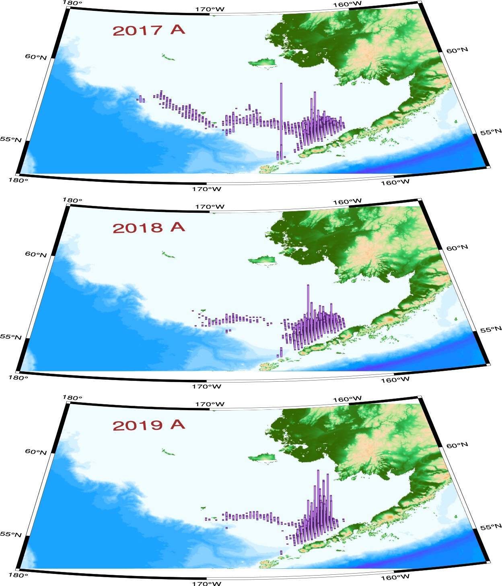

Figure 3: EBS pollock catch distribution during A-season, 2017–2019. Column height is propor- tional to total catch.

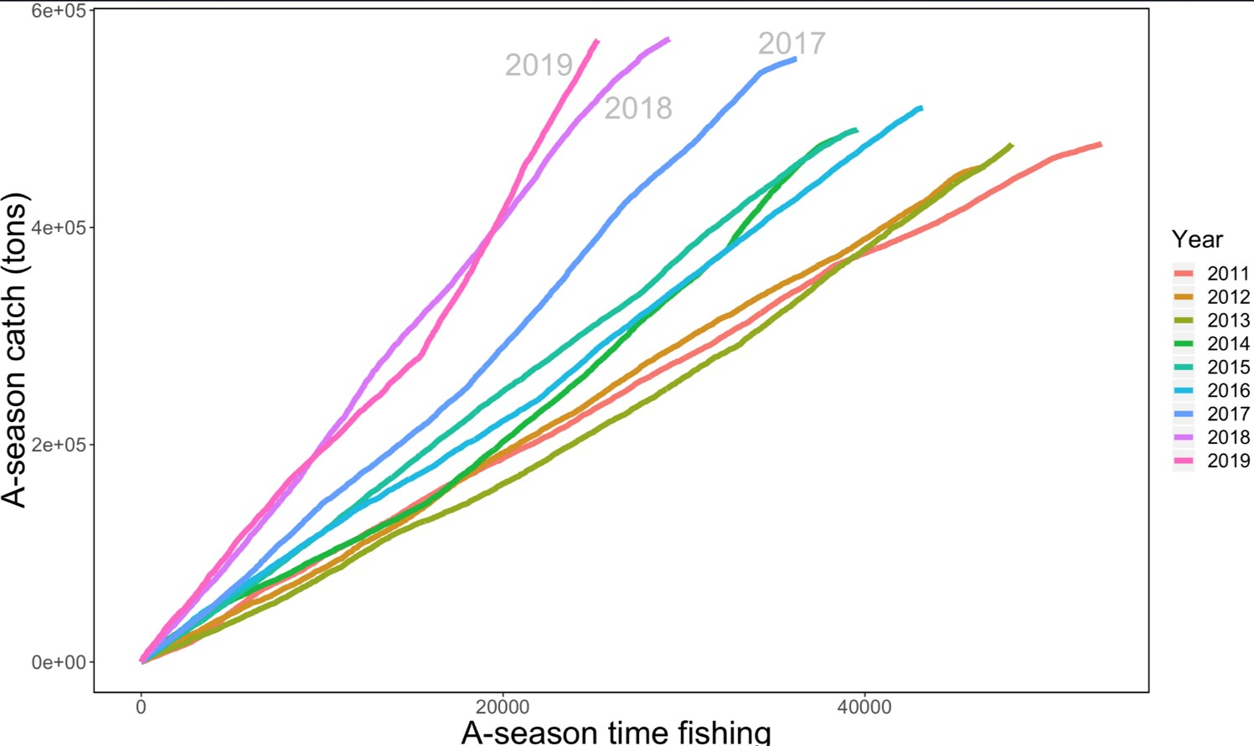

Figure 4: A-season EBS fleet-wide nominal pollock catch (kg) per hour of fishing recorded by NMFS scientific observers.

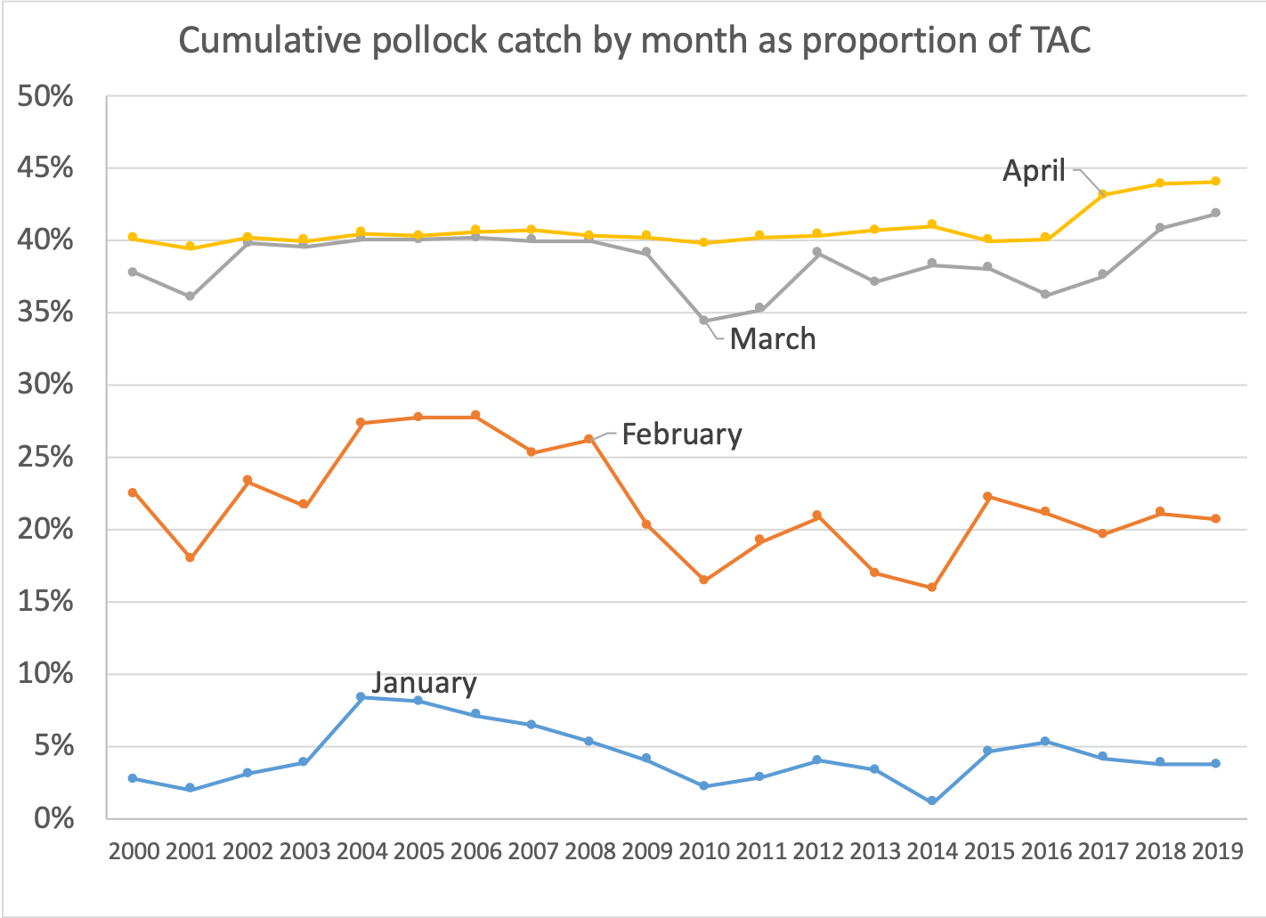

Figure 5: Proportion of the annual EBS pollock TAC by month during the A-season, 2000–2019. The higher value observed since 2017 was due to Amendment 110 of the FMP to allow greater flexibility to avoid Chinook salmon.

20000

●

●

●

●

●

●

●

●

●

●

●

●

●

●

●

●

●

●

●

●

10000

Tons of roe produced

Season

A B

~~●~~

0

2000 2002 2004 2006 2008 2010 2012 2014 2016 2018

#### Year

Figure 6: EBS pollock roe production in A and B seasons , 2000-2019.

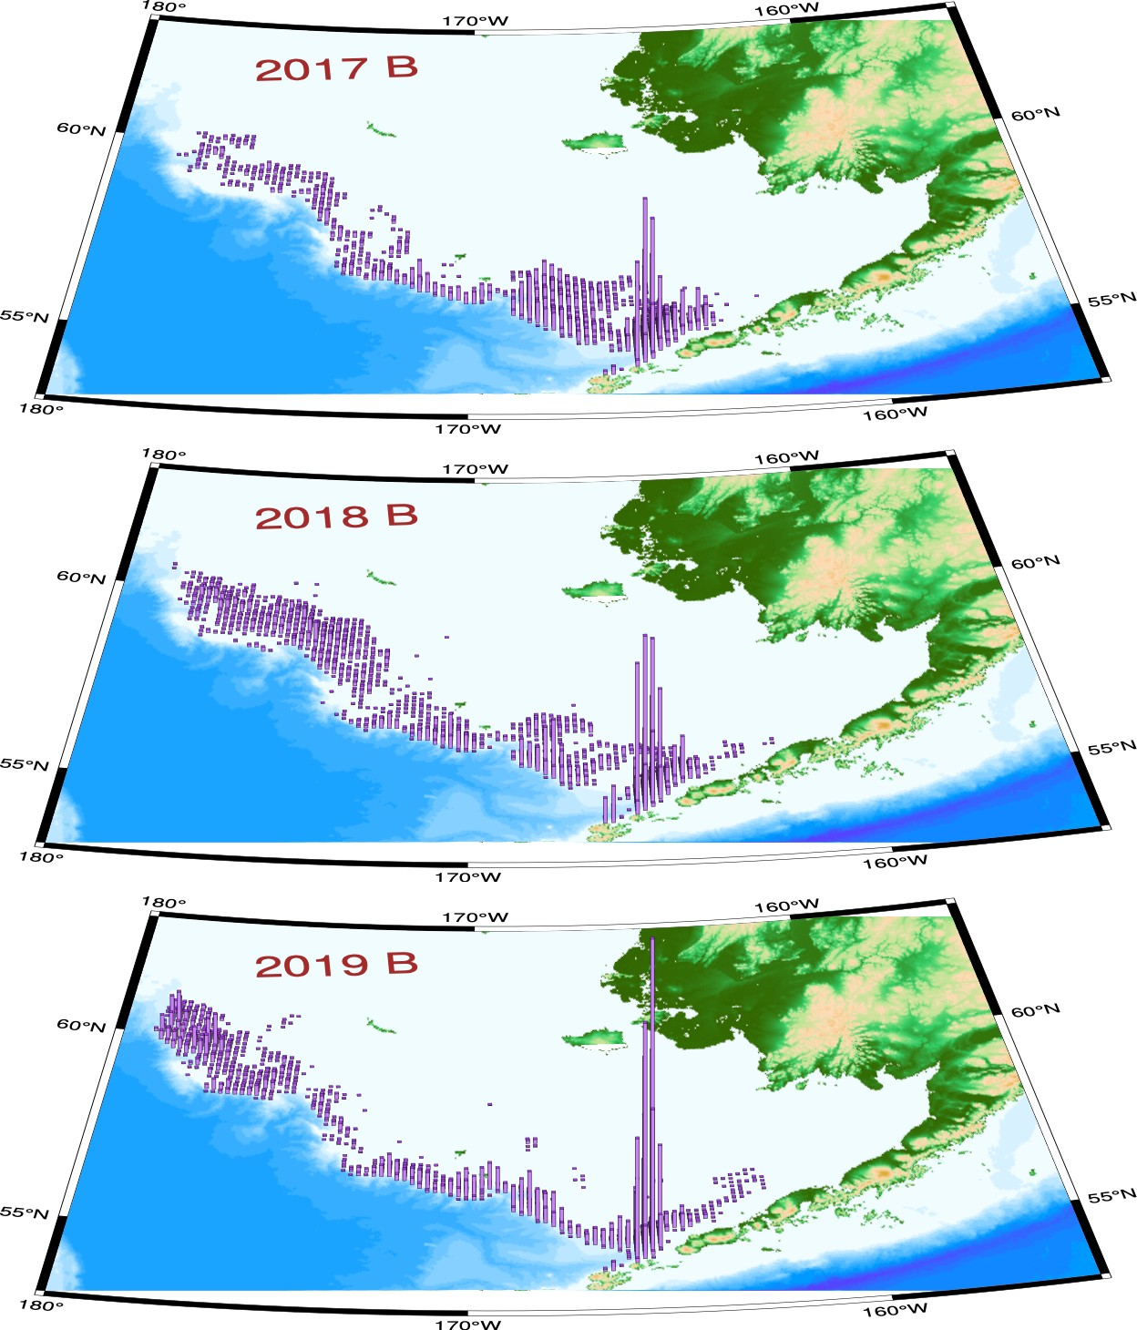

Figure 7: EBS pollock catch distribution during B-season, 2017–2019. Column height is propor- tional to total catch. Note that directed fishery for pollock generally is finished prior to October; the labels are indicative full-year catches.

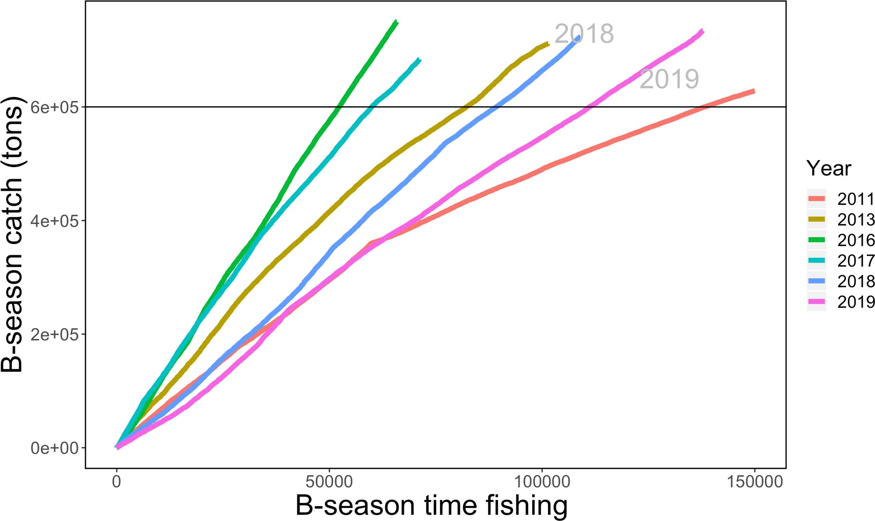

Figure 8: B-season EBS fleet-wide nominal pollock catch (kg) per hour of fishing recorded by NMFS scientific observers.

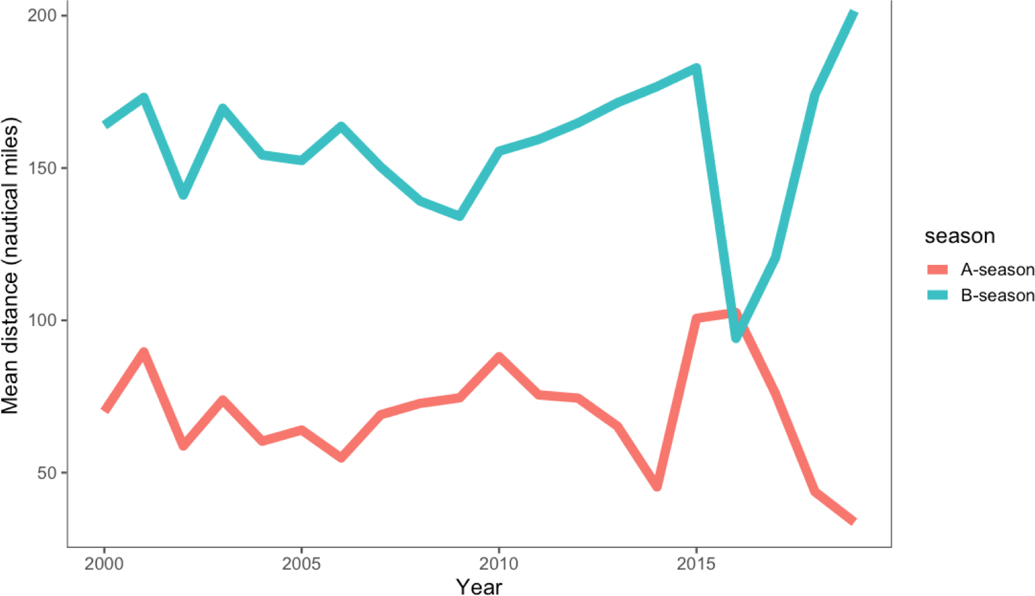

Figure 9: Estimated mean daily distance between operations, 2000-2019.

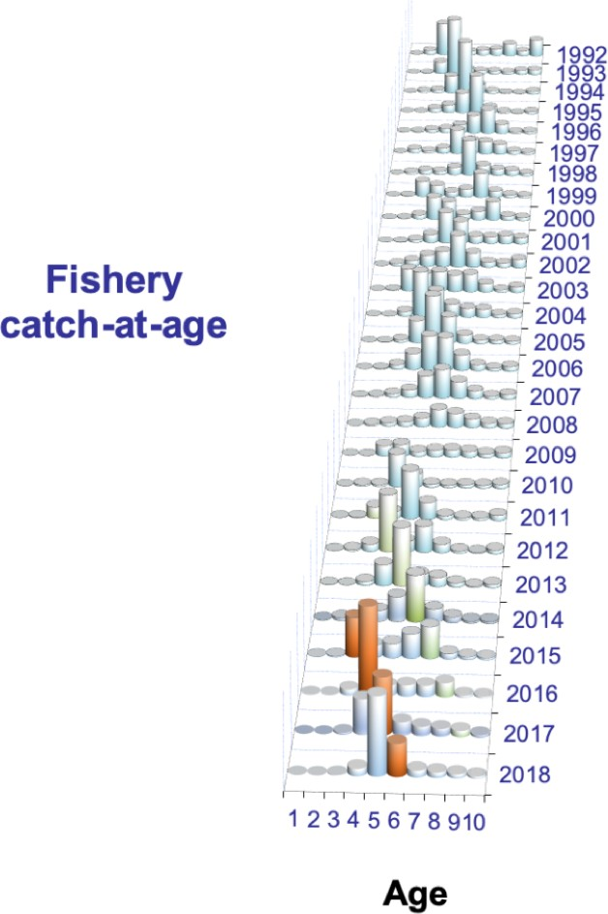

Figure 10: EBS pollock fishery estimated catch-at-age data (in number) for 1992–2018. Age 10 represents pollock age 10 and older. The 2008 year-class is shaded in green.

20

Bottom trawl survey biomass (Mt)

15

Method

Design-based

10 Density-corrected

5

0

1990 2000 2010 2020

Year

Figure 11: Bottom-trawl survey biomass estimates with error bars representing 1 standard deviation (for design-based and density-dependent correction method) for EBS pollock.

10.0

●

●

●

●

●

●

●

●

● ●

●

●

●

●

●

●

●

●

●

●

●

●

● ●

●

●

●

●

●

● ●

●

●

●

● ●

●

●

7.5

5.0

Degrees C

Source

Bottom Surface

●

2.5

0.0

1982 1985 1988 1991 1994 1997 2000 2003 2006 2009 2012 2015 2018

#### YEAR

Figure 12: Bottom and surface temperatures for the Bering Sea from the NMFS summer bottom- trawl surveys (1982–2018). Dashed lines represent mean values.

175˚ 170˚ 165˚ 160˚ 175˚ 170˚ 165˚ 160˚

60˚ 60˚

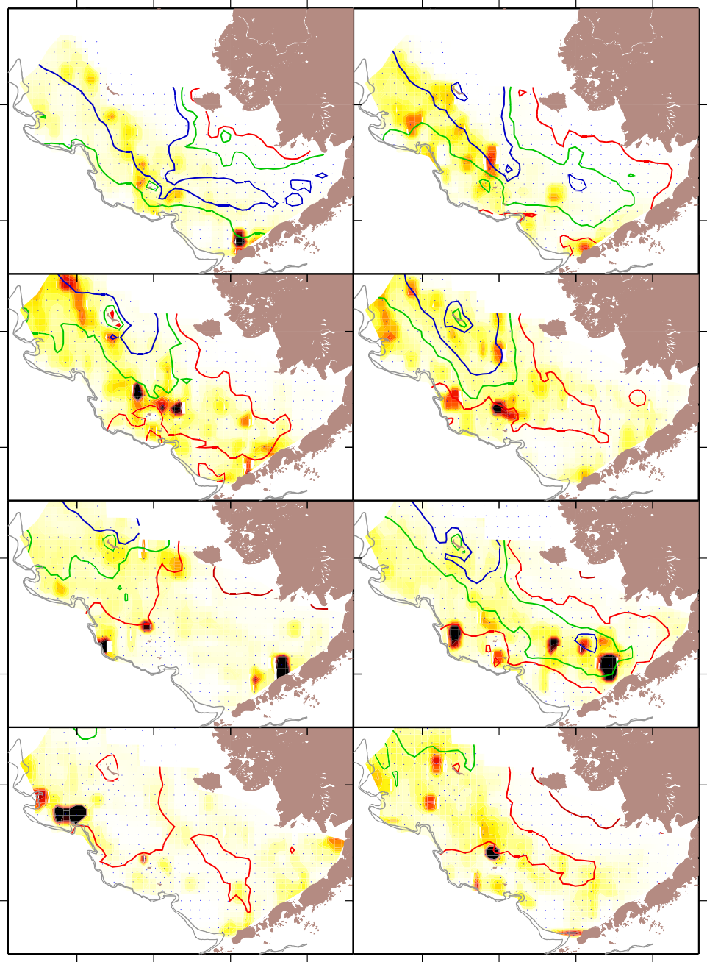

**Pollock**

**2012**

**2013**

**2014**

**2015**

**2016**

**2017**

**2018**

**2019**

56˚ 56˚

60˚ 60˚

56˚ 56˚

60˚ 60˚

56˚ 56˚

60˚ 60˚

56˚ 56˚



0.00 0.25 0.50 0.75 1.00

Relative CPUE

Figure 13: EBS pollock CPUE (shades = relative kg/hectare) and bottom temperature isotherms in degrees C; from the bottom trawl survey data 2011–2018.

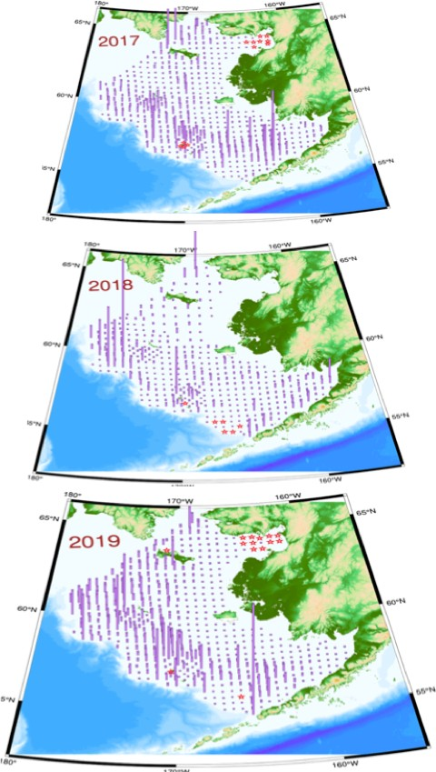

Figure 14: Bottom trawl survey pollock catch in kg per hectare for 2017 - 2019. Height of vertical lines are proportional to station-specific pollock densities by weight (kg per hectare) with constant scales for all years (red stars indicate tows where pollock were absent from the catch).

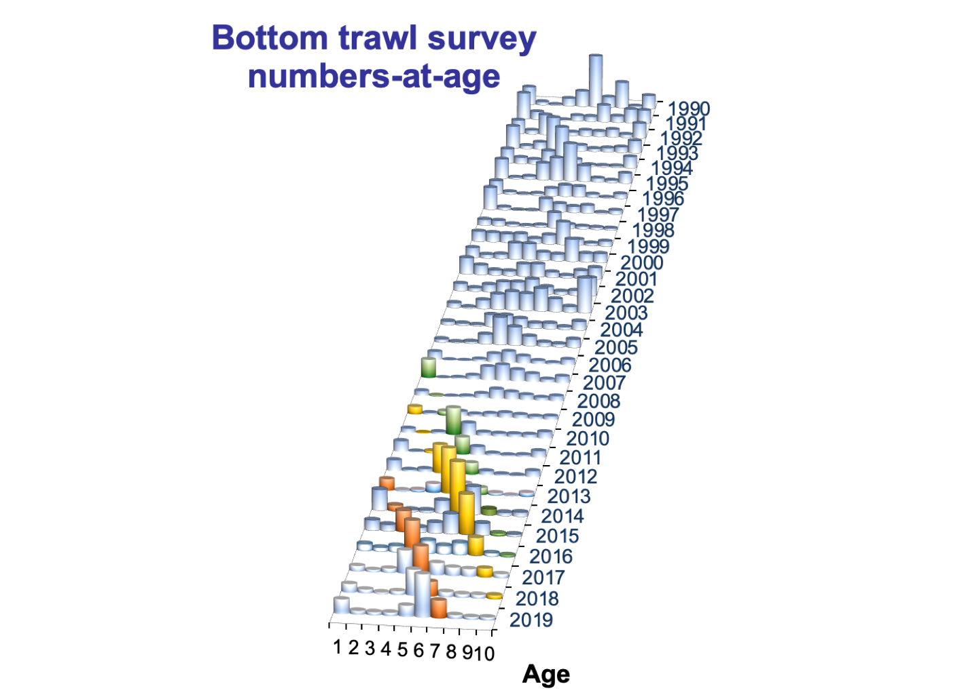

Figure 15: Pollock abundance levels by age and year as estimated directly from the NMFS bottom- trawl surveys (1990–2019). The 2006,2008, and 2012 year-classes are shaded diﬀerently.

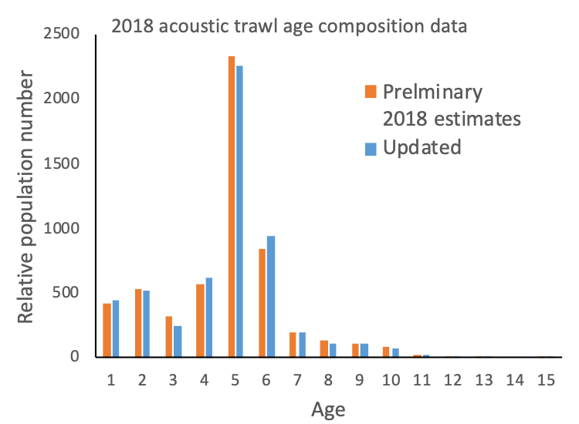

Figure 16: Pollock abundance at age estimates from the AT survey comparing the estimates based primarily on BTS age data used last year and the updates for this year’s assessment.

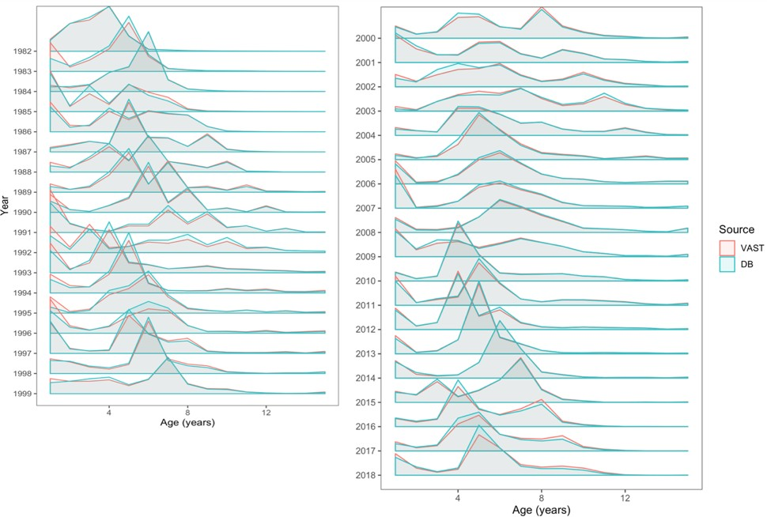

Figure 17: Pollock abundance levels by age and year as estimated directly from the NMFS bottom- trawl surveys (1990–2019) using standard ‘design-based’ (DB) and VAST approaches.

15

●●

●

●

●●

●●

●

●

●●

●●

●

●● ●●

●●

● ● ● ●●

●

●

●●

●

●● ●● ●

●

●

●

●

●●

● ●

●

●

●●

●●

●●

●●

●●

●●

●●

●● ●

●

●●

●●

●●

●●

●●

●

●

Combined

10

5

Biomass (millions of t)

0

3

●

●

●● ● ●

● ●

●

●

●

●●

●●

●●

●● ● ● ● ●●

● ●

●●

●● ● ●● ● ●● ● ● ●● ●● ●●

● ●

● ●

●● ● ●

● ● ●●

●● ●●

●● ●● ●● ●● ●● ●● ●● ●

●

### Model

NBS

2

1

0

15

●

●

●

●●

●●

●

●

●●

●

●

● ●

●

●●

●

● ●

●

●

●● ●● ●

●

●●

●●

●

●

●

●

●

●●

●●

●●

●●

●●

●● ●

●

●●

●●

●●

●●

●●

●●

●●

●

●

|  |  |
| --- | --- |
| ● | |
| ● ● | ● |

10

|  |  |
| --- | --- |
| ● | |
| ● | ● ● |

5

0

1982 1986 1990 1994 1998 2002 2006 2010 2014 2018

### Year

● Cold pool covariate

* No covariate

Standard

Figure 18: Pollock index values for the standard survey region, the NBS, and combined based on the VAST application to density-dependent corrected CPUE values from the BTS data, 1982–2019. The diﬀerent lines are smoothed trends for with and without including the cold-pool extent as a covariate.

#### 1.2



2014

1.0

0.8

1.2



2015

Body weight relative to mean

1.0

0.8

1.2



2016

1.0

0.8

1.2



2017

1.0

0.8

1.2



2018

1.0

0.8

3 4 5 6 7 8 9 10

Age

Figure 19: Recent fishery average weight-at-age anomaly (relative to mean) by strata for ages 3–10, 2014–2018. Vertical shape reflects uncertainty in the data (wider shapes being more precise), colors are consistent with cohorts.

1.50

A−season

B−season, NW

B−season, SE

Body weight relative to mean

1.25

1.00

0.75

0.50

3 4 5 6 7 8 9 10 3 4 5 6 7 8 9 10 3 4 5 6 7 8 9 10

# Age

Figure 20: Fishery average weight-at-age anomaly (relative to mean) across strata and combined for all ages (3–10), and available years (1991–2018). Vertical shape reflects uncertainty in the data (wider shapes being more precise), colors are consistent with cohorts.

1.3

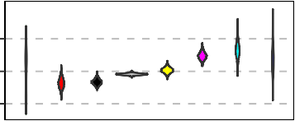

A−season

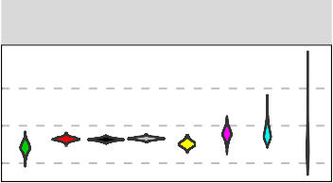

B−season, NW

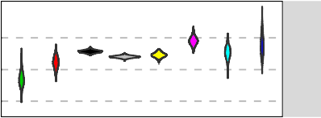

B−season, SE

2014

1.0

Body weight relative to mean

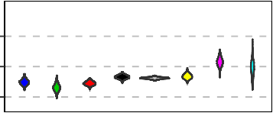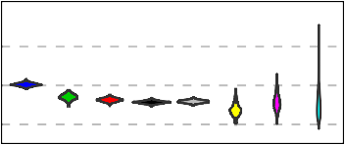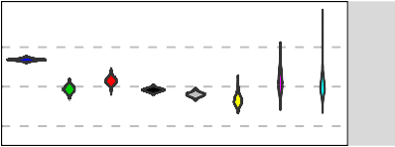0.7

1.3

2015

1.0

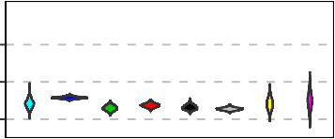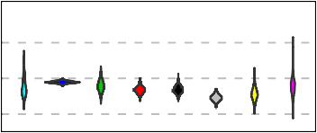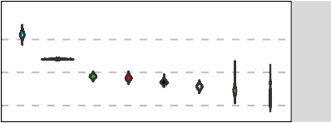0.7

1.3

2016

1.0

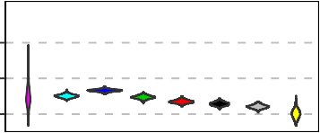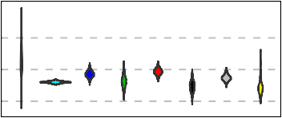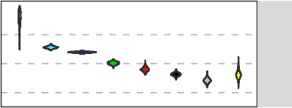0.7

1.3

2017

1.0

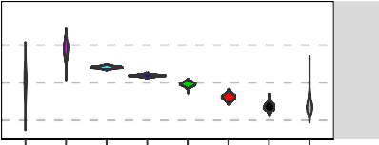0.7

1.3

1.0

0.7

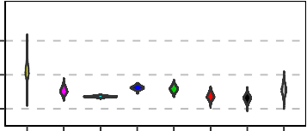3 4 5 6 7 8 9 10

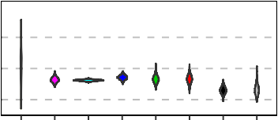3 4 5 6 7 8 9 10

# Age

3 4 5 6 7 8 9 10

2018

Figure 21: Recent fishery average weight-at-age anomaly (relative to mean) by strata for ages 3–10, 2014–2018. Vertical shape reflects uncertainty in the data (wider shapes being more precise), colors are consistent with cohorts.

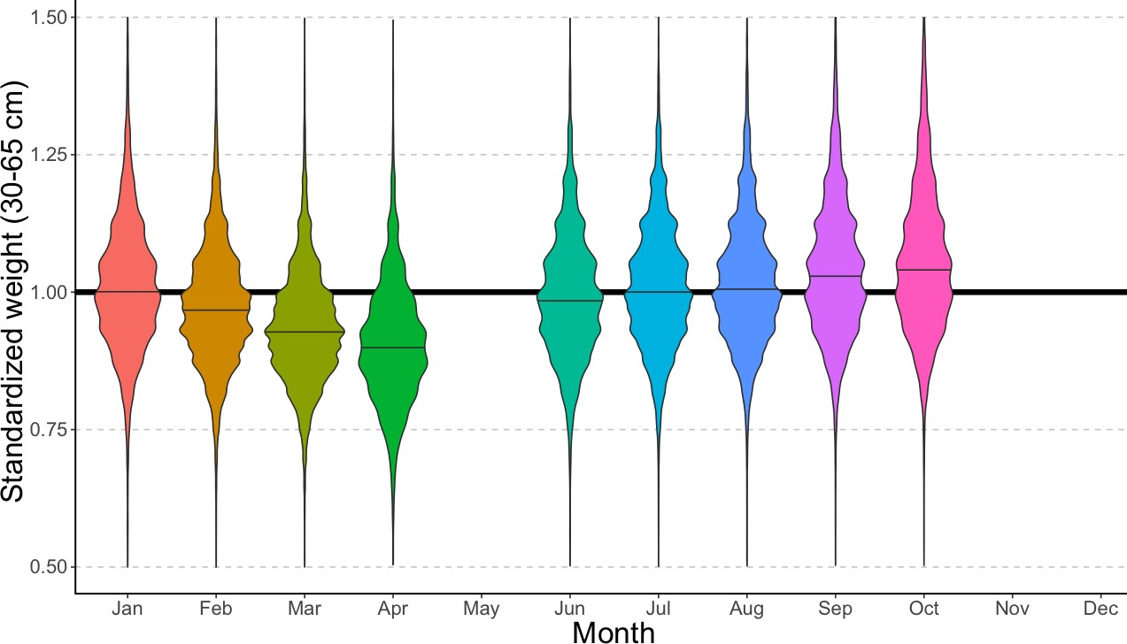

Figure 22: EBS pollock fishery body mass (given length) anomaly (standardized by overall mean body mass at each length) by month based on some over 700 thousand fish measurements from 1991–2018.

1.1

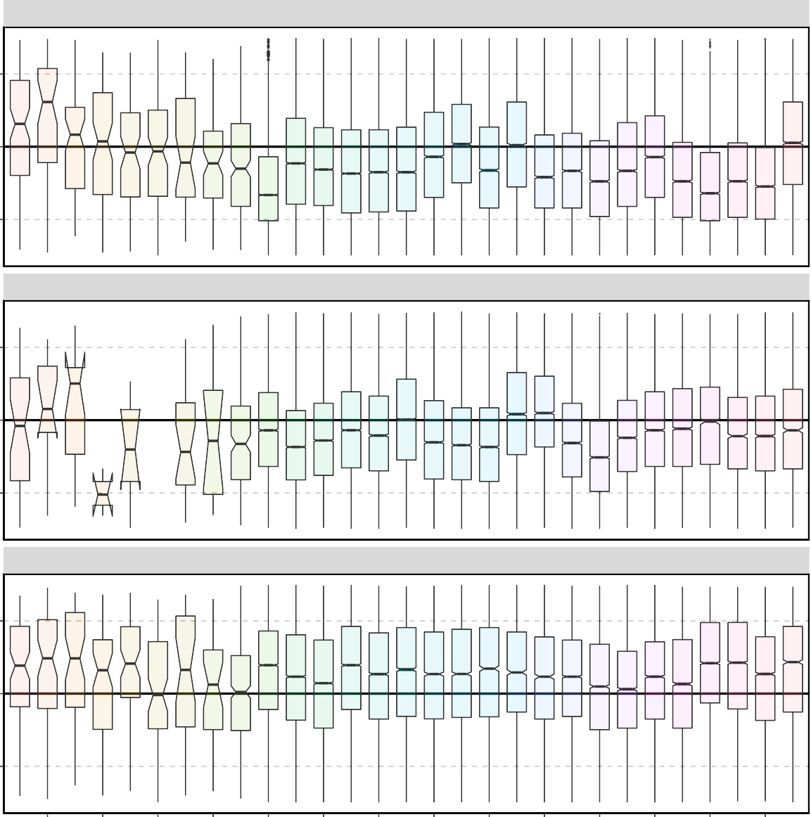

A−season

B−season, NW

B−season, SE

1.0

0.9

Standardized weight given length

1.1

1.0

0.9

1.1

1.0

0.9

1992 1994 1996 1998 2000 2002 2004 2006 2008 2010 2012 2014 2016 2018

## Year

Figure 23: EBS pollock fishery body mass (given length) anomaly (standardized by overall mean body mass at each length) by year and season/area strata, 1991–2019.

5000

4000

Female spawning biomass (kt)

3000

2000

1000

Model

last year Catch added

+Catch−age

+BTS

+AVO

0

2009 2010 2011 2012 2013 2014 2015 2016 2017 2018 2019

Year

Figure 24: Model runs comparing last year’s assessment with the impact of sequentially adding new data (first 2019 catch and 2018 fishery catch-at-age, then the bottom trawl survey (BTS) and the acoustic AVO data for model 16.1.

60000



● ● ●

●

● ●

● ●

●

● ● ●

● ● ●

● ● ●

● ●

●

● ● ● ●

● ● ● ● ●

● ●

Recruitment (millions of individu

40000

20000

Model

lastyr Model 16.1 VAST

0

2008 2010 2012 2014 2016 2018 2020

Year

5000

Female spawning biomass (kt)

4000

3000

2000

1000

Model

lastyr Model 16.1 VAST

0

2008 2010 2012 2014 2016 2018 2020

Year

Figure 25: EBS pollock model evaluation results of recruitment comparing last year’s model with this year.

30000

●●

●●

●● ●●

●●

●● ●●●●

●●

●●

●

●●

●

●●

●●

●● ●●●

●●

●

●●

●

●●

●

●

●

●

●●

●

●

●●●●

● ●

● ● ●

●

●

●

●●

●

●●

●● ●● ●●

●●

●●

●●

●●●● ●● ●

●

●● ●●

●●

●●●● ●●

●●●●

●● ●●

●●

●●

●●

●●●●

●●●●

●●●●

●●●

●●●●

●●●●

●● ●

●●●●

●

●● ●

●● ●●

●●

20000

Bottom trawl survey biomass

10000

Model

Model 16.1 VAST ATS

●●

●●

0

1980 1990 2000 2010 2020

Year

Figure 26: EBS pollock model evaluation results of female spawning biomass comparing model results with diﬀerent data treatments.

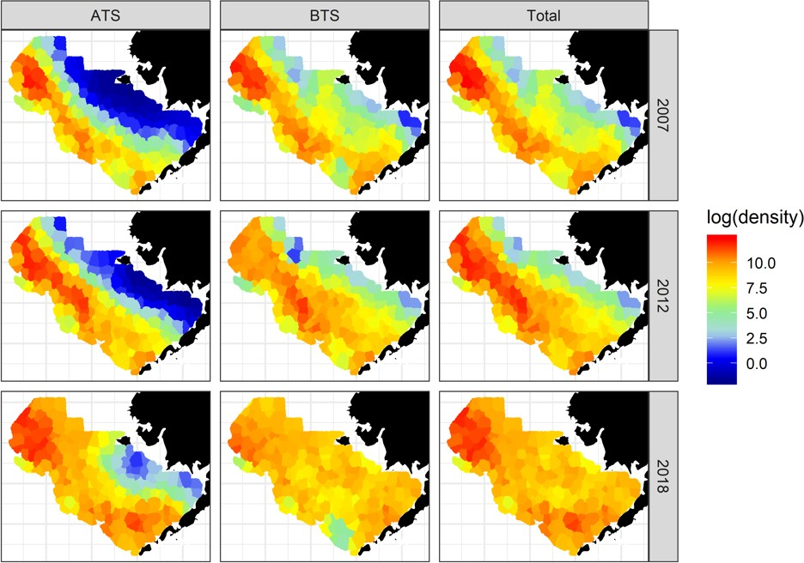

Figure 27: Estimated log-density (color) of pollock for three select years (rows) for the base case combined model. Columns represent the density available to the gear types, which for the ATS is the sum of strata 2 and 3, and for the BTS is the sum of strata 1 and 2, while the total is the sum of all three.



Figure 28: Estimated log-density (color) of pollock for three select years (rows) for the base case combined model. Columns represent the density available to the gear types, which for the ATS is the sum of strata 2 and 3, and for the BTS is the sum of strata 1 and 2, while the total is the sum of all three.

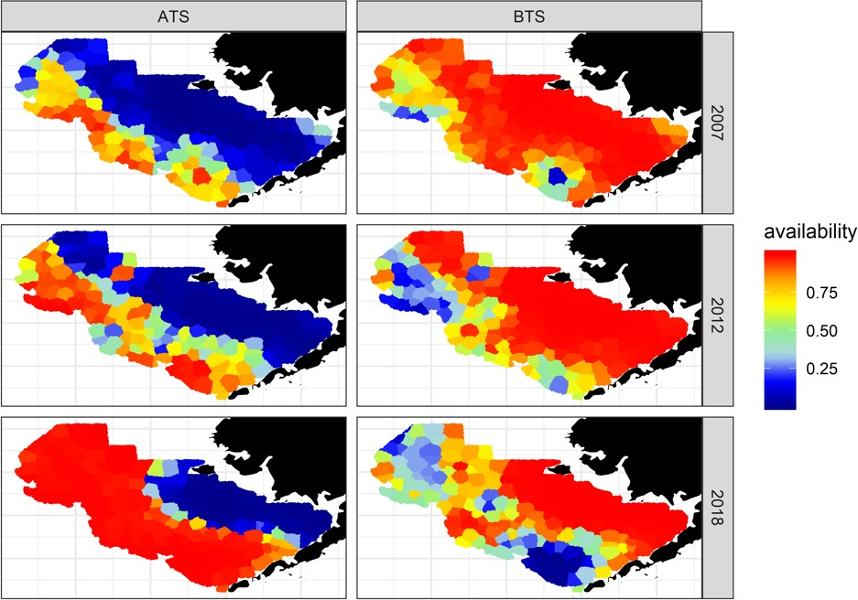

Figure 29: Estimated availability (i.e., fraction of pollock available to a survey gear type) for three select years (rows) for the bottom (BT) and acoustic (AT) trawl surveys (columns) from the combined base case model.

1.50

1.25

1.00

q

Model

CV50% CV05% COLE

0.75

0.50

1987 1990 1993 1996 1999 2002 2005 2008 2011 2014 2017

Year

Figure 30: Results of eﬀective BTS survey catchability/availability for diﬀerent levels of constraints on time-varying selectivity parameters, together with the estimate from the COLE model.

4000

Female spawning biomass (kt)

2000

Model

16.1

CV50%

0

1990 1995 2000 2005 2010 2015 2020

Year

4000

Female spawning biomass (kt)

2000

Model

16.1

CV05%

0

1990 1995 2000 2005 2010 2015 2020

Year

Figure 31: The estimated spawning stock biomass for diﬀerent constraints on time-varying selec- tivity parameters.

6000

●●

●●

●

●

●●

●●●●

●●●●

●●●●

●●●● ●●●●

●●●●

●●

●●●●

●●

●●

●●

●●●●

●●●●

●●

●●

●● ●●

●●

●●

Acoustic trawl survey biomass

4000

Model

Model 16.1 VAST ATS

●●

●●

2000

0

2000

2010

Year

Figure 32: EBS pollock model fit to the ATS biomass data, 1994–2018; green points to the right of vertical grey line are a preliminary treatment of applying a VAST model to the acoustic trawl survey data.

10000

●

●

●

●

●

● ●

● ●

●

●

●

7500

Early trawl fishery CPUE

5000

2500

0

1965 1968 1971 1974

Year

Figure 33: EBS pollock model fits to the Japanese fishery CPUE.

1.5

●

●

●

●

●

●

●

●

●

●

●

●

●

●

Acoustic return (Sa from AVO)

1.0

0.5

0.0

2006 2007 2008 2009 2010 2011 2012 2013 2014 2015 2016 2017 2018

Year

Figure 34: Model results of predicted and observed AVO index. Error bars represent assumed 95% confidence bounds of the input series.

20000

●

● ● ●

●

●

●

●

●

●

●

● ●

●

●

●

●

●

● ●

●

●

●

●

●●

●

●●

●

●

●

●

●

●

●

●

●

Bottom trawl survey biomass

10000

0

1980 1990 2000 2010 2020

Year

Figure 35: EBS pollock model fit to the BTS survey data (density dependence corrected estimates), 1982–2019. Units are relative biomass.

8

●

●

● ●

●

●

● ●

●

●

●

●

●

●

●

●

6

Acoustic trawl survey

4

2

0

8

●

●

●●

●●

●●

●

●

● ● ●●●

● ●● ●

●

●

● ●

● ●● ● ●

● ●

●

●●

●

●

● ●

●

6

Bottom trawl survey

4

Mean age

2

0

8

●

● ●●

●

●

●

● ●●

● ●

● ●

● ● ●

●

● ●

●

●

●●

●

●

●

●● ● ● ●

●

●

●

●

●

●

●

●●

● ●●

● ●

●● ●

●●●

●

6

Fishery

|  |  |
| --- | --- |
|  |  |
| ● | ● |

4

2

0

1980 2000 2020

Year

Figure 36: EBS pollock model fits to observed mean age for the Acoustic trawl survey (top), the bottom trawl survey (middle) and fishery (bottom)

1977

1978

1979

1980

1981

1982

1983

1984

1985

1986

1987

1988

1989

1990

1991

1992

1993

1994

1995

1996

Year

1997

1998

1999

2000

2001

2002

2003

2004

2005

2006

2007

2008

2009

2010

2011

2012

2013

2014

2015

2016

2017

2018

2019

4 8 12

Age (years)

Figure 37: Selectivity at age estimates for the EBS pollock fishery.

0.4

0.2

0.0

0.4

0.2

0.0

0.4

0.2

0.0

0.4

0.2

0.0

0.4

0.2

0.0

0.4

0.2

0.0

0.4

0.2

0.0

0.4

0.2

0.0

0.4

Proportion

0.2

0.0

0.4

0.2

0.0

0.4

0.2

0.0

0.4

0.2

0.0

0.4

0.2

0.0

0.4

0.2

0.0

0.4

0.2

0.0

0.4

0.2

0.0

0.4

0.2

0.0

0.4

0.2

0.0

0.4

0.2

0.0

#### EBS pollock fishery age composition data

(2019 Assessment)

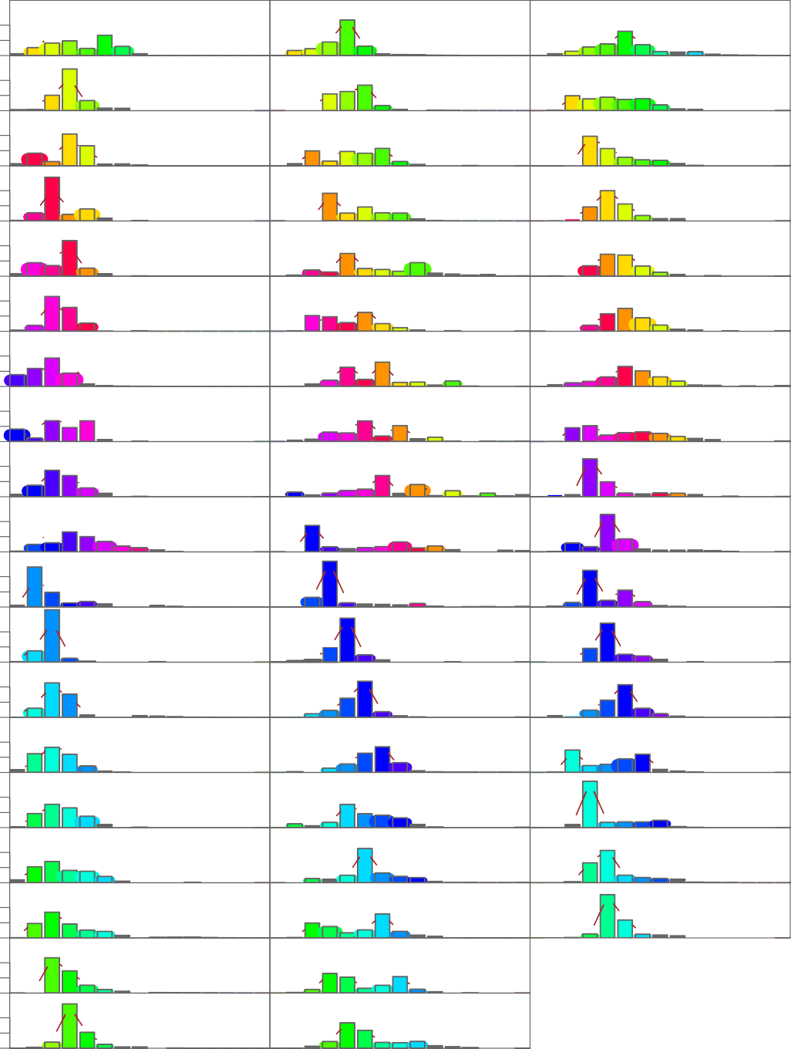

1964

●

1983

2002

●

● ●

●

●

●

●

●

●

●



● ●

●

●

●

●

● ● ● ● ● ● ● ● ● ●

1965

● ● ● ● ● ● ● ● ● ● ●

1984

● ●

● ● ● ● ●

2003

●

●

● ●

● ● ● ● ●

● ●

● ● ● ● ~~● ● ● ● ● ●~~ ● ● ● ●

1966

●

● ●

●

●

● ● ~~● ●~~ ● ● ● ● ● ● ●

1985

● ● ●

●

● ~~● ●~~ ● ~~● ● ●~~ ●

2004

●

●

●

● ~~●~~ ● ● ● ● ● ● ● ● ● ●

1967

● ● ~~●~~ ● ~~● ● ● ● ●~~ ● ● ● ●

1968

●

● ~~● ● ● ● ● ●~~ ● ● ~~●~~ ●

● ● ● ●

1986

~~● ● ● ● ●~~ ●

2005

●

●

● ●

● ●

●

●

●

●

●

●

●

● ● ● ● ● ● ● ● ~~●~~ ●

1987

●

●

● ●

●

●

● ● ● ● ● ● ● ● ● ● ● ● ●

●

●

● ●

●

1969

● ● ● ~~● ● ● ●~~ ● ● ~~●~~ ●

1988

●

●

● ●

●

●

●

●

●

● ● ● ● ● ● ● ● ● ● ● ● ●

1970

●

● ●

●

● ● ● ● ~~● ● ● ●~~ ● ● ~~●~~ ● ●

1989

●

●

●

● ● ● ~~● ● ● ● ●~~ ●

2006

●

● ● ● ~~● ● ● ●~~ ●

2007

●

● ● ~~● ● ● ● ●~~ ●

2008

●

●

● ●

● ● ● ● ● ● ● ● ● ● ● ●

1971

●

●

● ●

● ●

~~● ● ●~~ ● ● ●

1990

● ● ●

● ●

● ~~● ● ● ●~~ ●

2009

●

●

●

● ●

●

●

● ●

●

● ● ~~● ● ● ● ● ● ●~~ ● ● ~~● ●~~ ●

1972

●

●

● ● ● ~~● ● ● ● ● ●~~ ● ● ● ● ● ●

1973

●

● ● ● ● ● ● ● ● ~~●~~

1991

●

● ● ● ● ~~●~~ ● ● ● ●

1992

●

● ●

●

● ● ● ~~● ● ● ●~~ ●

2010

●

●

●

●

●

●

●

●

●

● ●

●

●

●

● ● ● ~~● ● ● ● ●~~ ~~●~~ ● ● ●

1974

● ● ● ●

●

●

● ● ~~●~~ ● ~~● ●~~ ● ● ●

1993

● ●

●

●

●

● ● ● ● ● ~~● ● ● ●~~ ●

2011

●

● ● ● ● ● ● ~~● ●~~ ●

2012

●

●

● ● ●

●

●

●

● ● ~~●~~ ● ● ● ● ● ● ● ●

1975

● ● ●

●

● ● ~~●~~ ● ● ● ● ● ● ● ●

1994

●

●

~~● ● ● ● ● ● ●~~ ●

2013

●

●

●

●

● ● ●

●

● ● ●

● ● ● ~~● ● ● ● ● ●~~ ●

●

● ~~● ● ● ● ● ● ●~~ ● ● ●

1976

● ● ~~● ● ● ●~~ ● ● ~~●~~ ●

●

1995

●

● ●

●

●

●

●

● ● ● ~~● ●~~ ● ● ● ● ● ● ● ● ● ●

1977

●

● ~~● ● ● ● ● ● ●~~ ● ● ~~●~~ ● ●

1996

●

●

●

●

2014

● ● ~~● ● ● ● ● ●~~ ●

2015

●

●

● ●

●

● ● ● ~~● ● ● ● ● ●~~ ● ● ~~●~~ ●

1978

●

● ●

●

● ● ●

● ●

●

●

● ~~● ● ● ● ● ● ●~~ ● ● ● ●

1979

●

● ~~●~~ ● ● ● ● ● ● ● ●

1997

● ● ●

● ~~● ● ● ● ●~~ ● ● ~~●~~

● ● ~~● ● ● ● ●~~ ●

2016

●

● ● ● ● ~~●~~

●

● ●

●

● ● ~~● ● ● ● ● ● ●~~ ● ● ● ● ● ●

1980

● ●

1998

● ~~● ●~~ ● ● ● ● ● ~~●~~ ●

1999

●

~~● ● ● ● ●~~ ●

2017

●

●

●

●

●

● ● ● ● ● ● ● ● ●

2018

●

●

●

●

●

●

● ● ●

● ●

● ●

● ● ●

●

● ● ● ● ● ● ● ● ● ●

1981

~~●~~ ● ● ● ● ● ~~●~~ ● ●

2000

● ● ● ● ~~● ● ● ●~~ ●

●

● ●

●

● ●

●

●

● ● ~~●~~ ● ● ● ● ● ● ● ● ● ●

1982

● ● ~~● ● ●~~ ● ● ● ● ● ● ● ● ●

●

●

● ● ● ~~● ● ●~~ ●

2001

●

●

●

● ●

●

● ● ● ● ● ~~● ● ●~~ ●

1 3 5 7 9 11 13 151 3 5 7 9 11 13 15

#### Age

Figure 38: Model fit (dots) to the EBS pollock fishery proportion-at-age data (columns; 1964– 2018). The 2018 data are new to this year’s assessment. Colors coincide with cohorts progressing through time.

1982

1983

1984

1985

1986

1987

1988

1989

1990

1991

1992

1993

1994

1995

1996

1997

1998

Year

1999

2000

2001

2002

2003

2004

2005

2006

2007

2008

2009

2010

2011

2012

2013

2014

2015

2016

2017

2018

2019

4 8 12

Age (years)

Figure 39: Model estimates of bottom-trawl survey selectivity, 1982–2019.

0.4

0.2

0.0

0.4

0.2

0.0

0.4

0.2

0.0

0.4

0.2

0.0

0.4

0.2

0.0

0.4

0.2

Proportion

0.0

0.4

0.2

0.0

0.4

0.2

0.0

0.4

0.2

0.0

0.4

0.2

0.0

0.4

0.2

0.0

0.4

0.2

0.0

0.4

0.2

0.0

#### EBS pollock survey age composition data

(2019 Assessment)

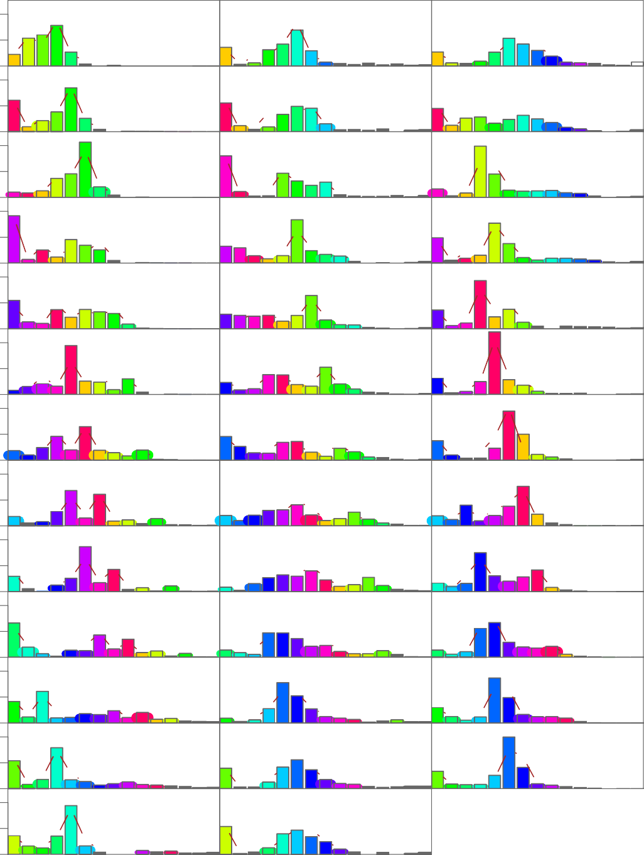

●

1982

●

1995

2008

●

●

●

● ● ●

●

●

●

● ●

●

●

●

●

● ● ● ~~● ● ● ● ●~~ ● ●

●

● ● ●

* 1983

● ● ● ● ~~● ●~~ ● ●

1996

● ● ● ~~●~~ ● ●

2009

● ●

●

●

●

● ●

●

●

●

● ●

●

● ● ● ● ● ● ● ● ●

● ●

●

● ● ● ●

● ●

●

1984

●

● ~~● ●~~ ● ~~●~~ ● ●

1997

●

● ● ● ● ●

2010

● ●

● ●

●

●

●

● ● ●

● ●

●

●

● ● ●

●

~~● ● ●~~ ● ●

1985

● ● ●

● ● ● ●  ~~●~~ ●

1998

●

● ●

● ● ●

● ● ~~● ●~~ ● ●

2011

●

●

●

●

●

●

●

●

●

●

●

●

●

● ● ● ● ● ● ●

1986

● ●

●

● ●

● ●

●

● ~~● ● ●~~ ● ●

1999

●

●

●

● ● ● ● ● ~~●~~ ● ●

2012

●

●

●

● ●

●

●

●

●

●

●

●

● ●

●

● ●

● ●

●

●

● ●

●

●

~~●~~ ● ● ● ●

1987

~~● ● ●~~ ● ●

2000

●

● ● ● ●

●

~~● ●~~ ● ●

2013

●

●

●

●

●

● ●

●

● ●

●

●

● ●

●

●

●

● ●

●

● ● ~~●~~ ● ● ●

1988

●

●

● ● ● ~~●~~ ● ●

2001

● ●

●

● ~~● ● ● ● ●~~ ● ●

2014

●

●

●

●

●

●

●

●

● ● ●

●

●

●



●

●

●

●

● ●

● ● ● ● ●

1989

● ●

● ● ● ●

2002

● ●

●



●

● ~~● ● ● ●~~ ● ●

2015

●

●

●

●

●

●

●

●

●

●

●

●

●

●

●

● ● ● ●

● ● ● ●

● ●

● ● ●

●

● ● ● ●

1990

● ● ● ● ●

2003

● ● ● ● ● ● ●

2016

● ●

●

●

●

●

●

● ● ● ●

● ●

● ●

● ●

●

●

● ●

●

● ● ● ● ●

1991

●

●

● ● ●

●

● ● ● ●

2004

●

● ● ~~● ● ●~~ ● ●

2017

●

●

●

● ● ●

●

●

●

● ● ●

● ● ●

●

● ● ●

●

● ● ● ●

● ●

● ● ●

●

● ● ●

● ● ●

●

● ●

●

1992

2005

● ● ● ● ●

2018

● ●

●

● ●

●

●

●

●

●

●

●

● ● ● ● ●

● ●

● ● ●

●

●

●

● ● ●

● ● ●

● ● ● ●

●

1993

● ● ● ● ●

2006

●

● ● ● ● ●

2019

●

●

●

●

● ●

●

●

●

●

● ● ●

●

● ● ● ● ●

1994

●

● ●

●

● ●

● ● ● ● ●

2007

●

● ● ●

● ● ●

●

● ~~●~~ ● ●

●

●

● ●

●

●

●

●

●

● ●

● ● ● ●

● ● ~~●~~ ● ● ● ● ●

● ● ● ~~● ●~~ ● ●

●

1 3 5 7 9 11 13 151 3 5 7 9 11 13 15

#### Age

Figure 40: Model fit (dots) to the bottom trawl survey proportion-at-age composition data (columns) for EBS pollock. Colors correspond to cohorts over time. Data new to this assessment are from 2018.

#### EBS pollock survey age composition data

(2018 Assessment)

0.4



1994

2004

2012

●

●

●

●

●

●

●

● ●

●

●

●

●

●

●

● ● ● ● ● ● ● ● ●

● ● ● ● ● ●

● ● ●

● ●

● ● ● ● ● ● ●

●

1996

2006

2014

●

● ●

●

●

●

●

●

● ●

●

●

●

● ● ●

● ● ● ● ● ● ● ●

● ● ● ●

● ● ● ●

● ●

● ● ● ● ● ● ●

1997

2007

2016

●

●

●

●

●

●

● ●

●

●

●

● ●

●

● ●

●

● ● ● ●

● ● ● ● ● ● ●

● ● ● ● ● ● ●

● ● ● ● ● ● ●

1999

●

2008

2018

●

●

●

●

●

●

●

●

●

●

● ●

●

● ● ● ●

● ● ● ● ● ● ●

●

●

● ● ● ● ● ●

● ● ● ●

● ● ● ● ●

2000

2009

●

●

●

●

●

●

●

●

● ●

● ● ● ● ● ● ●

● ● ● ● ●

● ● ● ● ● ●

●

2002

2010

●

●

●

●

●

● ●

●

●

● ● ● ● ● ● ● ●

● ● ● ● ● ● ● ● ● ●

0.2

0.0

0.4

0.2

0.0

0.4

0.2

Proportion

0.0

0.4

0.2

0.0

0.4

0.2

0.0

0.4

0.2

0.0

2 4

6 8 10 12 14 2

4 6 8 10 12 14

#### Age

Figure 41: Model fit (dots) to the acoustic-trawl survey proportion-at-age composition data (columns) for EBS pollock. Colors correspond to cohorts over time (for years with consecutive surveys).

4

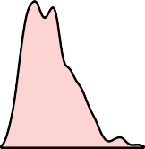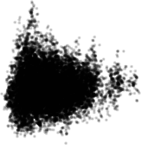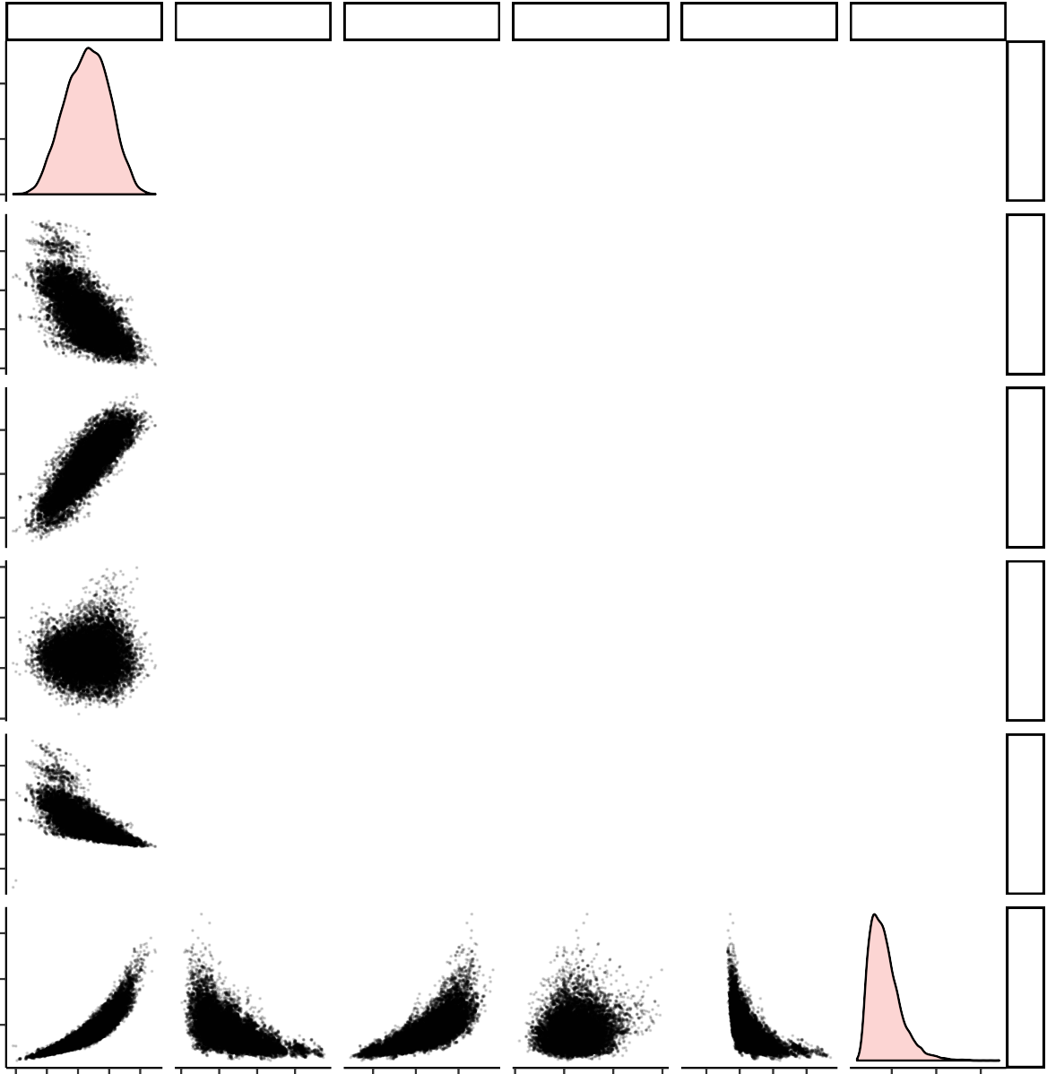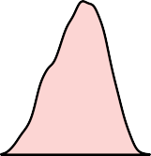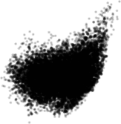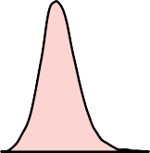

Steepness

|  |  |  |  |  |
| --- | --- | --- | --- | --- |
| Steepness lnR0 | DynB0 | B19 | Bmsy | Fmsyr |
| Corr: | Corr: | Corr: | Corr: | Corr: |
| −0.682 | 0.841 | 0.0381 | −0.728 | 0.895 |
|  | Corr:  −0.885 | Corr: 0.0373 | Corr: 0.974 | Corr:  −0.591 |
|  |  | Corr: 0.315 | Corr:  −0.887 | Corr: 0.754 |

2

0

10.8

10.4

lnR0

10.0

9.6

0.7

DynB0

0.5

0.3

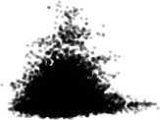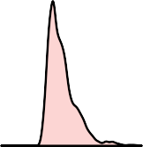5000

B19

Bmsy

|  |  |  |  |  |  |  |
| --- | --- | --- | --- | --- | --- | --- |
| 4000 | Corr: | | | | | Corr: |
| 3000 |  |  |  |  | 0.0304 | 0.109 |
| 2000 |  |  |  |  |  |  |
| 6000 |  |  |  |  |  |  |
| 4000 |  |  |  |  |  | Corr: |
| 2000 |  |  |  |  |  | −0.625 |
| 0 |  |  |  |  |  |  |
| 1.5 |  |  |  |  |  |  |
| 1.0 |  |  |  |  |  |  |
| 0.5 |  |  |  |  |  |  |
|  | 0.4 0.5 0.6 0.7 0.8 | 9.6 10.010.410.8 | 0.3 0.5 0.7 | 2000 3000 4000 5000 | 0 200040006000 | 0.5 1.0 1.5 |

Figure 42: Pairwise plot of selected EBS pollock parameters and output from 3 million MCMC iterations thinned such that 5 thousand draws were saved as an approximation to the multivariate posterior distribution. Note that the figures on the diagonal represent the marginal posterior distributions. Key: lnR0 is the parameter that scales the stock-recruit relationship, B_Bmsy is estimated *B*2018*/BMSY* , DynB0 is the ratio of spawning biomass estimated for in 2018 over the value estimated that would occur if there had been no fishing, B19 is the spawning biomass in 2019, and B_Bmean is *B*2019*/B*¯.

Fmsyr

0.0012

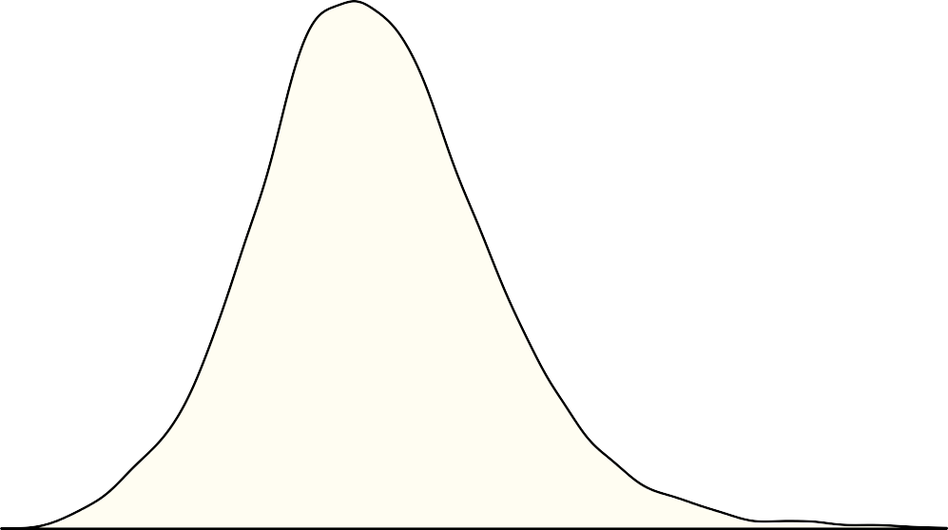

0.0009

0.0006

density

0.0003

0.0000

2000 3000

4000 5000

2019 Female spawning biomass

Figure 43: Integrated marginal posterior density (based on MCMC results) for the 2019 EBS pollock female spawning biomass compared to the point estimate (dashed red line). The mean of the posterior is shown in green (under the dashed line).

0.5

0.4

0.3

Spawning Exploitation rate

0.2

0.1

0.0

1965 1970 1975 1980 1985 1990 1995 2000 2005 2010 2015 2020

Year

Figure 44: Estimated spawning exploitation rate (defined as the percent removal of egg production in a given spawning year).

10

Age 6 F (x10)

9

8

7

F



0.6

6

Age

0.4

5 0.2

4

3

2

1

0

1965 1969 1973 1977 1981 1985 1989 1993 1997 2001 2005 2009 2013 2017

Year

Figure 45: Estimated instantaneous age-specific fishing mortality rates for EBS pollock.

10000

●

●

●

●

● ● ●

●

●

●

●

●

●

●

Age 3+ biomass (kt)

5000

0

1980 1985 1990 1995 2000 2005 2010 2015 2020

Year

Figure 46: Comparison of the current assessment results with past assessments of begin-year EBS age-3+ pollock biomass.

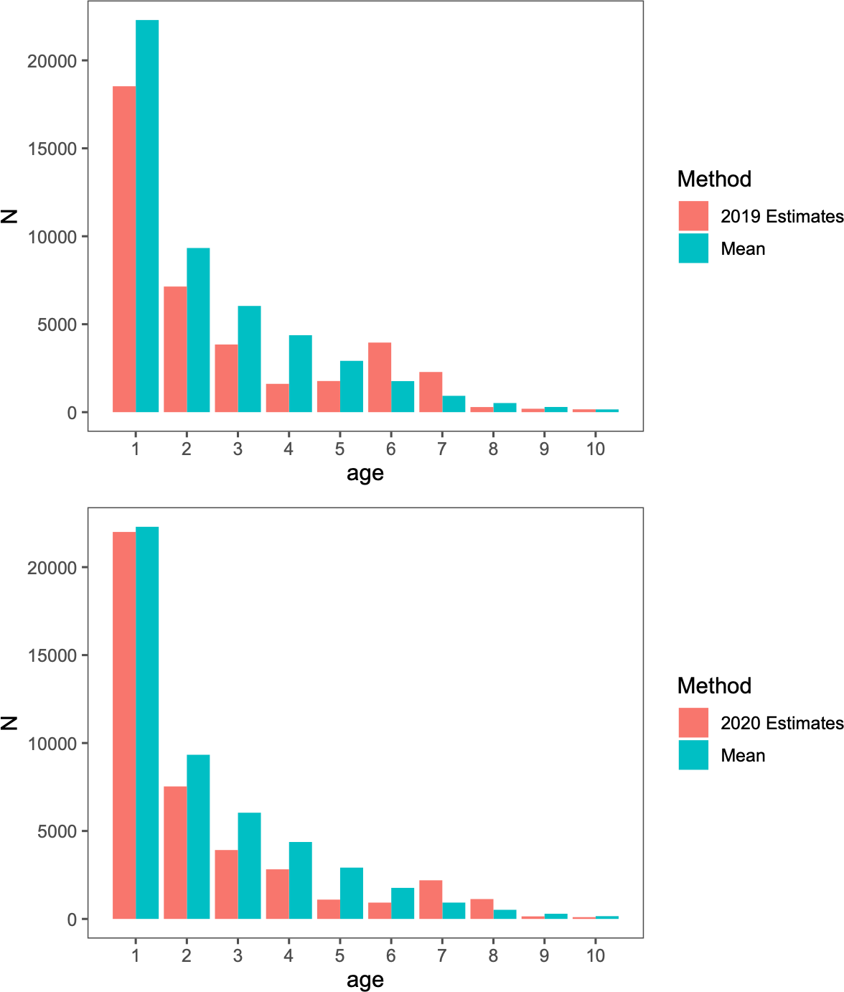

Figure 47: Numbers-at-age estimates for 2019 (top) and 2020 (bottom) cmpared to the mean values since 1991.

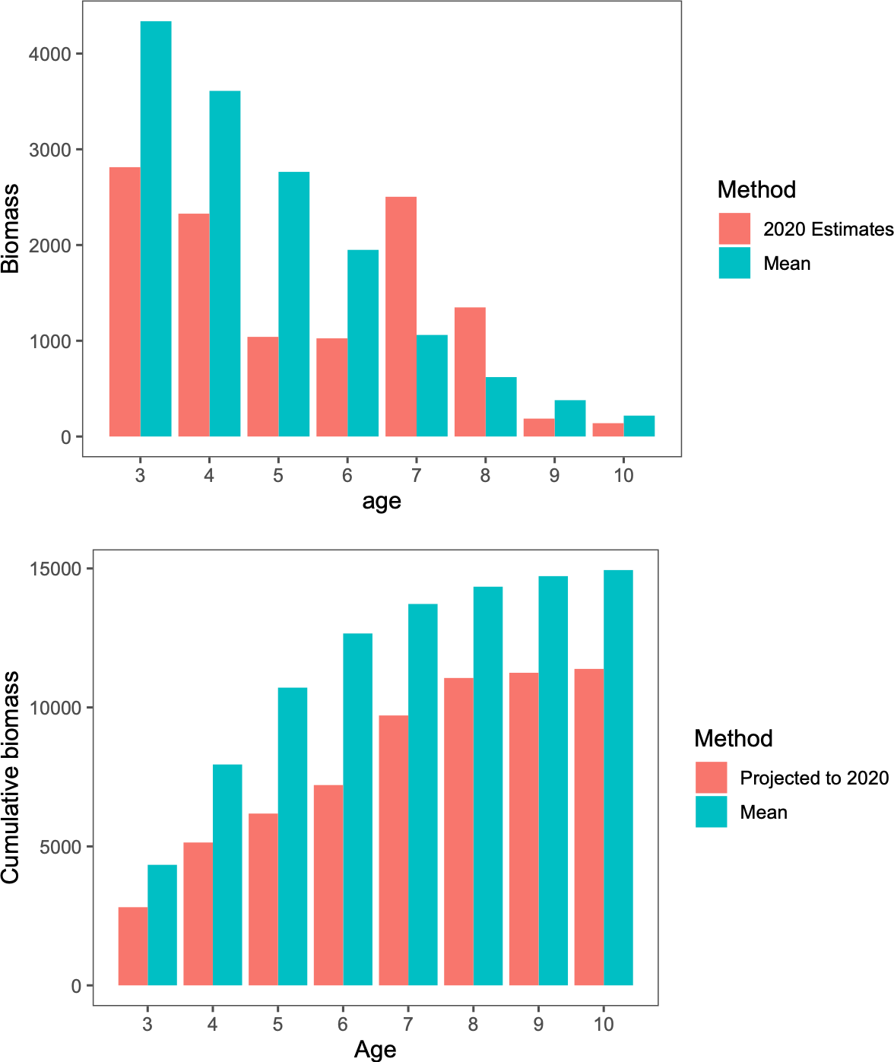

Figure 48: Numbers-at-age multiplied by weights-at-age estimates for 2020 (top) and accumulated (bottom).

0.9

78

79

80

81

08

09

07

92

10 91

06

90

1282

9304

16

1983 94

88

98

97 95

1884

96

85 86

87

0.6

F/Fmsy

0.3

0.0

0.0 0.5 1.0 1.5 2.0

B/Bmsy

Figure 49: Estimated spawning biomass relative to annually estimated *FMSY* values and fishing mortality rates for EBS pollock. Most recent two years are shaded in yellow

5000

4000

Female spawning biomass (kt)

3000

2000

1000

2000 2002 2004 2006 2008 2010 2012 2014 2016 2018 2020 2022 2024

Year

Figure 50: The estimated EBS pollock spawning stock biomass for model 16.1 with projections equal to the estimated fishing mortality from 2019.

60000

●

●

●

●

●

●

●

●

●

●

●

●

●

●

●

●

●

●

●

●

●

●

●

●

●

●

●

●

●

● ●

●

●

●

●

● ●

●

●

●

●

●

●

●

●

●

●

●

●

●

●

●

● ●

●

●

Recruitment (millions of individuals)

40000

20000

0

1980 2000 2020

Year

Figure 51: Recruitment estimates (age-1 recruits) for EBS pollock for all years since 1964 (1963– 2017 year classes) for Model 16.1. Error bars reflect 90% credible intervals based on model estimates of uncertainty.

60000

1978

1978

22000088

2012

2012

1982 19280213 1989

1989

11999922

2013

1980

1980

129028004000

1996

19189496

1977

11996644 11996677

11997744

119916696161799717179996688

11997722

11996699

22000066 1199990019199999

11999911

2020010119915995

1973

197232009

1199665511997756

19811981

1976

11997700

11997711

20120007

2109121852093019029329139112016

2018

191998 20210717

2011

22001144

2005 1983

92978095176

2015

200519914994 1988

19815988

22000033

1986

22000044

198171998867

Recruits (age 1, millions)

40000

Model

~~a~~ lastyr

~~a~~ Model 16.1

20000

0

0 1000 2000 3000 4000 5000

Female spawning biomass (kt)

Figure 52: Stock-recruitment estimates (shaded represnts structural uncertainty) and age-1 EBS pollock estimates labeled by year-classes

4

●

●

●

●

●●●

●●●

● ●●●●

●

●

●

●

●

●

●

●

●

● ●

●

●

●

● ●

●

●

● ●

●

●

● ●

●

●

●

●

● ● ●

●

●

●●

●

●

●

●

●

3

ln(Recruits/spawning biomass)

2

1

1970 1980 1990 2000 2010 2020

Year

4

78

64 66

08

65 67 68

775674

777980

92 12

73

69

72

09

70 81

7110

8213

89

91

06

90

00

9091

84

96

07

11

14

029938

18

95

05

15

83 1967

94

17

85 88

03

86

04 87

3

ln(Recruits/spawning biomass)

2

1

1000 2000 3000 4000

Spawning biomass (kt)

Figure 53: EBS pollock productivity as measured by logged recruits per spawning biomass, log(R/S), as a function of spawning biomass with a linear fit (bottom) and over time, 1964–2018 (top).

6000

4000

Female spawning biomass (kt)

2000

0

1990 1992 1994 1996 1998 2000 2002 2004 2006 2008 2010 2012 2014 2016 2018

Year

1.50

1.25

Relative female spawning biomass

1.00

0.75

0.50

1990 1992 1994 1996 1998 2000 2002 2004 2006 2008 2010 2012 2014 2016 2018

Year

Figure 54: Retrospective patterns for EBS pollock spawning biomass showing the point estimates relative to the terminal year (top panel) and approximate confidence bounds on absolute scale (+2 standard deviations).

3000

●

● ●

● ●

● ●

●

●

●

●

●

●

●

2000

Tier 3 ABC (kt)

1000

0

2020 2022 2024 2026 2028 2030

Year

5000

●

●

● ● ●

●

●

●

● ● ● ●

●

●

4000

Tier 3 Spawning biomass (kt)

3000

2000

1000

0

2020 2022 2024 2026 2028 2030

Year

Figure 55: Projected EBS Tier 3 pollock yield (top) and female spawning biomass (bottom) relative to the long-term expected values under *F*35% and *F*40% (horizontal lines). *B*40% is computed from average recruitment from 1978–2017. Future harvest rates follow the guidelines specified under Tier 3 Scenario 1.

9

8

Measure

7 Population Age

Age

diversity

SSB Age

6 diversity

5

1980 1985 1990 1995 2000 2005 2010 2015 2020

Year

Figure 56: For the mature component of the EBS pollock stock, time series of estimated average age and diversity of ages (using the Shannon-Wiener H statistic), 1980–2018.

1.5

1.0

Selectivity

Model

VAST 16.1

0.5

0.0

1 2 3 4 5 6 7 8 9 10 11 12 13 14 15

Age

Figure 57: Comparison of the selectivity estimates between Model 16.1 and the implementation with the VAST treatment of the survey (including the NBS).

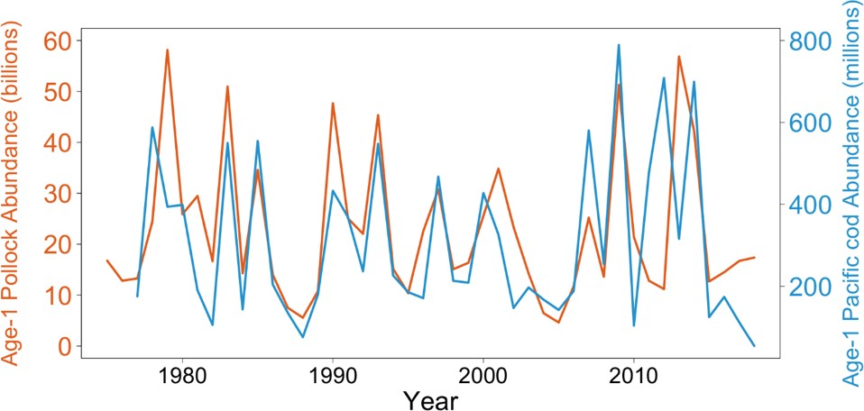

Figure 58: Plot of age-1 abundance for walleye pollock (orange; in millions) and Pacific cod (blue; in 1000s) as estimated in the 2018 stock assessments (Ianelli et al. 2018; Thompson 2018).

##### EBS Pollock Model Description

###### Dynamics

This assessment is based on a statistical age-structured model with the catch equation and popu- lation dynamics model as described in Fournier and Archibald (1982) and elsewhere (e.g., Hilborn and Walters 1992, Schnute and Richards 1995, McAllister and Ianelli 1997). The catch in numbers at age in year *t*(*Ct,a*) and total catch biomass (*Yt*) can be described as:

( )*−*

*Ct,a*

= *Ft,a* 1 *e−Zt,a N Zt,a*

*t,a*

*,* 1 *≤ t ≤ T,* 1 *≤ a ≤ A* (1)

*Nt*+1*,a*+1 = *Nt,a−*1*e−Zt,a−*1 1 *≤ t ≤ T,* 1 *≤ a < A* (2)

*Nt*+1*,A* = *Nt,A−*1*e−Zt,A−*1 + *Nt,Ae−Zt,A,* 1 *≤ t ≤ T* (3)

*Zt,a* = *Ft,a* + *Mt,a* (4)

*A*

∑

*Ct,.* = *Ct,a* (5)

*a*=1

*pt,a*

= *Ct,a*

*Ct,.*

*A*

∑

(6)

*Yt* = *wt,aCt,a* (7)

*a*=1

(8)

where

*T* is the number of years,

*A* is the number of age classes in the population,

*Nt,a* is the number of fish age *a* in year *t*, *Ct,a* is the catch of age class *a* in year *t*,

*pt,a* is the proportion of the total catch in year *t*, that is in age class *a*, *Ct* is the total catch in year *t*,

*wa* is the mean body weight (kg) of fish in age class *a*, *Yt* is the total yield biomass in year *t*,

*Ft,a* is the instantaneous fishing mortality for age class *a*, in year *t*, *Mt,a* is the instantaneous natural mortality in year *t* for age class *a*, and *Zt,a* is the instantaneous total mortality for age class *a*, in year *t*.

Fishing mortality (*Ft,a*) is specified as being semi-separable and non-parametric in form with re- strictions on the variability following Butterworth et al. (2003):

*Ft,a* = *st,a µf eϵt, ϵt ∼ N* (0*, σ*2 ) (9)

*E*

*st*+1*,a* = *st,a eγt, γt ∼ N* (0*, σ*2) (10)

*s*

where *st,a* is the selectivity for age class *a* in year *t*, and *µf* is the median fishing mortality rate over time.

If the selectivities (*st,a*) are constant over time then fishing mortality rate decomposes into an age component and a year component. A curvature penalty on the selectivity coeﬃcients using the squared second-diﬀerences to provide smoothness between ages.

Bottom-trawl survey selectivity was set to be asymptotic yet retain the properties desired for the characteristics of this gear. Namely, that the function should allow flexibility in selecting age 1 pollock over time. The functional form of this selectivity was:

*st,a*

= [1 + *e−αta−βt* ]*−*1 *, a >* 1 (11)

*µ*

*st,a* = *µse−δt , a* = 1 (12)

*αt* = *α*¯*e t ,* (13)

*δα*

*βt* = *βe t ,* (14)

¯ *δβ*

where the parameters of the selectivity function follow a random walk process as in Dorn et al. (2000):

*δµ − δµ ∼ N* (0*, σ*2 ) (15)

*t t*+1 *δµ*

(16)

*αµ − αµ ∼ N* (0*, σ*2*µ* ) (17)

*t*

*t*+1

*α*

*βµ − βµ ∼ N* (0*, σ*2*µ* ) (18)

*t*

*t*+1

*β*

The parameters to be estimated in this part of the model are thus for t=1982 through to 2019. The variance terms for these process error parameters were specified to be 0.04.

In this assessment, the random-walk deviation penalty was optionally shifted to the changes in log-selectivity. that is, for the BTS estimates, the process error was applied to the logistic param- eters as above, but the lognormal penalty was applied to the resulting selectivities-at-age directly. The extent of this variability was evaluated in the context of the impact on age-specific survey catchability/availability and contrasted with an independent estimate of pollock availability to the bottom trawl survey.

*ln*(*st,a*) *− ln*(*st*+1*,a*) *∼ N* (0*, σ*2

*sel*

) (19)

(20)

In 2008 the AT survey selectivity approach was modified. As an option, the age one pollock observed in this trawl can be treated as an index and are not considered part of the age composition (which then ranges from age 2-15). This was done to improve some interaction with the flexible selectivity smoother that is used for this gear and was compared. Additionally, the annual specification of input observation variance terms was allowed for the AT data.

A diagnostic approach to evaluate input variance specifications (via sample size under multinomial assumptions) was added in the 2018 assessment. This method uses residuals from mean ages together with the concept that the sample variance of mean age (from a given annual data set) varies inversely with input sample size. It can be shown that for a given set of input proportions at age (up to the maximum age *A*) and sample size *Nt* for year *t*, an adjustment factor *ν* for input

sample size can be computed when compared with the assessment model predicted proportions at age (*p*ˆ*ta*) and model predicted mean age (*a*ˆ¯*t*):

*−*1

√ )*N*

(

*ν* = var *a t*

*r*

*t*

*κt*

(21)

*ra* = *a*¯*t − a*ˆ¯*t* (22)

*t*

*κt* =

where *ra* is the residual of mean age and

*t*

[∑*A*

*a*

*a*¯*t − a*ˆ¯*t*

]0*.*5

(23)

*A*

∑

*a*ˆ¯*t* = *ap*ˆ*ta* (24)

*a A*

∑

*a*¯*t* = *apta* (25)

*a*

Based on previous analyses, we used the above relationship as a diagnostic for evaluating input sample sizes by comparing model predicted mean ages with observed mean ages and the implied 95% confidence bands. This method provided support for modifying the frequency of allowing selectivity changes.

###### Recruitment

In these analyses, recruitment (*Rt*) represents numbers of age-1 individuals modeled as a stochastic function of spawning stock biomass.

*Rt* = *f* (*Bt−*1) (26)

with mature spawning biomass during year *t* was defined as:

*A*

∑

*Bt* = *wt,aϕaNt,a* (27)

*a*=1

and, *ϕa* is the proportion of mature females at age is as shown in the sub-section titled Natural mortality and maturity at age under “Parameters estimated independently” above.

A reparameterized form for the stock-recruitment relationship following Francis (1992) was used. For the optional Beverton-Holt form (the Ricker form presented in Eq. 12 was adopted for this assessment) we have:

where

*Rt* is recruitment at age 1 in year *t*,

*Rt* =

*Bt−*1*eεt α* + *βBt−*1

(28)

*Bt* is the biomass of mature spawning females in year *t*, *εt* is the recruitment anomaly for year *t*, (*εt ∼ N* (0*, σ*2 )

*R*

*α, β* are stock recruitment parameters.

Values for the stock-recruitment function parameters and are calculated from the values of (the number of 0-year-olds in the absence of exploitation and recruitment variability) and the steepness of the stock-recruit relationship (*h*). The steepness is the fraction of R0 to be expected (in the absence of recruitment variability) when the mature biomass is reduced to 20% of its pristine level (Francis 1992), so that:

*α* = *B*˜0

1 *− h*

4*h*

(29)

*β* = 5*h −* 1

4*hR*0

(30)

where *B*˜0 is the total egg production (or proxy, e.g., female spawning biomass) in the absence of exploitation (and recruitment variability) expressed as a fraction of *R*0.

Some interpretation and further explanation follows. For steepness equal 0.2, then recruits are a linear function of spawning biomass (implying no surplus production). For steepness equal to 1.0, then recruitment is constant for all levels of spawning stock size. A value of *h* = 0*.*9 implies that at 20% of the unfished spawning stock size will result in an expected value of 90% unfished recruitment level. Steepness of 0.7 is a commonly assumed default value for the Beverton-Holt form (e.g., Kimura 1988). The prior distribution for steepness used a beta distribution as in Ianelli et al. (2016). The prior on steepness was specified to be a symmetric form of the Beta distribution with *α* = *β* = 14*.*93 implying a prior mean of 0.5 and CV of 12% (implying that there is about a 14% chance that the steepness is greater than 0.6). This conservative prior is consistent with previous years’ application and serves to constrain the stock-recruitment curve from favoring steep slopes (uninformative priors result in *FMSY* values near an *FSP R* of about *F*18% a value considerably higher than the default proxy of *F*35%). The residual pattern for the post-1977 recruits used in fitting the curve with a more diﬀuse prior resulted in all estimated recruits being below the curve for stock sizes less than *BMSY* (except for the 1978 year class). We believe this to be driven primarily by the apparent negative-slope for recruits relative to stock sizes above *BMSY* and as such, provides a potentially unrealistic estimate of productivity at low stock sizes. This prior was elicited from the rationale that residuals should be reasonably balanced throughout the range of spawning stock sizes. Whereas this is somewhat circular (i.e., using data for prior elicitation), the point here is that residual patterns (typically ignored in these types of models) were qualitatively considered.

In model 16.1, “Bholt”, a Beverton Holt stock recruitment form was implemented using the prior value of 0.67 for steepness and a CV of 0.17. This resulted in beta distribution parameters (for the prior) at *α* = 6*.*339 and

*β* = 4*.*293.

The value of *σR* was set at 1.0 to accommodate additional uncertainty in factors aﬀecting recruit- ment variability.

To have the critical value for the stock-recruitment function (steepness, *h*) on the same scale for the Ricker model, we begin with the parameterization of Kimura (1990):

*α*(1*−Bt−*1 *R*0 )

*Rt* =

*Bt−*1*e ψ*0

*ψ*0

(31)

It can be shown that the Ricker parameter a maps to steepness as:

*eα*

*h* = *eα* + 4

(32)

so that the prior used on *h* can be implemented in both the Ricker and Beverton-Holt stock- recruitment forms. Here the term *ψ*0 represents the equilibrium unfished spawning biomass per- recruit.

###### Diagnostics

In 2006 a replay feature was added where the time series of recruitment estimates from a particular model is used to compute the subsequent abundance expectation had no fishing occurred. These recruitments are adjusted from the original estimates by the ratio of the expected recruitment given spawning biomass (with and without fishing) and the estimated stock-recruitment curve. I.e., the recruitment under no fishing is modified as:

*Rt′* = *R*ˆ

*f* (*Bt′−*1)

*t f* (*Bt−*1)

where *Rt* is the original recruitment estimate in year *t* with *Bt′* 1 and *Bt* 1 representing the stock- recruitment function given spawning biomass under no fishing and under the estimated fishing intensity, respectively.

*− −*

The assessment model code allows retrospective analyses (e.g., Parma 1993, and Ianelli and Fournier 1998). This was designed to assist in specifying how spawning biomass patterns (and uncertainty) have changed due to new data. The retrospective approach simply uses the current model to evaluate how it may change over time with the addition of new data based on the evolution of data collected over the past several years.

###### Parameter estimation

The objective function was simply the sum of the negative log-likelihood function and logs of the prior distributions. To fit large numbers of parameters in nonlinear models it is useful to be able to estimate certain parameters in diﬀerent stages. The ability to estimate stages is also important in using robust likelihood functions since it is often undesirable to use robust objective functions when models are far from a solution. Consequently, in the early stages of estimation we use the following log- likelihood function for the survey and fishery catch at age data (in numbers):

*nll*(*i*) = *n pta* ln *p*ˆ*ta* (33)

∑

*t,a*

*Ota*

∑

*C*ˆ*ta*

*p*ˆ =

(34)

*pta* =

*a*

*Ota*

*ta* ∑

*a C*ˆ*ta*

**C** = **CE** (35)

*b*1*,*1 *b*1*,*2 *. . . b*1*,*15 *b*2*,*1 *b*2*,*2 *b*2*,*15

**E** = .

. . . .

(36)

*b*15*,*1 *b*15*,*2 *. . . b*15*,*15

where *A*, and *T* , represent the number of age classes and years, respectively, n is the sample size, and represent the observed and predicted numbers at age in the catch. The elements bi,j represent

ageing mis-classification proportions are based on independent agreement rates between otolith age readers. For the models presented this year, the option for including aging errors was re-evaluated.

Sample size values were revised and are shown in the main document. Strictly speaking, the amount of data collected for this fishery indicates higher values might be warranted. However, the standard multinomial sampling process is not robust to violations of assumptions (Fournier et al. 1990). Consequently, as the model fit approached a solution, we invoke a robust likelihood function which fit proportions at age as:

∏ ∏ [( (

*A*

*T*

*−* 2 (*η*

exp

*a*=1 *t*=1

(*pta − p*ˆ*ta*)2 )

*ta*

+ 0*.*1*/A*) *τ* 2

) 1 ] (37)

*ta*

*t*

Taking the logarithm we obtain the log-likelihood function for the age composition data:

*t*

+ 0*.*01

+ 0*.*1*/A*) *τ*

∑ ∑ ∑

*A*

*T*

*×* √2*π* (*η*

∑ ∑ { (

(*pta − p*ˆ*ta*)2 ) }

*t*

*nll*(*i*) = *−*0*.*5

where

*a*=1 *t*=1

ln 2*π* (*ηta* + 0*.*1*/A*) *−*

*A* ln *τt* +

*t*

*T*

*A*

*T*

ln

*a*=1 *t*=1

exp

*−* (2*ηta*

+ 0*.*1*/A*) *τ* 2

+ 0*.*01

(38)

which gives the variance for *pta*

*ηta* = *pta*(1 *− pta*) (39)

and (40)

*τ* 2 = 1*/nt* (41)

*t*

(*ηta* + 0*.*1*/A*)*τ* 2 (42)

*t*

Completing the estimation in this fashion reduces the model sensitivity to data that would otherwise be considered outliers.

Within the model, predicted survey abundance accounted for within-year mortality since surveys occur during the middle of the year. As in previous years, we assumed that removals by the survey were insignificant (i.e., the mortality of pollock caused by the survey was considered insignificant). Consequently, a set of analogous catchability and selectivity terms were estimated for fitting the survey observations as:

*N*ˆ*s* = *e−*0*.*5*Zta NtaqssS*

(43)

*ta t ta*

where the superscript s indexes the type of survey (AT or BTS). For the option to use the survey predictions in biomass terms instead of just abundance, the above was modified to include observed survey biomass weights-at-age:

*N*ˆ*s* = *e−*0*.*5*Zta wtaNtaqssS*

(44)

*ta t ta*

For the AVO index, the values for selectivity were assumed to be the same as for the AT survey and the mean weights at age over time was also assumed to be equal to the values estimated for the AT survey.

For these analyses we chose to keep survey catchabilities constant over time (though they are estimated separately for the AVO index and for the AT and bottom trawl surveys). The contribution to the negative log-likelihood function (ignoring constants) from the surveys is given by either the lognormal distribution:

∑ ln(*us/N*ˆ*s*)2

*nll*(*i*) =

*t*

2

*s,t*

*t*

(45)

*t*

2*σ*

where *us* is the total (numerical abundance or optionally biomass) estimate with variance *σs,t* from survey *s* in year *t* or optionally, the normal distribution can be selected:

*t*

*nll*(*i*) =

*t*

*t t*

2

2*σ*

∑ (*us − N*ˆ*s*)2

*s,t*

*.* (46)

(47)

The AT survey and AVO index is modeled using a lognormal distribution whereas for the BTS survey, a normal distribution was applied.

For model configurations in which the BTS data are corrected for estimated eﬃciency, a multivariate lognormal distribution was used. For the negative- log likelihood component this was modeled as

*nlli* = 0*.*5**X**Σ*−*1**X***′* (48)

where is a vector of observed minus model predicted values for this index and Σ is the estimated covariance matrix provided from the method provided in Kotwicki et al. 2014. For the VAST estimates, the supplied covariance matrix was used in the same way.

The contribution to the negative log-likelihood function for the observed total catch biomass (*Cobs, C*ˆ*b*) by the fishery is given by

*b*

*nlli* = 0*.*5

*obs* ˆ 2

*b*

∑ ln(*C /C* )*b*

2*σ*2

(49)

*t Cb,t*

where *σC ,t* is pre-specified (set to 0.05) reflecting the accuracy of the overall observed catch in biomass. Similarly, the contribution of prior distributions (in negative log-density) to the log-

*b*

likelihood function include *λε* ∑*t ε*2 + *λγ* ∑*ta γ*2 + *λδ* ∑*t δ*2 where the size of the ’s represent prior

*t*

*t*

assumptions about the variances of these random variables. Most of these parameters are associated with year-to- year and age specific deviations in selectivity coeﬃcients. For a presentation of this type of Bayesian approach to modeling errors-in- variables, the reader is referred to Schnute (1994). To facilitate estimating such a large number of parameters, automatic diﬀerentiation software extended from Greiwank and Corliss (1991) and developed into C++ class libraries was used. This software provided the derivative calculations needed for finding the posterior mode via a quasi-Newton function minimization routine (e.g., Press et al. 1992). The model implementation language (ADModel Builder) gave simple and rapid access to these routines and provided the ability estimate the variance-covariance matrix for all dependent and independent parameters of interest.

###### Uncertainty in mean body mass

The approach we use to solve for *FMSY* and related quantities (e.g., *BMSY MSY* ) within a general integrated model context was shown in Ianelli et al. (2001). In 2007 this was modified to include uncertainty in weight-at-age as an explicit part of the uncertainty for *FMSY* calculations. This involved estimating a vector of parameters (*wfuture*) on current (2019) and future mean weights for each age *i*, *i*= (1, 2,. . . ,15), given actual observed mean and variances in weight-at-age over the period 1991-2018. The values of based on available data and (if this option is selected) estimates the parameters subject to the natural constraint:

*ta*

*wfuture ∼ N* (*w*¯*a, σ*2 )

*ta*

*wa*

Note that this converges to the mean values over the time series of data (no other likelihood component within the model is aﬀected by future mean weights-at-age) while retaining the nat- ural uncertainty that can propagate through estimates of *FMSY* uncertainty. This latter point is essentially a requirement of the Tier 1 categorization.

Subsequently, this method was refined to account for current-year survey data and both cohort and year eﬀects. The model for this is:

*w*ˆ*ta* = *w*¯*aeυ*

*t*

*w*ˆ*ta* = *w*ˆ*t−*1*,a−*1 + ∆*aeψ*

*t*

*a* = 1*, t ≥* 1964 (50)

*a >* 1*, t >* 1964 (51)

∆*a* = *w*¯*a*+1 *− w*¯*a a < A* (52)

( )}

*w*¯*a* = *α*

{*L*1 + (*L*2 *− L*1)

1 *− Ka−*1 3

1 *− KA−*1

(53)

(54)

where the fixed eﬀects parameters are *L*1*, L*2*, K,* and *α* while the random eﬀects parameters are *υt*

and *ψt*.

###### Tier 1 projections

Tier 1 projections were calculated two ways. First, for 2020 and 2021 ABC and *OFL* levels, the harmonic mean *FMSY* value was computed and the analogous harvest rate (*uH*¯*M* ) applied to the estimated geometric mean fishable biomass at *BMSY* :

*ABCt* = *Bf u*ˆ*HM ζt* (55)

*GM,t*

*Bf* = *e*ln *B*ˆ*f −*0*.*5*σ*2

(56)

*GM,t*

*t Bf*

*f HM,t*

*u*

*ζt*

= *e*ln *u*ˆ*MSY,t−*0*.*5*σ*2

= *Bt/BMSY −* 0*.*05

*uMSY*

1 *−* 0*.*05

*Bt < B*

*MSY*

(57)

(58)

*ζt* = 1*.*0 *Bt ≥ BMSY* (59)

where *B*ˆ*f* is the point estimate of the fishable biomass defined (for a given year): ∑ *Nastawta* with

*t*

*a*

*Nta*, *sta*, and *wta* the estimated population numbers (begin year), selectivity and weights-at-age, respectively. *BMSY* and *Bt* are the point estimates spawning biomass levels at equilibrium *FMSY* and in year *t* (at time of spawning). For these projections, catch must be specified (or solved for

if in the current year when *Bt* < *BMSY* ). For longer term projections a form of operating model (as has been presented for the evaluation of *B*20%) with feedback (via future catch specifications) using the control rule and assessment model would be required.

##### Appendix on spatio-temporal analysis of NMFS bottom-trawl survey data

###### Overview

This application of VAST was configured to model a subset of NMFS/AFSC bottom trawl survey data. Specifically, the station-specific CPUE (kg per hectare) for pollock were compiled from 1982- 2019. Further details can be found at the [GitHub repo](https://github.com/james-%20thorson/VAST/#description) mainpage, wiki, and glossary. The R help files, e.g., ?Data_Fn for explanation of data inputs, or ?Param_Fn for explanation of parameters. VAST has involved many publications for developing individual features (see references section below). What follows is intended as a step by step documentation of applying the model to these data.

Settings and configurations are available here (link to come. . . ).

###### Spatio-temporal treatment of survey age composition data

To date, assessments using spatio-temporal indices have kept age-composition data unchanged (i.e., the estimates were based on the original design-based approach). Here we develop a spatio-temporal approach to obtain age composition estimates. We found that design-based and model-based inputs provided stock-assessment parameter estimates consistent with previous approaches (Fig. 17).

###### Diagnostic plots

*Encounter-probability component*

One can check to ensure that observed encounter frequencies for either low or high probability samples are within the 95% predictive interval for predicted encounter probability (Figure 60. Di- agnostics for positive-catch-rate component was evaluated using a standard Q-Q plot. Qualitatively, the fits to pollock data are reasonable (Figures 61 and 62).

*Pearson residuals*

Spatially the residual pattern can be evaluated over time. Results for pollock data shows that consistent positive or negative residuals accross or within years is limited for the encounter prob- ability component of the model and for the positive catch rate component (Figures 63 and 64, respectively).

*Densities and biomass estimates*

Relative densities over time suggests that the biomass of pollock can reflect abundances in the NBS even in years where samples are unavailable (all years except 2010, 2017–2019; (Figure 65). Index values and error terms (based on diagonal of covariance matrix over time) are shown in Figure 66

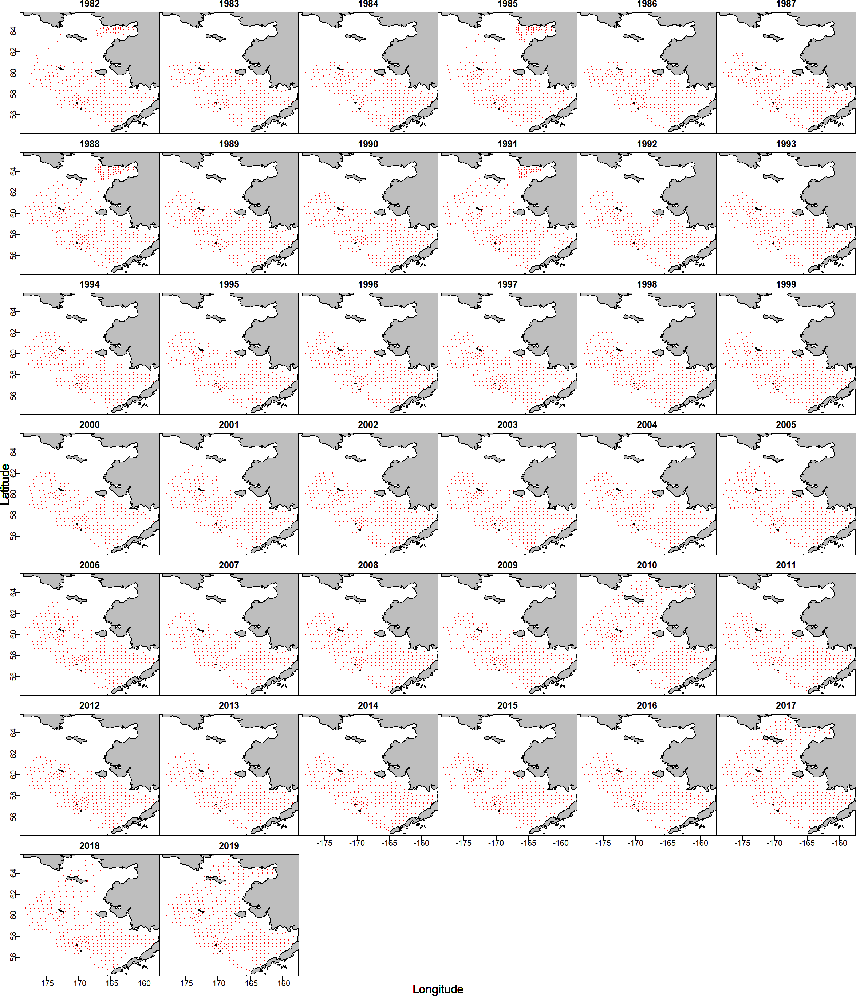

Figure 59: Numbers-at-age estimates for 2019 (top) and 2020 (bottom) cmpared to the mean values since 1991.

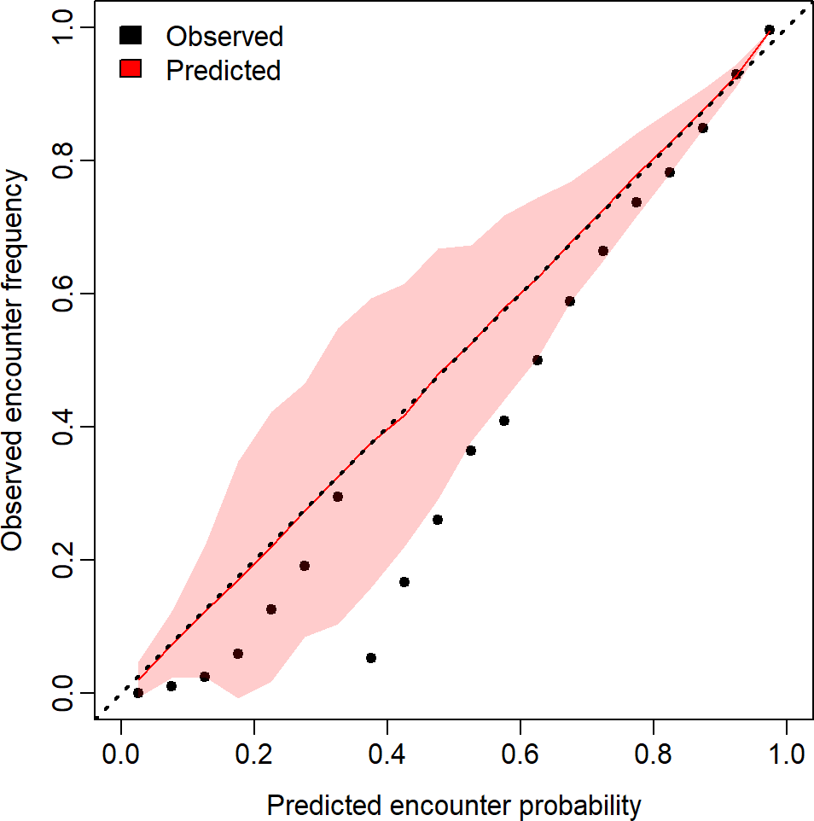

Figure 60: Observed encounter rates and predicted probabilities for pollock in the combined survey area.

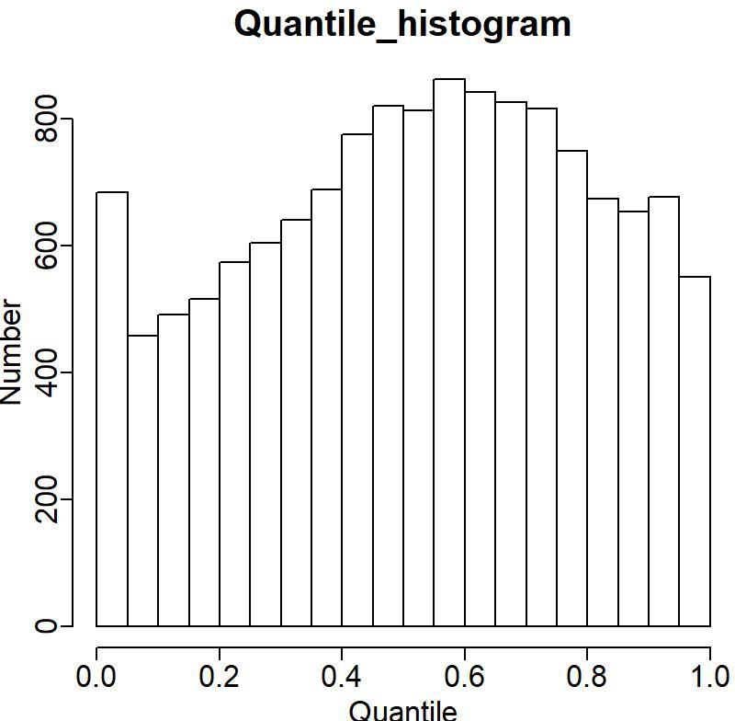

Figure 61: Plot indicating distribution of quantiles for “positive catch rate” component.

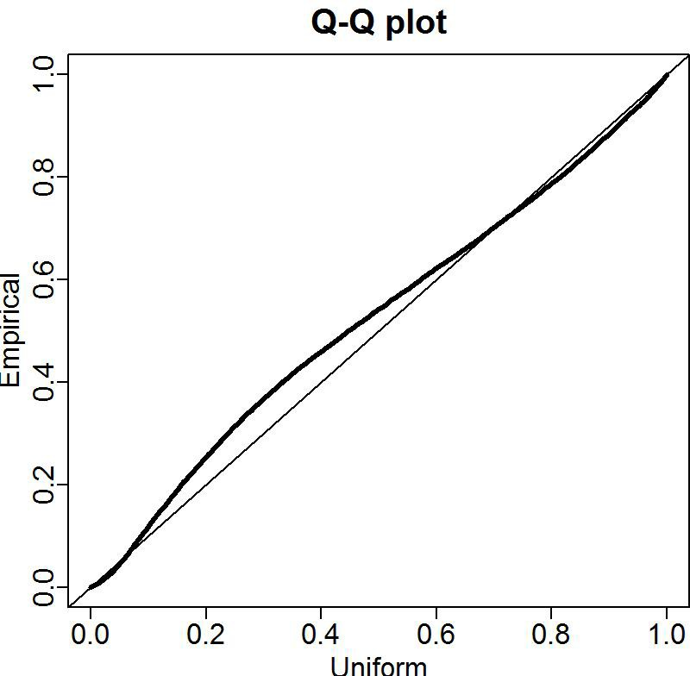

Figure 62: Quantile-quantile plot of residuals for “positive catch rate” component.

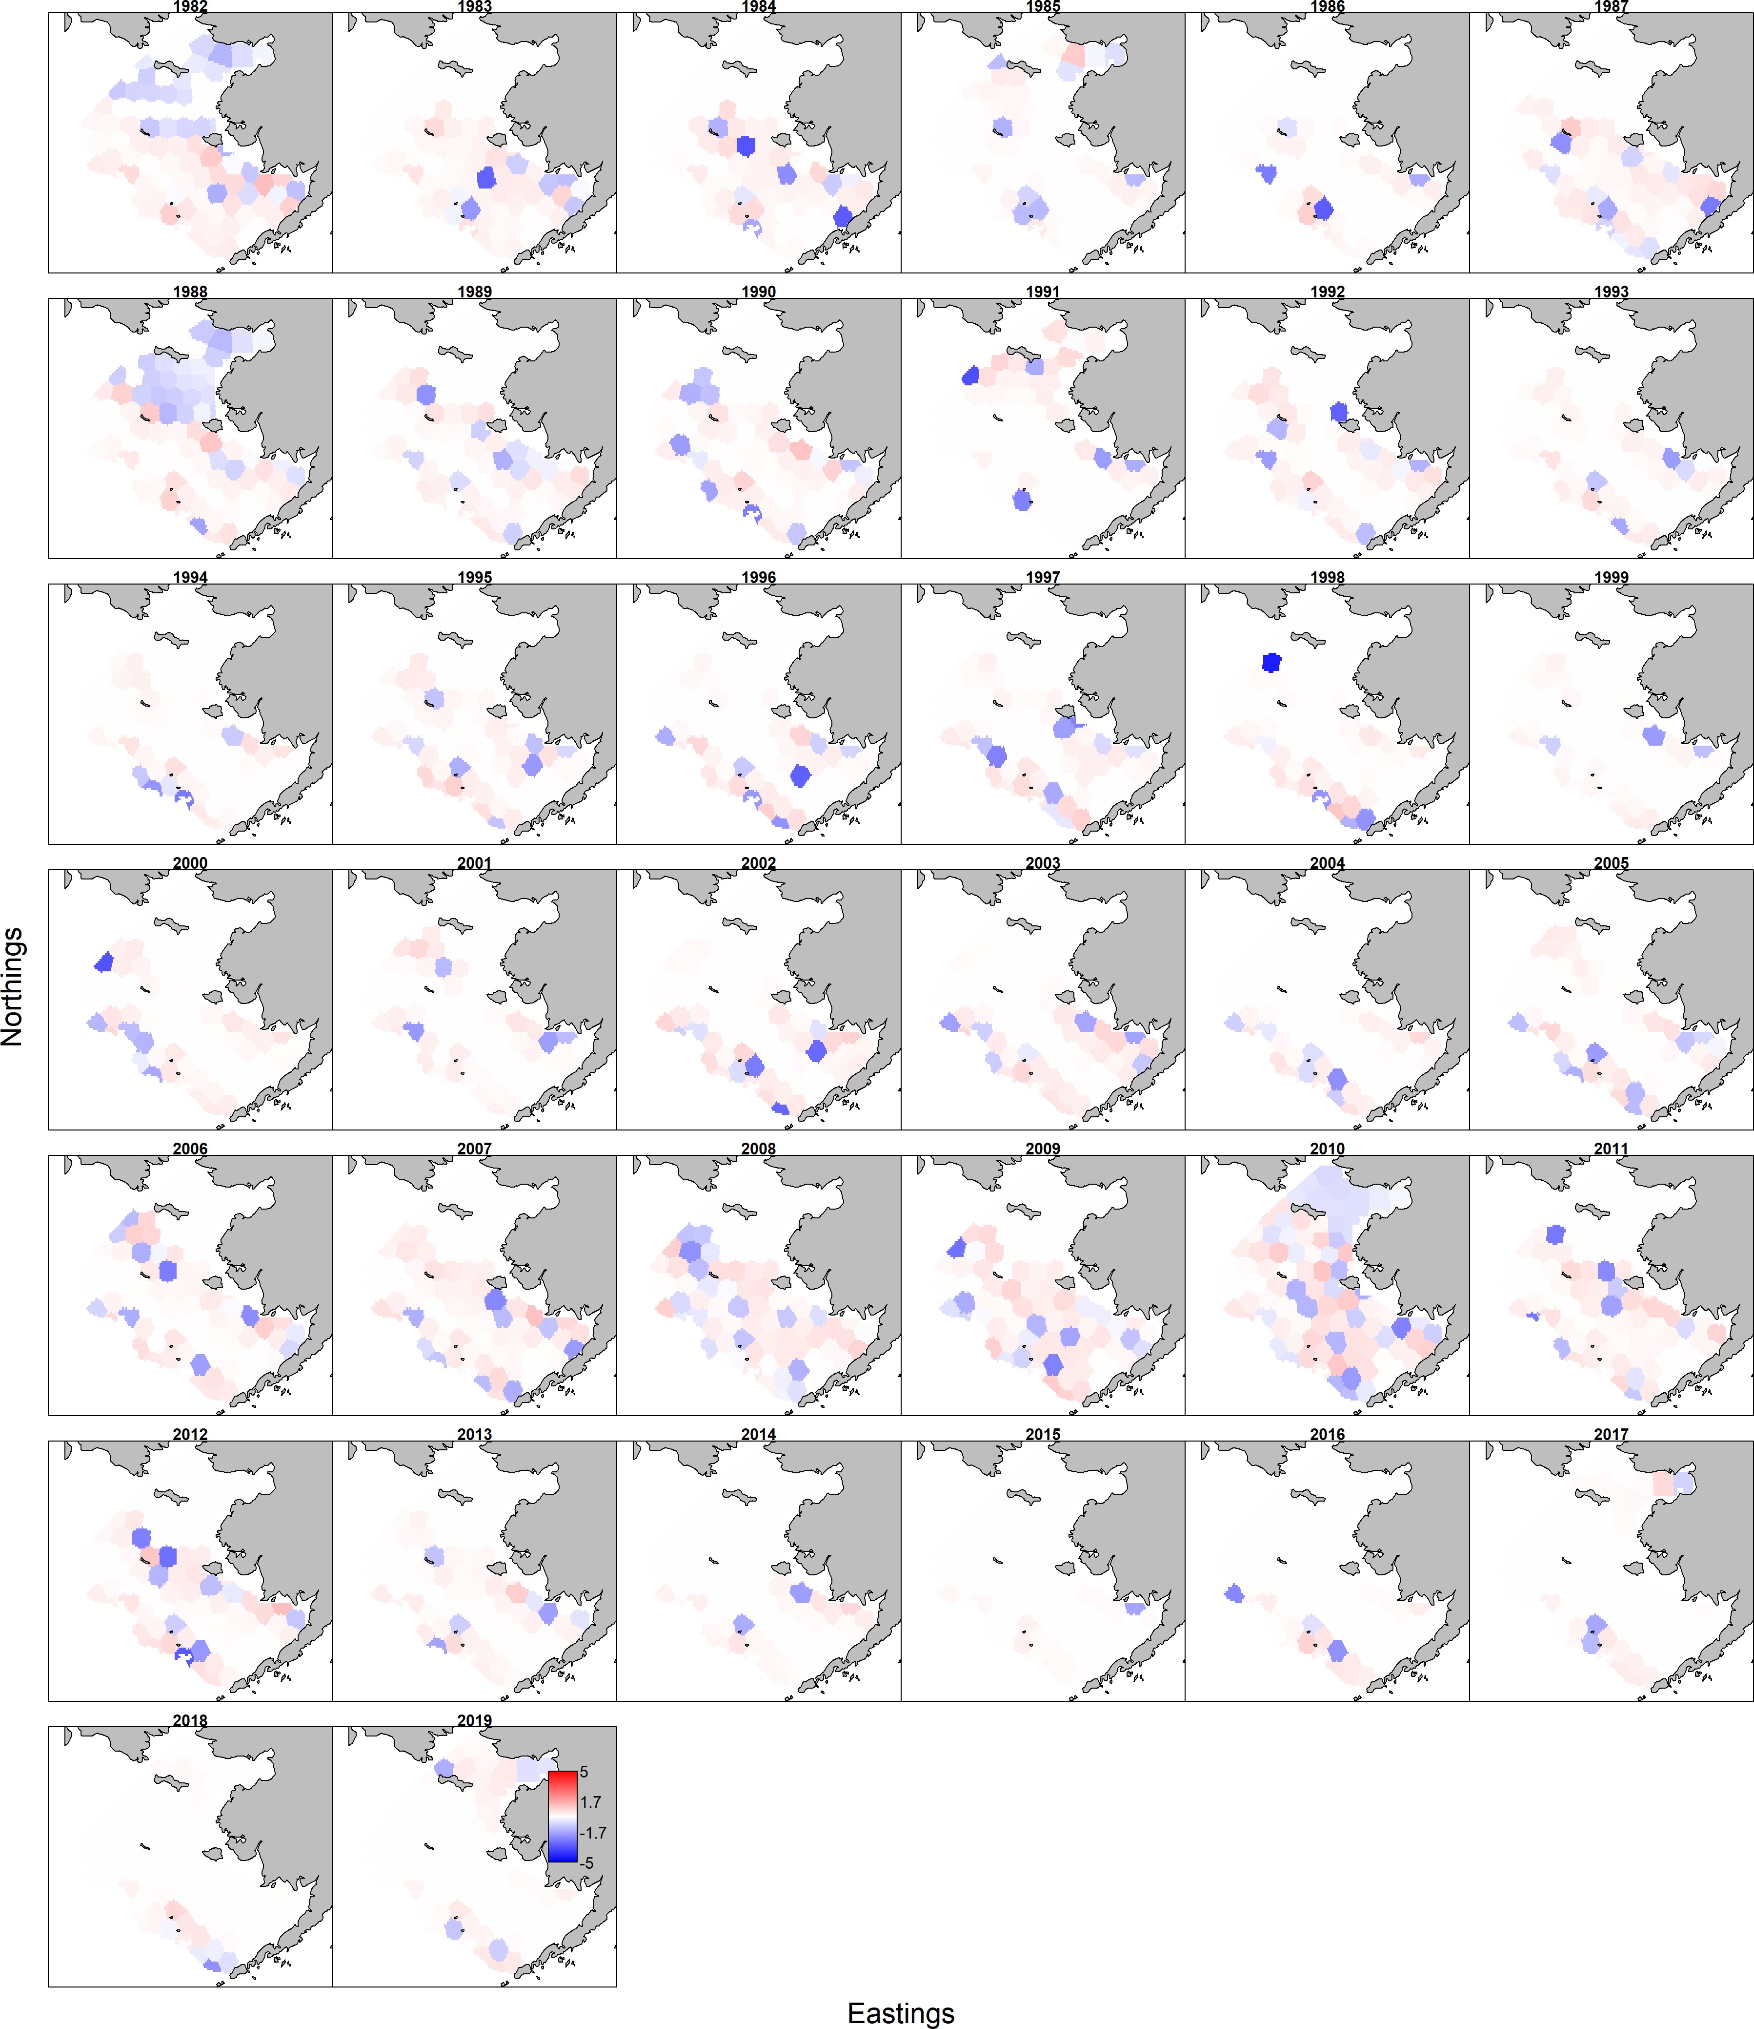

Figure 63: Pearson residuals of the encounter probability component for the combined survey area, 1982-2018.

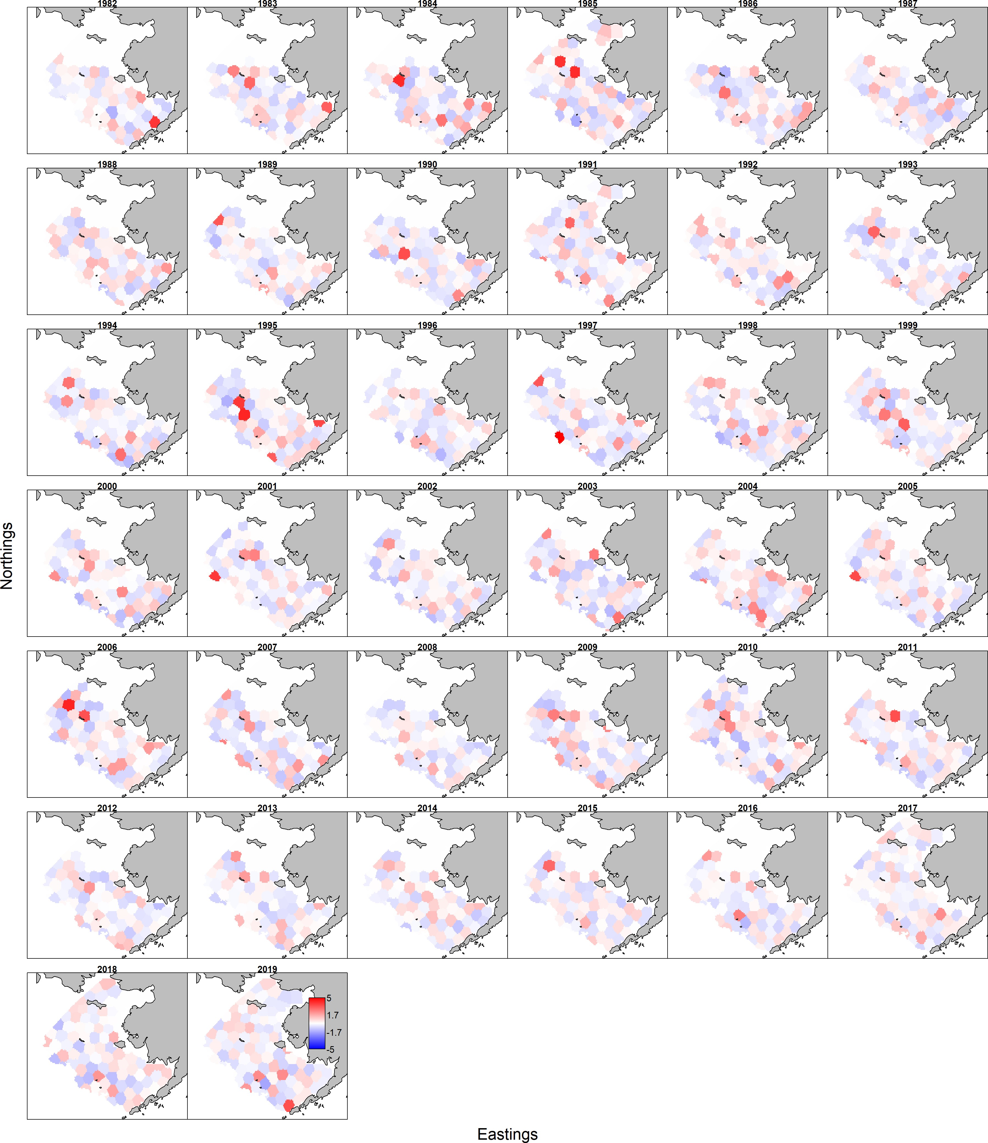

Figure 64: Pearson residuals of the positive catch rate component for the combined survey area, 1982-2018.

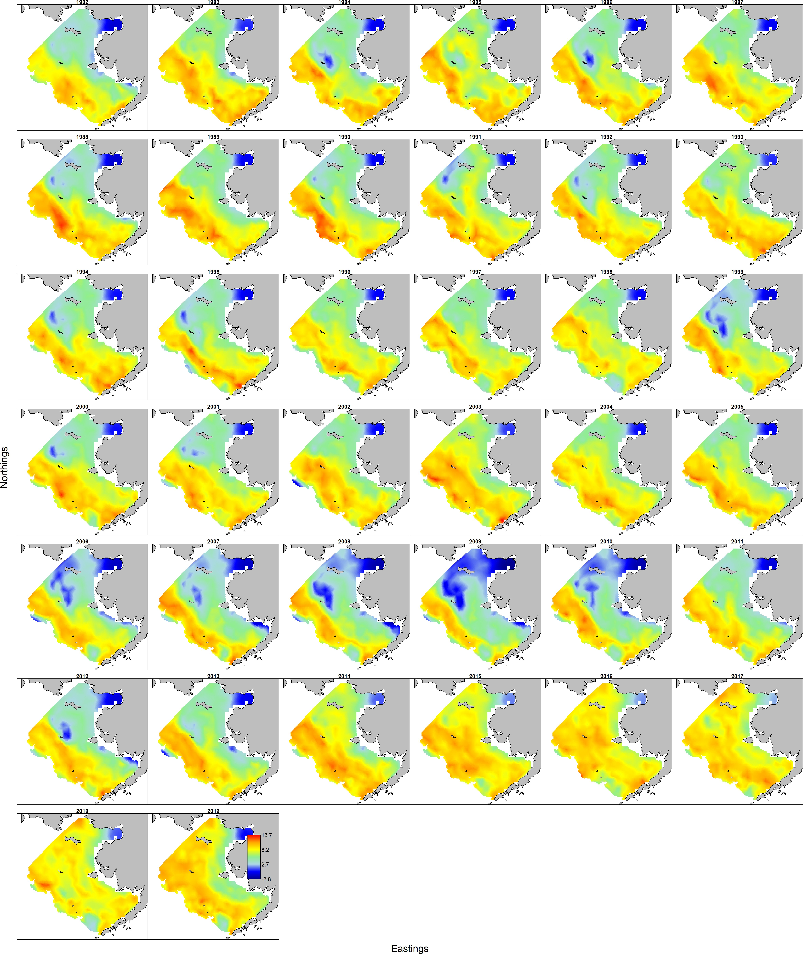

Figure 65: Pollock density maps using the VAST model approach, 1982-2019.

15

●●

●

●

●●

●●

●

●

●●

●●

●

●● ●●

●●

● ● ● ●●

●

●

●●

●

●● ●● ●

●

●

●

●

●●

● ●

●

●

●●

●●

●●

●●

●●

●●

●●

●● ●

●

●●

●●

●●

●●

●●

●

●

Combined

10

5

Biomass (millions of t)

0

3

●

●

●● ● ●

● ●

●

●

●

●●

●●

●●

●● ● ● ● ●●

● ●

●●

●● ● ●● ● ●● ● ● ●● ●● ●●

● ●

● ●

●● ● ●

● ● ●●

●● ●●

●● ●● ●● ●● ●● ●● ●● ●

●

Model

NBS

2

1

0

15

●

●

●

●●

●●

●

●

●●

●

●

● ●

●

●●

●

● ●

●

●

●● ●● ●

●

●●

●●

●

●

●

●

●

●●

●●

●●

●●

●●

●● ●

●

●●

●●

●●

●●

●●

●●

●●

●

●

|  |  |
| --- | --- |
| ● | |
| ● ● | ● |

10

|  |  |
| --- | --- |
| ● | |
| ● | ● ● |

5

0

1982 1986 1990 1994 1998 2002 2006 2010 2014 2018

### Year

● Cold pool covariate

* No covariate

Standard

Figure 66: Pollock index values for the standard survey region, the NBS, and combined based on the VAST application to density-dependent corrected CPUE values from the BTS data, 1982–2019. The diﬀerent lines are smoothed trends for with and without including the cold-pool extent as a covariate.

##### Summary tables for alternative models and/or Tiers

###### Tier 3, Model 16.1

|  |  |  |  |  |
| --- | --- | --- | --- | --- |
| Quantity | As estimated or *specified*  *last* year for:  2019 2020 | | As estimated or *recommended*  *this* year for:  2020 2021 | |
| M (natural mortality rate, ages 3+) | 0.3  1a 9,110,000 t  3,107,000 t  5,866,000 t  2,280,000 t  0.645  0.510  0.356  3,913,000 t  3,096,000 t  2,163,000 t | 0.3  1a 8,156,000 t  2,725,000 t  5,866,000 t  2,280,000 t  0.645  0.51  0.375  3,082,000 t  2,437,000 t  1,792,000 t | 0.3 | 0.3 |
| Tier | 3a | 3a |
| Projected total (age 3+) biomass (t) | 8,580,000 t | 7,990,000 t |
| Projected female spawning biomass (t) | 2,781,000 t | 2,476,000 t |
| 6,165,000 t | 6,165,000 t |
| *B*0*orB*100 |
| 2,158,000 t | 2,158,000 t |
| *Bmsy* |
| 0.314 | 0.321 |
| *FOFL* |
| 0.253 | 0.262 |
| *maxFABC* |
| 0.253 | 0.262 |
| *FABC* |
| 4,273,000 t | 3,458,000 t |
| *OFL* |
| 2,045,000 t | 1,716,000 t |
| *maxABC* |
| 2,045,000 t | 1,716,000 t |
| *ABC* |
| Status | 2017 | 2018 | 2018 | 2019 |
| Overfishing  Overfished Approaching overfished | No  n/a n/a | n/a  No No | No  n/a n/a | n/a  No No |

***Tier 1, Model 16.2 (VAST bottom trawl survey data, full time series, include NBS)***

|  |  |  |  |  |
| --- | --- | --- | --- | --- |
| Quantity | As estimated or *specified*  *last* year for:  2019 2020 | | As estimated or *recommended*  *this* year for:  2020 2021 | |
| M (natural mortality rate, ages 3+) | 0.3  1a 9,110,000 t  3,107,000 t  5,866,000 t  2,280,000 t  0.645  0.510  0.356  3,913,000 t  3,096,000 t  2,163,000 t | 0.3  1a 8,156,000 t  2,725,000 t  5,866,000 t  2,280,000 t  0.645  0.51  0.375  3,082,000 t  2,437,000 t  1,792,000 t | 0.3 | 0.3 |
| Tier | 1a | 1a |
| Projected total (age 3+) biomass (t) | 9,128,000 t | 8,494,000 t |
| Projected female spawning biomass (t) | 2,991,000 t | 2,674,000 t |
| 5,777,000 t | 5,777,000 t |
| *B*0 |
| 2,148,000 t | 2,148,000 t |
| *Bmsy* |
| 0.449 | 0.449 |
| *FOFL* |
| 0.383 | 0.383 |
| *maxFABC* |
| 0.225 | 0.235 |
| *FABC* |
| 4,085,000 t | 3,385,000 t |
| *OFL* |
| 3,485,000 t | 2,888,000 t |
| *maxABC* |
| 2,043,000 t | 1,767,000 t |
| *ABC* |
| Status | 2017 | 2018 | 2018 | 2019 |
| Overfishing  Overfished Approaching overfished | No  n/a n/a | n/a  No No | No  n/a n/a | n/a  No No |

***Tier 3, Model 16.2 (VAST bottom trawl survey data, full time series, include NBS)***

|  |  |  |  |  |
| --- | --- | --- | --- | --- |
| Quantity | As estimated or *specified*  *last* year for:  2019 2020 | | As estimated or *recommended*  *this* year for:  2020 2021 | |
| M (natural mortality rate, ages 3+) | 0.3  1a 9,110,000 t  3,107,000 t  5,866,000 t  2,280,000 t  0.645  0.510  0.356  3,913,000 t  3,096,000 t  2,163,000 t | 0.3  1a 8,156,000 t  2,725,000 t  5,866,000 t  2,280,000 t  0.645  0.51  0.375  3,082,000 t  2,437,000 t  1,792,000 t | 0.3 | 0.3 |
| Tier | 3a | 3a |
| Projected total (age 3+) biomass (t) | 9,128,000 t | 8,494,000 t |
| Projected female spawning biomass (t) | 2,991,000 t | 2,674,000 t |
| 6,256,000 t | 6,256,000 t |
| *B*0*orB*100 |
| 2,190,000 t | 2,190,000 t |
| *Bmsy* |
| 0.277 | 0.29 |
| *FOFL* |
| 0.225 | 0.235 |
| *maxFABC* |
| 0.225 | 0.235 |
| *FABC* |
| 4,085,000 t | 3,385,000 t |
| *OFL* |
| 2,043,000 t | 1,767,000 t |
| *maxABC* |
| 2,043,000 t | 1,767,000 t |
| *ABC* |
| Status | 2017 | 2018 | 2018 | 2019 |
| Overfishing  Overfished Approaching overfished | No  n/a n/a | n/a  No No | No  n/a n/a | n/a  No No |

**Contents**

**Executive summary**

Summary of changes in assessment inputs . . . . . . . . . . . . . . . . . . . . . . . .

Changes in the assessment methods . . . . . . . . . . . . . . . . . . . . . . . . . . .

Summary of EBS pollock results . . . . . . . . . . . . . . . . . . . . . . . . . . . . . . . .

Response to SSC and Plan Team comments . . . . . . . . . . . . . . . . . . . . . . . . . .

General comments . . . . . . . . . . . . . . . . . . . . . . . . . . . . . . . . . . . . .

##### Introduction

General . . . . . . . . . . . . . . . . . . . . . . . . . . . . . . . . . . . . . . . . . . . . . .

Review of Life History . . . . . . . . . . . . . . . . . . . . . . . . . . . . . . . . . . . . . .

Stock structure . . . . . . . . . . . . . . . . . . . . . . . . . . . . . . . . . . . . . . . . . .

##### Fishery

Description of the directed fishery . . . . . . . . . . . . . . . . . . . . . . . . . . . . . . .

Catch patterns . . . . . . . . . . . . . . . . . . . . . . . . . . . . . . . . . . . . . . .

Management measures . . . . . . . . . . . . . . . . . . . . . . . . . . . . . . . . . . . . . .

Economic conditions as of 2018 . . . . . . . . . . . . . . . . . . . . . . . . . . . . . . . . .

Pollock fillets . . . . . . . . . . . . . . . . . . . . . . . . . . . . . . . . . . . . . . . .

##### Data

Surimi seafood . . . . . . . . . . . . . . . . . . . . . . . . . . . . . . . . . . . . . . .

Pollock roe . . . . . . . . . . . . . . . . . . . . . . . . . . . . . . . . . . . . . . . . .

Fish oil . . . . . . . . . . . . . . . . . . . . . . . . . . . . . . . . . . . . . . . . . . .

Fishery . . . . . . . . . . . . . . . . . . . . . . . . . . . . . . . . . . . . . . . . . . . . . .

Catch . . . . . . . . . . . . . . . . . . . . . . . . . . . . . . . . . . . . . . . . . . . .

Surveys . . . . . . . . . . . . . . . . . . . . . . . . . . . . . . . . . . . . . . . . . . . . . .

Bottom trawl survey (BTS) . . . . . . . . . . . . . . . . . . . . . . . . . . . . . . . .

Acoustic trawl (AT) surveys . . . . . . . . . . . . . . . . . . . . . . . . . . . . . . . .

Other time series used in the assessment . . . . . . . . . . . . . . . . . . . . . . . . . . . .

Japanese fishery CPUE index . . . . . . . . . . . . . . . . . . . . . . . . . . . . . . .

Biomass index from Acoustic-Vessels-of-Opportunity (AVO) . . . . . . . . . . . . . .

##### Analytic approach

General model structure . . . . . . . . . . . . . . . . . . . . . . . . . . . . . . . . . . . . .

Description of alternative models . . . . . . . . . . . . . . . . . . . . . . . . . . . . . . . .

Input sample size . . . . . . . . . . . . . . . . . . . . . . . . . . . . . . . . . . . . . .

Parameters estimated outside of the assessment model . . . . . . . . . . . . . . . . . . . .

Natural mortality and maturity at age . . . . . . . . . . . . . . . . . . . . . . . . . .

Length and Weight at Age . . . . . . . . . . . . . . . . . . . . . . . . . . . . . . . . .

Parameters estimated within the assessment model . . . . . . . . . . . . . . . . . . . . . .

##### Results

Model evaluation . . . . . . . . . . . . . . . . . . . . . . . . . . . . . . . . . . . . . . . . .

Time series results . . . . . . . . . . . . . . . . . . . . . . . . . . . . . . . . . . . . . . . .

Recruitment . . . . . . . . . . . . . . . . . . . . . . . . . . . . . . . . . . . . . . . . . . . .

Retrospective analysis . . . . . . . . . . . . . . . . . . . . . . . . . . . . . . . . . . . . . .

##### Harvest recommendations

Status summary . . . . . . . . . . . . . . . . . . . . . . . . . . . . . . . . . . . . . . . . .

Amendment 56 Reference Points . . . . . . . . . . . . . . . . . . . . . . . . . . . . . . . .

Specification of OFL and Maximum Permissible ABC . . . . . . . . . . . . . . . . . . . .

Standard Harvest Scenarios and Projection Methodology . . . . . . . . . . . . . . . . . . .

Projections and status determination . . . . . . . . . . . . . . . . . . . . . . . . . . . . . .

ABC Recommendation . . . . . . . . . . . . . . . . . . . . . . . . . . . . . . . . . . . . . .

Should the ABC be reduced below the maximum permissible ABC? . . . . . . . . .

##### Additional ecosystem considerations

Ecosystem eﬀects on the EBS pollock stock . . . . . . . . . . . . . . . . . . . . . . . . . .

EBS pollock fishery eﬀects on the ecosystem. . . . . . . . . . . . . . . . . . . . . . . . . .

##### Data gaps and research priorities Acknowledgments

**References****Tables****Figures**

**EBS Pollock Model Description**

Dynamics . . . . . . . . . . . . . . . . . . . . . . . . . . . . . . . . . . . . . . . . . . . . .

Recruitment . . . . . . . . . . . . . . . . . . . . . . . . . . . . . . . . . . . . . . . . . . . .

Diagnostics . . . . . . . . . . . . . . . . . . . . . . . . . . . . . . . . . . . . . . . . . . . .

Parameter estimation . . . . . . . . . . . . . . . . . . . . . . . . . . . . . . . . . . . . . .

Uncertainty in mean body mass . . . . . . . . . . . . . . . . . . . . . . . . . . . . . . . . .

Tier 1 projections . . . . . . . . . . . . . . . . . . . . . . . . . . . . . . . . . . . . . . . . .

##### Appendix on spatio-temporal analysis of NMFS bottom-trawl survey data

Overview . . . . . . . . . . . . . . . . . . . . . . . . . . . . . . . . . . . . . . . . . . . . .

Spatio-temporal treatment of survey age composition data . . . . . . . . . . . . . . . . . .

Diagnostic plots . . . . . . . . . . . . . . . . . . . . . . . . . . . . . . . . . . . . . . . . . .

Encounter-probability component . . . . . . . . . . . . . . . . . . . . . . . . . . . . .

Pearson residuals . . . . . . . . . . . . . . . . . . . . . . . . . . . . . . . . . . . . . .

Densities and biomass estimates . . . . . . . . . . . . . . . . . . . . . . . . . . . . . .

##### Summary tables for alternative models and/or Tiers

Tier 3, Model 16.1 . . . . . . . . . . . . . . . . . . . . . . . . . . . . . . . . . . . . . . . .

Tier 1, Model 16.2 (VAST bottom trawl survey data, full time series, include NBS) . . . .

Tier 3, Model 16.2 (VAST bottom trawl survey data, full time series, include NBS) . . . .

##### List of Tables

1. Catch from the Eastern Bering Sea by area, the Aleutian Islands, the Donut Hole, and the Bogoslof Island area, 1979–2019 (2019 values through October 15th 2019). The southeast area refers to the EBS region east of 170W; the Northwest is west of 170W. Note: 1979–1989 data are from Pacfin, 1990–2019 data are from NMFS Alaska Regional Oﬃce, and include discards. The 2019 EBS catch estimates are preliminary. . . . . . . . . . . . . . . . . . . . . . . . . . . . . . . . . . . . . . . . .
2. Time series of 1964–1976 catch (left) and ABC, TAC, and catch for EBS pollock, 1977–2019 in t. Source: compiled from NMFS Regional oﬃce web site and various NPFMC reports. Note that the 2019 value is based on catch reported to October 25th 2019 plus an added component due to bycatch of pollock in other fisheries. . . .
3. Estimates of discarded pollock (t), percent of total (in parentheses) and total catch for the Aleutians, Bogoslof, Northwest and Southeastern Bering Sea, 1991–2019. SE represents the EBS east of 170W, NW is the EBS west of 170W, source: NMFS Blend and catch-accounting system database. 2019 data are preliminary. Note that the higher discard rates in the Aleutian Islands and Bogoslof region reflect the lack of directed pollock fishing. . . . . . . . . . . . . . . . . . . . . . . . . . . . . . . . . .
4. Total EBS shelf pollock catch recorded by observers (rounded to nearest 100 t) by year and season with percentages indicating the proportion of the catch that came from within the Steller sea lion conservation area (SCA), 1998–2019. The 2019 data are preliminary. . . . . . . . . . . . . . . . . . . . . . . . . . . . . . . . . . . . . . . .
5. Highlights of some management measures aﬀecting the pollock fishery. . . . . . . . .
6. BSAI pollock catch and ex-vessel data showing the total and retained catch (in kt), the number of vessels for all sectors and for trawl catcher vessels including ex-vessel value (million US$), price (US$ per pound), and catcher vessel shares. Years covered include the 2005-2007 average, the 2008-2010 average, the 2011-2013 average, and annual from 2014-2018. . . . . . . . . . . . . . . . . . . . . . . . . . . . . . . . . . .
7. BSAI pollock first-wholesale market data including production (kt), value (million US$), price (US$ per pound) for all products and then separately for other categories (head and gut, fillet, surimi, and roe production). Years covered include the 2005- 2007 average, the 2008-2010 average, the 2011-2013 average, and annual from 2014- 2018. . . . . . . . . . . . . . . . . . . . . . . . . . . . . . . . . . . . . . . . . . . . . .
8. Alaska pollock U.S. trade and global market data showing global production (in kt) and the U.S. and Russian shares followed by U.S. export volumes (kt), values (million US$), export prices (US$ per pound), import values (million US$), and net exports (million US$). Subsequent rows show the breakout of export shares (of U.S. pollock) by country (Japan, China and Europe) and the share of U.S. export volume and value of fish (i.e., H&G and fillets), and other product categories (surimi and roe). Years covered include the 2005-2007 average, the 2008-2010 average, the 2011-2013 average, and annual from 2014-2019 (2019 through June). . . . . . . . . . . . . . . .
9. BSAI pollock fish oil production index (tons of oil per 100 tons of retained catch); 2005-2007 average, the 2008-2010 average, the 2011-2013 average, and annual from 2014-2018. . . . . . . . . . . . . . . . . . . . . . . . . . . . . . . . . . . . . . . . . . .
10. Eastern Bering Sea pollock catch at age estimates based on observer data, 1979–2018. Units are in millions of fish. . . . . . . . . . . . . . . . . . . . . . . . . . . . . . . . .
11. Numbers of pollock NMFS observer samples measured for fishery catch length fre- quency (by sex and strata), 1977–2018. . . . . . . . . . . . . . . . . . . . . . . . . . .
12. Number of EBS pollock measured for weight and length by sex and strata as collected by the NMFS observer program, 1977-2018 . . . . . . . . . . . . . . . . . . . . . . .
13. Numbers of pollock fishery samples used for age determination estimates by sex and

strata, 1977–2018, as sampled by the NMFS observer program. . . . . . . . . . . . .

1. NMFS total pollock research catch by year in t, 1964–2019. . . . . . . . . . . . . . .
2. Survey biomass estimates (age 1+, t) of Eastern Bering Sea pollock based on design- based area-swept expansion methods from NMFS bottom trawl surveys 1982–2019. .
3. Sampling eﬀort for pollock in the EBS from the NMFS bottom trawl survey 1982–2019.
4. Bottom-trawl survey estimated numbers *millions* at age used for the stock assess- ment model. Note that in 1982–84 and 1986 only strata 1–6 were surveyed. Note these estimates are based on design-based procedures. . . . . . . . . . . . . . . . . .
5. Mean EBS pollock body mass (kg) at age as observed in the summer NMFS bottom trawl survey, 1982–2019. . . . . . . . . . . . . . . . . . . . . . . . . . . . . . . . . . .
6. Biomass (age 1+) of Eastern Bering Sea pollock as estimated by surveys 1979–2019 (millions of t). Note that the bottom-trawl survey data only represent biomass from the survey strata (1–6) areas in 1982–1984, and 1986. For all other years the estimates include strata 8–9. DDC indicates the values obtained from the Kotwicki et al. Density-Dependence Correction method and the VAST columns are for the standard survey area including the Northern Bering Sea (NBS) extension. . . . . . .
7. Number of (age 1+) hauls and sample sizes for EBS pollock collected by the AT surveys. Sub-headings E and W represent collections east and west of 170W (within the US EEZ) and US represents the US sub-total and RU represents the collections

from the Russian side of the surveyed region. . . . . . . . . . . . . . . . . . . . . . .

1. Mid-water pollock biomass (near surface down to 3m from the bottom unless oth- erwise noted) by area as estimated from summer acoustic-trawl surveys on the U.S. EEZ portion of the Bering Sea shelf, 1994–2018 (Honkalehto et al. 2015). CVs for biomass estimates were assumed to average 25% (inter-annual variability arises from the 1-dimensional variance estimation method). Note last column reflects biomass to 0.5m from bottom (as used in the model). . . . . . . . . . . . . . . . . . . . . . .
2. AT survey estimates of EBS pollock abundance-at-age (millions), 1979–2019. Age 2+ totals and age-1s were modeled as separate indices. . . . . . . . . . . . . . . . . .
3. An abundance index derived from acoustic data collected opportunistically aboard bottom-trawl survey vessels (AVO index; Honkalehto et al. 2014). Note values in parentheses are the coeﬃcients of variation from using 1-D geostatistical estimates of sampling variability (Petitgas, 1993). See Honkalehto et al. (2011) for the derivation of these estimates. The column “*CV**AV O*” was assumed to have a mean value of 0.30

for model fitting purposes (scaling relative to the AT and BTS indices). . . . . . . .

1. Pollock sample sizes assumed for the age-composition data likelihoods from the fish- ery, bottom-trawl survey, and AT surveys, 1964–2019. Note fishery sample size for 1964–1977 was fixed at 10. . . . . . . . . . . . . . . . . . . . . . . . . . . . . . . . . .
2. Mean weight-at-age (kg) estimates from the fishery (1991–2018; plus projections 2019–2021) showing the between-year variability (bottom row)." . . . . . . . . . . . .
3. Goodness of fit to primary data used for assessment model parameter estimation pro- filing over diﬀerent constraints on the extent bottom-trawl survey selectivity/availability is allowed to change; EBS pollock. . . . . . . . . . . . . . . . . . . . . . . . . . . . .
4. Goodness of fit to primary data used for assessment model parameter estimation for diﬀerent model configurations, EBS pollock. . . . . . . . . . . . . . . . . . . . . . . .
5. Summary of diﬀerent model results and the stock condition for EBS pollock. Biomass units are thousands of t. . . . . . . . . . . . . . . . . . . . . . . . . . . . . . . . . . .
6. Estimates of begin-year age 3 and older biomass (thousands of tons) and coeﬃcients of variation (CV) for the current assessment compared to 2012–2018 assessments for EBS pollock. . . . . . . . . . . . . . . . . . . . . . . . . . . . . . . . . . . . . . . . .
7. Estimated billions of EBS pollock at age (columns 2–11) from the 2019 assessment model. . . . . . . . . . . . . . . . . . . . . . . . . . . . . . . . . . . . . . . . . . . . .
8. Estimated millions of EBS pollock caught at age (columns 2–11) from the 2019 assessment model. . . . . . . . . . . . . . . . . . . . . . . . . . . . . . . . . . . . . .
9. Estimated EBS pollock age 3+ biomass, female spawning biomass, and age 1 re- cruitment for 1964–2019. Biomass units are thousands of t, age-1 recruitment is in millions of pollock. . . . . . . . . . . . . . . . . . . . . . . . . . . . . . . . . . . . . .
10. Summary of model 16.1 results and the stock condition for EBS pollock. Biomass units are thousands of t. . . . . . . . . . . . . . . . . . . . . . . . . . . . . . . . . . .
11. Summary results of Tier 1 2019 yield projections for EBS pollock. . . . . . . . . . .
12. For the configuration named Model 16.1, Tier 3 projections of EBS pollock catch for the 7 scenarios. . . . . . . . . . . . . . . . . . . . . . . . . . . . . . . . . . . . . . . .
13. For the configuration named Model 16.1, Tier 3 projections of EBS pollock ABC for the 7 scenarios. Note: scenario 2 results for 2020 and 2021 are conditioned on catches in that scenario listed in Table 39). . . . . . . . . . . . . . . . . . . . . . . .
14. For the configuration named Model 16.1, Tier 3 projections of EBS pollock fishing mortality for the 7 scenarios. . . . . . . . . . . . . . . . . . . . . . . . . . . . . . . .
15. For the configuration named Model 16.1, Tier 3 projections of EBS pollock spawning biomass (kt) for the 7 scenarios. . . . . . . . . . . . . . . . . . . . . . . . . . . . . . .
16. For the configuration named VAST, Tier 3 projections of EBS pollock catch for the 7 scenarios. . . . . . . . . . . . . . . . . . . . . . . . . . . . . . . . . . . . . . . . . .
17. For the configuration named VAST, Tier 3 projections of EBS pollock ABC for the 7 scenarios. Note: scenario 2 results for 2020 and 2021 are conditioned on catches in that scenario listed in Table 39). . . . . . . . . . . . . . . . . . . . . . . . . . . . .
18. For the configuration named VAST, Tier 3 projections of EBS pollock fishing mor- tality for the 7 scenarios. . . . . . . . . . . . . . . . . . . . . . . . . . . . . . . . . . .
19. For the configuration named VAST, Tier 3 projections of EBS pollock spawning biomass (kt) for the 7 scenarios. . . . . . . . . . . . . . . . . . . . . . . . . . . . . . .
20. Bycatch estimates (t) of other target species caught in the BSAI directed pollock fish- ery, 1997–2019 based on then NMFS Alaska Regional Oﬃce reports from observers (2019 data are preliminary). . . . . . . . . . . . . . . . . . . . . . . . . . . . . . . . .
21. Bycatch estimates (t) of pollock caught in the other non-pollock EBS directed fish-

eries, 1997–2019 based on then NMFS Alaska Regional Oﬃce reports from observers.

1. Bycatch estimates (t) of non-target species caught in the BSAI directed pollock fishery, 2003–2019, based on observer data as processed through the catch accounting

system (NMFS Regional Oﬃce, Juneau, Alaska). . . . . . . . . . . . . . . . . . . . .

1. Bycatch estimates of prohibited species caught in the BSAI directed pollock fishery, 1997–2019 based on the AKFIN (NMFS Regional Oﬃce) reports from observers. Herring and halibut units are in t, all others represent numbers of individuals caught. Data for 2019 are preliminary. . . . . . . . . . . . . . . . . . . . . . . . . . . . . . . .
2. Ecosystem considerations for BSAI pollock and the pollock fishery. . . . . . . . . . .
3. Details and explanation of the decision table factors selected in response to the Plan Team requests (as originally proposed in the 2012 assessment). . . . . . . . . . . . .
4. Outcomes of decision (expressed as chances out of 100) given diﬀerent 2020 catches (first row, in kt). Note that for the 2017 and later year-classes average values were assumed. Constant Fs based on the 2020 catches were used for subsequent years. .

##### List of Figures

1. Pollock catch estimates (t) from the Eastern Bering Sea by season and region. The A-season is defined as from Jan-May and B-season from June-October. . . . . . . . .
2. Estimate of EBS pollock catch numbers by sex for the A season (January-May) and B seasons (June-October) and total. . . . . . . . . . . . . . . . . . . . . . . . . . . .
3. EBS pollock catch distribution during A-season, 2017–2019. Column height is pro- portional to total catch. . . . . . . . . . . . . . . . . . . . . . . . . . . . . . . . . . .
4. A-season EBS fleet-wide nominal pollock catch (kg) per hour of fishing recorded by NMFS scientific observers. . . . . . . . . . . . . . . . . . . . . . . . . . . . . . . . . .
5. Proportion of the annual EBS pollock TAC by month during the A-season, 2000– 2019. The higher value observed since 2017 was due to Amendment 110 of the FMP to allow greater flexibility to avoid Chinook salmon. . . . . . . . . . . . . . . . . . .
6. EBS pollock roe production in A and B seasons , 2000-2019. . . . . . . . . . . . . . .
7. EBS pollock catch distribution during B-season, 2017–2019. Column height is pro- portional to total catch. Note that directed fishery for pollock generally is finished prior to October; the labels are indicative full-year catches. . . . . . . . . . . . . . .
8. B-season EBS fleet-wide nominal pollock catch (kg) per hour of fishing recorded by NMFS scientific observers. . . . . . . . . . . . . . . . . . . . . . . . . . . . . . . . . .
9. Estimated mean daily distance between operations, 2000-2019. . . . . . . . . . . . .
10. EBS pollock fishery estimated catch-at-age data (in number) for 1992–2018. Age 10 represents pollock age 10 and older. The 2008 year-class is shaded in green. . . . . .
11. Bottom-trawl survey biomass estimates with error bars representing 1 standard de- viation (for design-based and density-dependent correction method) for EBS pollock.
12. Bottom and surface temperatures for the Bering Sea from the NMFS summer bottom- trawl surveys (1982–2018). Dashed lines represent mean values. . . . . . . . . . . . .
13. EBS pollock CPUE (shades = relative kg/hectare) and bottom temperature isotherms in degrees C; from the bottom trawl survey data 2011–2018. . . . . . . . . . . . . . .
14. Bottom trawl survey pollock catch in kg per hectare for 2017 - 2019. Height of vertical lines are proportional to station-specific pollock densities by weight (kg per hectare) with constant scales for all years (red stars indicate tows where pollock were absent from the catch). . . . . . . . . . . . . . . . . . . . . . . . . . . . . . . . . . .
15. Pollock abundance levels by age and year as estimated directly from the NMFS bottom-trawl surveys (1990–2019). The 2006,2008, and 2012 year-classes are shaded diﬀerently. . . . . . . . . . . . . . . . . . . . . . . . . . . . . . . . . . . . . . . . . . .
16. Pollock abundance at age estimates from the AT survey comparing the estimates based primarily on BTS age data used last year and the updates for this year’s assessment. . . . . . . . . . . . . . . . . . . . . . . . . . . . . . . . . . . . . . . . . .
17. Pollock abundance levels by age and year as estimated directly from the NMFS bottom-trawl surveys (1990–2019) using standard ‘design-based’ (DB) and VAST approaches. . . . . . . . . . . . . . . . . . . . . . . . . . . . . . . . . . . . . . . . . .
18. Pollock index values for the standard survey region, the NBS, and combined based on the VAST application to density-dependent corrected CPUE values from the BTS data, 1982–2019. The diﬀerent lines are smoothed trends for with and without including the cold-pool extent as a covariate. . . . . . . . . . . . . . . . . . . . . . .
19. Recent fishery average weight-at-age anomaly (relative to mean) by strata for ages 3–10, 2014–2018. Vertical shape reflects uncertainty in the data (wider shapes being more precise), colors are consistent with cohorts. . . . . . . . . . . . . . . . . . . . .
20. Fishery average weight-at-age anomaly (relative to mean) across strata and com- bined for all ages (3–10), and available years (1991–2018). Vertical shape reflects uncertainty in the data (wider shapes being more precise), colors are consistent with cohorts. . . . . . . . . . . . . . . . . . . . . . . . . . . . . . . . . . . . . . . . . . . .
21. Recent fishery average weight-at-age anomaly (relative to mean) by strata for ages 3–10, 2014–2018. Vertical shape reflects uncertainty in the data (wider shapes being more precise), colors are consistent with cohorts. . . . . . . . . . . . . . . . . . . . .
22. EBS pollock fishery body mass (given length) anomaly (standardized by overall mean body mass at each length) by month based on some over 700 thousand fish measurements from 1991–2018. . . . . . . . . . . . . . . . . . . . . . . . . . . . . . .
23. EBS pollock fishery body mass (given length) anomaly (standardized by overall mean body mass at each length) by year and season/area strata, 1991–2019. . . . . . . . .
24. Model runs comparing last year’s assessment with the impact of sequentially adding new data (first 2019 catch and 2018 fishery catch-at-age, then the bottom trawl

survey (BTS) and the acoustic AVO data for model 16.1. . . . . . . . . . . . . . . .

1. EBS pollock model evaluation results of recruitment comparing last year’s model with this year. . . . . . . . . . . . . . . . . . . . . . . . . . . . . . . . . . . . . . . .
2. EBS pollock model evaluation results of female spawning biomass comparing model results with diﬀerent data treatments. . . . . . . . . . . . . . . . . . . . . . . . . . .
3. Estimated log-density (color) of pollock for three select years (rows) for the base case combined model. Columns represent the density available to the gear types, which for the ATS is the sum of strata 2 and 3, and for the BTS is the sum of strata 1 and 2, while the total is the sum of all three. . . . . . . . . . . . . . . . . . . . . . . . . .
4. Estimated log-density (color) of pollock for three select years (rows) for the base case combined model. Columns represent the density available to the gear types, which for the ATS is the sum of strata 2 and 3, and for the BTS is the sum of strata 1 and 2, while the total is the sum of all three. . . . . . . . . . . . . . . . . . . . . . . . . .
5. Estimated availability (i.e., fraction of pollock available to a survey gear type) for three select years (rows) for the bottom (BT) and acoustic (AT) trawl surveys (columns) from the combined base case model. . . . . . . . . . . . . . . . . . . . . .
6. Results of eﬀective BTS survey catchability/availability for diﬀerent levels of con- straints on time-varying selectivity parameters, together with the estimate from the

COLE model. . . . . . . . . . . . . . . . . . . . . . . . . . . . . . . . . . . . . . . . .

1. The estimated spawning stock biomass for diﬀerent constraints on time-varying se- lectivity parameters. . . . . . . . . . . . . . . . . . . . . . . . . . . . . . . . . . . . .
2. EBS pollock model fit to the ATS biomass data, 1994–2018; green points to the right of vertical grey line are a preliminary treatment of applying a VAST model to the acoustic trawl survey data. . . . . . . . . . . . . . . . . . . . . . . . . . . . . . . . .
3. EBS pollock model fits to the Japanese fishery CPUE. . . . . . . . . . . . . . . . . .
4. Model results of predicted and observed AVO index. Error bars represent assumed 95% confidence bounds of the input series. . . . . . . . . . . . . . . . . . . . . . . . .
5. EBS pollock model fit to the BTS survey data (density dependence corrected esti- mates), 1982–2019. Units are relative biomass. . . . . . . . . . . . . . . . . . . . . .
6. EBS pollock model fits to observed mean age for the Acoustic trawl survey (top), the bottom trawl survey (middle) and fishery (bottom) . . . . . . . . . . . . . . . . .
7. Selectivity at age estimates for the EBS pollock fishery. . . . . . . . . . . . . . . . .
8. Model fit (dots) to the EBS pollock fishery proportion-at-age data (columns; 1964– 2018). The 2018 data are new to this year’s assessment. Colors coincide with cohorts progressing through time. . . . . . . . . . . . . . . . . . . . . . . . . . . . . . . . . .
9. Model estimates of bottom-trawl survey selectivity, 1982–2019. . . . . . . . . . . . .
10. Model fit (dots) to the bottom trawl survey proportion-at-age composition data (columns) for EBS pollock. Colors correspond to cohorts over time. Data new to this assessment are from 2018. . . . . . . . . . . . . . . . . . . . . . . . . . . . . . .
11. Model fit (dots) to the acoustic-trawl survey proportion-at-age composition data (columns) for EBS pollock. Colors correspond to cohorts over time (for years with consecutive surveys). . . . . . . . . . . . . . . . . . . . . . . . . . . . . . . . . . . . .
12. Pairwise plot of selected EBS pollock parameters and output from 3 million MCMC iterations thinned such that 5 thousand draws were saved as an approximation to the multivariate posterior distribution. Note that the figures on the diagonal represent the marginal posterior distributions. Key: lnR0 is the parameter that scales the stock-recruit relationship, B_Bmsy is estimated *B*2018*/BMSY* , DynB0 is the ratio of spawning biomass estimated for in 2018 over the value estimated that would occur if there had been no fishing, B19 is the spawning biomass in 2019, and B_Bmean is

*B*2019*/B*¯. . . . . . . . . . . . . . . . . . . . . . . . . . . . . . . . . . . . . . . . . . . .

1. Integrated marginal posterior density (based on MCMC results) for the 2019 EBS pollock female spawning biomass compared to the point estimate (dashed red line). The mean of the posterior is shown in green (under the dashed line). . . . . . . . . .
2. Estimated spawning exploitation rate (defined as the percent removal of egg produc- tion in a given spawning year). . . . . . . . . . . . . . . . . . . . . . . . . . . . . . .
3. Estimated instantaneous age-specific fishing mortality rates for EBS pollock. . . . .
4. Comparison of the current assessment results with past assessments of begin-year EBS age-3+ pollock biomass. . . . . . . . . . . . . . . . . . . . . . . . . . . . . . . .
5. Numbers-at-age estimates for 2019 (top) and 2020 (bottom) cmpared to the mean values since 1991. . . . . . . . . . . . . . . . . . . . . . . . . . . . . . . . . . . . . . .
6. Numbers-at-age multiplied by weights-at-age estimates for 2020 (top) and accumu- lated (bottom). . . . . . . . . . . . . . . . . . . . . . . . . . . . . . . . . . . . . . . .
7. Estimated spawning biomass relative to annually estimated *FMSY* values and fishing mortality rates for EBS pollock. Most recent two years are shaded in yellow . . . . .
8. The estimated EBS pollock spawning stock biomass for model 16.1 with projections equal to the estimated fishing mortality from 2019. . . . . . . . . . . . . . . . . . . .
9. Recruitment estimates (age-1 recruits) for EBS pollock for all years since 1964 (1963– 2017 year classes) for Model 16.1. Error bars reflect 90% credible intervals based on model estimates of uncertainty. . . . . . . . . . . . . . . . . . . . . . . . . . . . . . .
10. Stock-recruitment estimates (shaded represnts structural uncertainty) and age-1 EBS pollock estimates labeled by year-classes . . . . . . . . . . . . . . . . . . . . . . . . .
11. EBS pollock productivity as measured by logged recruits per spawning biomass, log(R/S), as a function of spawning biomass with a linear fit (bottom) and over time, 1964–2018 (top). . . . . . . . . . . . . . . . . . . . . . . . . . . . . . . . . . . .
12. Retrospective patterns for EBS pollock spawning biomass showing the point esti- mates relative to the terminal year (top panel) and approximate confidence bounds on absolute scale (+2 standard deviations). . . . . . . . . . . . . . . . . . . . . . . .
13. Projected EBS Tier 3 pollock yield (top) and female spawning biomass (bottom) relative to the long-term expected values under *F*35% and *F*40% (horizontal lines). *B*40% is computed from average recruitment from 1978–2017. Future harvest rates follow the guidelines specified under Tier 3 Scenario 1. . . . . . . . . . . . . . . . . .
14. For the mature component of the EBS pollock stock, time series of estimated average age and diversity of ages (using the Shannon-Wiener H statistic), 1980–2018. . . . .
15. Comparison of the selectivity estimates between Model 16.1 and the implementation with the VAST treatment of the survey (including the NBS). . . . . . . . . . . . . .
16. Plot of age-1 abundance for walleye pollock (orange; in millions) and Pacific cod (blue; in 1000s) as estimated in the 2018 stock assessments (Ianelli et al. 2018; Thompson 2018). . . . . . . . . . . . . . . . . . . . . . . . . . . . . . . . . . . . . . .
17. Numbers-at-age estimates for 2019 (top) and 2020 (bottom) cmpared to the mean values since 1991. . . . . . . . . . . . . . . . . . . . . . . . . . . . . . . . . . . . . . .
18. Observed encounter rates and predicted probabilities for pollock in the combined

survey area. . . . . . . . . . . . . . . . . . . . . . . . . . . . . . . . . . . . . . . . .

1. Plot indicating distribution of quantiles for “positive catch rate” component. . . . .
2. Quantile-quantile plot of residuals for “positive catch rate” component. . . . . . . .
3. Pearson residuals of the encounter probability component for the combined survey area, 1982-2018. . . . . . . . . . . . . . . . . . . . . . . . . . . . . . . . . . . . . . .
4. Pearson residuals of the positive catch rate component for the combined survey area, 1982-2018. . . . . . . . . . . . . . . . . . . . . . . . . . . . . . . . . . . . . . . . . .
5. Pollock density maps using the VAST model approach, 1982-2019. . . . . . . . . . .
6. Pollock index values for the standard survey region, the NBS, and combined based on the VAST application to density-dependent corrected CPUE values from the BTS data, 1982–2019. The diﬀerent lines are smoothed trends for with and without including the cold-pool extent as a covariate. . . . . . . . . . . . . . . . . . . . . . .